

DEPARTMENT OF PUBLIC WORKS

GAP ANALYSIS REPORT

AUTHOR | : | Jan Schutte
DATE | : | 29 March 2006
IDENTIFICATION CODE | : | IMS
REVISION | : | 1.0 Draft

TABLE OF CONTENTS

DOCUMENT MANAGEMENT 5
Approval Page 5
Acceptance of the Report: 5
Revision Notice 5
1 INTRODUCTION 6
1.1 Background 6
1.2 Information as a Prime Resource 6
1.3 Information in Context 7
1.4 The Information Management Vision 8
2 PURPOSE AND BUSINESS OBJECTIVES 8
3 INFORMATION MANAGEMENT DEFINED 9
3.1 Data 9
3.2 Information 9
3.3 Knowledge 9
3.4 Explicit knowledge 10
3.5 Tacit knowledge 10
3.6 Wisdom 10
3.7 Content 10
3.8 Structured vs Unstructured Information 11
4 THE MANAGEMENT CONCEPTS OF THE DIFFERENT INFORMATION TYPES 11
4.1. Data Management 11
4.2. Information Management 11
4.3. Knowledge Management 11
4.4. Document Management 12
4.5. Enterprise Content Management 12
4.6. Groupware 12
5 COLLABORATION 12
6 MESSAGING 12
7 SCHEDULING 13
8 INTRANET 13
9 EXTRANET 13
10 WORKFLOW 13
11 DIRECTORY SERVICES 13
12 SOME EXTERNAL INFORMATION TRENDS 14
13 INFORMATION MANAGEMENT BEST PRACTICE 15
14 INFORMATION MANAGEMENT ARCHITECTURE PRINCIPLES 16
15 CONCLUDING THE DEFINITIONS OF INFORMATION MANAGEMENT 20
16 METHODOLOGY 21
17 MANAGEMENT SUMMARY 24
17.1 “Mature” User Experience 24
17.2 ”Immature” User Experience 24
17.3 Training 25
17.4 Support 25
17.5 Functionality 25
17.6 General Experience 26
18 ORGANISATIONAL MATURITY 26
19 RECOMMENDATIONS 26
19.1 Business Process Definition and Mapping 29
19.2 Training 29
19.3 General Experience 30
19.4 Attitude 31
19.5 General Recommendation 31
20 NEXT STEPS 31
20.1 Business Process Definition and Mapping 31
20.2 Training 31
20.3 Support 32
20.4 Close the Loop 32
21 DETAIL OF FINDINGS 33
21.1 Current Application Architecture 33
21.2 Information Categories 36

DOCUMENT MANAGEMENT

Approval Page

PURPOSE OF DOCUMENT | : | - The purpose of the document is to identify, the gap in information management and the issues and problems surrounding the collection, processing and dissemination of information within the Department, which have impeded efficient and successful information management, and to make recommendations to address these areas.
PROJECT NAME | : | - Information Management Strategy
DELIVERABLES | : | - Gap Analysis Report

Acceptance of the Report:

NAME | DESIGNATION | SIGNATURE | DATE | APPROVE / REJECT / DEFER
 | Executive Sponsor
 | Project Owner
Jeannette Kirk | Project Manager (SITA)
Thomson Kubeka | Project Manager (RGBS)
Jan Schutte | Lead Architect

Revision Notice
REVISION NUMBER | DATE | SECTIONS EFFECTED | DESCRIPTION OF REVISION
Draft | 22 April 2006 | All | Initial

INTRODUCTION

Background
“The new source of power is not money in the hands of a few but information in the hands of many.”
John Naisbitt
It is general knowledge that a fair amount of productive time is wasted on unproductive information hunting during any one day at work. Listed below are some remarks from a research done by IDC:

■ “Workers spent from 15% to 25% of their time — up to 10 hours per week — searching for information.”

■ “Workers spend more time recreating existing information than they do creating new information, products, services.”

■ “Roughly 50% of “Web” searches are abandoned due to user frustration stemming from an inability to find what they want.”

■ According to IDC, “1,000 workers at a typical enterprise will waste up to $3 million per year searching for information that doesn’t exist, recreating information that can’t be found, or failing to find existing information.”

Again, all signs point to the business requirement to make information and content available in the proper context, at the right time and place and to ensure the repeatability of information, and to design Web applications and portals that consider not only how content will be created and published, but where and when it will be used and how it will be accessed.

It must be realised that there are no wrong or right answers when compiling an information management strategy as information deals with not only the business type and management style but also the employee skills and the maturity of the organisation.

Tom Jenkins in his book Enterprise Content Management states that up to 90% of an organisations information is not managed through an acclaimed methodology.

According to an article in the Wall Street Journal, August 26, 2004 the number of e-mails in North America has tripled in the space of 5 years. It claims that employees on average spend 2.2 hours each day reading, managing and organising their mail

Information as a Prime Resource

In this current age for organisations to succeed by achieving their business objectives and delivering on their strategic expectations they must know how to best make use of the information and content in and around their organisation. The question arises as how to determine what their needs are, what information to keep and how to establish a structure that will them to understand the information and therefore put it to optimal use within the organisation.

In establishing a solution it must be remembered that an information solution has to deal with people, content business processes.

Through the nineties organisations moved from data manipulation to document management. They have gone from the traditional Management Information Systems (MIS) that captured, stored, retrieved and reported raw data to utilising business intelligence. The reporting of information was basically only on request and without contextual detail. It was used and discarded with very little repeatability and often this caused inferior decisions.
Information during this stage was for so-called decision making purposes. To move toward knowledge management, information had to become actionable and therefore the business intelligence layer became necessary. A very good example of moving into the business intelligence arena is the powerful search engines that were developed. With which information can be categorised and structured to satisfy a particular need.

It was when this era dawned that the importance of truly managing information as a prime resource was realised. It was then that organisations started to categorise, organise and created structures to represent information. This was the beginning of the philosophy of enterprise architecture.

The organisation of information was based on the organisation structure, it meant that there were operational information, financial information and administrative information, although this made information more readily available it was very much silo oriented and on request.
Apart from organising the information some categorisation was added. Whereby each piece of information was intelligently tagged, known as meta-data, with this development came the realisation that information must be made available cross functionally to really benefit the organisation. So the first enterprise architecture was born.

Information in Context

Information must be dealt with in its context when considering defining an Information Management Strategy. Information firstly can be either Explicit or Tacit in its existence. When looking at the tacit component one is focussing on the intellectual capital part of it, which is in the knowledge management ambit.

For the sake of this document and the subsequent strategy, the focus will mainly fall on the explicit part which can either be Static of nature or Non-static as per Figure 1.

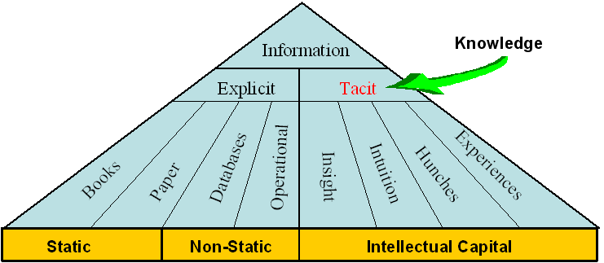

Figure 1

The technologies and applications used to manage Static information differs from the technologies and applications used to manage Non-static information. Within the Static environment the typical Library/Registry can suffice. In the Non-static environment we find the real management problem. This is where information changes on a frequent basis and because of that, the technologies and applications are more inadequately used.

The Information Management Vision

Information that is timeous, accurate, complete, consistent, up-to-date, and within the context of business requirements, are collected, stored and disseminated for use by the clients, suppliers, partners and employees of the Department of Public Works that need it, when they need it, where they need it and in the format that they need it to enhance the quality and effectiveness of decision-making and the related service delivery. Too long a vision must be preferably short so that users can easily recite and understand it ?

PURPOSE AND BUSINESS OBJECTIVES
The purpose of this report is to examine the issues and concerns surrounding the management and utilisation of information and to further clarify, identify and quantify those issues, which have prevented the successful deployment of information management principles.

The report considers current recommendations that will be included in the information management strategy or corrective actions to redress the problem areas.

Agreement on the above within the context of the strategy will lead to different projects to implement the recommendations contained in the final strategy.

The primary objective of the Information Management Strategy will be to provide a framework that will lead to the improvement of the quality and effectiveness of the appropriate information for decision-making within the department by making it accessible to those that need it, when they need it.

Appropriate information means information that is timeous, accurate, complete, consistent, and up-to-date, all within the context of the defined business requirements.

The secondary objective (which has to be met in order to achieve the primary objective) is to provide a set of managed repositories of all the information resources necessary for the effective running of the department, that can be made easily accessible to any employee where and when needed, in part or in whole, depending on the responsibilities of that employee and the existing access and security control.

Information resources are all inclusive and include categories such as: client intelligence, market intelligence, government intelligence, supplier and contractor information, proposal information, communication and marketing, project files, financial information, legal documentation, policies, procedures – and other operational information.

If these two objectives can be achieved, the resulting operational benefits will include:
- Improved information to enhanced thought leadership by individuals both in respect of internal and client-facing activities
- More effective and productive client engagements through all phases of the client relationship life-cycle
- Cost reduction through improvements in efficiency
- Improved protection of the department’s intellectual capital

The specific IM benefits will include:
- Improved information sharing and externalisation
- Operational efforts linked to overall enterprise direction and strategy
- Improved information quality, security, and integrity
  - Increased business effectiveness

INFORMATION MANAGEMENT DEFINED this is a repetition from the AS IS report
In order to address the question of Information Management, it would be appropriate to discuss the various terms and definitions in the realm of KM. As a point of departure, Knowledge and the progression thereof can be seen in Figure 2: Knowledge Progression. The difference between data, information and knowledge and the management there-of will briefly be discussed.

Subsequently document, record and content and the management there-of will be defined as the possible forms of data, information and knowledge. The definitions will be concluded with a description of Groupware, as an enabling infrastructure for data, information and knowledge management.

These terms and definitions will be used as the foundation for the scope of the strategy and further discussion.

Data

Data can be seen as an object without context – an object in isolation is almost meaningless without understanding relationships with other objects. (Internal EA Project, 2002:184)

Information

Data placed in context – Information is the understanding of the relationships between the components of data itself, or components of data and other information.

Knowledge

Beyond relationships there is pattern, which is more than simply a relationship of relations. Patterns encompass both consistency and completeness of relations, and create its own context to some extent. When a pattern exists between data and information, the pattern can potentially present Knowledge. It only becomes Knowledge once the patterns can be realised and its implications are fully understood. Knowledge can evolve over time and is seldom of a static nature, and normally contains a high level of reliability and predictability. Knowledge tend to create it’s own context.

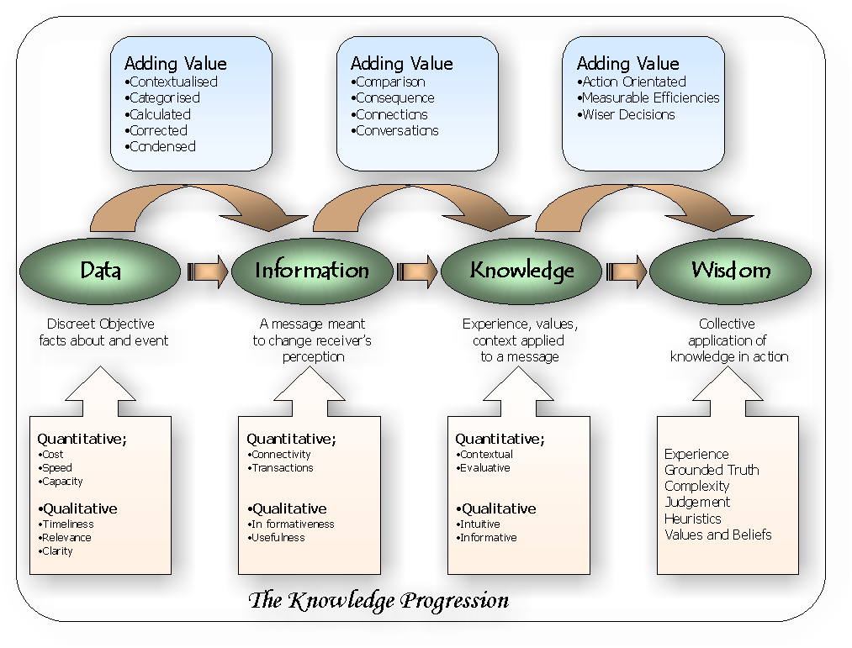
Knowledge is information that has been organised and analysed to make it understandable and applicable to problem solving or decision-making. (Turban, 1992).

Figure 2: Knowledge Progression

Explicit knowledge

Explicit knowledge is seen everyday. It is written down in the form of words and numbers and is used to solve such problems as fixing a machine or performing other work-related tasks. Explicit knowledge is easily communicated between people in the form of hard data, formulas, and written or universal procedures. Some examples would include books, papers, databases, policy manuals, and lessons learned.

Tacit knowledge

Tacit knowledge is found in the heads of your employees and in the experience of your customers. Because it contains their insights, intuitions, and hunches, tacit knowledge is highly personal, hard to formalize, and deeply rooted in a person’s actions and experiences as well as in their ideals, values, and emotions. Because of its nature, tacit knowledge is difficult to communicate or share with others.

Wisdom

Wisdom arises when one understands the fundamental principles responsible for the patterns representing Knowledge. (Internal EA Project, 2002:184)

Content

Meaning that is recorded on a medium.
- Narrow sense: The essential matter or substance of a written work or discourse.
- Broader sense: All the intrinsic information and data (ideas, topics, facts, or statements) contained in books, moving and still images, sound, textual resources and manuscripts. (Synonymous in this sense with subject matter.)
- Document management context: The data portion, as opposed to the attributes, of a document. The document components, which can be text, graphics, images, and other documents.
- Publishing content refers to individual documents that can be graphic, textual or illustrative in nature, or amalgamations of documents that can be combined into individual articles or complete publications.
- Web context: The information provided on a web page, as opposed to its design and layout. Content can take the form of text, graphics, audio, video, or a searchable database.
- Digital Content products are available in digital form - typically sound files, video and images that are available for download or distribution on electronic media.

Structured vs Unstructured Information

Structured data – in databases (formal IS and db)
Unstructured data – documents, email, minutes, etc

THE MANAGEMENT CONCEPTS OF THE DIFFERENT INFORMATION TYPES not sure about this. May be Annex or something. Seems there are definations as well which should be in the glossary section?

Data Management

Refers to several levels of managing data. From bottom to top, they are:
- The part of the operating system that manages the physical storage and retrieval of data on a disk or other device. See access method.
- Software that allows for the creation, storage, retrieval and manipulation of files interactively at a terminal or personal computer. See file manager and DBMS.
- The function that manages data as an organizational resource.
- The management of all data/information in an organization. It includes data administration, the standards for defining data and the way in which people perceive and use it.

Information Management

Macpherson (1999) defines Information Management (IM) as “the set of objects that govern the collection, storage, dissemination, and delivery of corporate information.” It was also stated by Macpherson (1999) that IM ensures the availability of information to customers, suppliers, and partners, and enables organizations to expose and leverage information products.

Knowledge Management

Knowledge Management is the process of capturing a company’s collective expertise wherever it resides – in databases, on paper, or in people’s heads – and distributing it to whoever it can help produce the biggest payoff. (Hibbard, 1997)

KM is the formalisation of and access to experience, knowledge, and expertise that create new capabilities, enable superior performance, encourages innovation, and enhances customer value. (Beckman, 1997)

Knowledge management is a discipline that promotes an integrated approach to identifying, managing and sharing all of an enterprise's information assets. These information assets may include databases, documents, policies and procedures as well as previously unarticulated expertise and experience resident in individual workers.

Document Management

The system that is used to automate the creation, capturing, configuration control, storage and retrieval of documents such as contracts, policy, project deliverables, etc.
An electronic document management system (EDMS) keeps track of stored documents (1) created by a computer using word processing, spreadsheet, or other software, or (2) scanned into a computer and converted to computer code by optical character recognition software or (3) scanned into a computer and saved in a computer image format. The document management application must be able to allow employees to share documents and depending on the security classification only read a document, copy a document or print a document, while only the author or owner of the document will be allowed to modify the document. The application must have full version control while only making the latest copy available.

Enterprise Content Management

Enterprise Content Management encompasses all business practices and technical processes that are performed for the purpose of capturing, managing, maintaining, sharing and preserving recorded meaning. It includes the distribution of content across a variety of applications and types of output.

Groupware

A collective term for software that provides the infrastructure allowing employees to work collaboratively, sharing information electronically, and use messaging to support the employees in working toward a common goal, regardless of where they are geographically located. Groupware services range from unstructured electronic mail to rigorously structured workflow systems. The main groupware categories are: All forms of Collaboration (electronic meetings, videoconferencing); Messaging (e.g. electronic mail); Intranet (web services, access to shared databases, hypertext documents) EDMS (including collective writing & document sharing and tracking); Workflow; Scheduling (sharing of calendars) and Directory Services.

COLLABORATION
Collaboration describes the rules and behaviours of conversation-focused (as opposed to activity-focused) business behaviour allowing employees to directly interact or perform as virtual teams to communicate. It is focused on the Meta analysis of workflow and concentrates more on supporting what we “say” about the enterprise, than what we “do” within it.

MESSAGING
Different services that provides the mechanisms to create, edit, send, receive, read, forward, store, print and administer messages as a form of conversation. It can be in the form of e-mails, SMSs or MMSs. Inside the organisation e-mail has become one of the most used communication technologies, rivaled only by the telephone. E-mail systems are cutting across all traditional internal and external boundaries. Furthermore the e-mail has become the most popular method for sending and receiving unstructured information both inside and outside of the organisation.

SCHEDULING
Calendar / Scheduling that provides the mechanisms to view, search, print, create, modify and delete personal calendar appointments, and to invite, schedule, search for free time, accept, reject, delegate group meetings.

INTRANET
An intranet is a corporate network that uses Internet software, standards and protocols to provide shared information functionality that supports collaboration in an organisation. It consists of any number of interconnected (internal) networks and web servers, protected from outside interference or access.

An intranet’s power lies in the combination of Internet functionality with the speed and security of an internal corporate LAN. An Intranet differs from the Internet in that it provides connectivity only between specific departmental sites, creating a pre-determined infrastructure for users.

EXTRANET
An extranet is a private (corporate) network that uses Internet software, standards and protocols to provide shared corporate information between the organisation and its selected partners. It provide access to a limited number of internal resources that must be shared as part of a common project and is protected from outside interference or access.

An extranet’s power lies in the combination of Internet functionality with the speed and security of an internal corporate LAN. An Extranet differs from the Intranet and Internet in that it provides connectivity only between specific departmental sites and partners, creating a pre-determined infrastructure for authorised users.

WORKFLOW
Workflow describes the rules and practices of activity-focused as opposed to conversation-focused business behaviour. It distils the essence of the bureaucratic functions within an enterprise, “translating” human behaviour into data processing events. Workflow therefore is the combination of tasks or steps that define a process. It allows and manages the flow of tasks between individuals, systems and business units involved in the circulation of information to achieve a predetermined result.

DIRECTORY SERVICES
Directory Service (Configuration Management) comprises all services, components and interfaces required to provide a sub-system for naming, describing, finding, accessing, managing and protecting resources in a distributed computing environment. Directories provide an authoritative source of information for identity and relation amongst people, applications and infrastructure [resources].

SOME EXTERNAL INFORMATION TRENDS
Some Information Management trends in the information management industry (external to DPW) were identified and the implications of the trends on Information Management in DPW were identified. The identified trends and implications will assist in understanding the context of IM in the department and in determining the requirements for IM in the department.

- Source. META Group
Source Date. 3 June 2003
Content. IBM, Oracle, Microsoft attempt to reposition their databases into comprehensive information management systems through 2005/06, with the ability to address structured (data), semi-structured (XML, catalogue SKUs), and unstructured (everything else) information. It is expected that this evolution will lead to the next boom in data warehouse/storage volumes and software licenses, as well as blur structured and unstructured tools through 2008.
Implications. Information Management in DPW must address structured, semi-structured and unstructured information, accompanied by the appropriate tools. Take into account the implication on storage volumes and software licences.

- Source. META Group
Source Date. Feb 2003
Content. In 2003/04, data quality and data mining will emerge as requisite core IT competencies. By 2005/06, data mining industry standards will greatly ease interoperability of algorithms and models. Concurrently, data profiling technologies will become a conventional technique for identifying data quality issues, planning data integration, and auditing information assets.
Implications. The requirement for data quality and data mining must be clear in DPW and should be addressed by utilising industry standard technology.

- Source. Meta Group
Source Date. Feb 2003
Content. The convergence of structured and unstructured information management systems will continue through 2004/05, with additional overlaps among document-authoring tools, application interfaces, documents, forms, and relational database technologies. Through 2007, driven by increasing content usability/reuse, rights management, and life-cycle/records management issues, organisations will increasingly seek and deploy content management technologies addressing various unstructured content types (e.g., images, documents, reports, rich media, e-mail, product data).
Implications. The overlaps among document-authoring tools, application interfaces, document, forms and relational database technologies must be understood in DPW. The drive for content reuse, rights management and records management must be well defined within DPW before any decision is made on a content management application.

- Source. Meta Group
Source Date. Feb 2003
Content. Knowledge Management (KM) will remain an organisational imperative through 2004/2006, driving individual, workgroup, and enterprise efficiencies. As technologies supporting KM initiatives are increasingly provided via Web services within a knowledge worker infrastructure, vendors will seek to provide complete platforms via aggressive M&A activity through 2005. Business, people, and process issues will continue to provide the most significant barriers to KM project success through 2007/08.
Implications. IM as supporting technology for KM, should be provided as Web based technology. The business, people and process issues regarding IM implementation and use in DPW must be well understood, identified and managed else it might just become the major barrier to achieve optimal success.

INFORMATION MANAGEMENT BEST PRACTICE are y then benchmaking DPW against these. It is not clear to me on this one as the comparison seems missing
In any endeavour there is always some form of best practice to consider, information management is no different.

- Source. Meta Group
- Information Ecology
The Enterprise Information Architecture (EIA) exists within an information ecosystem that presents layers of context for the different information engineering activities (see Figure 3).
  - The information ecology represents the integration of key strategic planning artifacts from the enterprise business architecture and is the purview of senior executive management.
  - The EIA represents the set of artifacts that describe and model the enterprise’s information value chain and is the purview of the chief information officer.
  - Information management represents the set of artifacts that govern the collection, storage, dissemination, and delivery of corporate information, and is the purview of the enterprise information architect.
  - Data architecture represents the set of artifacts that govern the design, implementation, and maintenance of databases, and is the purview of data architects and administrators.

- Implications. Within the context of EIA, information management exists to:
- Establish communication and enforce a governance framework to coordinate and collaborate with suppliers/partners, employees, stakeholders, and customers in business activities across the enterprise value network
- Establish the relevance of information and data within the context of business strategies, goals, and objectives
- Classify business information to ensure information sharing between organisational members, trading partners, and regulatory bodies
- Ensure alignment of information products to the enterprise bottom line (value proposition)
- Formalise the roles, organisational structure, and procedures for managing information content and delivery
- Establish information security access, privacy, confidentiality, quality, integrity, authenticity, and archival cycles
- Support risk management and business resumption planning activities
- Provide a foundation for the development and endorsement of common or standard data definitions
- Ensure data access and sharing and supports the physical value chain and information value network
- Ensure governance of data ownership and stewardship roles are identified and communicated
- Ensure data compliance within audit and legal requirements

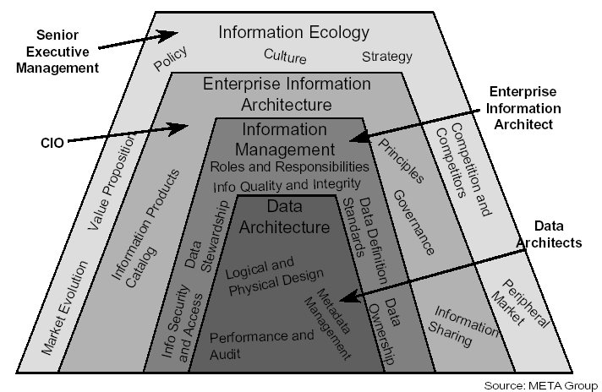

Figure 3 The Information Management Ecology

INFORMATION MANAGEMENT ARCHITECTURE PRINCIPLES how and what do they mean given position of DPW
- Minimize the data collection burden
- Rationale. DPW should be able to collect, manipulate, and transmit accurate and consistent data quickly and easily. The lack of data integration due to incompatible database structures; poor quality and integrity of data; and the mixture of organisational culture, processes, and business rules with data, hinder data collection, manipulation, and transmission. Data should be shared across the enterprise.

- Implications.
- Data standardisation, including a common vocabulary and data definition, will be difficult to achieve but is critical.
- A common organisational vision on information management eliminates redundancy and ensures data consistency.
- To ensure success, organisational units, as well as IT personnel should be involved.
- Each data element should have a owner accountable for data quality.
- Secure information against unauthorised access
- Rationale. DPW must be aware of security breaches and data compromise and the impact of these events. Appropriate security monitoring and planning, including the analysis of risks and contingencies and the implementation of appropriate contingency plans must be completed to prevent unauthorised access to information. Information security must be ensured and increased, to commensurate with increased access to information.

- Implications.
- Protecting systems from hackers requires considerable effort and costs.
- The business unit manager, where each system is implemented, must take responsibility for security measures and contingency.
- Provide access to information
- Rationale. Employees should have access to information efficiently, effectively, and economically. The access to information should be attainable any place, any time, and in the right format.

- Implications.
- DPW should encourage a diversity of public and private access methods for information, including multiple access points, the separation of transactional from analytical data, and data warehousing architecture.
- Accessibility involves the ease with which users obtain information.
- Information access and display must be sufficiently adaptable to a wide range of users and access methods, including formats accessible to those with sensory disabilities.
- Provide adaptive information delivery mechanisms
- Rationale. Information must be easily accessible and delivered in a very timely manner, when appropriate, when and where it is needed to efficiently and effectively compliment the enterprise’s business processes. It must be available, consistent, and valuable to the authorised user. Those users should not need to know the physical details for obtaining the data, or be concerned about its origination, as long as it is deemed official and authentic information.

- Implications.
- Aggressively move to an environment that is flexible, secure, and capable of rapidly responding to change
- Funding must be provided for evaluation of new technology to ensure its support of the business requirements
- A standards based network is a must
- Security systems that support simple end user identification and authentication
- Support for heterogeneous data (from multiple systems)
- More intuitive and functionally richer systems that require expanded skill sets
- Technologies designed to rapidly query and retrieve
- Transactions may span multiple systems
- Applications will be developed for disparate platforms
- In the application architecture, the presentation service will be separated from the functional logic
- Information is user-centric and owner-driven
- Rationale. To be successful, information must meet users' requirements and enable effective decision-making. With declining budgets and staffing levels, the need to increase productivity and efficiency is critical. Users will require access to information in an easy-to-use manner with the ability to retrieve information from many sources.

- Implications.
- Information may exist on a variety of servers and locations but must be available to the user in an integrated, seamless fashion.
- Enterprise wide connectivity for both internal and external users will be required through high-speed communications networks.
- Users will require support on multiple desktops including standards for these desktops and the ability to customise their work environment.
- Information must be accessible on a role based basis
- Information architecture is based on open standards
- Rationale.
- Software applications and information need to be more easily moved to computers of various sizes or brands.
- Computers of different sizes and brands need to communicate with each other in an interoperable environment.
- A vendor-neutral architecture provides long-term potential cost savings through enhanced competition in the marketplace.

- Implications.
- Easy-to-use standard data formats and search-and-retrieval tools are needed, with the ability to both accommodate older formats and media and adjust to emerging multimedia technologies.
- The skills of people become portable, that is, to be applicable to different computing environments.
- Resources, information, and software applications can be shared.
- Short-term functionality, based on proprietary solutions, may be sacrificed for long-term interoperability.
- Lifecycle costs should be minimized, although cost savings from implementing standards-based information architecture might not be achieved in the short term.
- The architecture must accommodate the current legacy systems built on proprietary components.
- Continue to encourage vendors to provide products based on open systems standards.
- Information is not only a BU asset but also an enterprise asset for which the information owners are the stewards
- Rationale.
- One of the goals of the Administration's Reinventing Government Initiative is to make quality information available to every citizen in a timely fashion. Treating information as a Departmental asset is necessary to accomplish this goal.
- The availability of timely and accurate information is a key ingredient of sound decision-making. As such, information warrants a similar degree of management as other Departmental resources (e.g., people, money, facilities, etc.). Information management involves ensuring the integrity, timeliness, protection, and sharing of information.
- Stewardship rather than ownership encourages information use without sacrificing security.

- Implications.
- Identified stewards are responsible for specific information categories
- Establish a process to share information enterprise wide, that must address:
  - Consistent data definitions.
  - Standard data interchange formats.
  - A management approach commensurate with the value of the information.
  - The establishment of an information locator capability as part of a meta data repository.
  - Information stewards responsible for the definition, integrity, and timeliness of the information within their domain.
  - Operational issues related to the physical implementation of a shared information environment.
- Partnership with information stewards and information technologists is critical.
- Enterprise wide access to information is the rule rather than the exception
- Rationale.
- Productivity, decision making, and customer service all benefit from easy, direct, and timely availability of information
- For optimal decision-making, people need access to the broadest range of information possible within the constraints of enterprise regulation
- Time spent overcoming unnecessary hurdles in the quest for quality information can be wasted. Time is often the most precious of resources. Timeliness is also an important information quality indicator.

- Implications.
- For unclassified information, the right-to-know should be presumed unless regulation specify otherwise.
- The business necessity of sharing information must be established.
- Technology must be deployed to distribute and allow access to information.
- Classification of information must be clearly stated -- rules need to be better defined. Secure information must not be accidentally released.
- The information architecture incorporates a robust interface that optimises the nature, efficiency, and effectiveness of the human operator
- Rationale.
- Usability engineering pays off in cost effectiveness, quality, and ease of use.
- The effectiveness of information delivery systems is jeopardised if the human interface is too difficult for non-computer-literate users to master.
- The attainment of successful work group collaboration using networked computers requires knowledge of the Human/Computer Interaction issues.
- Usability engineering pays off in cost effectiveness, quality, and ease of use.

- Implications.
- The expertise required for a productivity enhancing system must be engineered into all levels of systems.
- The Human/Computer Interaction field is an interdisciplinary field with roots in ergonomics, cognitive science, and human factors. A foundation for this understanding must be developed.
- An advocacy position for the importance and use of the Human/Computer Interaction knowledge in all aspects of system development needs to be developed and propagated to information technology development stakeholders.
- Human computer interactions are complex domains requiring more than the use of a graphical user interface. The department must develop methods of incorporating informed Human/Computer Interaction knowledge into its systems development efforts and its end products.
- DPW will have an information technology infrastructure that seamlessly links offices, programs, facilities, and field locations together
- Rationale.
- Barriers to accomplish objectives are often the result of the lack of a consistent and robust information technology infrastructure.
- The infrastructure can be centrally coordinated and implemented in a decentralised manner so that non- value added redundant efforts as well as implementation gaps are easily identified and eliminated.
- A seamless information technology infrastructure facilitates sharing of information and other resources across the enterprise.

- Implications.
- Central direction and a degree of central funding will be required to provide an infrastructure, which is consistent across the enterprise.
- Organisations must give up some degree of autonomy to achieve the necessary organisational consistency.
- A major component of this infrastructure must be an enterprise wide network capability that allows the exchange of sensitive (classified) data. This requires management of security policy issues.
- The information technology infrastructure includes some common databases and applications with commonly available access mechanisms.
- Information technology infrastructure planning and implementation requires wide and active participation from various organisational elements. The information technology infrastructure is based upon interoperability and standards, supporting the sharing of resources.
- Shared resources include data, information, applications, infrastructure, and computing, enabling users to leverage the work of others.

CONCLUDING THE DEFINITIONS OF INFORMATION MANAGEMENT
Information Management in the Department of Public Works must be seen in the context of the future objective to realise Knowledge Management as a discipline to promote “an integrated approach to identifying, managing and sharing all of the enterprise's information assets. These information assets may include databases, documents, policies and procedures as well as previously unarticulated expertise and experience resident in individual workers.”

However, attention will only be given to explicit knowledge or rather information at this time, which is “written down in the form of words and numbers and is used to solve business problems …… explicit information is easily communicated between people in the form of hard data, formulas, and written or universal procedures.” The “expertise and experience resident in individual employees” will not be addressed as part of the eventual Information Management Strategy.

No differentiation will be made between structured and unstructured data. Content and document management is regarded to contribute to Information Management and Groupware is regarded as “the collective term for software that provides the infrastructure” to enable Information Management.

METHODOLOGY ????
The list of divisions included/excluded in the investigation was identified before the start of the project and is contained in the list included. The head of each division and nominated people was informed as to the scope and objectives of the project and of the investigation as part of the project by means of awareness sessions.

Secondly workshops were set up for each division to discuss the specific information issues based on a information management questionnaire. The divisional head determined participants for individual workshops. In addition One on One interviews were conducted with the relevant role-players and support structures.

A summary or “minutes’ of each workshop was prepared and these were analysed and together with the contents contained in the questionnaires used to compile this report. These summaries and completed questionnaires form the basis or input to this report.

The table below summarises the invitees and participants per division in terms of this investigation. Note that invitees unable to attend the initial workshops were given the option to have individual meetings.

WHY IS IT OTHER ATTENDEES HAVE NAMES AND OTHERS ARE NOT NAMED ?

Division | Invitee | Attended
GITO |  | Yes
GITO |  | Yes
GITO |  | Yes
GITO |  | Yes
GITO |  | Yes
GITO |  | Yes
GITO |  | Yes
HOD |  | Yes
Professional Services |  | Yes
Professional Services |  | Yes
Professional Services |  | Yes
Professional Services |  | Yes
Project Management |  | Yes
Project Management |  | Yes
Project Management |  | Yes
Project Management |  | Yes
Project Management |  | Yes
Project Management |  | Yes
Project Management |  | Yes
Real Estate
Real Estate |  | Yes
Real Estate |  | Yes
Buildings |  | Yes
Maintenance
MEC Support | Kgomo KR | Yes
MEC Support | Ramahuma MM | Yes
MEC Support | Buthane MJ | Yes
Strategic Finance
Strategic Finance |  | Yes
Strategic Finance |  | Yes
Strategic Finance |  | Yes
Strategic Planning | Manamela MP | Yes
Strategic Planning | Makhubele DT | Yes
Strategic Planning |  | Yes
Strategic Planning |  | Yes
EPWP |  | Yes
EPWP |  | Yes
EPWP |  | Yes
EPWP |  | Yes
EPWP |  | Yes
EPWP |  | Yes
EPWP |  | Yes
Supply Chain |  | Yes
Supply Chain |  | Yes
Supply Chain |  | Yes
Human Resources | Rameetse PO | Yes
Human Resources | Van Wyk AMB | Yes
Human Resources | Mulaudzi DD | Yes
Human Resources | Matjie SJ | Yes
Human Resources | Molema RM | Yes
Human Resources | Phophi MD | Yes
Human Resources | Netelieliemi SD | Yes
Human Resources | Zwane NB | Yes
Human Resources | Maruma KA | Yes
Human Resources | Masangu MS | Yes
Human Resources | Bell Nadene | Yes
Districts | Sekhu J | Yes
Districts | Nkuna Y | Yes
Districts | Mogakane P | Yes
Districts | Hlongwane MS | Yes
Districts | Masedi NL | Yes
Districts | Setwaba MM | Yes
Districts | Tshivhinda MM | Yes
Districts | Mabotja NM

MANAGEMENT SUMMARY
In order to successfully support the DPW Information Environment, the business requires an integrated architecture capability that can successfully evolve over time and become part of the organisational culture. While developing individual architectures as part of the enterprise architecture and acquiring the related products does provide a limited capability, the integrated development of a total enterprise architecture is required to satisfy the business needs of the department. The aim should be to develop a mature architecture culture in which any architecture is developed in a well-defined context, at the right time, using an appropriate methodology, and is one that can be integrated with others and used widely and effectively.

The users from the different organisational units do not share a common experience on information availability and usage. This is because the implementation of information management as managing a resource, does not address the collection, structuring and dissemination of information on an organisational wide basis.
Information although available is very much silo owned.

“Mature” User Experience ??????????????????????

All these units claim to be using information successfully, and express confidence in the accuracy of their own information. The information input and flow issues seem largely procedural in nature and should be easily resolved by determining operational and management procedures to deal with this issue of organisational information management.

The concept of using the enterprise architecture approach to establish an information management strategy is a relatively new initiative that has been instituted by RGBS. The mature units seem to be approaching the issue of information in an organised manner and in particular the service delivery units are proactive in planning and using information to ensure that the services delivery information is correctly populated.

However there are some relevant issues here that should be addressed. Although the information is functionality usable it adds little value to the repeatability and organisational wide availability of the individual unit’s effort as there is virtually no organisational integration and the interface is often clumsy and difficult to use. To ensure that data will be input on a corporate wide basis, will require strong management processes to be put in place and a strategy that deals with end user frustrations on having to continually reproduce reports.

”Immature” User Experience

Immature users have of course not experienced any information management service at all, as they have not been using the concept nor understand the concept of information management in any significant way. They have an inclination that information management is for the information management functional unit and does have any bearing on their job execution.

The major issue in this area is the failure to map the business processes they use to the inputs, outputs and processing of information required to achieve organisational or group objectives. Mapping and the documentation of the operational and management processes required to make information usage functional in these areas is a prerequisite to successful implementation any information management strategy.

There is also a potential financial issue here as the expense of the Siebel licenses required to support implementation may be difficult to justify.

Training

Almost all the participants complained about inadequate training. In particular they do not like the passive training techniques and would like to have structured training based on documented course material with hands on participation. Divisions would also like to have the training geared towards the role they fulfill in the organisation and tailored to the type of business processes and information that the unit utilises.

While it is clear that training has been a limiting factor there are far more important underlying issues that are exposed in this area. These are management issues regarding the definition of an organisational strategy and process needed to successfully implement a strategy. At an operational level it is important to understand and document the business processes that need to be applied to capture relevant information and performance measurements in order to achieve the desired organisational objectives The strategy will result in an operational roadmap which details what is to be done, who will do it, when it will be done and how it will be done. The management processes determine the points of responsibility, who will track and enforce, how this will happen, be measured and reported.

Support

All divisions report a very unsatisfactory information support experience, resulting in strong negative attitudes, exasperation, dissatisfaction and questions the feasibility of implementing the recommendations of the strategy. The issues vary from poor service levels (response to issues) to data integrity issues, mention was made that this project will be a fruitless exercise unless the support functions changes their attitudes.

Again there is an underlying issue here, and that is the lack of clearly defined business internal services, strategic objectives and processes to deal with the support of a complex integrated organisation.

Functionality

There are a large number of complaints about the functionality of an “information management system” (or lack thereof). This to a large degree stems from the knowledge that information is a product and many of the users have had basic exposure to information management. Users are therefore disappointed and frustrated by the limitations of the current situation surrounding the implementation of a information management solution.

To a large degree these frustrations could be mitigated and mapped if there was a clear strategy in terms of information and there was a formal forum for expressing and dealing with user issues.

Mention was made at different sessions of a previously specified or developed “solution” supposedly aiming to assist with information management but it could not be pinpointed.

General Experience

There are concerns as to the general understanding of the project objectives. Some individual users believe that it is an over kill and that the current financial means of running and managing information of the organisation is sufficient. This misconception needs to be resolved as soon as possible.

The project deliverables need to coordinate head office and district initiatives to maximize the effort and avoid duplication of effort and/or conflicting programs to establish information management.

ORGANISATIONAL MATURITY
Mature organisations realises that fitting information management applications are critical to the successful operation of the organisation, promoting collaboration, and allowing the efficient cross-functional sharing of information.
Within the mature stable organisations information management is embedded in the compliance and governance structure ensuring the early detection, prevention and correction of corruption and fraud.
Corporate governance is defined by Robert A Monks and Nell Minnow “as the structure that is intended to make sure that the right questions get asked when it must be asked and that checks and balances are in place to make sure that the answers reflect what is right.” For this to happen the organisation needs a well defined and implemented information management strategy because organisations must not only achieve regulatory compliance in terms of governance but also have to prove compliance.
The mature organisation have come to realise that there are far greater benefits to be achieved with improved governance because legislated regulations are inherently based on achieving optimal business performance and industry established best practices and procedures.
DPW stills lacks considerably in the overall category of having a comprehensive information management architecture that delivers on the aforementioned criteria.

RECOMMENDATIONS

Conceptual Enterprise Architecture Framework

The IM Conceptual Architecture will define the realisation of IM within DPW that will justify future investment in people, processes and technology. It is essential that the IM Conceptual Architecture reflect the current Business Drivers and Business Requirements for IM, the IM Vision and the application of the IM Architecture Principles. The resulting conceptual architecture will become the “Definitive Information Framework” for IM in DPW once physically developed.

The IM Conceptual Architecture will define the basic components that are required to eventually constitute IM in DPW. The concepts will be expressed in terms of the Conceptual Architecture Models for DPW by way of an EA Framework.

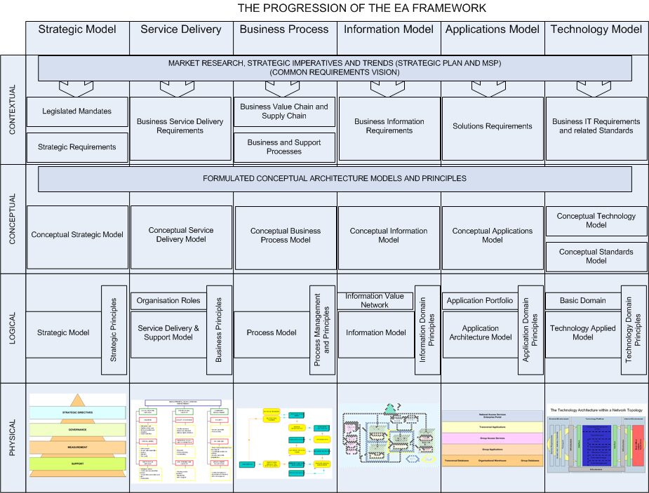

CONCEPTUAL ARCHITECTURE

Business Process Definition and Mapping ( THIS SEEMS FINE)

The foundation for the implementation of any large integrated information management strategy in a multi disciplinary, geographically dispersed organisation is the definition and formulation of the requisite management and related operational business processes required to support and sustain the business strategic objectives as determined in the strategic plan and by this project. This is the basic approach we would recommend.

The evidence uncovered by the research done during this project experience as documented, in this document strongly suggests that the consolidation of required information within the department was never determined and has never happened. As each business unit has different business information that is critically important to improve the overall efficiency and effectives of decision making.

Of equal importance is the understanding that management as well as operational processes must be put in place to effectively manage information. An information strategy must not be implemented to solve any one operational problem. It is a rather a strategy that permeates all levels of the organisational psyche and underlying business processes and information needs to be implemented in a thoroughly professional manner to gain maximum benefit.

If this exercise is done well and the benefits realised, all divisions will be brought on board, and each person in the business loop will understand his/her role in achieving the business objectives thru information management and the results will be measurable.

On the short term we recommend that an internal project be launched to define the project registers and resultant management information structures within the enterprise architecture.

Training

A good training plan should accompany the implementation of the strategy and must exhibit the following characteristics: -

  - User-friendly, structured and comprehensive training material.
  - Role based.
  - Encapsulates business processes.
  - Hands on proactive.
  - Repeatable quality of information.
  - Formal on the job experience.
  - Suitable materials and workspace made available.
  - Experienced trainer(s).
  - Result in transfer of knowledge.
  - It must benefit the individual worker

We believe the geographical remoteness and size of the user base is enough to justify a “train the trainer” approach and the training surrounding the concepts of information management must start sooner than later.

General Experience

Support in terms of information management practices are clearly one of the weakest links in the business chain. Virtually all users complain bitterly about the lack of support and inability of the support structures to resolve issues on a timeous and permanent basis revolving around information management.

It is clear from the evidence collected that there are no clear and formal structures and procedures in place to deal with information collection, processing and dissemination support on an organisational wide basis.

In a client context and even for internal support we would recommend the establishment of a Help Desk role( What will this do?) and that the management and responsibility for this function to be vested in the IM functional unit within the department.

In the general business environment there is confusion and disagreement as to the role of the IM function in the context of information management, in addition to the basic weaknesses portrayed by the broader perception of the employees one can argue that the user group within the department is not following a common or agreed procedure concerning information management.

Support issues at both infrastructure and product levels must be clearly thought through and identified and the relevant support structures put in place to deliver a professional service.

Attitude

“There is no “true reality” in information management; only the individual’s perception of what it is and all perceptions are influenced by the individual’s attitude”.

It is a reasonable assertion to state that the experiences documented as a result of this investigation suggest that information management in the DPW environment is largely passive and reactive when it comes to the real issue of information management (with the exception of the current initiative). Even this initiative is seen by some as time and money wasting and remotely enforced from head office and a source of frustration rather than inspiration. With this perception it is easy to find fault rather than virtue, less risky to avoid the problem rather than confront it, and one can always point fingers at head office instead of embarking on common vision of the solution.

These comments are harsh, but information and its management is here to stay and it is much more productive to embrace the change now than avoid it and face the consequents later.

General Recommendation

NEXT STEPS
The challenge facing organisations today is not just to manage information as a resource by effectively finding, organising, storing and distributing it, but also managing the growing of information to fit within the structures created by the organisation for their information management.

Between 2001 and 2003 more than 20 new laws were enacted through out the world that impacted the way in which an organisation managed its information. International events such as 9/11 and Enron have placed a far greater responsibility on organisations to be more transparent.

Business Process Definition and Mapping

It is important to complete the strategy in line with the current information requirements as defined by the various business units through the workshops and the completion of the questionnaires.

Training

- Agree on approach

Timings will depend on option chosen and group initiatives –.

Support

Close the Loop

Required resources: -

When: - As soon as possible – should be coordinated with immature divisions.

DETAIL OF FINDINGS

Current Application Architecture

The Applications Architecture defines a set of applications that will support the shared data environment and provide the automated capabilities to store, share, and use data needed to conduct the organisation’s business efficiently. The Applications Architecture does not design systems or collect detailed requirements. The Applications Architecture addresses capabilities of existing, planned, and future applications to form a complete picture of the vehicles needed for delivering data resources and accomplishing business activities. The Applications Architecture is a key component in building the Implementation Plan.
In defining the applications in a shared data environment, it is beneficial to plan for managing data (Information Architecture) separately from the applications (Applications Architecture) that actually process the data. Data Repositories enable multiple applications to use the same data without duplicative maintenance. The business functions must be used to identify specific automated capabilities to support the functions outlined in the Business Model and the defined systems applications needed for those purposes.

The current list of applications is reflected in Figure 3.

DEPARTMENT OF PUBLIC WORKS
LIMPOPO PROVINCE
CATALOGUE OF APPLICATION SYSTEMS | MAJOR USERS
Transversal Systems
PerSal | Human Resources
BAS | Finance
Finest | Asset management
Standard Systems
Desktop Excell | All functions
BafMis | Properties
NPSLDS | Properties
MeasureIt | Roads and Bridges / SDI
Help desk system | Properties
Architect 2005 | Building and construction
QS Plus | Building and construction
TrackIt | ICT asset management
Map Guide | Properties
ArkTek | Building and construction
Sakhasonke | Building and construction
WestBank Fleet management | Transport
SuperF | Transport
Dream Weaver | ICT
Man Client | TELECOMMUNICATION
Shop Assist | Office services

Figure 4 List of Applications

DEPARTMENT OF PUBLIC WORKS
LIMPOPO PROVINCE
CATALOGUE OF APPLICATION SYSTEMS | MAJOR USERS
Additional Transversal Systems
Vulindlela | Finance and Management
LOGIS
Additional Internal Applications
Desktop Word | All Functions
Desktop Powerpoint
Microsoft Project
Microsoft VISIO

The typical application portfolio is divided into seven classifications each group represent specific sets of applications as indicated below:

- Customer Management System. The customer management system is currently silo based and will make a large contribution of structured and unstructured data to the Information Management once it is centralised.
- Financial applications. The transversal financial applications are integrated but the financial applications linked to project management are fragmented and lack integrated functionality. This poses a risk to corporate governance, which should be addressed in the short term. Integrated financial applications will be a source of structured data for Information Management.
- Human Resource applications. The human resource applications concerning the districts are fragmented and some may be regarded as legacy. The PERSAL application can be seen as integrated. Predominantly structured data will be obtained from the human resource application for Information Management.
- Web based applications. Multiple web based applications are in use. Unstructured data is provided by the web based applications.
- Document management. Different approaches to document management are used in DPW. The implementation of an ECM application to formally manage documents. An online system should be the prime focuses to integrate document management and should be the mechanism to manage all unstructured data of the enterprise.
- Commercial Off the Shelf (COTS). Microsoft Office products are used as the COTS applications, which are used for business support. The COTS applications are predominantly used to create unstructured data.
- Network support applications. Multiple network support applications are used to maintain required level of availability of the enterprise network.
- Licensed Computer System Software Consisting of all operating and data base management software.

Information Categories

Seventeen information categories have been identified that should be available to the users of information concerning the business of DPW. The information can be unstructured data, which would reside in a document management system or structured data, which would reside in a financial application or data warehouse. Information Categories is a method to classify unstructured information to be able to make easily accessible. It is based on the logical grouping of similar information with sub-groups in each major group. This is part of the enterprise architecture structure to facilitate organisations to provide employees access to the relevant information needed to execute their daily assignments. Are these that you started the project with. Cant we tailor them to DPW. What sort of information will fall within each sub class ?

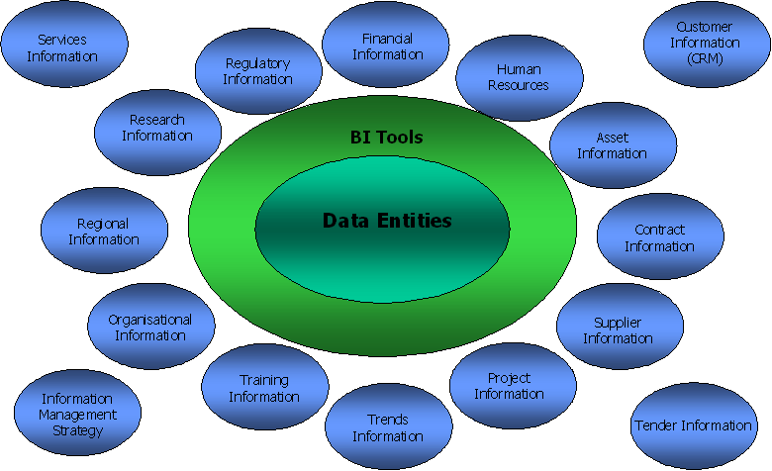

This part of the report will cover the current information structural existence. As of the present very little exist by way of formal structuring information to make it searchable and easily accessible. ( seems fine but need more breakdown on contents

Category | Contents | Organisational Situation
Financial | Budgets, Expenditure, Revenue, Projections, History | The more structured information is provided as this area of information provisioning is the highly govern of all categories
Human Resource finest is handling this | Payroll Detail, Employee Detail, Job Descriptions | The area covering payroll are also structured and well developed, but the general employee type information needs to be organised on an organisational wide access to relevant information basis
Assets finest is handling this | Fixed and Movable assets needed to perform business | This area needs to be departmentalized as there are certain information lacking in this area
Contract | Repository of all legal agreements | Although some registers on contracts is available in is not on a department wide basis accessible. A CENTRAL REPOSITORY NEEDS TO BE DEVELOPED.
Supplier | Relevant information about organisations that provide equipment and material | The supplier information to be made a central departmental source and to be enhanced to include the Contractor information
Project | List of information on Major assignments managed | Project information mostly silo based. A departmental repository needs to be put in place to provide project and progress information.
Trends | Industry development trends | There is a need for the department to enlist with various industry related professional institutions to obtain trend information from
Client | Relevant information about the client | Currently silo based, but the need for a central repository exists to contain information ob previous projects, current projects and expected projects.
Training | Relevant employee development information | A central repository containing training available in terms of course content, cost, institution, status of institution, employees that have attended etc
Organisational | Information about who and what the organisation is | This should be a central repository containing organisational structures and have norms and standards, organisational profile, stand points, speeches, policies etc
Regional | Specific information about all districts | A central repository containing information on the responsible official, contact persons, maps functions, projects, etc
Research | Reports on previous and existing industry relevant research | A central repository is needed with all relevant research that was done within and on behalf of the province affecting DPW
Regulatory | All legislation, rules and policies that governs the organisation | All acts, legislation and regulatory requirements impacting the service delivery of the department, nationally or internationally
Client Services Delivered | All relevant information about the services delivered to external clients | A repository containing the rules and regulations budgets etc on all services delivered is needed
Internal Service Delivered | Internal services detail | A central rep[ository is needed containing all internal services rendered, contact persons including and events time table and deadlines
Tenders | Tender information award history etc | A central repository containing information on all tenders issued, cancelled and awarded including values and tenderer information is needed
Information Management | Rules and regulations concerning information management | The rules and regulations on information management, what repositories exist, what information is available, contact persons etc is needed.

The information currently available is mostly silo based, limited and on request. There are very little departmental wide repositories providing information when it is needed in the format needed and at the time when it is needed.

