

Department of Public Works:
Gap Analysis Report

Document no | : | GAP01
Revision | : | 1.A (Draft Confidential)
Author | : | Jan Schutte
Effective date | : | 2006/04/29
Electronic file | : | input.doc
Classification | : | RESTRICTED
Identification Code | : | IMS



Department of Public Works



© 2006 Public Works. All rights reserved.
The document configuration centre shall hold all change requests and approval documentation. No part of this document may be reproduced or transmitted in any form by any means without the express written permission of Public Works. This electronic version of the document is the only Official/approved version of this document for distribution. Any printed copy of this document is for information purposes only and regarded as obsolete for any other date than the printed date, unless specifically agreed with Client where printed controlled documentation is required for distribution.
Gap Analysis Report
Contents
1. Introduction 5
1.1 Background 5
1.2 Information as a Prime Resource 5
1.3 Information in Context 6
1.4 The Information Management Vision 7
1.5 E-government requirement 7
1.5.1 E-governance 7
1.5.2 E-services (delivery and feedback) 7
1.5.3 E-business 7
2. Purpose and Business Objectives 7
3. The Management Concepts Of The Different Information Types 8
3.1 Data Management 8
3.2 Information Management 8
3.3 Knowledge Management 8
3.4 Document Management 9
3.5 Enterprise Content Management 9
3.6 Groupware 9
4. Collaboration 9
5. Messaging 9
6. Scheduling 9
7. Intranet 10
8. Extranet 10
9. Workflow 10
10. Directory Services 10
11. Current External Information Trends 10
12. Information Management Best Practice 11
13. Information Management Architecture Principles 12
14. Concluding the definitions of Information Management 12
15. Methodology 12
16. Management Summary 13
16.1 “Mature” User Experience 13
16.2 “Immature” User Experience 14
16.3 Training 14
16.4 Support 14
16.5 Functionality 15
16.6 General Experience 15
17. Organisational Maturity 15
18. Recommendations 15
18.1 Conceptual Enterprise Architecture Framework 15
18.2 Business Process Definition and Mapping 16
18.2.1 State Land Management 17
18.3 Training 18
18.4 General Experience 18
18.5 Attitude 18
18.6 General Recommendation 19
18.6.1 Communities of Practice and Vertical Units 19
19. Next Steps 19
19.1 Business Process Definition and Mapping 20
19.2 Training 20
19.3 Support 20
19.4 Close the Loop 20
20. Detail Of Findings 21
20.1 Current Application Structure 21
20.2 Current Information Situation 22
20.3 The Current Business Strategic Information Requirements 23
20.3.1 Proposed Supply Chain Discussed 24
20.4 The Current Information Requirements Per Core Process in the Value Chain 26
20.4.1 Strategic Planning Process 26
20.4.2 Notification/Identification 27
20.4.3 Project Qualification 27
20.4.4 Response 28
20.4.5 Implementation 28
20.4.6 Service Management 28
20.4.7 Termination 28
20.5 Some More BPR Theory (Hammer) 29
20.5.1 Strategic Information Requirements 29
20.5.2 The Departmental Value and Related Information Requirements 29
20.5.3 Business Strategy - Information Requirements 29
20.6 Current Technology Architecture 30
20.7 Current Information Categories 35
21. Report Conclusion 38
Annex A: High Level Processes 39
A.1 Professional Services – Electrical and Mechanical 39
A.2 Property and Facilities Management 39
A.3 Building Maintenance 40
A.4 Project Management 40
A.5 EPWP 41
A.6 Skills Development and Performance Management 41
A.7 Risk Management 42
A.8 Service Delivery Improvement 42
A.9 Building Maintenance (Districts) 43
A.10 Strategic Planning 43
A.11 Financial Management 44
A.12 Real Estate (GM) 44
A.13 Maintenance (Buildings) 45
A.14 Human Resources 45
A.15 Wellness Programme 46
A.16 Corporate Services (GM) 46
A.17 Transport 47
A.18 Office Services 47
A.19 Shared Services 48
A.20 Real Estate (Districts) 48
A.21 Supply Chain Management 49
A.22 CFO 49
A.23 Professional and Project Management (GM) 50
A.24 COO 50
A.25 Infrastructure Support (Finance) 51
A.26 Infrastructure Support (Other) 51
Annex B: List of Gaps 52
Annex C: Input from one on one Sessions 52
Terms, definitions, acronyms and abbreviations 60
C.1 Terms 60
C.1.1 Information Management Defined 60
C.2 Acronyms & abbreviations 62
Annex D: Amendment History 63
Annex E: Annexures 64
Annex F: Distribution List 65
Annex G: Public Works Approval Page 66
Annex H: Client Approval Page 67

Figures
Figure 1: The Information Domain 6
Figure 2: The Progression of the Enterprise Architecture Framework 16
Figure 3: State Land Management 17
Figure 4: Communities of Practice 19
Figure 5: List of Applications 22
Figure 6: The Proposed Supply Chain 25
Figure 7: The Proposed Value Chain 26
Figure 8: The Proposed Categories 36
Figure 9: Knowledge Progression 61

Tables

Introduction

Background

“The new source of power is not money in the hands of a few but information in the hands of many.”
John Naisbitt

It is general knowledge that a fair amount of productive time is wasted on unproductive information hunting during any one day at work. Listed below are some remarks from a research done by IDC:

- “Workers spent from 15% to 25% of their time — up to 10 hours per week — searching for information.”
- “Workers spend more time recreating existing information than they do creating new information, products, services.”
- “Roughly 50% of “Web” searches are abandoned due to user frustration stemming from an inability to find what they want.”
- According to IDC, “1,000 workers at a typical enterprise will waste up to $3 million per year searching for information that doesn’t exist, recreating information that can’t be found, or failing to find existing information.”

Again, all signs point to the business requirement to make information and content available in the proper context, at the right time and place and to ensure the repeatability of information, and to design Web applications and portals that consider not only how content will be created and published, but where and when it will be used and how it will be accessed.

It must be realised that there are no wrong or right answers when compiling a information management strategy as information deals with not only the business type and management style but also the employee skills and the maturity of the organisation.

Tom Jenkins in his book Enterprise Content Management states that up to 90% of an organisations information is not managed through an acclaimed methodology.

According to an article in the Wall Street Journal, August 26, 2004 the number of e-mails in North America has tripled in the space of 5 years. It claims that employees on average spend 2.2 hours each day reading, managing and organising their mail.

Information as a Prime Resource
In this current age for organisations to succeed by achieving their business objectives and delivering on their strategic expectations they must know how to best make use of the information and content in and around their organisation. The question arises as how to determine what their needs are, what information to keep and how to establish a structure that will them to understand the information and therefore put it to optimal use within the organisation.

In establishing a solution it must be remembered that an information solution has to deal with people, content business processes.

Through the nineties organisations moved from data manipulation to document management. They have gone from the traditional Management Information Systems (MIS) that captured, stored, retrieved and reported raw data to utilising business intelligence. The reporting of information was basically only on request and without contextual detail. It was used and discarded with very little repeatability and often this caused inferior decisions.
Information during this stage was for so-called decision making purposes. To move toward knowledge management, information had to become actionable and therefore the business intelligence layer became necessary. A very good example of moving into the business intelligence arena is the powerful search engines that were developed. With which information can be categorised and structured to satisfy a particular need.

It was when this era dawned that the importance of truly managing information as a prime resource was realised. It was then that organisations started to categorise, organise and created structures to represent information. This was the beginning of the philosophy of enterprise architecture.

The organisation of information was based on the organisation structure, it meant that there were operational information, financial information and administrative information, although this made information more readily available it was very much silo oriented and on request.
Apart from organising the information some categorisation was added. Whereby each piece of information was intelligently tagged, known as meta-data, with this development came the realisation that information must be made available cross functionally to really benefit the organisation. So the first enterprise architecture was born.

Information in Context
Information must be dealt with in its context when considering defining an Information Management Strategy. Information firstly can be either Explicit or Tacit in its existence. When looking at the tacit component one is focussing on the intellectual capital part of it, which is in the knowledge management ambit.

For the sake of this document and the subsequent strategy, the focus will mainly fall on the explicit part which can either be Static of nature or Non-static as per Figure 1.

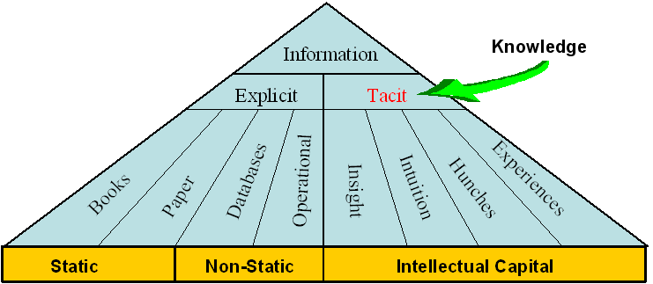

- The Information Domain

The technologies and applications used to manage Static information differs from the technologies and applications used to manage Non-static information. Within the Static environment the typical Library/Registry can suffice. In the Non-static environment we find the real management problem. This is where information changes on a frequent basis and because of that, the technologies and applications are more inadequately used.

The Information Management Vision
Information that is timeous, accurate, complete, consistent, up-to-date, and within the context of business requirements, are collected, stored and disseminated for use by the clients, suppliers, partners and employees of the Department of Public Works that need it, when they need it, where they need it and in the format that they need it to enhance the quality and effectiveness of decision-making and the related service delivery.

E-government requirement
It must be noted that this recommendation takes full cognisance of the E-government requirements as contained in the National and Provincial E-government document. Thus, we have considered and based our recommendation on an electronic (‘e-’) government initiative that addresses at least the three major issues:

E-governance
- the application of IT to intra-governmental operations, including the interaction between
central, provincial and local government. This includes paperless messaging and reporting, electronic document management and archiving, integrated systems for finance, asset and human resource management (including training), as well as systems for real-time collaboration and project management, conferencing, decision support and executive information.

E-services (delivery and feedback)
– the application of IT to transform the delivery of public services from ‘standing in line’ to online: anytime, anywhere, by any means, and in interactive mode. The services affected include general information and regulations, education and culture, health consulting and telemedicine, benefits, taxation etc. The new delivery vehicles also offer the opportunity to let people participate in government, by collecting direct and immediate public input in respect of policy issues, specific projects, service delivery problems, cases of corruption etc.

E-business
– the application of IT to operations performed by government in the manner of business-to-business transactions and other contractual relations. An obvious example is the procurement of goods and services by government: e5 procurement covers the steps from electronic tender to electronic payment. More cases become available for IT application with the spread of outsourcing and the development of public-private partnerships.

Purpose and Business Objectives
The purpose of this report is to examine the issues and concerns surrounding the management and utilisation of information and to further clarify, identify and quantify those issues, which have prevented the successful deployment of information management principles.

The report considers current recommendations that will be included in the information management strategy or corrective actions to redress the problem areas.

Agreement on the above within the context of the strategy will lead to different projects to implement the recommendations contained in the final strategy.

The primary objective of the Information Management Strategy will be to provide a framework that will lead to the improvement of the quality and effectiveness of the appropriate information for decision-making within the department by making it accessible to those that need it, when they need it.

Appropriate information means information that is timeous, accurate, complete, consistent, and up-to-date, all within the context of the defined business requirements.
The secondary objective (which has to be met in order to achieve the primary objective) is to provide a set of managed repositories of all the information resources necessary for the effective running of the department, that can be made easily accessible to any employee where and when needed, in part or in whole, depending on the responsibilities of that employee and the existing access and security control.

Information resources are all inclusive and include categories such as: client intelligence, market intelligence, government intelligence, supplier and contractor information, proposal information, communication and marketing, project files, financial information, legal documentation, policies, procedures – and other operational information.

If these two objectives can be achieved, the resulting operational benefits will include:
- Improved information to enhanced thought leadership by individuals both in respect of internal and client-facing activities.
- More effective and productive client engagements through all phases of the client relationship life-cycle.
- Cost reduction through improvements in efficiency.
- Improved protection of the department’s intellectual capital.

The specific IM benefits will include:
- Improved information sharing and externalisation.
- Operational efforts linked to overall enterprise direction and strategy.
- Improved information quality, security, and integrity.
- Increased business effectiveness.

The Management Concepts Of The Different Information Types

Data Management
Refers to several levels of managing data. From bottom to top, they are:
- The part of the operating system that manages the physical storage and retrieval of data on a disk or other device. See access method.
- Software that allows for the creation, storage, retrieval and manipulation of files interactively at a terminal or personal computer. See file manager and DBMS.
- The function that manages data as an organizational resource.
- The management of all data/information in an organization. It includes data administration, the standards for defining data and the way in which people perceive and use it.

Information Management
Macpherson (1999) defines Information Management (IM) as “the set of objects that govern the collection, storage, dissemination, and delivery of corporate information.” It was also stated by Macpherson (1999) that IM ensures the availability of information to customers, suppliers, and partners, and enables organizations to expose and leverage information products.

Knowledge Management
Knowledge Management is the process of capturing a company’s collective expertise wherever it resides – in databases, on paper, or in people’s heads – and distributing it to whoever it can help produce the biggest payoff. (Hibbard, 1997)

KM is the formalisation of and access to experience, knowledge, and expertise that create new capabilities, enable superior performance, encourages innovation, and enhances customer value. (Beckman, 1997)

Knowledge management is a discipline that promotes an integrated approach to identifying, managing and sharing all of an enterprise's information assets. These information assets may include databases, documents, policies and procedures as well as previously unarticulated expertise and experience resident in individual workers.

Document Management
The system that is used to automate the creation, capturing, configuration control, storage and retrieval of documents such as contracts, policy, project deliverables, etc.
An electronic document management system (EDMS) keeps track of stored documents (1) created by a computer using word processing, spreadsheet, or other software, or (2) scanned into a computer and converted to computer code by optical character recognition software or (3) scanned into a computer and saved in a computer image format. The document management application must be able to allow employees to share documents and depending on the security classification only read a document, copy a document or print a document, while only the author or owner of the document will be allowed to modify the document. The application must have full version control while only making the latest copy available.

Enterprise Content Management

Enterprise Content Management encompasses all business practices and technical processes that are performed for the purpose of capturing, managing, maintaining, sharing and preserving recorded meaning. It includes the distribution of content across a variety of applications and types of output. Currently the department does not use a electronic document management or enterprise content management application. So the capturing storing and managing of departmental “records” i.e. documents, images and other physical records are not version controlled and stored on a central repository with the required access control attached.

Groupware
A collective term for software that provides the infrastructure allowing employees to work collaboratively, sharing information electronically, and use messaging to support the employees in working toward the organisational strategic goals, regardless of where they are geographically located. Groupware services range from unstructured electronic mail to rigorously structured workflow and business automated process systems. The main groupware categories are: All forms of Collaboration (electronic meetings scheduler, videoconferencing); Messaging (e.g. electronic mail, MMS etc); Intranet (web services, access to shared databases, hypertext documents, images, etc) EDMS (including collective writing & document sharing and tracking with full version control); Workflow; Process Automation and Activity Scheduling (sharing of calendars) and Directory Services (Single sign on and other network security.

Collaboration
Collaboration describes the rules and behaviours of all conversation-focused (as opposed to activity-focused) business behaviour allowing employees to directly interact or perform as virtual teams and to communicate while the communication is captured. It is focused on the Meta analysis of workflow and concentrates more on supporting what we “say” about the enterprise, than what we “do” within it.

Messaging
Different services that provides the mechanisms to create, edit, send, receive, read, forward, store, print and administer messages as a form of conversation. It can be in the form of e-mails, SMSs or MMSs. Inside the organisation e-mail has become one of the most used communication technologies, rivaled only by the telephone. E-mail systems are cutting across all traditional internal and external boundaries. Furthermore the e-mail has become the most popular method for sending and receiving unstructured information both inside and outside of the organisation. E-mails contain a lot of corrective and instructive types of information. It has become far easier to send out a e-mail covering specific issues about the organisation than sending a paper notice.

Scheduling
Calendar and event Scheduling that provides the mechanisms to view, search, print, create, modify and delete personal calendar appointments, and to invite, schedule, search for free time, accept, reject, delegate group meetings.

Intranet
An intranet is a corporate network that uses Internet software, standards and protocols to provide shared information functionality that supports collaboration in an organisation. It consists of any number of interconnected (internal) networks and web servers, protected from outside interference or access.

An intranet’s power lies in the combination of Internet functionality with the speed and security of an internal corporate LAN. An Intranet differs from the Internet in that it provides connectivity only between specific departmental sites, creating a pre-determined infrastructure for users.

Extranet
An extranet is a private (corporate) network that uses Internet software, standards and protocols to provide shared corporate information between the organisation and its selected partners. It provide access to a limited number of internal resources that must be shared as part of a common project and is protected from outside interference or access.

An extranet’s power lies in the combination of Internet functionality with the speed and security of an internal corporate LAN. An Extranet differs from the Intranet and Internet in that it provides connectivity only between specific departmental sites and partners, creating a pre-determined infrastructure for authorised users.

Workflow
Workflow describes the rules and practices of activity-focused as opposed to conversation-focused business behaviour. It distils the essence of the bureaucratic functions within an enterprise, “translating” human behaviour into data processing events. Workflow therefore is the combination of tasks or steps that define a process. It allows and manages the flow of tasks between individuals, systems and business units involved in the circulation of information to achieve a predetermined result.

Directory Services
Directory Service (Configuration Management) comprises all services, components and interfaces required to provide a sub-system for naming, describing, finding, accessing, managing and protecting resources in a distributed computing environment. Directories provide an authoritative source of information for identity and relation amongst people, applications and infrastructure [resources].

Current External Information Trends
Some Information Management trends in the information management industry (external to DPW) were identified and the implications of the trends on Information Management in DPW were identified. The identified trends and implications will assist in understanding the context of IM in the department and in determining the requirements for IM in the department.

Source: META Group
Source Date: 3 June 2003
Content: IBM, Oracle, Microsoft attempt to reposition their databases into comprehensive information management systems through 2005/06, with the ability to address structured (data), semi-structured (XML, catalogue SKUs), and unstructured (everything else) information. It is expected that this evolution will lead to the next boom in data warehouse/storage volumes and software licenses, as well as blur structured and unstructured tools through 2008.
Implications: Information Management in DPW must address structured, semi-structured and unstructured information, accompanied by the appropriate tools. Take into account the implication on storage volumes and software licences.

Source: META Group
Source Date: Feb 2003
Content: In 2003/04, data quality and data mining will emerge as requisite core IT competencies. By 2005/06, data mining industry standards will greatly ease interoperability of algorithms and models. Concurrently, data profiling technologies will become a conventional technique for identifying data quality issues, planning data integration, and auditing information assets.
Implications: The requirement for data quality and data mining must be clear in DPW and should be addressed by utilising industry standard technology.

Source: Meta Group
Source Date: Feb 2003
Content: The convergence of structured and unstructured information management systems will continue through 2004/05, with additional overlaps among document-authoring tools, application interfaces, documents, forms, and relational database technologies. Through 2007, driven by increasing content usability/reuse, rights management, and life-cycle/records management issues, organisations will increasingly seek and deploy content management technologies addressing various unstructured content types (e.g., images, documents, reports, rich media, e-mail, product data).
Implications: The overlaps among document-authoring tools, application interfaces, document, forms and relational database technologies must be understood in DPW. The drive for content reuse, rights management and records management must be well defined within DPW before any decision is made on a content management application.

Source: Meta Group
Source Date: Feb 2003
Content: Knowledge Management (KM) will remain an organisational imperative through 2004/2006, driving individual, workgroup, and enterprise efficiencies. As technologies supporting KM initiatives are increasingly provided via Web services within a knowledge worker infrastructure, vendors will seek to provide complete platforms via aggressive M&A activity through 2005. Business, people, and process issues will continue to provide the most significant barriers to KM project success through 2007/08.
Implications: IM as supporting technology for KM, should be provided as Web based technology. The business, people and process issues regarding IM implementation and use in DPW must be well understood, identified and managed else it might just become the major barrier to achieve optimal success.

Information Management Best Practice
In any endeavour there is always some form of best practice to consider, information management is no different.

A business practice is a habitual way of carrying out work. It gets at how work is carried out not what work is carried out
Vs.
Best practices are those work practices that have been determined to be the best approach for all or large parts of an organisation.

Why do we need best practices for information management?

..”Because our “Information Enabled” partners and other government bodies have it”

Information will increasingly form the basis of service delivery performance within the build industry and government structures. Executives must explicitly articulate and define the role information will play in the execution of the organisation’s business strategy.

Information Management Architecture Principles
Eminent librarians and information scientists working during the first five to six decades of the 20th century established the principles of information management. And wherever they worked their objectives were the same. Their aim was to:
- enable easy access to relevant information;
- at the time when it was valuable to the person who needed it;
- in the most usable format available;
- within an appropriately secure environment;
- to enable to building and sharing of knowledge.

Therefore information management principles can be defined as a standard set of rules governing the collection, processing, storage, retrieval and dissemination of information.

Concluding the definitions of Information Management
Information Management in the Department of Public Works must be seen in the context of the future objective to realise Knowledge Management as a discipline to promote “an integrated approach to identifying, managing and sharing all of the enterprise's information assets. These information assets may include databases, documents, policies and procedures as well as previously unarticulated expertise and experience resident in individual workers.”

However, attention will only be given to explicit knowledge or rather information at this time, which is “written down in the form of words and numbers and is used to solve business problems …… explicit information is easily communicated between people in the form of hard data, formulas, and written or universal procedures.” The “expertise and experience resident in individual employees” will not be addressed as part of the eventual Information Management Strategy.

No differentiation will be made between structured and unstructured data. Content and document management is regarded to contribute to Information Management and Groupware is regarded as “the collective term for software that provides the infrastructure” to enable Information Management.

Methodology
The list of divisions included/excluded in the investigation was identified before the start of the project and is contained in the list included. The head of each division and nominated people was informed as to the scope and objectives of the project and of the investigation as part of the project by means of awareness sessions.

Secondly workshops were set up for each division to discuss the specific information issues based on a information management questionnaire. The divisional head determined participants for individual workshops. In addition One on One interviews were conducted with the relevant role-players and support structures.

A summary or “minutes’ of each workshop was prepared and these were analysed and together with the contents contained in the questionnaires used to compile this report. These summaries and completed questionnaires form the basis or input to this report.

The table below summarises the invitees and participants per division in terms of this investigation. Note that invitees unable to attend the initial workshops were given the option to have individual meetings.

Division | Invitee | Attended
GITO | Jasper Chimanze | Yes
GITO | Tshidi Makhafola | Yes
HOD | Mr J Rantete | Yes
Professional Services | T Baikie | Yes
Professional Services | H Mayombolo | Yes
Professional Services | H Phiri | Yes
Project Management | Kaseke A | Yes
Real Estate | Naidoo R | Yes
Buildings | A Kaseke | Yes
Maintenance | C T Madale | Yes
MEC Support | Kgomo KR | Yes
MEC Support | Ramahuma MM | Yes
MEC Support | Buthane MJ | Yes
Quantity Survey | Rikhotso KW | Yes
Quantity Survey | Dlamini LG | Yes
Quantity Survey | Modipa TR | Yes
Strategic Finance | Kekana PW | Yes
Strategic Planning | Manamela MP | Yes
Strategic Planning | Makhubele DT | Yes
EPWP | Mokone TA | Yes
EPWP | Doras UU | Yes
EPWP | Maphalla MS | Yes
EPWP | Ndwalane FF | Yes
EPWP | Asare Osei | Yes
EPWP | Kidanu Asfaw | Yes
EPWP | Hlaing H | Yes
Human Resources | Rameetse PO | Yes
Human Resources | Van Wyk AMB | Yes
Human Resources | Mulaudzi DD | Yes
Human Resources | Matjie SJ | Yes
Human Resources | Molema RM | Yes
Human Resources | Phophi MD | Yes
Human Resources | Netelieliemi SD | Yes
Human Resources | Zwane NB | Yes
Human Resources | Maruma KA | Yes
Human Resources | Masangu MS | Yes
Human Resources | Bell Nadene | Yes
Districts | Sekhu J | Yes
Districts | Nkuna Y | Yes
Districts | Mogakane P | Yes
Districts | Hlongwane MS | Yes
Districts | Masedi NL | Yes
Districts | Setwaba MM | Yes
Districts | Tshivhinda MM | Yes
Districts | Mabotja NM | Yes

Management Summary
In order to successfully support the DPW Information Environment, the business requires an integrated architecture capability that can successfully evolve over time and become part of the organisational culture. While developing individual architectures as part of the enterprise architecture and acquiring the related products does provide a limited capability, the integrated development of a total enterprise architecture is required to satisfy the business needs of the department. The aim should be to develop a mature architecture culture in which any architecture is developed in a well-defined context, at the right time, using an appropriate methodology, and is one that can be integrated with others and used widely and effectively.

The users from the different organisational units do not share a common experience on information availability and usage. This is because the implementation of information management as managing a resource, does not address the collection, structuring and dissemination of information on an organisational wide basis.
Information although available is very much silo owned.

“Mature” User Experience
All these units claim to be using information successfully, and express confidence in the accuracy of their own information. The information input and flow issues seem largely procedural in nature and should be easily resolved by determining operational and management procedures to deal with this issue of organisational information management.

The concept of using the enterprise architecture approach to establish an information management strategy is a relatively new initiative that has been instituted by RGBS. The mature units seem to be approaching the issue of information in an organised manner and in particular the service delivery units are proactive in planning and using information to ensure that the services delivery information is correctly populated.

However there are some relevant issues here that should be addressed. Although the information is functionality usable it adds little value to the repeatability and organisational wide availability of the individual unit’s effort as there is virtually no organisational integration and the interface is often clumsy and difficult to use. To ensure that data will be input on a corporate wide basis, will require strong management processes to be put in place and a strategy that deals with end user frustrations on having to continually reproduce reports.

“Immature” User Experience
Immature users have of course not experienced any information management service at all, as they have not been using the concept nor understand the concept of information management in any significant way. They have an inclination that information management is for the information management functional unit and does have any bearing on their job execution.

The major issue in this area is the failure to map the business processes they use to the inputs, outputs and processing of information required to achieve organisational or group objectives. Mapping and the documentation of the operational and management processes required to make information usage functional in these areas is a prerequisite to successful implementation any information management strategy.
There is also a potential financial issue here as the expense of the Siebel licenses required to support implementation may be difficult to justify.

Training
Almost all the participants complained about inadequate training. In particular they do not like the passive training techniques and would like to have structured training based on documented course material with hands on participation. Divisions would also like to have the training geared towards the role they fulfill in the organisation and tailored to the type of business processes and information that the unit utilises.

While it is clear that training has been a limiting factor there are far more important underlying issues that are exposed in this area. These are management issues regarding the definition of an organisational strategy and process needed to successfully implement a strategy. At an operational level it is important to understand and document the business processes that need to be applied to capture relevant information and performance measurements in order to achieve the desired organisational objectives The strategy will result in an operational roadmap which details what is to be done, who will do it, when it will be done and how it will be done. The management processes determine the points of responsibility, who will track and enforce, how this will happen, be measured and reported.

Support
All divisions report a very unsatisfactory information support experience, resulting in strong negative attitudes, exasperation, dissatisfaction and question the feasibility of implementing the recommendations of the strategy. The issues vary from poor service levels (response to issues) to data integrity issues, mention was made that this project will be a fruitless exercise unless the support functions changes their attitudes.

Again there is an underlying issue here, and that is the lack of clearly defined business internal services, strategic objectives and processes to deal with the support of a complex integrated organisation.

Functionality
There are a large number of complaints about the functionality of an “information management system” (or lack thereof). This to a large degree stems from the knowledge that information is a product and many of the users have had basic exposure to information management. Users are therefore disappointed and frustrated by the limitations of the current situation surrounding the implementation of a information management solution.

To a large degree these frustrations could be mitigated and mapped if there was a clear strategy in terms of information and there was a formal forum for expressing and dealing with user issues.

Mention was made at different sessions of a previously specified or developed “solution” supposedly aiming to assist with information management but it could not be pinpointed.

General Experience
There are concerns as to the general understanding of the project objectives. Some individual users believe that it is an over kill and that the current financial means of running and managing information of the organisation is sufficient. This misconception needs to be resolved as soon as possible.

The project deliverables need to coordinate head office and district initiatives to maximize the effort and avoid duplication of effort and/or conflicting programs to establish information management.

Organisational Maturity
Mature organisations realises that fitting information management applications are critical to the successful operation of the organisation, promoting collaboration, and allowing the efficient cross-functional sharing of information.
Within the mature stable organisations information management is embedded in the compliance and governance structure ensuring the early detection, prevention and correction of corruption and fraud.
Corporate governance is defined by Robert A Monks and Nell Minnow “as the structure that is intended to make sure that the right questions get asked when it must be asked and that checks and balances are in place to make sure that the answers reflect what is right.” For this to happen the organisation needs a well defined and implemented information management strategy because organisations must not only achieve regulatory compliance in terms of governance but also have to prove compliance.
The mature organisation have come to realise that there are far greater benefits to be achieved with improved governance because legislated regulations are inherently based on achieving optimal business performance and industry established best practices and procedures.
DPW still lacks considerably in the overall category of having a comprehensive information management architecture that delivers on the aforementioned criteria.

Recommendations

Conceptual Enterprise Architecture Framework
The IM Conceptual Architecture will define the realisation of IM within DPW that will justify future investment in people, processes and technology. It is essential that the IM Conceptual Architecture reflect the current Business Drivers and Business Requirements for IM, the IM Vision and the application of the IM Architecture Principles. The resulting conceptual architecture will become the “Definitive Information Framework” for IM in DPW once physically developed.

The IM Conceptual Architecture will define the basic components that are required to eventually constitute IM in DPW. The concepts will be expressed in terms of the Conceptual Architecture Models for DPW by way of an EA Framework.

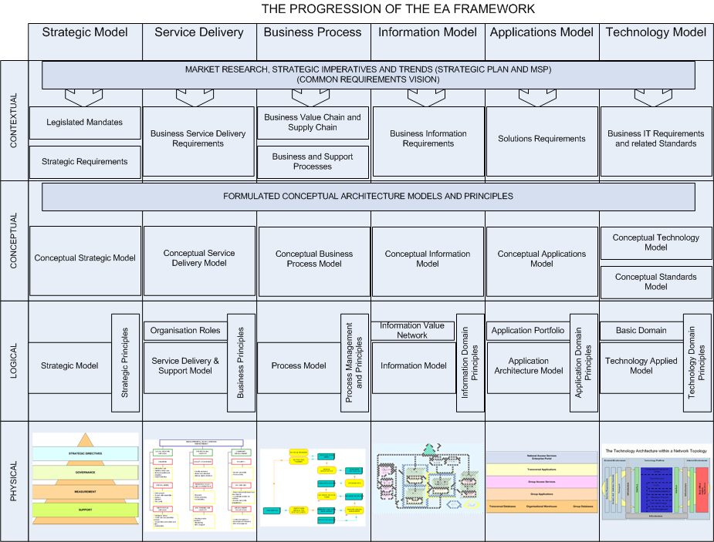
- The Progression of the Enterprise Architecture Framework

Business Process Definition and Mapping
The foundation for the implementation of any large integrated information management strategy in a multi disciplinary, geographically dispersed organisation is the definition and formulation of the requisite management and related operational business processes required to support and sustain the business strategic objectives as determined in the strategic plan and by this project. This is the basic approach we would recommend.

The evidence uncovered by the research done during this project experience as documented, in this document strongly suggests that the consolidation of required information within the department was never determined and has never happened. As each business unit has different business information that is critically important to improve the overall efficiency and effectives of decision making.

Of equal importance is the understanding that management as well as operational processes must be put in place to effectively manage information. An information strategy must not be implemented to solve any one operational problem. It is a rather a strategy that permeates all levels of the organisational psyche and underlying business processes and information needs to be implemented in a thoroughly professional manner to gain maximum benefit.

If this exercise is done well and the benefits realised, all divisions will be brought on board, and each person in the business loop will understand his/her role in achieving the business objectives thru information management and the results will be measurable in terms of the information management attributes.

The following figure represents the high level information process within the business unit of State Land Management:

State Land Management
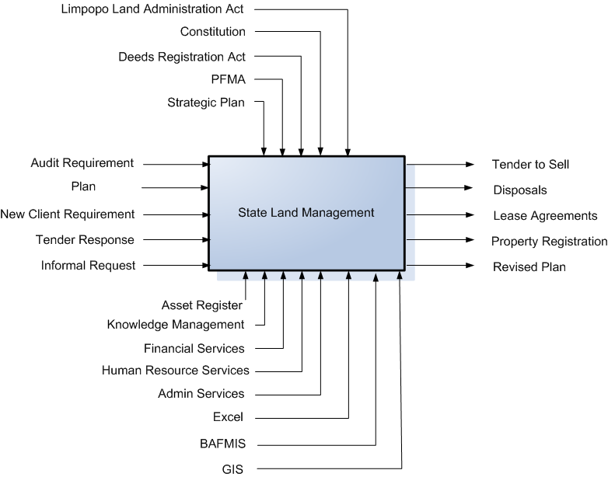

- State Land Management

It must be understood that any one process deals with people in terms of responsibility and information, the information required for the execution of a process could be classified as:
- Governance or Legislated information
- Input Information
- Support Information
- Output Information as well as the processing information.
For that reason the high level processed will indicate these four types of information requirements.
From this high level process flow the lower level processes and information requirements for the business unit of State Land Management. Similar processes must be developed for each business unit to complete the information analysis phase for the formulation of the information management strategy.
The processes must be classified into service delivery processes, district service support processes, head office service support processes and other administrative processes.

All the other high level processes obtained during the one-on-one sessions are reflected as Annex A.

Training
A good information management training plan should accompany the implementation of the strategy and must exhibit the following characteristics: -

- User-friendly, structured and comprehensive training material.
- Role based.
- Encapsulates business processes.
- Hands on proactive.
- Repeatable quality of information.
- Formal on the job experience.
- Suitable materials and workspace made available.
- Experienced trainer(s).
- Result in transfer of knowledge.
- It must benefit the individual worker.

We believe the geographical remoteness and size of the user base is enough to justify a “train the trainer” approach and the training surrounding the concepts of information management must start sooner than later.

General Experience
Support in terms of information management practices are clearly one of the weakest links in the business chain. Virtually all users complain bitterly about the lack of support and inability of the support structures to resolve issues on a timeous and permanent basis revolving around information management.

It is clear from the evidence collected that there are no clear and formal structures and procedures in place to deal with information collection, processing and dissemination support on an organisational wide basis.

In a “client” context and even for internal support we would recommend the establishment of a Help Desk role and that the management and responsibility for this function to be vested in the IM functional unit within the department.

In the general business environment there is confusion and disagreement as to the role of the IM function in the context of information management, in addition to the basic weaknesses portrayed by the broader perception of the employees one can argue that the user group within the department is not following a common or agreed procedure concerning information management.

Support issues at both infrastructure and product levels must be clearly thought through and identified and the relevant support structures put in place to deliver a professional service.

Attitude
“There is no “true reality” in information management; only the individual’s perception of what it is and all perceptions are influenced by the individual’s attitude”.

It is a reasonable assertion to state that the experiences documented as a result of this investigation suggest that information management in the DPW environment is largely passive and reactive when it comes to the real issue of information management (with the exception of the current initiative). Even this initiative is seen by some as time and money wasting and remotely enforced from head office and a source of frustration rather than inspiration. With this perception it is easy to find fault rather than virtue, less risky to avoid the problem rather than confront it, and one can always point fingers at head office instead of embarking on common vision of the solution.

These comments are harsh, but information and its management is here to stay and it is much more productive to embrace the change now than avoid it and face the consequents later.

General Recommendation

Communities of Practice and Vertical Units
Communities of Practice (COP) is all about business units that share information, insight, experience and tools about a business area of common interest (the region and the client segment e.g., building, maintenance etc.) The vertical units are the business units and service units that enable the regional organisations to deliver value to the clients. The different regional organisations can therefore be regarded as communities of practice that share knowledge, learn together, and create common practices.

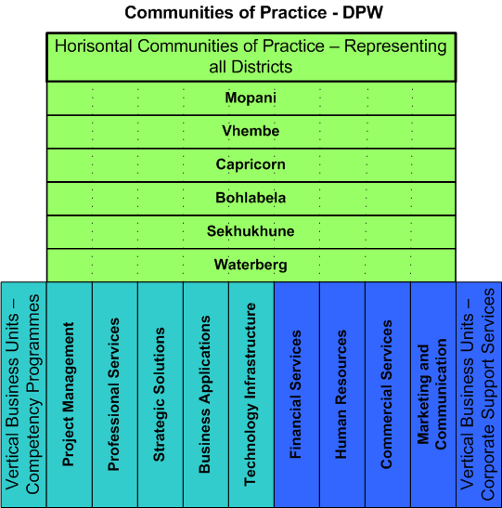

- Communities of Practice

Next Steps
The challenge facing the department today is not just to manage information as a resource by effectively finding, organising, storing and distributing it, but also managing the growing of information to fit within the structures created by the organisation for their information management in the future.

Between 2001 and 2003 more than 20 new laws were enacted through out the world that impacted the way in which an organisation managed its information. International events such as 9/11 and Enron have placed a far greater responsibility on organisations to be more efficient and effective in terms of information management, so as to be transparent.

Business Process Definition and Mapping
It is important to complete the strategy in line with the current information requirements as defined by the various business units through the workshops and the completion of the questionnaires as well as different one on one sessions. Related to information are the processes to capture, validate, process, store and disseminate the relevant information to who needs it when they need it.
For that reason it is advantages to have a value chain and a supply chain formalised for the organisation to be able to define the high level core processes for the department and then explode and cascade it down within the organisation.
Furthermore it must be stressed that each business unit needs to understand and have at its fingertips the governing information, the input information, the support information and the output information that has to be generated. The must also have defined the processes required to process the information.

The IDEF0 high level processes/information flows will have to be cascaded down to the next lower levels.

On the short term we recommend that an internal project be launched to define the project registers and resultant management information structures within the enterprise architecture.

Training
Start with the development of an information management training course. Agree internally on the approach and content

Timings for training will depend on the training option chosen and how group initiatives on implementing the strategy are facilitated and impacted.

Support
As part of the information management strategy development a information support/help desk functionality needs to be establish to provide employees with information about information in terms where they can obtain it and from whom.

The support organisational structures need rethinking as the organisation is struggling to get accurate and timeous information.

Close the Loop
The definition of a information management strategy is but the start of the process. The required resources need to be defined acquired and trained up front to be in a position to implement the recommendations from the strategy. Resources also include the systems and technology needed to close the loop in terms of the inception of the strategy to having all required reports available as and when required.

When: - As soon as possible the resource requirements must be determined – it should be coordinated with immature divisions.

Detail Of Findings

Current Application Structure
The Applications Architecture defines a set of applications that will support the shared data environment and provide the automated capabilities to store, share, and use data needed to conduct the organisation’s business efficiently. The Applications Architecture does not design systems or collect detailed requirements. The Applications Architecture addresses capabilities of existing, planned, and future applications to form a complete picture of the vehicles needed for delivering data resources and accomplishing business activities. The Applications Architecture is a key component in building the Implementation Plan.
In defining the applications in a shared data environment, it is beneficial to plan for managing data (Information Architecture) separately from the applications (Applications Architecture) that actually process the data. Data Repositories enable multiple applications to use the same data without duplicative maintenance. The business functions must be used to identify specific automated capabilities to support the functions outlined in the Business Model and the defined systems applications needed for those purposes.

The current list of applications is reflected in Figure 6.

DEPARTMENT OF PUBLIC WORKS
LIMPOPO PROVINCE
CATALOGUE OF APPLICATION SYSTEMS | MAJOR USERS
Transversal Systems
PerSal | Human Resources
BAS | Finance
Finest | Asset management
Standard Systems
Desktop Excel | All functions
BafMis | Properties
NPSLDS | Properties
MeasureIt | Roads and Bridges / SDI
Help desk system | Properties
Architect 2005 | Building and construction
QS Plus | Building and construction
TrackIt | ICT asset management
Map Guide | Properties
ArkTek | Building and construction
Sakhasonke | Building and construction
WestBank Fleet management | Transport
SuperF | Transport
Dream Weaver | ICT
Man Client | TELECOMMUNICATION
Shop Assist | Office services

DEPARTMENT OF PUBLIC WORKS
LIMPOPO PROVINCE
CATALOGUE OF APPLICATION SYSTEMS | MAJOR USERS
Additional Transversal Systems
Vulindlela | Finance and Management
LOGIS
Additional Internal Applications
Desktop Word | All Functions
Desktop Powerpoint
Microsoft Project
Microsoft VISIO

- List of Applications

The typical application portfolio is divided into seven classifications each group represent specific sets of applications as indicated below:

- Customer Management System: The customer management system is currently silo based and will make a large contribution of structured and unstructured data to the Information Management once it is centralised.
- Financial applications: The transversal financial applications are integrated but the financial applications linked to project management are fragmented and lack integrated functionality. This poses a risk to corporate governance, which should be addressed in the short term. Integrated financial applications will be a source of structured data for Information Management.
- Human Resource applications: The human resource applications concerning the districts are fragmented and some may be regarded as legacy. The PERSAL application can be seen as integrated. Predominantly structured data will be obtained from the human resource application for Information Management.
- Web based applications: Multiple web based applications are in use. Unstructured data is provided by the web based applications.
- Document management: Different approaches to document management are used in DPW. The implementation of an ECM application to formally manage documents. An online system should be the prime focuses to integrate document management and should be the mechanism to manage all unstructured data of the enterprise.
- Commercial Off the Shelf (COTS): Microsoft Office products are used as the COTS applications, which are used for business support. The COTS applications are predominantly used to create unstructured data.
- Network support applications: Multiple network support applications are used to maintain required level of availability of the enterprise network.
- Licensed Computer System Software: Consisting of all operating and data base management software.

Current Information Situation
It was found that although the department has embarked on the establishment of an IM function it is still very much at the initiation phase within the organisation. The discipline of managing information as a resource within the bigger picture of the department still needs a lot of attention.

From the analysis of the current information scenario, it can be concluded that the following information will be supplied and required in terms of the Information Management Strategy.
- External requirements
- Previous client engagement information
- Discontinued project information
- Submitted responses and budgets
- Signed contracts
- Employee Information
- Asset Information

The breakdown of the information is as follows:
- External Requirements
  - Supplier/Contractor information
  - Political Requirements
  - Technology trends
  - Economical requirements
  - Social Needs
  - Client Requirements
  - External Best Practice
  - External Principles
  - Industry Information
- Previous Engagement Information
  - People used
  - Resources used
  - Budget
  - Actual Expenditure
  - Best practice
  - Lessons learned
- Discontinued opportunity information
  - People required
  - Resources required
  - Budget
  - Expenditure to date
  - Reason for cancellation
- Submitted Response
  - Authorised request
  - Budget
  - Project plan
  - Approval documents
  - Responsibility notes
  - Response and cover letter
  - Resource requirements
- Signed Contract
  - Contract number
  - Contract date
  - Parties involved
  - Contract end date
  - Legal entities
  - Description of service to be delivered
  - Description of product to be delivered
- Employee Information
  - Personal detail
  - Job detail
  - Previous positions
  - Rate history
  - Training
  - Qualifications
  - Payroll Information

The Current Business Strategic Information Requirements
According to the Limpopo Growth and Development Strategy (LGDS) document, the provincial profile is as follows:
- The Province covers an area of 123 910 square km which is 10.2 % of national.
- The Province has a population of 4.9m, which is 12.1 % of national.
- The Province is 89 % rural in nature.
- A relative high proportion of the population is younger than 15 years of age.
- The Public Sector is the highest provider of employment opportunities.
- The unemployment rate in the Province is presently 46 % (Census 1996).
- HIV and AIDS infection in estimated at 17 persons per 100 with a potential to affect our young people most.

The continued focus of the Department of Public Works is economic growth and socio-economic transformation through the provision of strategic leadership in sustainable integrated provincial infrastructure development. In terms of this focus, the department therefore aims to give effect to the Inter- Governmental Relations Act whose main objective is good co-operative governance to ensure a better life for all through: -
- The provision of sustainable Integrated Provincial Infrastructure Planning and Development
- The creation of sustainable jobs
- Poverty alleviation
- Skills transfer, and
- The transformation of the construction and property industries.

It has been proven that where there has been State intervention in the economy through direct public investment in infrastructure, there has been economic growth and more job creation. Therefore, the Department of Public Works seeks to position itself to relate directly to the Limpopo Growth and Development Strategy in terms of planning, development and management of provincial infrastructure.

The Strategic Planning process is informed by information from the following broad government agenda:
- State of the nation address
- State of the Province address
- Limpopo Growth and Development Strategy
- MEC’s Budget Speech
- Municipal Integrated Development Plans (IDPs)
- Cluster Programmes of Action.

Based on the aforementioned strategies specific Business Strategic Information Requirements (BSIR) is derived this includes information related to the, Supply Chain and Value Chain. Five high level BSIRs have been identified, which are the requirements to:
- Grow the wealth of the province.
- Have a client centric approach to service and product delivery.
- Obtain insight into client future requirements .
- Know and understand the client’s problems.
- Harvest information from all appropriate client touch points.
- Measure service and product delivery against service levels and requirements.
- Measure effectiveness of strategic objectives and strategies.

Proposed Supply Chain Discussed
The proposed supply chain is included as it has to be finalised to define the processes and information relate to the Supply Chain from a departmental perspective.

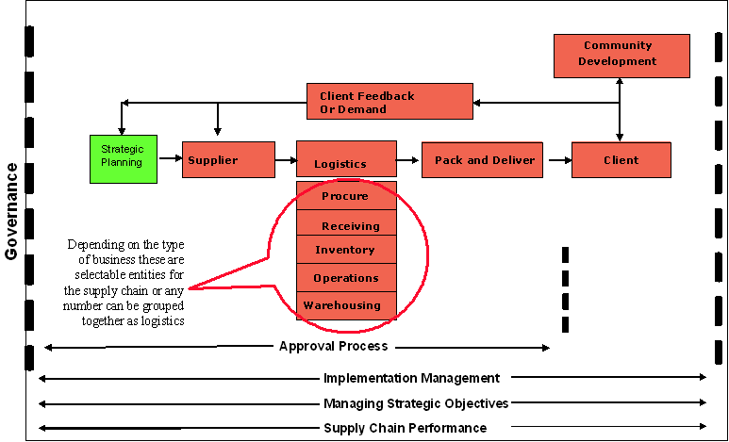

- The Proposed Supply Chain

“The term value chain describes a way of looking at a business as a chain of single activities that transform inputs into outputs that customers value.”
Strategic Management, 2003, Pearce & Robinson

The value chain depicts the core processes that add value to the input while generating the required output as demanded by the client.

The purpose of the Value Chain therefore is to identify the strategically relevant activities performed by the organisation, and to depict each activity for its role in creating value. It distinguishes between the core (primary) and support (secondary) business processes. The Value Chain furthermore indicates where value is added to the products and services that the organisation delivers, in order to maximise client satisfaction while ensuring the efficient usage of investments. It also attempts to disperse with the traditional bureaucratic/static presentation of business models.

The value chain therefore reflects the core business processes and related information required. The value chain Figure included is proposed and must still be finalised.

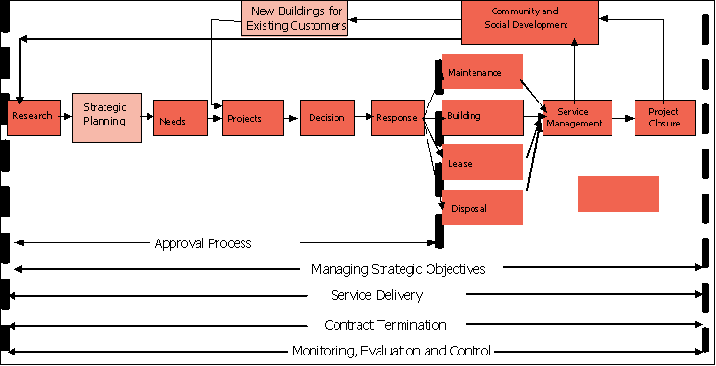

- The Proposed Value Chain

The Current Information Requirements Per Core Process in the Value Chain

Strategic Planning Process
The Strategic Planning Process is the process that depicts the flow of the strategic planning activities. Its output governs the solution delivery part of the value chain.

Executive Management

- Internal Information Requirements
- The previous Strategic Plan
- Departmental Financial Performance
- Performance per service

- External Information Requirements
- Legislation
- Social Demands
- Political
- Technology
- Economical
- Client Requirements?
- Best Practices
- Market Industry Information
- Supplier Requirements

- Information Output (Strategic Guidelines)
- Financial Indicators
- Budgets and Expenditure
- Service Indicators
- Strategic Plans
- Operational Requirements
- Norms, Standard and Policy Requirements

Senior Management

- Information Requirements
- Strategic Guidelines
- Service Detail
- Service Rules and Regulations

- External Requirements
- Political
- Technology
- Economical
- Financial Guidance
- Social
- Client Requirements?
- Best Practices
- Market Information
- Supplier Requirements

- Information Output
- Programme Strategy
- Strategic Objectives
- Budget Needed
- Services Delivered
- New Requirements

Notification/Identification
This really is the first process in the value chain as part of the actual solution delivery. This process highlights the steps to identify service requirements. Sources are the request or notification of a social need, news paper articles, personal engagement through client facing employees.

Engagement

- Information Requirements
- New request Info from existing or new client
- Modification of Services Delivered
- Services Information – to compile recommendation
- Notification of Service Requirement

- Information Output
- Updated Client Information or New Client Information
- Service delivery Proposition
- Terminated Services
- Services Delivered
- Registered Request

Project Qualification

Engagement

- Information Requirements
- Pro-active information (Predictions)
- Budget/Expenditure
- Re-active information (Notifications Received)
- Client Information
- Current Services Rendered
- Decision Criteria
- Severity of Current Request/problem

- Information Output
- Request analysis
- Implementation plan
- Expense Forecast
- Technology requirements (Business plan)
- Qualified decision (Yes/No)
- Risks
- Resource requirements
- Up front costs
- Imbursement Cash flow
- Go/No go decision Motivation

Response

- Information Requirements
- Qualified request detail
- Board resolution

- Information Output
- Completed recommendation
- Service specifications
- Legal evaluation
- Approval documents
- Cover letter

Implementation

- Information Requirements
- Qualified request detail
- Client Detail
- Board resolution

- Information Output
- Completed recommendation
- Service specifications
- Periodic Monitoring and Evaluation Report
- Change Approval documents
- Cover letter

Service Management

- Information Requirements
- Qualified request detail
- Responsibility Matrix

- Information Output
- Recommendation on Changes
- New Service specifications
- Legal implications
- Approval documents
- Cover letter

Termination

- Information Requirements
- Qualified request detail
- Board resolution

- Information Output
- Completed recommendation
- Further Client Requirements
- Legal evaluation
- Approval documents
- Cover letter

Some More BPR Theory (Hammer)
Applied Infonomics Services state that:
“Real business issues do not appear in a nice, synchronous, ordered fashion in a neat day-to-day manner.” Hence “processes designed around transaction flows tend to have a brief life because they lack flexibility in a fast changing business world.”

Therefore the organisation needs to focus on business flow processes rather than plotting transaction processes per se.

Strategic Information Requirements
Strategic Goals
- Management of government properties
- Offering a building construction management, project management, contract management and building maintenance service to other provincial government departments.
- Contribute towards poverty alleviation, promotion of job creation and skills development in the Province through EPWP.

The Departmental Value and Related Information Requirements
The Limpopo Department of Public Works prides itself on the following core values:
- Professionalism
- Humility
- Accessibility
- Courtesy
- Consultation
- Transparency
- Prudence
- Integrity
- Respect
- Customer Citizen focus
- Punctuality
- Impartiality
- Continuous Improvement
- Reliability
- Zero tolerance to fraud and corruption

Business Strategy - Information Requirements
Based on the VISION
Adequate and Reliable Integrated Public Infrastructure for Growth, Development and a Prosperous Provincial Economy
Business Strategy, there is a requirement for information on:
- The products and services that are provided, supported and the integration of service delivery.
- The current clients of DPW
- Potential new clients for DPW.
- Other service providers within Limpopo.
- The products and services that the partners of DPW provide and the support and integration of services.

Based on the MISSION
To facilitate the management of sustainable integrated Provincial Infrastructure by providing leadership in the planning, management and implementation of programmes through optimal utilisation of resources for accountable and customer oriented service delivery for a united, non-racial, non-sexist, demographic South Africa.

There is a requirement for information on:
- The different stakeholders of the achievement of the mission
- Appropriate business practice to be followed.
- Corporate governance that is in place in.
- BEE levels and targets.
- Success factors

Based on the values of the Business Strategy, there is a requirement for information on:
- Performance levels of different Centres, against service level agreements.
- The opinion that clients have of DPW.
- Problems experienced by clients with the products and services rendered.
- The different touch points that DPW have with specific clients.
- Detail of contracts between DPW and clients.
- Management Processes required too satisfy client requirements.
- Industry forecasts and scenarios.
- Internal and external problems that are experienced by stakeholders, partners and employees in satisfying the requirements of the client.
- Trust levels of clients, stakeholders, suppliers, partners and employees in DPW.

Current Technology Architecture
 | 10. Security services | 1. Software Engineering Tools |  | 2. Information Systems Engineering Tools | 11. Enterprise System Management
 | 10. Security services | 3. Presentation |  |  | 11. Enterprise System Management
 | 10. Security services | 4. Groupware |  | 5. COTS Applications | 11. Enterprise System Management
 | 10. Security services | 6. Integration and Synchronisation |  |  | 11. Enterprise System Management
 | 10. Security services | 7. Data and Information |  |  | 11. Enterprise System Management
 | 10. Security services | 8. Communication Infrastructure |  |  | 11. Enterprise System Management
 | 10. Security services | 9. Platform |  |  | 11. Enterprise System Management
Domain |  |  | Current technology used
- Software Engineering Tools
- Software Engineering Tools  The Software Engineering Architecture defines the methodology and tools used for application design, development and testing, and for application release management. It defines the way applications are developed and how they interact. Enabling the department’s applications portfolio.  - Visual Basic programming language for development of Applications and Reports  - MS-Access a Microsoft elementary database development tool  - Object and Component  The Object and Component Architecture provides standards and guidelines that support the reuse of robust application code for programmer productivity gains and cost-effective development efficient reuse of existing application assets, faster deployment of new applications, and improved responsiveness to changing business needs. Reusable software components are the building blocks that make a system able to respond quickly to change. Object-oriented components encapsulate both the business logic and the data accessed by the business logic. Objects have the potential to become intelligent, self-managing entities, allowing for more simplified management. The architecture defines the methodology, toolset and components required for the development and successful reuse of objects and components. |  |  | No evidence  No evidence
- Information System Engineering Tools
- Information Systems Engineering Tools Architecture  Defines the way applications are designed and deployed, and how they integrate. Focus for the department’s applications portfolio. (Modelling tools, Repository, Architecture knowledge base)  - Visio (Microsoft Drawing Application used to draw different types of Drawings)  - Casewise is a Architecture knowledge base tool and repository |  |  | No evidence
- Presentation
- User interface  The interface by which the operator interacts with an application. (Terminal emulators, GUIs Graphical User Interface, TUIs Text-Based User Interface [WordPerfect])  Windows Office Products  NT, Workstation  Terminal Server  - Print and view services  The facilities that provides printout management, routing and browsing functionality. Such facilities will be used before a printout is actually printed.  - Win2000 Server |  |  | No evidence  Windows Server
- Groupware
- Groupware architecture  Provides the infrastructure for departmental staff (as well as clients and business partners) to work collaboratively and share information electronically, regardless of where they are geographically located. This includes, Intranet / Internet, Collaboration & Workflow.  - Web Services  The web services exploits the technologies of the Web to create, seamless, platform-independent, electronic and inter-business communications and universal access to business information. The architecture addresses issues of security, development tools, search engines, database connectivity and business logic. These technologies reduce the cost and complexity of information access, especially to the external world (customers and partners).  - Collaboration  The Collaboration architecture describes the rules and behaviours of conversation-focused (as opposed to activity-focused) business behaviour. It is focused on the Meta analysis of workflow and concentrates on supporting what we “say” about the enterprise, not what we “do” within it.  - Workflow  The Workflow architecture describes the rules and practices of activity-focused (as opposed to conversation-focused) business behaviour. It distils the essence of the bureaucratic functions within an enterprise, “translating” human behaviour into data processing events  - EDMS  Systems that automates the creation, capturing, configuration control, storage and retrieval of documents such as contracts, policy, project deliverables, etc.  - Humming Bird or Livelink (Electronic Document Management Application)  - Contract Management  - Legal Tracking system |  |  | - Exchange on MS for E-mail  - MS-Office and Windows Server for collaboration  - MS Internet Explorer 5.0 / 6.0  - MS Server  - Dream weaver  - MS Exchange  - MS Outlook  - MS Server  No evidence  No evidence
- COTS (Common of the Shelf) Applications
- COTS Application Architecture  Office Suites, CAD (Computer Aided Design) Productivity Applications, Project Scheduling, Diagramming, Database  - VISIO (Microsoft Drawing Application used to draw different types of Drawings)  - Desktop Publisher (desktop publishing  The production of publication-quality documents using a personal computer in combination with text, graphics, and page layout programs. )  - FrontPage (Microsoft Application used for WEB Development) |  |  | - MS-Office Suite (Word, PowerPoint, Excel)  - MS-Project
- Integration and Synchronisation
- Middleware Architecture  Provides robust, standardised mechanisms by which inter-process communication can take place e.g. over the network. Middleware solutions sit between the applications and the network communication mechanisms. They create uniform mechanisms for application integration independent of network and platform technologies. (Directory services, Message-Oriented Middleware (MOM), message brokers, Transaction Managers Online Transaction Processing (OLTP))  - Synchronisation Architecture  Directories are paramount to facilitate and manage the relation and links amongst distributed components.  - MS Active Directory (Managing Access to the network and subsequent applications) |  |  | No evidence  No evidence
- Data and Information
- Data Access Services  Provides high-quality, consistent data where it is needed to support business and transactional systems. It requires that data be accurate and easily accessible. (File service and Database Management Services - DBMS)  - Data Warehouse Architecture  Data warehouse architecture describes the internally consistent logical structure of authoritative databases and provides the standards for accessing Decision Support Systems (DSS) and Online Analytical Processing (OLAP) data. The data contained within these databases has typically been transformed, cleaned, and audited to adhere to corporate information architecture quality standards  - SQL Server 7  - Cognos (Proprietary Software for Data warehousing)  - Business Intelligence Architecture  The Business Intelligence Architecture is a subset of the enterprise’s overall data architecture that provides high-quality, consistent data where it is needed to support information, analytical and decision support systems. It describes the internally consistent logical structure of authoritative databases and defines the standards for accessing decision support systems (DSS),executive information system (EIS) and online analytical processing (OLAP) data. It requires the use of flexible and dynamic design principles.  - Cognos (Proprietary Software for Data warehousing) for EIS/DDS  - Crystal Reporting for Operational and Financial Reporting |  |  | - SQL 7 Server  No evidence  No evidence
- Communication Infrastructure
- Communication Infrastructure Architecture  The Communications / Network architecture provides the communication infrastructure for the distributed computing environment. It consists of logical elements (structure, topology, bandwidth, management), physical hardware components (wiring, LANs, hubs), carrier services (frame relay, leased channels, ATM), and protocols (access, routing, naming). It may incorporate telecommunication services if they are integrated within the enterprise organisational structure. (Network hardware, LAN, WAN)  - Dial-up: (RAS) Remote Access Service  - 3G wireless |  |  | - Routers:  - Switches:  - Cabling: CAT5 Ethernet,  - Protocol: TCP/IP
- Platform
- Hardware Architecture  The hardware architecture defines the physical technical components of the structure, including the client and server hardware platforms, and the database environments.  - Operating System Architecture  The Operating System Architecture defines the technical components of operating systems executing on the hardware platforms. |  |  | - Desktops:  - Notebooks:  - Workstations & Notebooks: Windows XP Prof, Windows 2000 Prof, Windows 98, NT and Windows 95
- Security Services
- Security Services Architecture  Information Security Architecture defines the security services needed to protect the information resource as asset of DPW. This is a common basis for the design, development, implementation and management of the enterprises’ information security policy and approach. These services include authentication, access control, data integrity, data confidentiality, non-repudiation, audit trails and encryption. It is applicable across the enterprise on all platforms. |  |  | - Firewall: Internet  - Access Control: Security & Application specific authentication
- Enterprise System Management
- Enterprise System Management Architecture  The Enterprise Systems Management Architecture identifies the components that efficiently and effectively manage the company’s computing environment to support and enhance the productivity of its automated business systems in the information technology environment. It addresses the management of service levels, configuration, problems, change, operations and performance measurement, security and billing. (Network management, DBMS management, server management, software distribution, data recovery.) |  |  | No evidence

Current Information Categories
Currently information is not grouped into specific categories and stored as such to make searching and finding information easy. The purpose of categories are to help with the collection and dissemination of operational information that is basically in “document” form and falls within the ambit of unstructured information, categories are therefore defined and used to group the information. Although not in existence as such some groupings exist for the more structured information such as the financial and payroll information. Seventeen conceptual information categories have been identified for DPW that should be used to gather information and make it available to the users of DPW. The information will be unstructured data, which would normally reside in a document management system while the more structured data will reside in a financial application or data warehouse. Information Categories is a method to classify unstructured information to be able to make it easily accessible. It is based on the logical grouping of similar information with sub-groups in each major group. This is part of the enterprise architecture structure to facilitate organisations to provide employees access to the relevant information needed to execute their daily assignments.

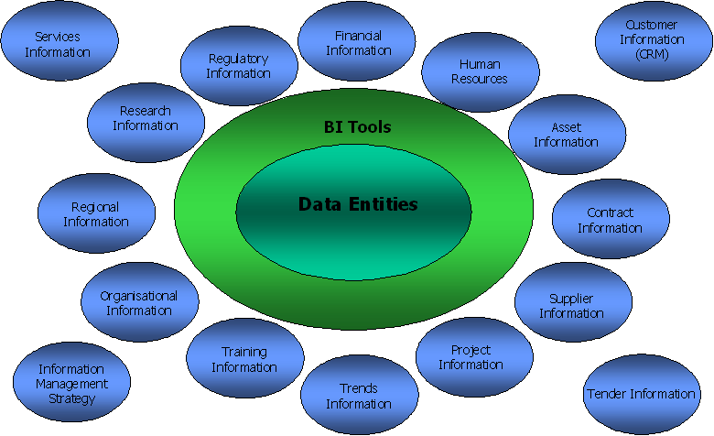

- The Proposed Categories

This part of the report will cover the current information structural existence. As of the present very little exist by way of formal structuring information to make it searchable and easily accessible within the department.

Category | Contents | Organisational Situation
Financial | Budgets, Expenditure, Revenue, Projections, History | The more structured information is provided as this area of information provisioning is the highly govern of all categories
Human Resource | Payroll Detail, Employee Detail, Job Descriptions | The area covering payroll are also structured and well developed, but the general employee type information needs to be organised on an organisational wide access to relevant information basis
Assets | Fixed and Movable assets needed to perform business | This area needs to be departmentalized as there are certain information lacking in this area
Contract | Repository of all legal agreements | Although some registers on contracts is available it is not on a department wide basis accessible. A CENTRAL REPOSITORY NEEDS TO BE DEVELOPED.
Supplier | Relevant information about organisations that provide equipment and material | The supplier information to be made a central departmental source and to be enhanced to include the Contractor information
Project | List of information on Major assignments managed | Project information mostly silo based. A departmental repository needs to be put in place to provide project and progress information.
Trends | Industry development trends | There is a need for the department to enlist with various industry related professional institutions to obtain trend information from
Client | Relevant information about the client | Currently silo based, but the need for a central repository exists to contain information ob previous projects, current projects and expected projects.
Training | Relevant employee development information | A central repository containing training available in terms of course content, cost, institution, status of institution, employees that have attended etc
Organisational | Information about who and what the organisation is | This should be a central repository containing organisational structures and have norms and standards, organisational profile, stand points, speeches, policies etc
Regional | Specific information about all districts | A central repository containing information on the responsible official, contact persons, maps functions, projects, etc
Research | Reports on previous and existing industry relevant research | A central repository is needed with all relevant research that was done within and on behalf of the province affecting DPW
Regulatory | All legislation, rules and policies that governs the organisation | All acts, legislation and regulatory requirements impacting the service delivery of the department, nationally or internationally
Client Services Delivered | All relevant information about the services delivered to external clients | A repository containing the rules and regulations budgets etc on all services delivered is needed
Internal Service Delivered | Internal services detail | A central repository is needed containing all internal services rendered, contact persons including and events time table and deadlines
Tenders | Tender information award history etc | A central repository containing information on all tenders issued, cancelled and awarded including values and tender information is needed
Information Management | Rules and regulations concerning information management | The rules and regulations on information management, what repositories exist, what information is available, contact persons etc is needed.

The information currently available is mostly silo based, limited to an on request basis. There are very little departmental wide repositories providing information when it is needed in the format needed and at the time when it is needed.

Report Conclusion
This document covers the gap between the current information structures and possible structures to manage and present information within the day to day operations of the department. When defining the information strategies there no real wrong or right answers the final answer will be subject to the final decision by the organisation in terms of what road they want to embark on.

This document therefore covers the concepts and possibilities that lies within the boundaries of an information strategy and will lead to the final formulation of a strategy for the department.
In essence it reflects on the areas that are considered not addressed by the department through a formal strategy.

For the final strategy to be finalised the department needs to realise that the management of the organisation requires centralised repositories to be available where information can be captured, store and made available within the access security rules of the department.
- High Level Processes
  - Professional Services – Electrical and Mechanical

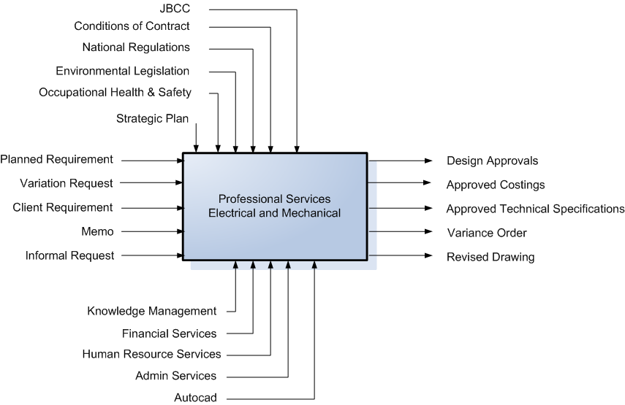

  - Property and Facilities Management

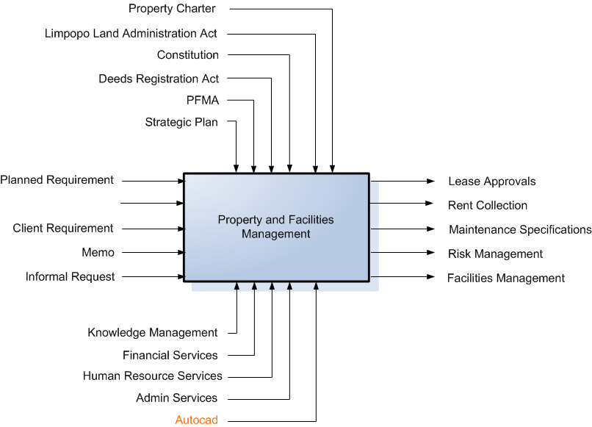

  - Building Maintenance

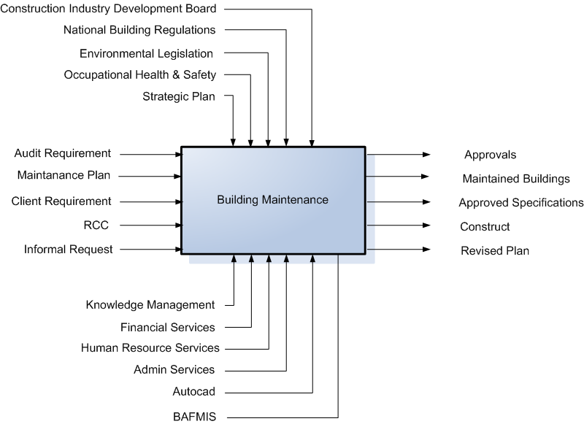

  - Project Management

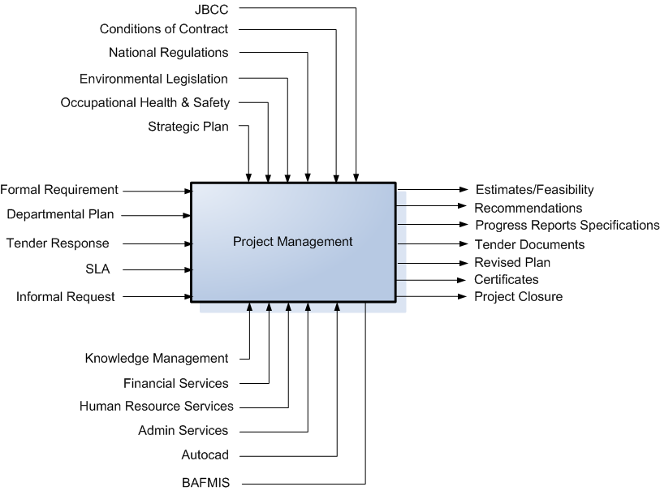

  - EPWP

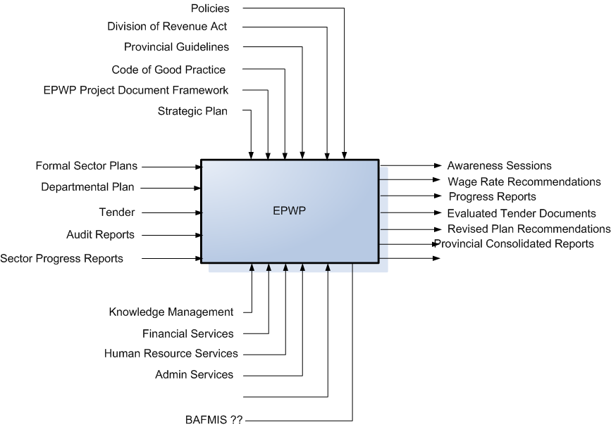

  - Skills Development and Performance Management

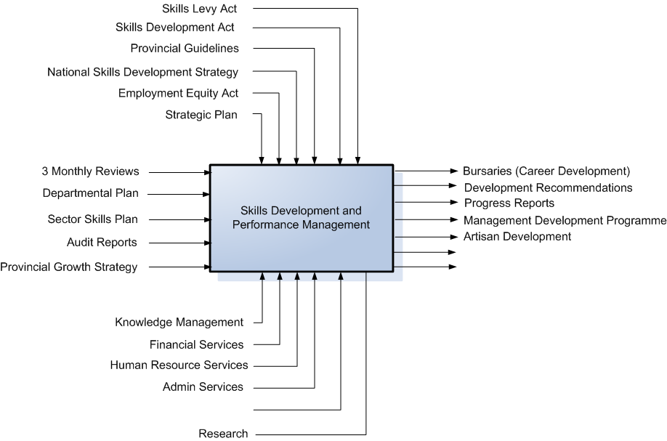
  - Risk Management

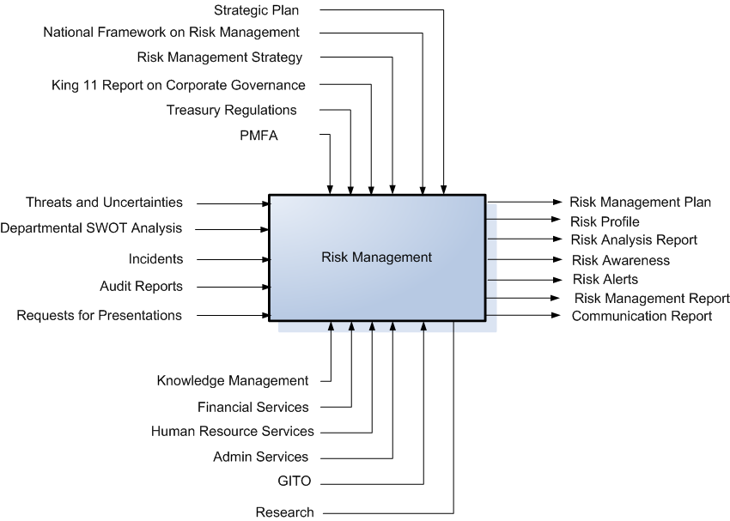

  - Service Delivery Improvement

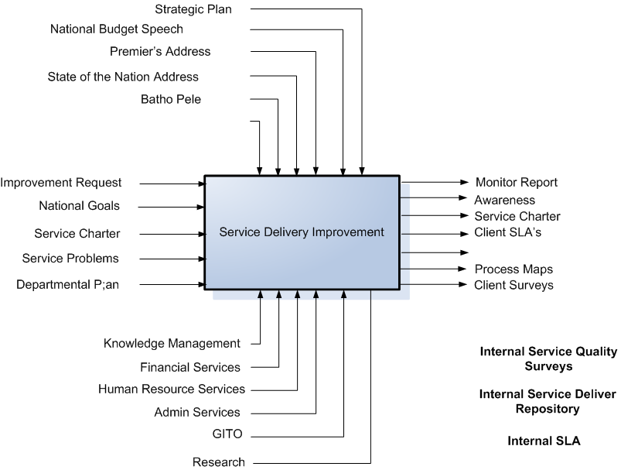

  - Building Maintenance (Districts)

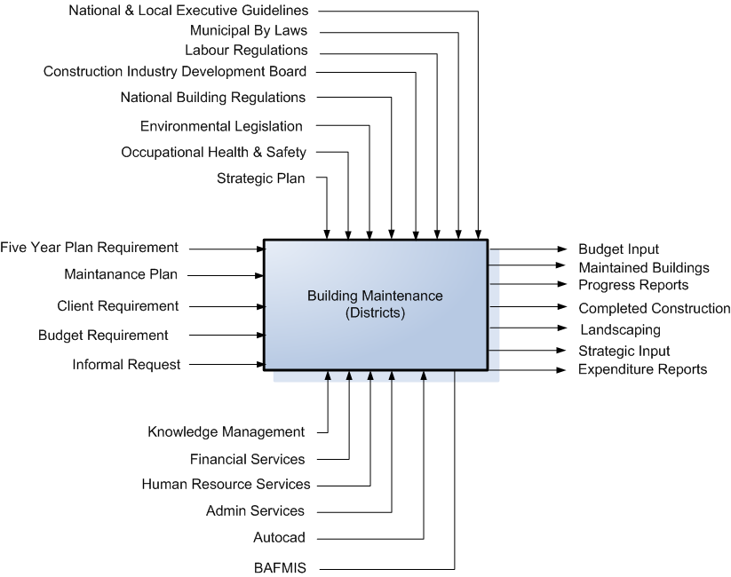

  - Strategic Planning

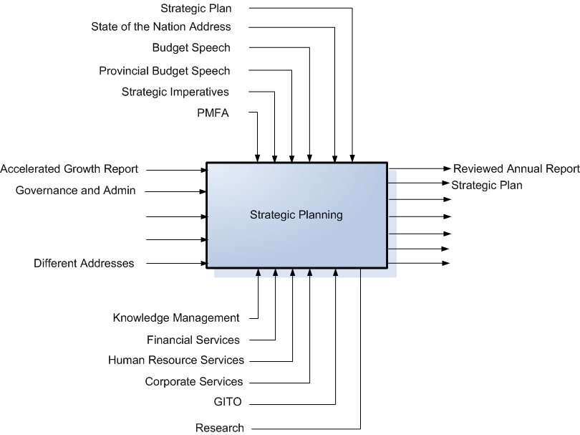
  - Financial Management

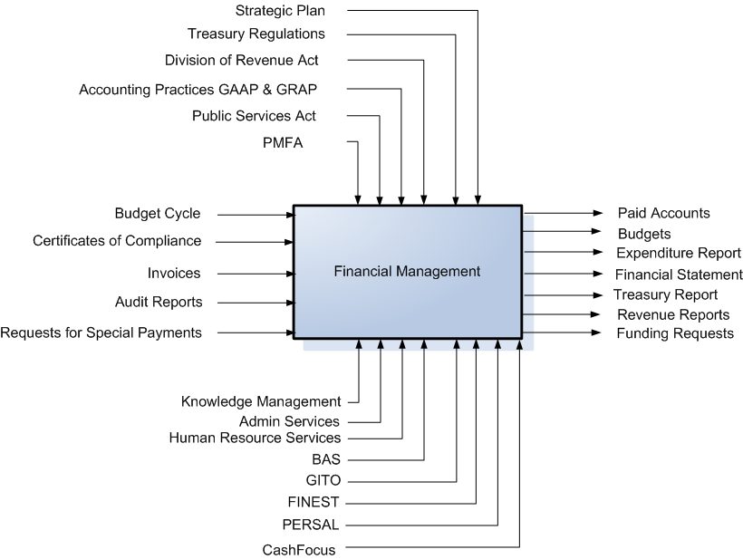

  - Real Estate (GM)

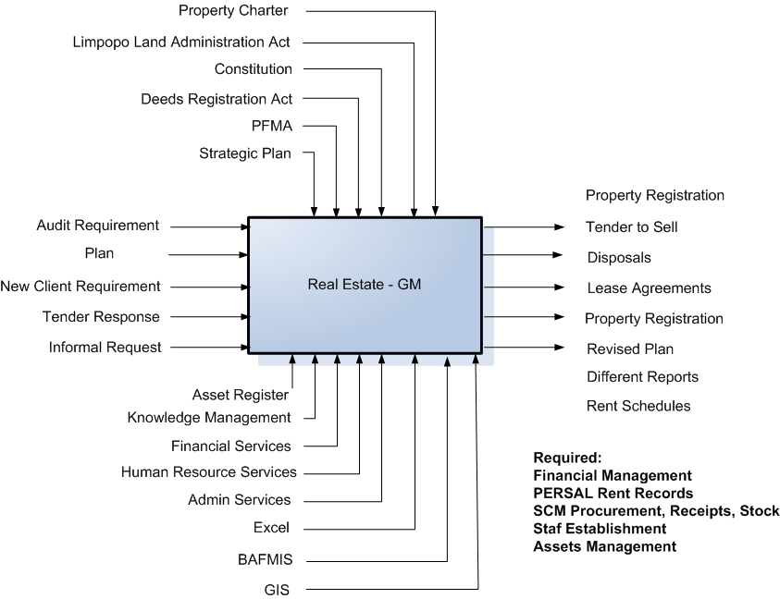

  - Maintenance (Buildings)

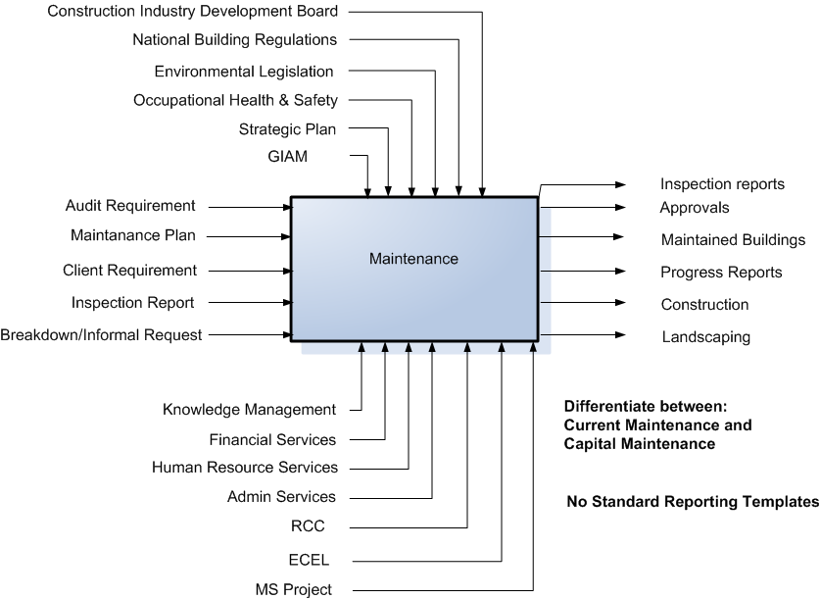

  - Human Resources

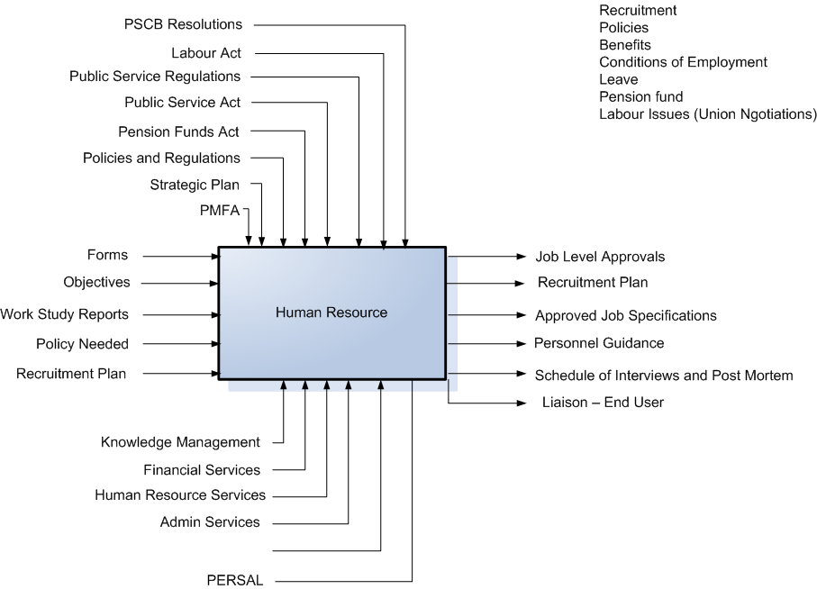
  - Wellness Programme

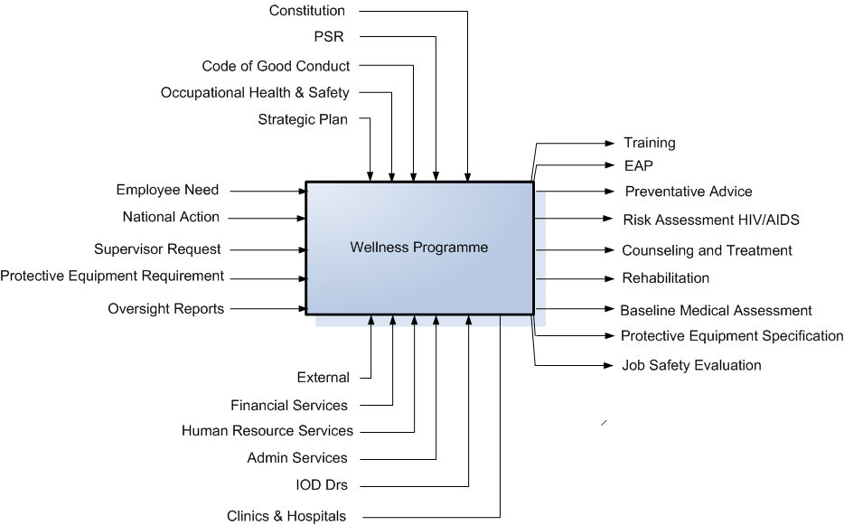

  - Corporate Services (GM)

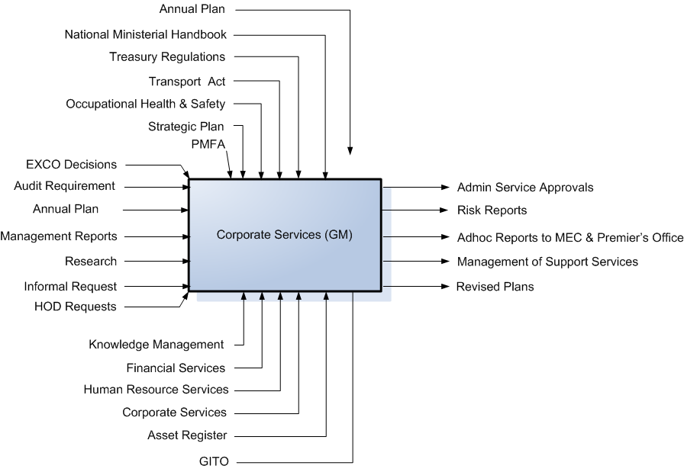
  - Transport

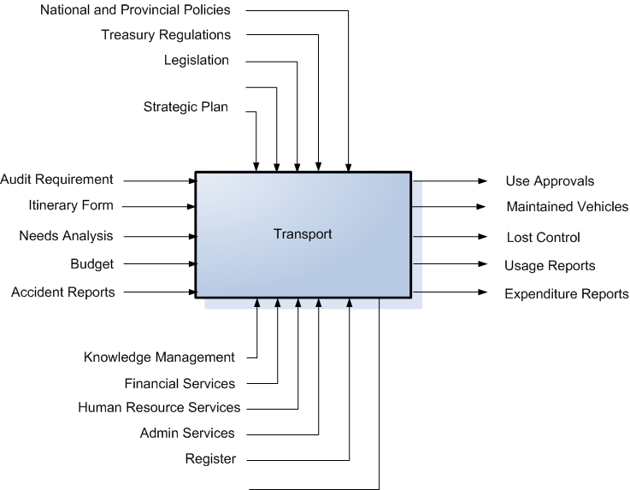

  - Office Services

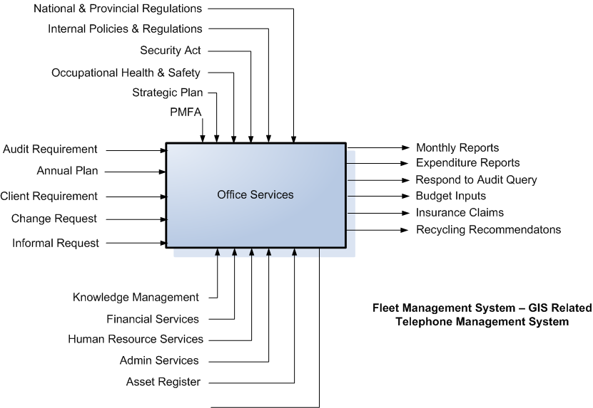

  - Shared Services

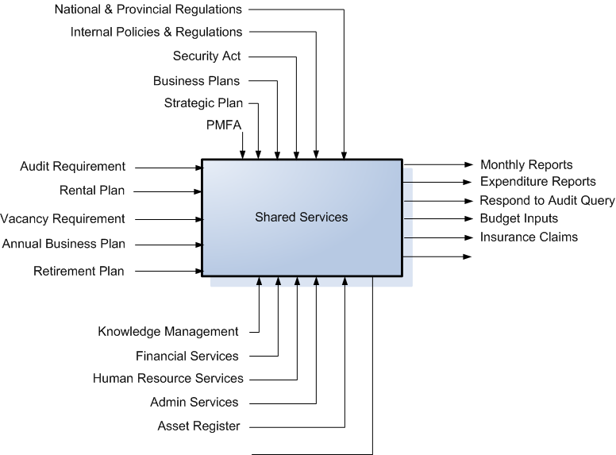

  - Real Estate (Districts)

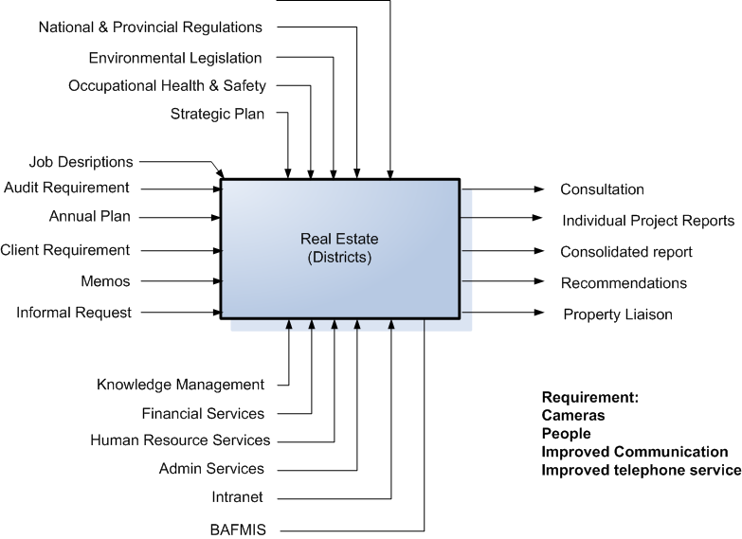

  - Supply Chain Management

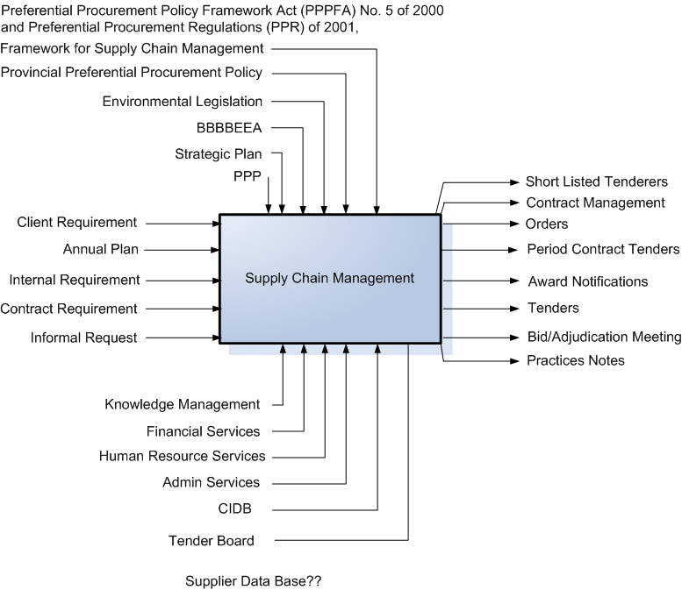

  - CFO

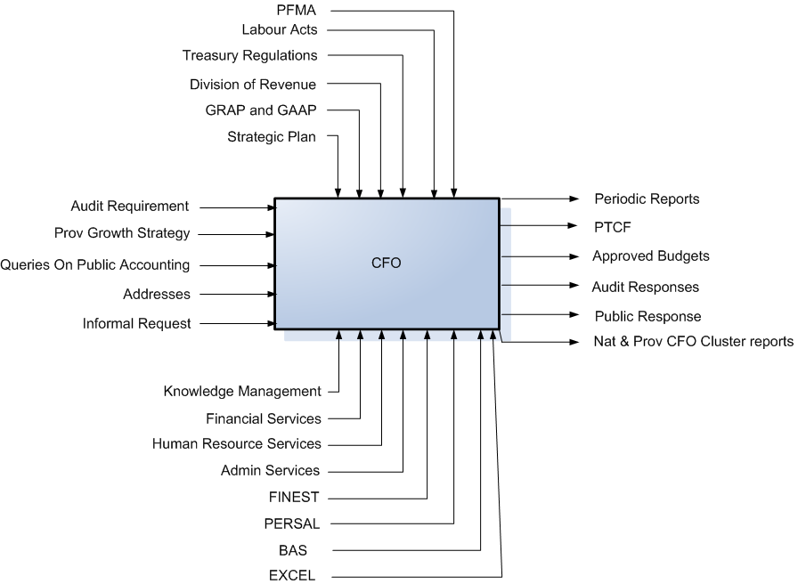

  - Professional and Project Management (GM)

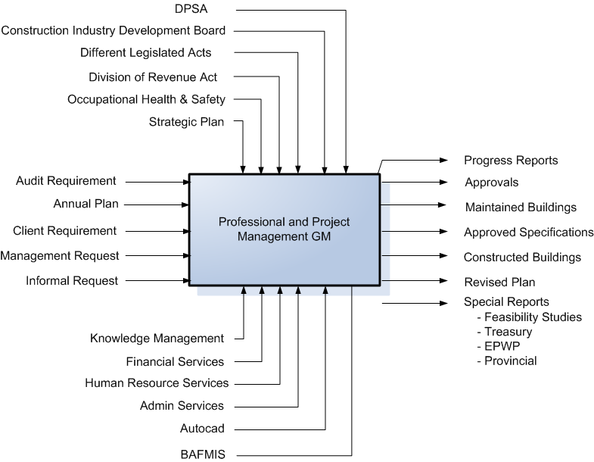

  - COO

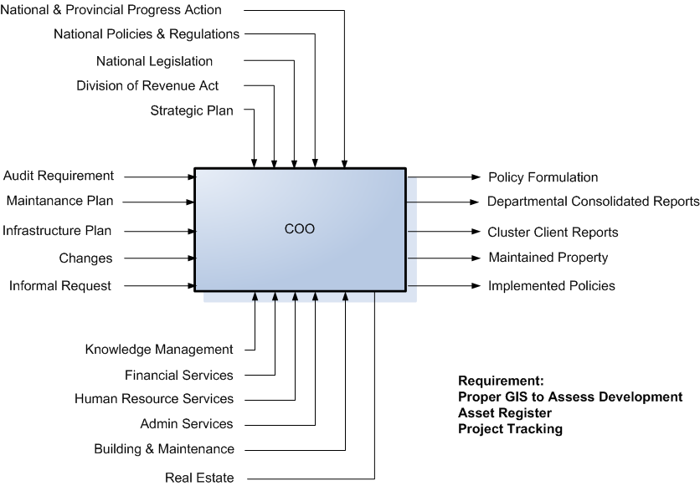

  - Infrastructure Support (Finance)

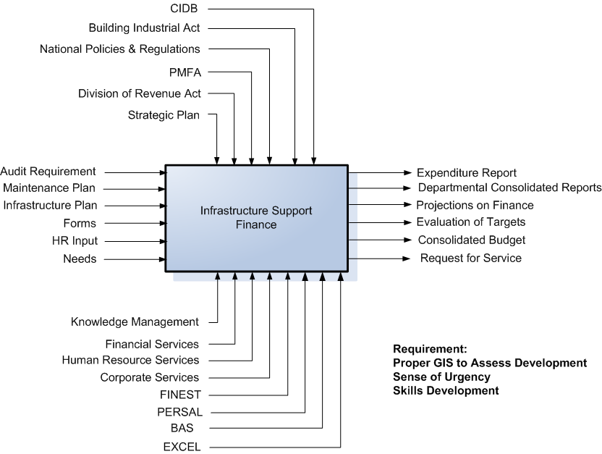

  - Infrastructure Support (Other)

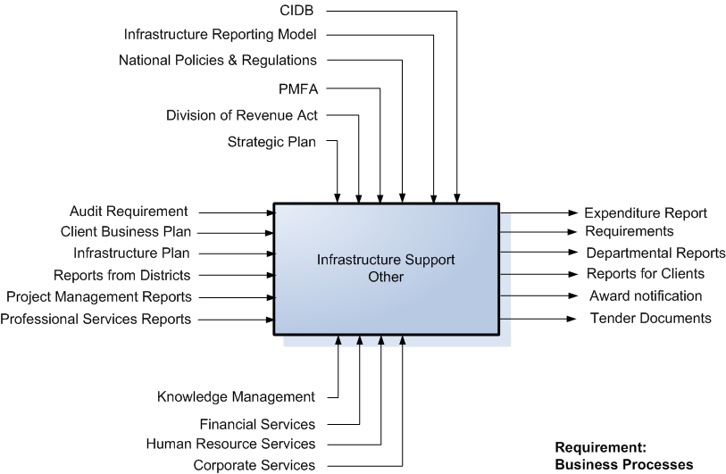
- List of Gaps

Information Management Definitions
Concepts of Information Management
Collaboration
Information Management Architecture Principles
Messaging
Scheduling
Intranet
Extranet
Workflow
Directory Services
Information Management Best Practices
Methodology
Management Summary

- Input from one on one Sessions

Business area | Manger Name | Comments | Gap Description
COO | Mr T Phiri | - 40%.......... Land and Assets  - 40% infrastructure Development  - 20% Maintenance of Assets  - Core programmes Professional, Building and Real Estate  - Infrastructure Support-Admin support  - Infrastructure implementation  - Policies and Regulation Implementation  - -PPD the details do all the …. Of Operation  - Reports to Treasury, All Clusters, Client Departments, EXCO  - National and Provincial Policies  - Strategic Plan  - Division of Revenue  - National Legislation  - National and Provincial Progress Action | - GIS  - No information for Policy decisions  - Assets Register  - Tenders information  - BAFMIS  - FINEST recons do not tally  - Project tracking System Detailing Status  - Procedure manual does not exist  - Reporting-Delayed  - Correct content for detailed Reports
 | Mr C Mabona  Mr Nyiko (Infrastructure Support) | - Public Finance Management Act  - Division of Revenue  - Strategic Plan  - National Policies and Regulations  - Building Industrial Act  - CIDB  - Infrastructure Reporting Model  - Infrastructure- Reports to support infrastructure-To COO  - Reporting is normally done at Head office then sent to Districts  - Charles will do the external clients  - Infrastructure Reporting models | - Consolidation of information  - Delivery mechanisms to the Districts  - Lack of information detail  - Manual translation of information  - Integrity of content received
Real Estate | Mr R NAIDOO | - All Administration legislation  - Limpopo Land Administration Act, 1999 (Act No. 6 of 1999)  - Deeds Registries Act, 1937 (Act No. 47 of 1937)  - Restitution of Lands Rights Act, 1994, (Act No. 22 of 1994)  - Communal Land Rights Act, 1994 (Act No. 11 of 1994)  - Provincial land Act  - Directives, Parastals, Legislation, Public, Policies  - Schedules, Rent collection  - Rewrite is an issue for Real Estates  - Treasury Acquisitions  - National no response  - Legislation guidelines  - Strategic plan  - Constitution | - All HR Information  - Payroll information  - Comprehensive Asset Register  - Integrated Reporting Facility  - BAFMIS- Revival must happen  - EPWP Linkages not existent  - Property charter way forward Giyama  - MEC Property information
 | Mr John Mothibi | - All the Administration legislation  - Limpopo Land Administration Act, 1999 (Act No. 6 of 1999)  - Deeds Registries Act, 1937 (Act No. 47 of 1937) | - Comprehensive Asset register  - Centralised view of all updated legislation  - Rental management processes
 | Mr Nempfumbada | - All the administration legislation  - Limpopo Land Administration Act, 1999 (Act No. 6 of 1999)  - Deeds Registries Act, 1937 (Act No. 47 of 1937)  - Restitution of Lands Rights Act, 1994, (Act No. 22 of 1994)  - Communal Land Rights Act, 1994 (Act No. 11 of 1994)  - Provincial land Act | - Comprehensive Asset register  - Centralised view of all updated legislation  - Documented systematic approach to land management  - Revival of BAFMIS
 | Districts  Vhembe- Land Ravhuhali M.A  Prop Nekhofhe N.S  Mopane- Chauke M.S  Waterberg- MRS VAN ZYLY | - District are not Autonomous  - Records Management exist at District Level  - Most of the information is Top-Down  - People Property inspectors and need  - Legislation guidelines:  - National and Provincial Regulations  - Strategic Plan  - Environmental Legislation  - Occupational Health and Safety Act | - Communication channels must exist  - Inspection is an issue at District Level  - Camera for photo capture  - Reports are cascaded up to head office  - Distributed management services
Building Maintenance | Mr Shlongwane | - All the administration legislation  - Public Finance Management Act  - Occupational Health and Safety  - Strategic plan  - Applications:  - FINESS  - BAS  - Master Plan  - Operational  - Progress Report  PLANNED  - Audit- Maintenance Plan  - BAFMIS- Monitoring and Tracking  - Construction in small space  Unplanned  - RCC- coordinated  Strategic plan | - Consolidation of all reports is an issue  - Both people and Process issue  - No Uniform operations from District  - Inspectorate Unit needs to be trained and Capacitated  - No formal asset Register to identify assets  - HR information not readily available
 | Mr Madale | - All the administration legislation  - Client-Schools, Clinic,  - Public Works-Social Development, Residential Houses  - Infrastructure plan –  - Schedules  - Routine generic maintenance  - Excel  - Function  - Services- Real Estate  - Current Maintenance-Routine  - Capital Maintenance  - Landscaping | - No standardized Reporting  - Asset Register must be looked at  - Look at access of RCC- Systems  - Information is not easily accessible  - No centralized storage
 | District-Capricorn-  Masapa Kenning | - District support  - Municipal by laws  - Exco, Labour  - Localities force the split  - District Report to Head Office  - Functional Responsibilities | - No Standardized reporting  - Clear functional lines of reporting
Professional Services | Mr Aubrey | - Implementing agent for Government Legislation around infrastructure Management  - All Government regulations  - Project Management Report Admin Office  - Support Admin support  - Processes are there but the systems around are failing  - SDI Report will have processes  - Mainly…….resources | - Information about Restrictions Public service regulations  - Processes are there but the systems around are failing
 | Mr Phiri | - Strategic Plan  - Occupational Health and Safety Act  - Environmental Legislation  - JBBC  - National Regulation  - Conditions of Contracts | - Job descriptions  - No office space  - No standardization  - Systems not available
 | Mr Thomas and Mr Don(Project management) | - Construction Industry Development Board  - Environmental Legislation  - National Regulation  - Occupational Health and Safety Act  - Project and Construction Management Profession Act  - PROCESS  - Require spec (client)  - Project team  - Planning cycle (dpw-project manager)  - Approval (client)  - Tender  - Bid/tender  - Conditions of contracts  - JBCC?  - Working documents  - Excel, ms project tool  - HR Manages the Training aspect  - Auto card and Architech-Architechtas  - Wings and bills of quantities  - Project Management system | - Reporting is an issue  - Standardized data collection and collation  - No clear outlined standard processes  - No centralized management of information
EPWP | Ms Salome | - Code of Good Practice  - Division of Revenue  - Provincial guideline  - Epwp Project Document Framework  - Policies  - Strategic Plan  - CO-ordination role head office  - SETA Funded  - In house Training-EPWP Projects  - The normal running cost for the  - LIC-  - PRO ACT- Mandate  - Training in these clusters social, economic , infrastructure and transport  - ILO responsible for professional advise | - Reporting is an issue  - Standardized data collection and collation  - Reports drafted at National so no control of that constrains
Strategic Management | Mr Abednego Hlungwane (Strategic Planning) | - EPWP- Co-ordinate  - -Three Clusters  - -Growth Development Strategy  - Legislation guidelines  - Strategic Plan  - Provincial Speech  - Budget Speech  - Public Finance Management Act | - Report strategies not available  - No centralized information source  - Records not maintained  - Tracking is an issue
 | Ms Manamela (SDI) | - Batho Pele  - Service Charter  - Growth Development Strategy  - Legislation guidelines  - Strategic Plan  - Provincial Speech  - Budget Speech  - Public Finance Management Act | - Process development  - Standards development and management  - Best Practices management
Financial Management | Mr P Kekana | - Risk Financial SCM  - PFMA  - PTCF- Financial Management with Treasury  - CFO Forum- Cluster meetings  - Application: Vulindlela, Finest, BAS, BAF MIS(human component)  - Labour Act  - Public Finance Management Act  - Strategic Plan  - Division of Revenue  - Treasury Regulations  - GRAP and GAAP | - Central point of information standards  - Access to acts and policies  - Proper training drive for systems usage
 | Mr Joe | - Budget, Planning Revenue system Expenditure  - -Budget cycle- PFMA- Budget Review  - Strategic Plan  - Treasury Regulations  - Public Finance Management Act  - Division of Revenue  - Public Service Act  - Accounting Practice and GRAP&GAAP | - Budgeting information  - Updated reports not centralized  - Process management and distribution
 | Mr Mandla Mali  Mr ?? | - Broadcast Economic Empowerment ACTS looking at all Policies and Regulations……….activity  - Reporting  - Planning  - FINEST, Suppliers Database  - Supply chain does Bid committee  - Audit Query  - Training Contractors policies and procedures  - CIDB- Professional Services (must jack up process)  - Project is available  - Report back periodically to GDE SUMMIT  - Two Directorates that Report to CFO  - Which are Bids &Advisory and Inventory and Assets  - Three ways of Contracts  - Provincial- All Departments participates  - Provincial Preferential Procurement Policy(Supply Chain)  - Preferential Procurement Regulation(Supply chain)  - Preferential Procurement Policy Framework  - Framework for Supply Chain Management  - BBBBEEA  - Environmental Legislation Act  - Strategic Plan | - Asset management  - Standard SCM implementation  - Process standardization  - Central point of reference  - Appointment of Senior Manager
Corporate Services | Ms Mswele | - Fleet management and office management  - Strategic Plan  - Transport Act  - Public Finance Management Act  - Treasury Regulations  - Occupational Health and Safety Act  - Annual Plan  - National Ministerial handbook  - legislation:  - Strategic Plan  - Public Finance Management Act  - Security Act  - National and Provincial Regulations  - Internal Policies and Regulations | - Risk management is clandestine  - Consolidated reporting  - Availability of policy information  - Training and development
 | Mr Matome | - Cell phone Security, Facility  - All Several policy Area’s`  - New employees are introduced than only poes IT Change  - Can not always plan will poster change Reporting patterns  - Fleet Management, Telephone management  - Paper recycling  - Strategic Plan  - Transport Act  - Public Finance Management Act  - Treasury Regulations  - Occupational Health and Safety Act  - Annual Plan  - National Ministerial handbook  - legislation:  - Strategic Plan  - Public Finance Management Act  - Security Act  - National and Provincial Regulations  - Internal Policies and Regulations | - Communication in the Department  - Systems to support operations  - Training and development
 | Mr Nkwinika | - Treasury Regulations  - Strategic Plan  - National and Provincial Policies  - Legislation | - Transport tracking  - Fleet management System
 | Mr M Nkuna (Shared Services)  Capricon | - Administration function for release of pressure  - Consult for all the support components  - Consolidation function for all the Head Office  - Bid Committee will look at the District operational issues  - In.of process they are driven by the processes of GITO  - Management of all support services in the District  - Rental plan to remind for rent due  - Access control in Asset Register is a problem  - Control of all co-operates Services  - Security Act  - National and Provincial Regulations  - Strategic Plan  - Public Finance Management Act  - Internal Policies and Regulations  - Business Plan | - Report structure  - Skilled resources for districts  - Programme support for Implementations  - Training and development  - Information sharing sessions from head office to Districts
Human Resource Development | Ms N Bell | - Preventative Programmes  - Research and Survey  - Facilitative a lot of this indications  - Services- Counsel  - OHS- TOD ,Risk, Baseline  - Safety committee  - PPE Programmes  - HIV AIDS-Events and commemoration  - Peer Education is running external training  - Name base cane  - EAP- Crisis Debriefing (Mandatory, voluntary and Evaluating the programme)  - EAP- System for  - Occupational Health and Safety name a full record  - HIV Reports on raw data- training  - District side- Vhembe  - Creation of database one wellness  - FINEST and BAS are used for procurement  - Recruitment within HR | - Supplier Database  - System fro EAP programmes  - Skilling for Districts  - Report Standardized  - Database on wellness  - HIV data  - Centralisation of data for information sharing  - Information Interchange with other stakeholders  - Training and development around Information management and its application  - Audit of the recruitment process
 | Mr M Sithole | - Recruitment,  - Needs Analysis from Strategic plan  - End users work study must drive  - Both Electronic and Manual Documents  - Recruitment plan with Programmes  - Labour -Wellness environment, Nadine will look at the individual and Only issues that eliminate from………..action  - Benefits- regulated by DPSA  - Retirements  - Labour Act  - Public Service Regulation  - Strategic Plan  - Pension Fund  - Public Service Act  - Public Finance Management Act  - Policies and Regulation  - RSCB Resolution | - Mature systems for administration  - Process management and documentation  - Centralised documentation  - Standardised reporting  - Access to policy information  - Access to other stakeholders plans  - Updated and correct labour information
GITO | Mr TP Maanda | - Report production, Collation of reports.  - Disseminate the reports  - Recommends on the type of technology to be bought.  - Development of branding perspective and detail  - Development of the strategy of backup development  - Strategy will identified  - The information silos  - The standards of content control  - Access to information  - Information life cycle  - Provide a platform that will facilitate the growth cycle  - Provide principals for | - The standards of content control  - Standards not in place for the verification process and going forward  - Training and development around Information management
 | Mr Mashele | - Custody of records of organizational wide  - Development of the policy and registry policy manual  - Still in Draft stage  - Development of departmental file plan is informed by national and it is functional nature.  - Development of the Payiya manual section 14  - Section 17 deals with designation of the information officer  - Section 15 reporting to the human rights commission  - Section 32 reporting of minister of Justice  - Application:  - Hopefully get an ECM product  - Training of the natural elements of records management | - Disposal must also not be forgotten  - Districts detail is not known  - No control of document trail and centralizing the former Government records  - Value from strategy  - ECM – understanding  - The use of paper and reduction of paper usage  - Control of current processes within Records management.  - Centralising of the information in one point  - Training and development around Information management  - Process driven delivery of Mail in the organisation  - Retention schedule is not approved yet.
 | Ms M Seriti | - Managing Library service  - Managing web environment content  - Development of information Policy  - Development of content for info kiosk  - Management of information decimation for kiosk  - Management of content to Sita for Internet uploading  - Co-ordinate the info for premiers office | - Space for resource center  - Conduct awareness for services provision  - Getting intranet Up  - Redesign the intranet  - Internet managed by premiers office  - Library systems  - Training and development around Information management
 | Ms S Haramse | - Collection of organisation presentation and information archiving  - Annual report, citizen’s report, budget speech,  - Strategic Management looks at the consolidation process  - Resource capacity – research on anything for information management  - Corporate Branding and graphic’s for the organisation  - Printing of graphical work  - Skills filler in terms of technology and applications support. Desktop support  - Administration for GITO, HR and PFMS function. | - Value from strategy Solution – One entry point in terms of process and exit point is in the same place.  - Information owner ship is a must for all levels  - Control of information collation
 | Ms S Mamabolo | - Get quotes register and catalogue for IM  - Applications:  - Sabinet  - Registry sometimes has  - Needs analysis done periodically within IM  - Books need to be service delivery improvement  - Van skyke | - Register is manual and takes to long

Terms, definitions, acronyms and abbreviations
  - Terms
    - Information Management Defined
In order to address the question of Information Management, it would be appropriate to discuss the various terms and definitions in the realm of KM. As a point of departure, Knowledge and the progression thereof can be seen in Figure 2: Knowledge Progression.
The difference between data, information and knowledge and the management there-of will briefly be discussed.

Subsequently document, record and content and the management there-of will be defined as the possible forms of data, information and knowledge. The definitions will be concluded with a description of Groupware, as an enabling infrastructure for data, information and knowledge management.

These terms and definitions will be used as the foundation for the scope of the strategy and further discussion.
      - Data
Data can be seen as an object without context – an object in isolation is almost meaningless without understanding relationships with other objects.
      - Information
Data placed in context – Information is the understanding of the relationships between the components of data itself, or components of data and other information.
      - Knowledge
Beyond relationships there is pattern, which is more than simply a relationship of relations. Patterns encompass both consistency and completeness of relations, and create its own context to some extent. When a pattern exists between data and information, the pattern can potentially present Knowledge. It only becomes Knowledge once the patterns can be realised and its implications are fully understood. Knowledge can evolve over time and is seldom of a static nature, and normally contains a high level of reliability and predictability. Knowledge tend to create it’s own context.

Knowledge is information that has been organised and analysed to make it understandable and applicable to problem solving or decision-making. (Turban, 1992).
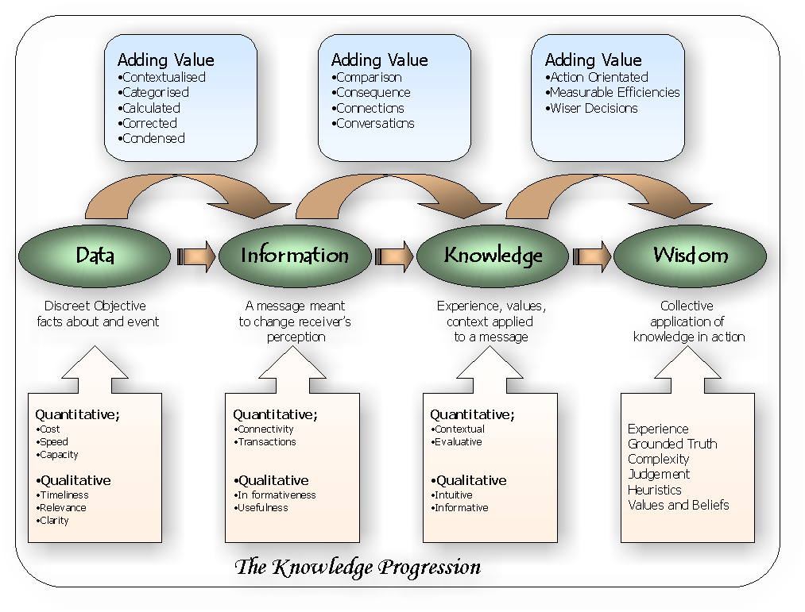
- Knowledge Progression
      - Explicit Knowledge
Explicit knowledge is seen everyday. It is written down in the form of words and numbers and is used to solve such problems as fixing a machine or performing other work-related tasks. Explicit knowledge is easily communicated between people in the form of hard data, formulas, and written or universal procedures. Some examples would include books, papers, databases, policy manuals, and lessons learned.
      - Tacit Knowledge
Tacit knowledge is found in the heads of your employees and in the experience of your customers. Because it contains their insights, intuitions, and hunches, tacit knowledge is highly personal, hard to formalize, and deeply rooted in a person’s actions and experiences as well as in their ideals, values, and emotions. Because of its nature, tacit knowledge is difficult to communicate or share with others.
      - Wisdom
Wisdom arises when one understands the fundamental principles responsible for the patterns representing Knowledge. (Internal EA Project, 2002:184)
      - Content
Meaning that is recorded on a medium.
- Narrow sense: The essential matter or substance of a written work or discourse.
- Broader sense: All the intrinsic information and data (ideas, topics, facts, or statements) contained in books, moving and still images, sound, textual resources and manuscripts. (Synonymous in this sense with subject matter.)
- Document management context: The data portion, as opposed to the attributes, of a document. The document components, which can be text, graphics, images, and other documents.
- Publishing content refers to individual documents that can be graphic, textual or illustrative in nature, or amalgamations of documents that can be combined into individual articles or complete publications.
- Web context: The information provided on a web page, as opposed to its design and layout. Content can take the form of text, graphics, audio, video, or a searchable database.
- Digital Content products are available in digital form - typically sound files, video and images that are available for download or distribution on electronic media.
      - Structured vs Unstructured Information
Structured data: in databases (formal IS and db)
Unstructured data: documents, email, minutes, etc

  - Acronyms & abbreviations
DPW | Department of Public Works
- Amendment History

Revision | Date | Change request no | Paragraphs changed
1.A | 2006/04/22 | N.A. | New document
- Annexures

Annexure Number | Document Name | Document File Name

- Distribution List

Name | Revision | Copy Number
- Public Works Approval Page
<name>  Executive Manager |  | Date and time
<name>  Divisional Manager |  | Date and time

- Client Approval Page
<Add or delete signature list as required, Name, title, date and time of signature.>

<name>  Executive Manager |  | Date and time
<name>  Divisional Manager |  | Date and time

