

Department of Public Works

Information Management Strategy

Document no | : | IM0001
Revision | : | 1.A (Draft Confidential)
Author | : | Jan Schutte
Effective date | : | 2006-06-02
Electronic file | : | input.doc
Classification | : | RESTRICTED
Identification Code | : | IMS



Department of Public Works



© 2006 Public Works. All rights reserved.
The document configuration centre shall hold all change requests and approval documentation. No part of this document may be reproduced or transmitted in any form by any means without the express written permission of Public Works. This electronic version of the document is the only Official/approved version of this document for distribution. Any printed copy of this document is for information purposes only and regarded as obsolete for any other date than the printed date, unless specifically agreed with Client where printed controlled documentation is required for distribution.
Information Management Strategy
Contents
1. Background – Internal Enterprise Architecture 9
1.1 Findings of the project 9
1.2 Information in context 9
1.3 Considerations of the project 10
2. Information Management Strategy in context of Enterprise Architecture 12
3. Aim 12
4. Business Objects 12
5. Components of Information Management 14
5.1 Data Management 14
5.2 Information Management 14
5.3 Knowledge Management 14
5.4 Expertise Management 15
5.5 Wisdom 16
5.6 Artificial Intelligence Management 16
5.7 Content Management 16
5.8 Document Management or Electronic Document Management 17
5.9 Enterprise Content Management Implementation Methodology 17
5.10 Groupware 18
5.10.1 Collaboration 18
5.10.2 Messaging 19
5.10.3 Scheduling 19
5.10.4 Intranet 19
5.10.5 Extranet 20
5.10.6 Internet (WEB) 20
5.10.7 Workflow 20
5.10.8 Directory Services 21
5.11 Concluding on the components 21
6. Scope 21
6.1 Knowledge Management as a Discipline 21
6.2 Inclusions 22
6.3 Exclusions 22
7. Vision for Information Management in DPW 23
8. External Situation 24
8.1 Information Management Best Practice 25
8.2 Information Management Principles 26
9. Internal Situation – Current Architecture 30
9.1 Current Business Architecture 30
9.2 Current Information Architecture 31
9.3 Current Application Portfolio 32
9.4 Applications Architecture Concepts 34
9.5 The Proposed Conceptual Applications Architecture 35
9.6 The Boundaryless Concept 37
9.7 Current Conceptual Technology Architecture 37
10. Conceptual Architectures 43
10.1.1 The Strategic model comprises: 44
10.1.2 The Business and Support model comprises: 44
10.1.3 The Process model comprises: 44
10.1.4 The Information model comprises: 44
10.1.5 The Applications model comprises: 44
10.1.6 The Technical model comprises: 44
11. Internal Situation – Common Requirement 45
11.1 Business Strategic Requirements 45
11.2 Business Information Requirements 45
11.2.1 DPW Business Strategy – Information Requirements 45
11.2.2 DPW Business Architecture – Information Requirements 46
12. Impact Analysis 49
12.1 Impact on Individuals 49
12.2 Impact on Innovation 49
12.3 Impact on Task 49
12.4 Impact on Organisation 49
12.5 Impact on Environment 50
12.6 Impact on Group 50
13. Recommended Information Categories 50
14. Communities of Practice and Vertical Units 50
15. Information Management Scenario 51
16. Information Management Concept 55
17. The Promotion of Access to Information Act (PAIA) Act, 2 of 2000. 57
17.1 Introduction 57
17.2 Implications for Departments 57
17.3 Activities required by the Act 57
17.3.1 Activities that will enhance PAIA administration 58
18. South African Archives Act (Act no 43 of 1996), 58
18.1 Background 58
18.2 Implications for Departments 59
19. Electronic Communications and Transactions (ECT) Act (Act 25 of 2002) 60
19.1 Introduction 60
19.2 Implications for departments 60
20. Public Service Regulations 2001 (Government Notice No. R. 1 of 5 January 2001 as amended by 61
20.1 Specifications 62
21. Technology Roadmap 63
21.1 Why a Roadmap is Needed for Technology Adoption 64
21.2 Overview of the Development of a Roadmap 65
Annex A: Terms, definitions, acronyms and abbreviations 67
A.1 Acronyms & abbreviations 67
Annex B: Discussing the Approach to formulate the Information Management Strategy 68
B.1 Introduction 68
Annex C: DPW Current Architecture 74
1. DPW Current Business Architecture 74
1.1 DPW Proposed Current Value Chain 74
1.2 DPW Flat View of the Current Organisational Structure 77
1.3 Summary of the current information architecture 78
2. Current Application Portfolio 79
Annex D: Evaluation of the Information Management Practices in the Department of Public Works 80
Annex E: High Level IDEF0 Processes 83
E.1 State Land Management 83
E.2 Professional Services – Electrical and Mechanical 84
E.3 Property and Facilities Management 84
E.4 Building Maintenance 85
E.5 Project Management 85
E.6 EPWP 86
E.7 Skills Development and Performance Management 86
E.8 Risk Management 87
E.9 Service Delivery Improvement 87
E.10 Building Maintenance (Districts) 88
E.11 Strategic Planning 88
E.12 Financial Management 89
E.13 Real Estate (GM) 89
E.14 Maintenance (Buildings) 90
E.15 Human Resources 90
E.16 Wellness Programme 91
E.17 Corporate Services (GM) 91
E.18 Transport 92
E.19 Office Services 92
E.20 Shared Services 93
E.21 Real Estate (Districts) 93
E.22 Supply Chain Management 94
E.23 CFO 94
E.24 Professional and Project Management (GM) 95
E.25 COO 95
E.26 Infrastructure Support (Finance) 96
E.27 Infrastructure Support (Other) 96
Annex F: Proposed Organisational Structure for Information Management Function 97
1. IM structure in the Department 97
Annex G: Summary of the Completed Questionnaires 101
Annex H: Amendment History 102
Annex I: Annexures 103
Annex J: Distribution List 104
Annex K: Public Works Approval Page 105
Annex L: Client Approval Page 106

Figures
Figure 1: The Information Domain 10
Figure 2: Public Works’ Proposed Future Projects 11
Figure 3: Information Progression 15
Figure 4: ECM Methodology 17
Figure 5: Collaboration Matrix 19
Figure 6: Information Ecology 26
Figure 7: Public Works Value Chain 30
Figure 8: Public Works Organisational Units 31
Figure 9: List of Applications 33
Figure 10: Technology Reference Model 37
Figure 11: The Proposed Information Architecture 43
Figure 12: The Social Impact of IM adoption and use 49
Figure 13: Information Categories 50
Figure 14: Communities of Practise 51
Figure 15: Current access with required repository 54
Figure 16: Proposed Information Management Scenario 55
Figure 17: Information Management Concept 56
Figure 18: Information Management Roadmap 64
Figure 19: Visualization of Concept Indicators in a Collection of Fables 66
Figure 20: Information Management Strategy Approach 68
Figure 21: DPW EA Conceptual Framework – Context Only 70
Figure 22: DPW EA Framework – Conceptual Architecture Principles 71
Figure 23: DPW EA Framework – Conceptual Architecture Models 72
Figure 24: DPW Value Chain 74
Figure 25: Public Works Organisational Units 77
Figure 26: State Land Management 83
Figure 27: Professional Services – Electrical and Mechanical 84
Figure 28: Property and Facilities Management 84
Figure 29: Building Maintenance 85
Figure 30: Project Management 85
Figure 31: EPWP 86
Figure 32: Skills Development and Performance Management 86
Figure 33: Risk Management 87
Figure 34: Service Delivery Improvement 87
Figure 35: Building Maintenance (Districts) 88
Figure 36: Strategic Planning 88
Figure 37: Financial Management 89
Figure 38: Real Estate (GM) 89
Figure 39: Maintenance (Buildings) 90
Figure 40: Human Resources 90
Figure 41: Wellness Programme 91
Figure 42: Corporate Services (GM) 91
Figure 43: Transport 92
Figure 44: Office Services 92
Figure 45: Shared Services 93
Figure 46: Real Estate (Districts) 93
Figure 47: Supply Chain Management 94
Figure 48: CFO 94
Figure 49: Professional and Project Management (GM) 95
Figure 50: COO 95
Figure 51: Infrastructure Support (Finance) 96
Figure 52: Infrastructure Support (Other) 96
Figure 53: Current Organisation Structure for IM function 97
Figure 54: Proposed Organisation Structure for IM function 98

Tables

Table 1 Proposed List of Possible Applications 37
Table 2 Application and Related Technology 43
Table 3 Specific Information Requirements 48
Table 4 Current Applications 79

Strategy Requirements
- The strategy must enable the Department to manage their information from creation, storage and retrieval, maintenance and dissemination.
- The strategy must adhere to Access to Information Act and Archive Act.
- The strategy must clearly define the users of the information both internal and external.
- Sources of the information must be identified both internal and external.
- The strategy must clearly define the transition from paper based document to electronic document.
- The strategy must be able to cross reference the paper based document and electronic document.
- The strategy must include information security.

References
- The Departmental Strategic Plan
- The Departmental MSP
- Different Acts

Executive Summary
In 2005 everyone knew what a horse and buggy is and what an automobile is. Most citizens even know more about the story of the emergence of the automobile manufacturing business and the value of improved travel that came with the automobile than they know about Information Management.

We do not know to what extent the meaning of information management might be captured or even understood by the average citizen. We have not experienced anything that informs about the contrary of what is understood in terms of technology and information management. Relevant issues in linguistics, social theory and the nature of science are not well known in the overall departments of computer science. Most of what is known as computer science is shaped by engineering theory and scientific reductionism and therefore are primarily aimed at the computer hardware and related software.

The Information Management Programme of the Department of Public Works has embarked on a drive to establish an effective Information Management (IM) Service in the Department. This drive is based on a definite legislative mandate (which includes Acts like the Promotion of Access to Information Act, the National Archives Act, etc.). It is also supported by a strategic IM planning process (which included representatives from the whole Department as well as from the Districts), during which the need for reviewed IM services was confirmed and valuable for future use was gained.

The stated IM vision of the Programme IM is; a fully optimised IM service that, in conjunction with IT, provides in the total sphere of IM/IS needs of services on all departmental levels. The IM mission, flowing from the organisational vision is: Enabling quality service delivery in the Department by the provision of relevant timeous, up to date information services at departmental level, whilst providing IM advice and support to the districts and other Provincial and Local Government levels as and when needed.

In order to plan for the provisioning of the envisaged IM services, an IM strategy is needed. This strategy is presented in three parts:
- The first part provides the context within which the IM strategy will have to function. This includes a view on key concepts, background to an IM strategy, critical success factors for IM strategy deployment, and the strategic approach that was followed as well as the recommendations.
- The second deals with the issue of the governance of the strategic process; a description of the “as is” IM environment; and the “to be” IM environment, and the strategic information plan.
- The third part will talk to the Roadmap or schedule of initiatives based on the recommendations.

The IM Strategic Plan does not only serve as the baseline from which future IM projects should be identified, but also needs to be integrated with an IT strategy that needs to be developed in order to provide the Department with a total integrated Management Information Systems and Technology Plan (MISP).

Section 1 - Introduction

Background – Internal Enterprise Architecture
In June 2006 the Internal Enterprise Architecture (EA) was delivered for Public Works as part of the completed Information Management Strategy containing specific recommendations on information management.

The Internal Enterprise Architecture was initiated in order to:
- Establish an architected common frame of reference for internal information management that would support efficient and effective execution of the business model and strategic intent, and
- Resolve dilemmas regarding internal information systems technology and implementation choices, to best support strategic business objectives.

The primary thrust of this part of the information management project was to establish Business Information Requirements (BIRs) through discussions with business managers, and to utilise these BIRs to develop a a holistic list of future projects as well as a Project Roadmap setting out proposed internal information systems initiatives on the immediate future.

This document will set out, in the form of statements, how information will be created or acquired, stored, organised, disseminated, and retained or disposed of across the Department as a whole. Of vital importance will be policies developed by the department describing how the tools for the discovery of information will be deployed. The overall information framework will also state the roles, responsibilities the function of IRM.

Findings of the project
In general ample evidence was found to support the concerns that led to the establishment of the Department’s Information Management Strategy project in the first place. In particular:
- a multiplicity of independent information reporting inhibit effective business integration from an internal operations perspective (particularly in regard to multiple silos of information and different financial and operational reporting channels).
- a multiplicity of independent information gathering inhibit a single view of the client’s projects, and therefore effective client relationship management.
- there appears to be a lack of a clearly defined and communicated Information Architecture Principles, thus inhibiting the effective implementation of Information Management within the department.

Information in context
Information must be dealt with in its context when considering defining an Information Management Strategy. Information firstly can be either Explicit or Tacit in its existence. When looking at the tacit component one is focussing on the intellectual capital part of it, which is in the knowledge management ambit.

For the sake of this document and the subsequent strategy, the focus will mainly fall on the explicit part which can either be Static of nature or Non-static as per (Figure 1).

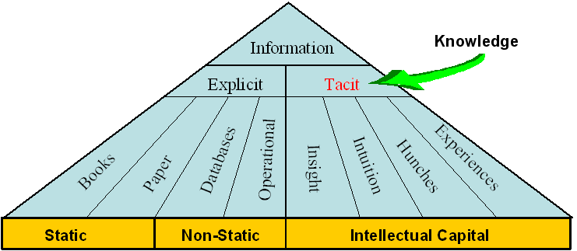
- The Information Domain

The technologies and applications used to manage Static information differs from the technologies and applications used to manage Non-static information. Within the Static environment the typical Library/Registry can suffice. In the Non-static environment we find the real management problem. This is where information changes on a frequent basis and because of that, the technologies and applications are more inadequately used.

Considerations of the project
The report recommend the adoption of a number of initiatives. The recommendations were based on an analysis of the MSP, business strategy, the business execution model, business information requirements identified in the course of the interviews undertaken and through business process evaluation, and the existing infrastructure.

The analysis and prioritisation details are set out in the report.

The recommendations are summarised in the form of a Schedule of Future Projects (Figure 2), comprising some fourteen projects within the red lines. Apart from that there are also some additional projects identified as part of the eventual roll out of the information strategy. The recommendation regarding Knowledge Management is of special interest to the deployment of the IM Strategy and the subsequent growth of the strategy.

- Knowledge Management
  - Develop and communicate a future KM strategy in terms of collaboration and organisational integration in the longer term.
  - Develop a information directory structure for use in conjunction with the future Windows 2000 Active Directory project.
  - Develop a Delivery Portal or upgrade the intranet and internet with proper structure and content definition.

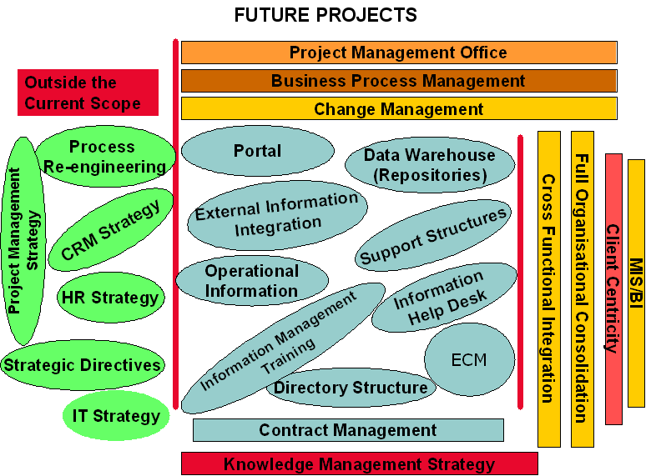
- Public Works’ Proposed Future Projects

The green coloured ovals identify projects that will have to be considered in some future scenario.

The blue coloured ovals are an indication of the projects that will have to be initiated in the near future as part of the implementation of this strategy. The projects are:
- Develop a organisational access portal as part of the future rollout of knowledge management
- Launch a project to start with the investigation and deployment of a data warehouse for the department
- Launch one or more projects to negotiate the provisioning of information for the department to enable and facilitate access to information from the transversal applications.
- Define operational information repositories
- Define the operational information structures for the management of information repositories
- Establish information management helpdesk to be able to provide assistance with the provisioning of information
- Define and develop the directory structures to accommodate the data definition and ownership responsibilities as well as the meta data directory
- Define the requirements for a fully fledged enterprise content management system that will incorporate the necessary functionality to allow the establishment of an intranet, extranet and the publishing to the internet.
- Establish a central asset register application and
- a contract management application
- Initiate a project to formulate the next phase of the enhancement of the information management strategy to develop a knowledge management strategy
- Establish a central project office for the department
- As part of SDI establish a business process management functionality
- The important aspect of the implementation of the strategy is to ensure that a comprehensive change management programme is launched

The critical part of the implementation of the strategy would be to ensure that it addresses the cross functional flow and dissemination of information.
The implementation must ensure that information is not duplicated and that it represents an organisational perspective.
What ever the focus all information must enable greater efficiency and improved client focus.

Information Management Strategy in context of Enterprise Architecture
The objective of the proposed project roadmap (Figure 15) is to reach a One Client Centric Application through the use of MIS / BI. The Cross-Functional Consolidation and Cross-Functional Integration need to be addressed in order to reach this objective. However, CRM, KM, Financial and HR applications must also be addressed in order to realise any sort of complete MIS / BI.

A Client Relationship Management Strategy and the Knowledge Management Strategy were identified as two urgent initiatives that had to be addressed. CRM is currently being addressed and a considerable amount of work has been done to satisfy the requirement for CRM.

Uncoordinated and unplanned activities have taken place to address KM and the requirement for a KM Strategy in DPW has become even more urgent. An Information Management (IM) Strategy will subsequently be formulated as the first structured effort to address KM in DPW.

Aim
The formulation of a Information Management Strategy and Information Plan to implement Information Management culture within DPW as a whole, including the relevant processes and recommend technology as the first building block of Knowledge Management.

Business Objects
The primary objective of the Information Management Strategy is to improve the quality and effectiveness of decision-making within Public Works through making appropriate information accessible to those that need it, when they need it.

Appropriate information means information that is accurate, complete, consistent, and up-to-date, all within the context of business requirements.

The secondary objective (which has to be met in order to achieve the primary objective) is to provide a managed repository of all information resources necessary for the effective running of the department, that can be made easily accessible to any employee where and when needed, in part or in whole, depending on the responsibilities of that employee.

Information resources could include: client intelligence, market intelligence, competitor intelligence, vendor & product information, proposal information, boilerplate and marketing collateral, project files, financial information, legal documentation, policies, procedures – and others.

If these two objectives can be achieved, the resulting benefits will include:
- Improved information will lead to enhanced thought leadership by individuals both in respect of internal and client-facing activities.
- More effective and productive client engagements through all phases of the client relationship life-cycle.
- Cost reduction through improvements in efficiency.
- Improved protection of department’s intellectual capital.

The benefits of IM include:
- Support information sharing and externalization.
- Link operational efforts to overall enterprise direction and strategy.
- Ensure information quality, security, and integrity.
- Increase business effectiveness.

Section 2 – Information Management Scope and Vision

Components of Information Management
In order to address the question of Information Management, it would be appropriate to discuss the various aspects of information and place it in the realm of KM. As a point of departure, Information and its progression to Knowledge can be seen in Figure 3: Knowledge Progression. The difference between data, information and knowledge and the management there-of will briefly be discussed.

Subsequently document, record and content and the management there-of will be discussed in context of the strategy as the possible forms of data, information and knowledge. The contextual section will be concluded with a description of the enablers of infrastructure for data, information and knowledge management.

These terms are used as the foundation for the scope of the strategy and further discussion.

Data Management
Data can be seen as an object without context – an object in isolation is almost meaningless without understanding relationships with other objects.

Data Management therefore refers to several levels of managing data. From bottom to top, they are:
- The part of the operating system that manages the physical storage and retrieval of data on a disk or other device. See access method.
- Software that allows for the creation, storage, retrieval and manipulation of files interactively at a terminal or personal computer. See file manager and DBMS.
- The function that manages data as an organizational resource.
- The management of all data/information in an organization. It includes data administration, the standards for defining data and the way in which people perceive and use it.
Data Management needs to maintain a data dictionary for the organisation. A data dictionary contains a list of all files in a database, the number of records in each file, and the names and types of each Data element/field within each file.
Data dictionaries do not contain any actual data from the database, only “bookkeeping” information for managing it. Without a data dictionary, however, a database management system cannot access data from the database.

Information Management
Data placed in context – Information is the understanding of the relationships between the components of different data elements, or selected components of data and other classes of information.

Macpherson (1999) therefore defines Information Management (IM) as “the set of objects that govern the collection, storage, dissemination, and delivery of useable corporate information.” It was also stated by Macpherson (1999) that IM ensures the availability of information to customers, suppliers, and partners, and enables organisations to expose and leverage information products to their advantage.

Information Management deals with the extractions of data into predefined relationships and formats useable for decision making purposes.

Knowledge Management
Beyond relationships there is pattern, which is more than simply a relationship of relations. Patterns encompass both consistency and completeness of relations, and create its own context to some extent. When a pattern exists between data and information, the pattern can potentially present Knowledge. It only becomes Knowledge once the patterns can be realised and its implications are fully understood. Knowledge can evolve over time and is seldom of a static nature, and normally contains a high level of reliability and predictability. Knowledge tends to create its own context. Knowledge talks to trends and norms etc.

Knowledge is information that has been organised and analysed to make it understandable and applicable to problem solving or decision-making. (Turban, 1992).
From this springs the Information Progression by (Jan Schutte) in 2001 that acknowledges all the work done on defining Information and Knowledge but take the progression further in terms of including Expertise as the specialisation of subject matter and going beyond wisdom to artificial knowledge where simulations and visualisations on information and knowledge gets extrapolated to predict the future

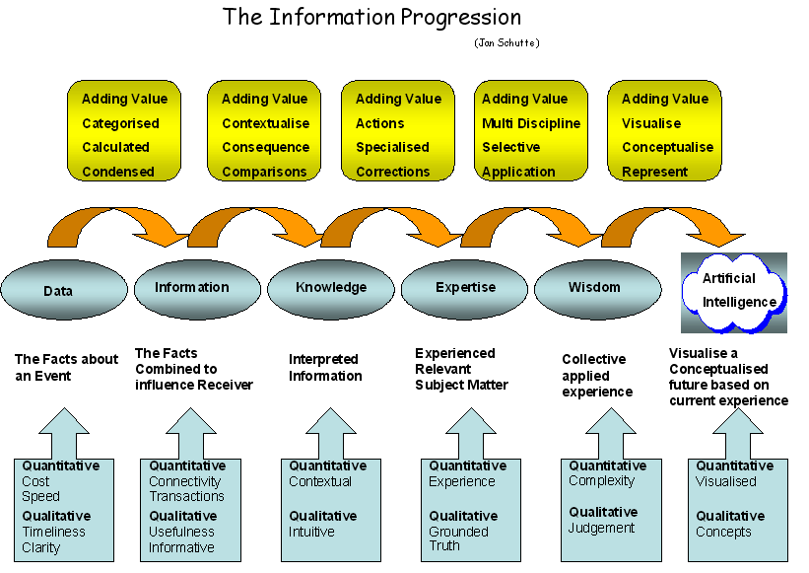
- Information Progression

Expertise Management
Within any organisation specific competencies of expert knowledge are required. Defining these are a prime concern within information management. The need exists not only to name but to contextually define the area of knowledge and the expert or subject-matter content. Organisations tend to confuse specialisation in the general workforce area with business or service delivery expertise. Managing expertise includes managing the individuals to ensure that they maintain their knowledge on the subject or area of expertise. This does not take away from the fact that the organisation has and needs to manage specialisation in general management areas.

Wisdom
Wisdom arises when one understands the fundamental principles and different views responsible for the different information patterns representing different compositions of multiple types of knowledge and service delivery expertise. Managing the identification of individuals within this category and their individual business areas of wisdom is critical.

Artificial Intelligence Management
This area is futuristic and talks to capturing knowledge and analysing it using artificial intelligence to visualise and conceptualise future outcomes.

Content Management
Meaning that is recorded on a medium, codified and stored for easy search and extraction.

Narrow sense: The essential matter or substance of a written work or discourse.
Broader sense: All the intrinsic information and data (ideas, topics, facts, or statements) contained in books, moving and still images, sound, textual resources and manuscripts (Synonymous in this sense with subject matter as well.)
Document management context: The content portion, as opposed to the attributes, of a document. The individual document attributes, which can be text, graphics, images, and other documents linked.
Publishing content refers to individual documents that can be graphic, textual or illustrative in nature, or amalgamations of documents that can be combined into individual subject related articles or complete publications.
Web context, the information content matter provided on a web page, as opposed to its physical design and layout. Content can take the form of text, graphics, audio, video, or a searchable database.
Digital Content products are available in digital form - typically sound files, video and images that are available for download or distribution on electronic media. Content can be either, Structured data: as in databases and Unstructured data: as in documents, e-mail, minutes, etc. Enterprise Content Management is the technology used to manage content.
Content Management encompasses all business practices and technical processes that are performed for the purpose of capturing, managing, maintaining, sharing and preserving recorded meaning. It includes the distribution of content across a variety of applications and types of output.
It is imperative that a holistic approach be adopted when addressing the issue of enterprise content management. Failure to use such an approach could cause high costs due to the following:
- Time wasted searching for electronic documents not properly coded;
- Storage without adequate planning for future retrieval;
- Deleted records due to inadequate retention procedures;
- Time wasted due to use of an incorrect version of a document;
- Storage wasted on unnecessary duplication of documents;
- Law suits can not be adequately defended as vital information stored in electronic documents, such as employee and other contract details, cannot be effectively retrieved;
- Loss of business due to inability to provide accurate and timeous project information;
- Lack of common departmental view;
- Embarrassment to the Organisation and loss of client confidence because of incorrect information;
- Failure to comply with legislative requirements for electronic records.

The Blueprint for ECM must attempt to address exactly this, and must assist DPW in developing an approach that supports the following:

- Formulation of key Business drivers and Strategies for ECM. Derive from that the prioritised Business processes, activities and tasks and align the Business Strategies to support the intended ECM.
- Seamless, integrated ECM across key DPW desktops as well as external scalability to customers, suppliers and Business Partners of key Business Units.
- Easy management and maintenance of a single directory system, enabling users or groups of users to easily select and target the relevant records and documents.
- Ability to centrally “publish” corporate information into hierarchically categorised databases.
- Easier methods for system administration, support and development to rapidly deploy and maintain information management architectures.
- The ability to protect sensitive information per groups of users or individually. This must be easily manageable and maintainable.

Document Management or Electronic Document Management
Document Management, a term used to describe the earlier versions of what is now known as “enterprise content management” is used to the describe the automated processes for managing the creation, capturing, configuration control, storage and retrieval of records and documents such as contracts, policy, business standards, project deliverables, etc. but not just focussing on the document artefacts as such but inclusive of the content as well.
Electronic Document Management System (EDMS) is included in the latter technology of Enterprise Content Management, and is nothing else than document management to keep track of stored documents (1) created by a computer using word processing, spreadsheet, or other software, or (2) scanned into a computer and converted to computer code by optical character recognition software or (3) scanned into a computer and saved in a computer image format. It is an essential part of collaboration and information sharing.

Enterprise Content Management Implementation Methodology

A generic ECM systems deployment methodology must be considered The following is and indication of such a methodology reflecting the Stages and a summary of DPW’s requirements regarding approval checkpoints. The simplified process is depicted below:

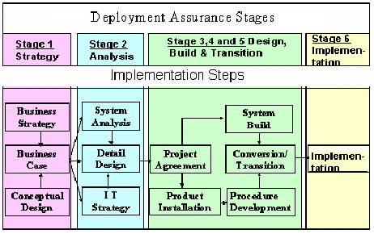
- ECM Methodology

Groupware
"systems that support groups engaged in a common task or goal, and that provide an interface to a shared environment." (CTRG Research - CTRG has a number of ongoing research projects exploring groupware implementations and environments.) It thus is a collective term for software that provides the infrastructure to work collaboratively, share information electronically, and use messaging to support them in working toward a common goal, regardless of where they are geographically located. Groupware services range from unstructured electronic mail to rigorously structured workflow systems. The main groupware categories are: All forms of Collaboration (electronic meetings, videoconferencing); Messaging (e.g. electronic mail, mobile SMS); Intranet (web services, access to shared databases, hypertext documents) ECM (including collective writing, storage & document sharing and tracking); Workflow; Scheduling (sharing of calendars) and Directory Services. To successfully implement groupware in an organisation requires well grounded technological development, with careful attention paid to the social and organisational environment into which the technology is being imbedded.

Collaboration
Collaboration describes the rules and behaviours of conversation-focused (as opposed to activity-focused) business behaviour. It is focused on the Meta analysis of workflow and concentrates on supporting what we “say” about the enterprise, not what we “do” within it.
There are a variety of tools and technologies to facilitate communication and collaboration. Collaboration can happen synchronously where all participants view information and/or meet at the same time or asynchronously where participants view information and provide feedback at different points in time. These tools and technologies include:
- Email exchange of drawings, models and project information (asynchronous)
- Teleconferencing and videoconferencing (synchronous)
- Web-hosted meetings (synchronous)
- Project hosting tools to create one pool of all released project documentation, with email alerts for updates (asynchronous)
- Drawing viewing sites (intranet and web-based) with view and mark-up capabilities (asynchronous)
- CAD collaboration sessions (synchronous)
- Workflow software (asynchronous)
- Product data management, product information management, collaborative product commerce (generally asynchronous)
The selection and use of these tools will be based on technology availability and cost; geographic dispersion and related customer and organisational differences; need for access by partners, suppliers and customers; product complexity and degree of technical issues; and other factors.
Collaboration requires effective team work. Team members must trust and respect one another. There must be open communication and a willingness to accept input from others.
There are often conflicting goals in organisational development and the related product/service delivery. Therefore decision-making must be based on a collaborative approach aimed at satisfying the customer. This is shown with the following model.

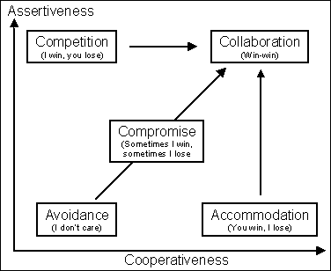
- Collaboration Matrix

This model represents two axes: Cooperativeness and Assertiveness. Different approaches to dealing with an issue are mapped against these two axes. A low degree of assertiveness and cooperativeness represents avoidance of an issue or the approach of "I don’t care". A high degree of cooperativeness and a low degree of assertion represents accommodation or the approach of "You win, I lose". A high degree of assertiveness and a low degree of cooperativeness represent competition or the approach of "I win, you lose".
Many people believe compromise is the ideal. Compromise represents a moderate degree of both assertiveness and cooperativeness. It represents the approach of "Sometimes I win and sometimes I lose". This, however, is not the ideal. A good team includes people that have strong beliefs and are professionally committed to the team members believe is important to the company and the development program (but not necessarily to just the narrow functional perspective of their discipline). We also want a high degree of cooperation. This represents the basis for a collaborative approach or the "win-win" approach. The key to the win-win approach is to creatively search for solutions that can mutually satisfy the needs of the team rather than focusing on just two competing solutions that involve trade-off’s or are mutually exclusive.

Messaging
E-Mail and other forms of services such as SMS and MMS that provides the mechanisms to create, edit, send, receive, read, forward, store, print and administer business related information messages.

Scheduling
Calendar / Scheduling that provides the mechanisms to view, search, print, create, modify and delete personal as well as organisational event calendar appointments, and to invite, schedule, search for free time, accept, reject, delegate group meetings.

Intranet
An intranet is a private (corporate) network that uses Internet software, standards and protocols to provide shared corporate information and supports collaboration in an organisation. It consists of a limited number of interconnected (internal) networks and web servers, protected from outside access.

An intranet’s power lies in the combination of Internet functionality with the speed and security of an internal corporate LAN. An Intranet differs from the Internet in that it provides connectivity only between specific sites, creating a pre-determined infrastructure for business users, customers, or other designated participants.
The Enterprise Architecture as a information architecture will be made available on the intranet. This will ease and facilitate information searching.

Extranet
An extranet is a private network that uses Internet technology and the public telecommunication system to securely share part of a business's information or operations with suppliers, vendors, partners, customers, or other businesses for collaboration purposes. An extranet can be viewed as part of a company's intranet that is extended to and for the exclusive use by organisations and people outside the company. It can also been described as a "state of mind" in which the Internet is perceived as a way to do business with other companies as well as to sell products to customers. The same security access rules need to be applied to the extranet as part of controlling access to sensitive information. External bodies need only be able to have access to information that they need to use as part of their collaboration with the department.

Internet (WEB)
The Internet (also known simply as the Net) is the worldwide, publicly accessible system of interconnected computer networks that transmit data by packet switching using the standard Internet Protocol (IP). It consists of millions of smaller domestic, academic, business, and government networks, which together carry various information and services, such as electronic mail, online chat, and the interlinked Web pages and other documents of the World Wide Web.
Contrary to some common usage, the Internet and the World Wide Web are not synonymous: the Internet is a collection of interconnected technologies such as computer networks, linked by copper wires, fiber-optic cables, wireless connections etc.; while the World Wide Web is a collection of interconnected documents (information), linked by hyperlinks and Uniform Resource Locators (URLs), and is accessible using the Internet. The Internet also provides many other services including e-mail, file sharing and others described below.
The World Wide Web ("WWW" or simply the "Web") is a global, read-write information space. Text documents, images, multimedia and many other items of information, referred to as resources, are identified by short, unique, global identifiers called Uniform Resource Identifiers (URIs) so that each can be found, accessed and cross-referenced in the simplest possible way.
The term is often mistakenly used as a synonym for the Internet itself, but the Web is actually something that is available over the Internet, just like e-mail and many other Internet services.
It can be used as a collaboration tool where a broader base of input is needed such as the public opinion on building a new highway or setting up a new factory where parts of the natural environment will have to be destroyed.

Workflow
Workflow describes the rules and practices of activity-focused (as opposed to conversation-focused) business behaviour. It distils the essence of the bureaucratic functions within an enterprise, “translating” human behaviour into data processing events. Workflow systems therefore are designed to assist groups of people to carry out work procedures, and contain organisational knowledge of where work flows in the default cases. Workflow is defined as "systems that help an organisation to specify, execute, monitor, and coordinate the flow of work items within a distributed office environment." The system typically contains two components. The first component is the workflow modelling subsystem, which assists administrators and analysts to define procedures and activities and their orderings and attributes. It allows analysis, simulation, assignment of activities to users, etc. This component is frequently associated with business process engineering. The second component is the workflow enactment subsystem consisting of the execution interface as seen by the end users, and the execution environment which assists in coordinating and performing the procedures and activities. It enables the units of work to flow from one users' workstation to another as the steps of a procedure are completed. Some of these steps may be executed in parallel, some may be executed automatically by the computer system. It speaks for itself that the modelling and enactment components need to be tightly interwoven, and can be useful to all participants at all phases of the information lifecycle. Any worthwhile ECM system would provide a workflow module better known as automating business processes.

Directory Services
Directory Service comprises all services, components and interfaces required to provide a sub-system for naming, describing, finding, accessing, managing and protecting resources in a distributed computing environment. Directories provide an authoritative source of information for identity and relation amongst people, applications and infrastructure [resources].

Concluding on the components
Information Management in DPW must be seen in the context of the future objective to realise Knowledge Management as a discipline to promote “an integrated approach to identifying, managing and sharing all of an enterprise's information assets. These information assets may include databases, documents, policies and procedures as well as previously unarticulated expertise and experience resident in individual workers.”

However, attention will only be given to explicit knowledge, which is “written down in the form of words and numbers and is used to solve problems …… explicit knowledge is easily communicated between people in the form of hard data, formulas, and written or universal procedures.” The “expertise and experience resident in individual workers” will not be addressed as part of Information Management.

No differentiation will be made between structured and unstructured data. Content and document management is regarded to contribute to Information Management and Groupware is regarded as “the collective term for software that provides the infrastructure” to enable Information Management.

Scope
The scope of the IM Strategy for DPW is formulated, taking into account all aspects of information management required to effectively discharge its service delivery responsibility, together with the theory of KM as pertaining to the whole organisation.

Knowledge Management as a Discipline
When compiling an Information Management strategy it is essential to understand knowledge management as a discipline, KM initiatives are a combination of continuous processes and unrelenting focus brought about by combining information patterns. KM is never "done," just as the financial or personnel management of an organisation is never "done." All organisations possess some level of KM within their existing information management structure. A formal KM initiative begins by raising the awareness of what's already being done. As initiatives progress, they will tend to move through some distinct logical phases. These phases are driven by both the level of enabling technology required and, more importantly, by the acceptance of KM within the organisational culture. We reference knowledge management as the next phase for information management.
A easy method of capturing tacit knowledge within an organisation is to develop a business orientated set of Frequently Asked Questions (FAQ) based on experiences and problem solving within the organisation. This will allow employees with advanced knowledge about the organisation to transfer some of the knowledge to the rest of the employees.

Level 1 – Information Retrieval: This level of KM focuses on making existing explicit knowledge readily available for reuse. The primary objective of an information retrieval project is ensuring easy access to relevant information. Advanced search engines that can apply semantic, pattern recognition and artificial intelligence technologies are capable of gleaning relevant knowledge from a broad array of existing information sources. An excellent example is the use of retrieval technologies to search competitive information (news feeds, trade press articles, news clipping services, internal competitive reports, Web sites, marketing literature, etc.). Such technologies can equip sales and marketing organizations to more effectively deal with competitive situations.

The primary limitation at this level is the focus on explicit knowledge. At this level there is no focus on capture and reuse of tacit knowledge. The onus is on individuals to document their tacit knowledge, thus making it explicit. This level has a strong tendency to Information Management.

Level 2 – Connectivity: At this level, organisations use communication technologies and virtual teams to break down the cultural and geographic barriers to knowledge sharing. Technologies such as indicated in groupware, discussion databases, video conferencing, data conferencing and Teamware provide opportunities for widely dispersed "strangers" to come together, work on a project activity, share tacit knowledge and disband. Over time, this activity significantly increases the cross pollination of knowledge within an organisation moving to expert knowledge.

Although tacit knowledge is shared and "multiplied" more effectively at this level, it is still constrained to the members of the virtual teams. Discussion database technologies capture some of the discussions and decision processes that would otherwise be undocumented and lost. But much of the real knowledge generated during these project activities remains un-captured.

Level 3 – The Intelligent Organisation: At this level, technologies are used to minimize the requirement of formally recording tacit knowledge to make it reusable. This is moving onto artificial intelligence. The combination of discussion databases, task assignments, activity tracking, workflow and document databases build a rich story of how individuals and groups interact and how decisions are made. By tracking the interactions of individuals within the teams, we can infer which individuals are subject-matter experts with tacit knowledge about specific topics. Significant amounts of tacit knowledge are captured as a by-product of teams working together in this environment. By identifying the contributors of relevant knowledge in the knowledge base, individuals can locate the "strangers" who are most able to help with new issues. This creates a rich environment for building new relationships among an organization's various disciplines. New applications for existing knowledge will become apparent and new market opportunities will surface.

Inclusions
Level 1 – Information retrieval, (explicit knowledge) will be addressed in this strategy. This will be done to leverage existing infrastructure and information sources, and to enhance information sharing in DPW.

Exclusions
Level 2 – Connectivity and Level 3 – the intelligent organisation will not be addressed in this strategy. However, Information retrieval will be addressed in the context of Connectivity and the intelligent organisation as part of information management.

Vision for Information Management in DPW
Information that is accurate, complete, consistent, up-to-date, and within the context of business requirements are collected, stored and disseminated for use by the clients, suppliers, partners, employees and management of Public Works that need it, when they need it, where they need it and in the format that they need it to enhance the quality and effectiveness of decision-making and service delivery by DPW.

Section 3 – Situational Analysis

External Situation
Some Information Management trends in the information industry (external to DPW) were identified and the implications of these trends on Information Management in DPW were identified. The identified trends and implications will assist in understanding the context of IM in DPW and in determining the requirements for IM for DPW.

Source: META Group
Source Date: 3 June 2003
Content: IBM, Oracle, Microsoft attempt to reposition their databases into comprehensive information management systems through 2005/06, with the ability to address structured (data), semi-structured (XML, catalogue SKUs), and unstructured (everything else) information. It is expected that this evolution will lead to the next boom in data warehouse/storage volumes and software licenses, as well as blur structured and unstructured tools through 2008.
Implications: Information Management in DPW must address structured, semi-structured and unstructured information, accompanied by the appropriate technology and tools. Take into account the implication on storage volumes and software licences when deciding on specific technology.

Source: META Group
Source Date: Feb 2003
Content: In 2003/04, data quality and data mining will emerge as requisite core IT competencies for business. By 2005/06, data mining industry standards will greatly ease interoperability of algorithms and models. Concurrently, data profiling technologies will become a conventional technique for identifying data quality issues, planning data integration, and auditing information assets.
Implications: The requirement for data quality and data mining must be clearly grasp and identified in DPW and should be addressed by utilising industry standard technology.

Source: META Group
Source Date: Feb 2003
Content: The convergence of structured and unstructured information management systems will continue through 2004/05, with additional overlaps among document-authoring tools, application interfaces, documents, forms, and relational database technologies. Through 2007, driven by increasing content usability/reuse, rights management, and life-cycle/records management issues, organisations will increasingly seek and deploy content management technologies addressing various unstructured content types (e.g., images, documents, reports, rich media, e-mail, product data).
Implications: The overlaps among document-authoring tools, application interfaces, document management, forms and relational database technologies must be understood in DPW. The drive for content reuse, rights management and records management must be well defined within DPW before any decision is made on a content management application.

Source: Meta Group
Source Date: Feb 2003
Content: Knowledge Management (KM) will remain an organisational imperative through 2004/2006, driving individual, workgroup, and enterprise efficiencies. As technologies supporting KM initiatives are increasingly provided via Web services within a knowledge worker infrastructure, vendors will seek to provide complete platforms via aggressive M&A activity through 2005. Business, people, and process issues will continue to provide the most significant barriers to KM project success through 2007/08.
Implications: IM as supporting the growth to KM, should be provided as Web based technology. The business, people and process issues regarding IM implementation and use in DPW must be well understood, identified and managed else it might just become the major barrier to achieve optimal success and efficiency.

Information Management Best Practice

“The new source of power is not money in the hands of a few but information in the hands of many.” (John Naisbitt)

BUSINESS PRACTICE vs. BEST PRACTICE

A business practice is a habitual way of carrying out work. It gets at how work is carried out not what work is carried out
Vs.
Best practices are those work practices that have been determined to be the best approach for all or large parts of an organization.

The body of best practices covers:

- Work practices (maintenance, operations, etc)
- Work environment (culture, behaviour)
- Use of resources (technology, skills, staffing, tools, etc.)
- Customer focus
- Quality of products and services
- Training
- Information Management

WHY DO WE NEED BEST PRACTICES FOR INFORMATION MANAGEMENT

…..”Because our “Information Enabled” partners, suppliers and competitors have it”

- Information will increasingly form the basis of competition and efficiency within the industry.
- Executives must explicitly articulate and define the role information will play in the execution of their organisation’s strategy.

Best practices to be considered:

Source: META Group
Information Ecology
The Enterprise Information Architecture (EIA) exists within an information ecosystem that presents layers of context for the different information engineering activities (see Figure 4)

- The information ecology represents the integration of key strategic planning artifacts from the enterprise business architecture and is the purview of senior executive management.
- The EIA represents the set of artifacts that describe and model the enterprise’s information value chain and is the purview of the chief information officer.
- Information management represents the set of artifacts that govern the collection, storage, dissemination, and delivery of corporate information, and is the purview of the enterprise information architect.
- Data architecture represents the set of artifacts that govern the design, implementation, and maintenance of databases, and is the purview of data architects and administrators.

Implications: Within the context of EIA, information management exists to:
- Establish communication and enforce a governance framework to coordinate and collaborate with suppliers/partners, employees, stakeholders, and customers in business activities across the enterprise value network.
- Establish the relevance of information and data within the context of business strategies, goals, and objectives.
- Classify business information to ensure information sharing between LOBs, trading partners, and regulatory bodies.
- Ensure alignment of information products to the enterprise bottom line (value proposition).
- Formalize the roles, organization structure, and procedures for managing information content and delivery.
- Establish information security access, privacy, confidentiality, quality, integrity, authenticity, and archival cycles.
- Support risk management and business resumption planning activities.
- Provide a foundation for the development and endorsement of common or standard data definitions.
- Ensure data access and sharing supports physical value chain and information value network.
- Ensure governance of data ownership and stewardship roles are identified and communicated.
- Ensure data compliance within audit and legal requirements.

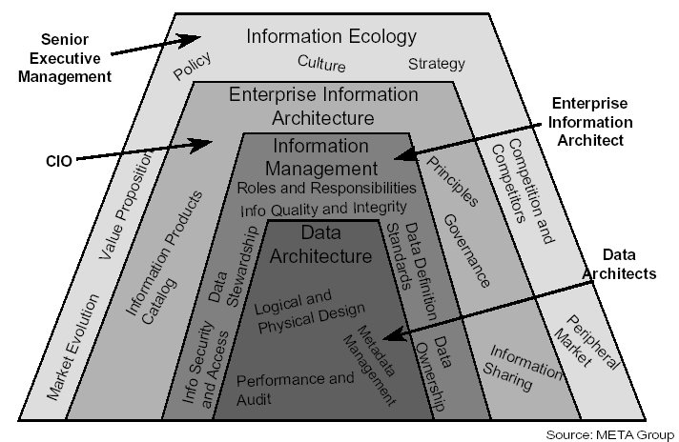
- Information Ecology

Information Management Principles
Principle 1: Minimize the data collection burden
Rationale:
The DPW should be able to collect, manipulate, and transmit accurate and consistent data quickly and easily. The lack of data integration due to incompatible database structures; poor quality and integrity of data; and the mixture of organizations, processes, and business rules with data, hinder data collection, manipulation, and transmission. Data should be shared across the enterprise.

Implications:
- Data standardization, including a common vocabulary and data definition, will be difficult to achieve but is critical.
- A common organization eliminates redundancy and ensures data consistency.
- To ensure success, business units as well as IT personnel should be involved.
- Each data element should have a trustee accountable for data quality.

Principle 2: Secure information against unauthorized access
Rationale:
DPW must be aware of security breaches and data compromise and the impact of these events. Appropriate security monitoring and planning, including an analysis of risks and contingencies and the implementation of appropriate contingency plans must be completed to prevent unauthorized access to information. Information security must be ensured and increased, commensurate with increased access to information.

Implications:
- Protecting systems hackers requires considerable effort and costs.
- The business unit manager, where each system is implemented, must take responsibility for security measures and contingency.

Principle 3: Provide access to information
Rationale:
Employees should have access to information efficiently, effectively, and economically. The access to information should be attainable any place, any time, and in the right format.

Implications:
- DPW should encourage a diversity of public and private access methods for information, including multiple access points, the separation of transactional from analytical data, and data warehousing architecture.
- Accessibility involves the ease with which users obtain information.
- Information access and display must be sufficiently adaptable to a wide range of users and access methods, including formats accessible to those with sensory disabilities.

Principle 4: Provide adaptive information delivery mechanisms
Rationale:
Information must be easily accessible and delivered in a very timely manner, when appropriate, when and where it is needed to efficiently and effectively compliment the enterprise’s business processes. It must be available, consistent, and valuable to the authorized user. Those users should not need to know the physical details for obtaining the data, or be concerned about its origination, as long as it is deemed official and authentic information.

Implications:
- Aggressively move to an environment that is flexible, secure, and capable of rapidly responding to change.
- Funding must be provided for evaluation of new technology to ensure its support of the business.
- A standards based network.
- Security systems that support simple end user identification and authentication.
- Support for heterogeneous data (from multiple systems).
- More intuitive and functionally richer systems that require expanded skill sets.
- Technologies designed to rapid query and retrieval.
- Transactions may span multiple systems.
- Applications will be developed for disparate platforms.
- In the application architecture, the presentation service will be separated from the functional logic.

Principle 5: Information is user-centric and owner-driven
Rationale:
To be successful, information must meet users' requirements and enable effective decision-making. With declining budgets and staffing levels, the need to increase productivity and efficiency is critical. Users will require access to information in an easy-to-use manner with the ability to retrieve information from many sources.

Implications:
- Information may exist on a variety of servers and locations but must be available to the user in an integrated, seamless fashion.
- Enterprise wide connectivity for both internal and external users will be required through high-speed communications networks.
- Users will require support on multiple desktops including standards for these desktops and the ability to customize their work environment.

Principle 6: Information architecture is based on open standards
Rationale:
- Software applications and information need to be more easily moved to computers of various sizes or brands.
- Computers of different sizes and brands need to communicate with each other in an interoperable environment.
- A vendor-neutral architecture provides long-term potential cost savings through enhanced competition in the marketplace.

Implications:
- Easy-to-use standard data formats and search-and-retrieval tools are needed, with the ability to both accommodate older formats and media and adjust to emerging multimedia technologies.
- The skills of people become portable, that is, to be applicable to different computing environments.
- Resources, information, and software applications can be shared.
- Short-term functionality, based on proprietary solutions, may be sacrificed for long-term interoperability.
- Lifecycle costs should be minimized, although cost savings from implementing standards-based information architecture might not be achieved in the short term.
- The architecture must accommodate the large inventory of legacy systems built on proprietary components.
- Continue to encourage vendors to provide products based on open systems standards.

Principle 7: Information is not only a BU asset but also an enterprise asset for which the information owners are the stewards
Rationale:
- One of the goals of the Administration's Reinventing Government Initiative is to make quality information available to every citizen in a timely fashion. Treating information as a Departmental asset is necessary to accomplish this goal.
- The availability of timely and accurate information is a key ingredient of sound decision-making. As such, information warrants a similar degree of management as other Departmental resources (e.g., people, money, facilities, etc.). Information management involves ensuring the integrity, timeliness, protection, and sharing of information.
- Stewardship rather than ownership encourages information use without sacrificing security.

Implications:
- Identified stewards are responsible for specific information categories.
- Establish a process to share information enterprise wide, and must address:
  - Consistent data definitions.
  - Standard data interchange formats.
  - A management approach commensurate with the value of the information.
  - The establishment of an information locator capability as part of a meta data repository.
  - Information stewards responsible for the definition, integrity, and timeliness of the information within their domain.
  - Operational issues related to the physical implementation of a shared information environment.
- Partnership with information stewards and information technologists is critical.

Principle 8: Enterprise wide access to information is the rule rather than the exception
Rationale:
- Productivity, decision making, and customer service all benefit from easy, direct, and timely availability of information.
- For optimal decision-making, people need access to the broadest range of information possible within the constraints of enterprise regulation.
- Time spent overcoming unnecessary hurdles in the quest for quality information can be wasted. Time is often the most precious of resources. Timeliness is also an important information quality indicator.

Implications:
- For unclassified information, the right-to-know should be presumed unless regulation specify otherwise.
- The business necessity of sharing information must be established.
- Technology must be deployed to distribute and allow access to information.
- Classification of information must be clearly stated -- rules need to be better defined. Secure information must not be accidentally released.

Principle 9: The information architecture incorporates a robust interface that optimises the nature, efficiency, and effectiveness of the human operator
Rationale:
- Usability engineering pays off in cost effectiveness, quality, and ease of use.
- The effectiveness of information delivery systems is jeopardized if the human interface is too difficult for non-computer-literate users to master.
- The attainment of successful work group collaboration using networked computers requires knowledge of the Human/Computer Interaction issues.
- Usability engineering pays off in cost effectiveness, quality, and ease of use.

Implications:
- The expertise required for a productivity enhancing system must be engineered into all levels of DOE systems.
- The Human/Computer Interaction field is an interdisciplinary field with roots in ergonomics, cognitive science, and human factors. A foundation for this understanding must be developed within DOE.
- An advocacy position for the importance and use of the Human/Computer Interaction knowledge in all aspects of system development needs to be developed in DOE and propagated to information technology development stakeholders.
- Human computer interactions are complex domains requiring more than the use of a graphical user interface. DOE must develop methods of incorporating informed Human/Computer Interaction knowledge into its systems development efforts and its end products.

Principle 10: DPW will have an information technology infrastructure that seamlessly links offices, programs, facilities, and field locations together
Rationale:
- Barriers to accomplishing objectives often are the result of the lack of a consistent and robust information technology infrastructure.
- The infrastructure can be centrally coordinated and implemented in a decentralized manner so that non- value added redundant efforts as well as implementation gaps are identified and eliminated.
- A seamless information technology infrastructure facilitates sharing of information and other resources across the enterprise.

Implications:
- Central direction and a degree of central funding will be required to provide an infrastructure, which is consistent across the enterprise.
- Organizations must give up some degree of autonomy to achieve the necessary consistency.
- A major component of this infrastructure must be an enterprise wide network capability that allows the exchange of sensitive (classified) data. This requires management of security policy issues.
- The information technology infrastructure includes some common databases and applications with commonly available access mechanisms.
- Information technology infrastructure planning and implementation requires wide and active participation from various organizational elements. The information technology infrastructure is based upon interoperability and standards, supporting the sharing of resources.
- Shared resources include data, information, applications, infrastructure, and computing, enabling users to leverage the work of others.

Internal Situation – Current Architecture
The full detail of the current architecture is described in Appendix C. A summary of each of the parts of the current architecture will now be provided, to be used as the basis from where to move forward with Information Management in Public Works and to identify possible shortcomings and requirements from the current architecture.

Current Business Architecture
The straight line core processes for the proposed value chain for the Department of Public Works:


- Public Works Value Chain

The current organisational units:

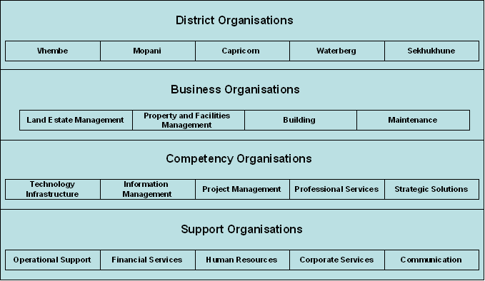
- Public Works Organisational Units

Public Works should be constituted as a matrix type organisation to effectively execute their value chain, which has a focus of client centricity. The “main production area” is the Business Organisation through five District organisations. Five competency centres, that each provide the business and district organisations with the required guidance and support to be successful in the execution of the activities as per the proposed value chain. The support organisations provide support to all the organisational units where relevant. Currently there are operational support provided by shared services and infrastructure support in terms of the flow and provisioning of operational information. This could lead to incomparable information as the time difference might impede the quality.

Current Information Architecture
From the analysis of the current information scenario, it can be concluded that the following information will be supplied or, and required in terms of Information Management.
- External requirements
- Previous engagement/operational information
- Discontinued opportunity information
- Submitted responses/proposal
- Tender information
- Signed contract
- Current operational information

The breakdown of the information is as follows:

- External requirements
  - Supplier/contractor/Information
  - Political
  - Technology
  - Economical
  - Social
  - Competition Information
  - Client Requirements
  - Internal and External Best Practice
  - Market / Industry Information
- Previous engagement/operational information
  - People
  - Response
  - Best practice
- Discontinued opportunity information
  - Client
  - Budget
  - Cost expended
  - Reason
- Submitted responses/proposal
  - Authorised response
  - Relevant Approval documents
  - Responsibility Information
  - Detail Response and cover letter
  - Resource requirements
  - Asset Requirements
- Tender information
  - Detail Specification Requirement
  - Resource requirements
  - Tenderer information
  - Detail tenderer response
  - Adjudication detail
  - Award notification
- Signed contract
  - Contract number
  - Contract date
  - Parties involved
  - Contract end date
  - Legal entities
  - Description of service to be delivered
  - Description of product to be delivered
- Current operational information
  - Land Estate Management
  - Property and Facilities Management
  - Building
  - Maintenance
  - Project Management

Current Application Portfolio

The Applications Architecture defines a set of applications that will support the shared data environment and provide the automated capabilities to store, share, and use data needed to conduct the organisation’s business efficiently. The Applications Architecture does not design systems or collect detailed requirements. The Applications Architecture addresses capabilities of existing, planned, and future applications to form a complete picture of the vehicles needed for delivering data resources and accomplishing business activities. The Applications Architecture is a key component in building the Implementation Plan.
In defining the applications in a shared data environment, it is beneficial to plan for managing data (Information Architecture) separately from the applications (Applications Architecture) that actually process the data. Data Repositories enable multiple applications to use the same data without duplicative maintenance. The business functions must be used to identify specific automated capabilities to support the functions outlined in the Business Model and the defined systems applications needed for those purposes.

The current list of applications is reflected in Figure 6.

DEPARTMENT OF PUBLIC WORKS
LIMPOPO PROVINCE
CATALOGUE OF APPLICATION SYSTEMS | MAJOR USERS
Transversal Systems
PerSal | Human Resources
BAS | Finance
Finest | Asset management
Standard Systems
Desktop Excel | All functions
BafMis | Properties
NPSLDS | Properties
MeasureIt | Roads and Bridges / SDI
Help desk system | Properties
Architect 2005 | Building and construction
QS Plus | Building and construction
TrackIt | ICT asset management
Map Guide | Properties
ArkTek | Building and construction
Sakhasonke | Building and construction
WestBank Fleet management | Transport
SuperF | Transport
Dream Weaver | ICT
Man Client | TELECOMMUNICATION
Shop Assist | Office services

DEPARTMENT OF PUBLIC WORKS
LIMPOPO PROVINCE
CATALOGUE OF APPLICATION SYSTEMS | MAJOR USERS
Additional Transversal Systems
Vulindlela | Finance and Management
LOGIS
Additional Internal Applications
Desktop Word | All Functions
Desktop Powerpoint
Microsoft Project
Microsoft VISIO

- List of Applications

The typical application portfolio can be divided into seven classifications each group represent specific sets of applications and information as indicated below:

- Customer Management System: The customer management system is currently silo based and very much manual, it will make a large contribution of structured and unstructured data to the Information Management once it is centralised.
- Financial applications: The transversal financial applications are integrated but the financial applications linked to project management are fragmented and lack integrated functionality. This poses a risk to corporate governance, which should be addressed in the short term. Integrated financial applications will be a source of structured data for Information Management.
- Human Resource applications: The human resource applications concerning the districts are fragmented and some may be regarded as legacy. The PERSAL application can be seen as integrated however it does not produce consolidated information on a organisation wide basis. Predominantly structured data will be obtained from the human resource application for Information Management.
- Web based applications: Multiple web based applications are in use, intranet and the internet. Unstructured data is provided by the web based applications.
- Document management: Different manual approaches to document management are used in DPW with the primary control as the registry service. The implementation of an ECM system to formally manage records and documents. An online ECM system should be the prime focus to integrate document management and should be the mechanism to manage all unstructured data of the enterprise.
- Commercial Off the Shelf (COTS): Microsoft Office products are used as the COTS applications, which are used for business support. The COTS applications are predominantly used to create unstructured data.
- Network support applications: Multiple network support applications are used to maintain required level of availability of the enterprise network.
- Licensed Computer System Software: Consisting of all operating and data base management software.

Applications Architecture Concepts

The Applications Architecture defines a set of applications that can support the shared data environment and provide the automated capabilities to store, share, and use data needed to conduct the Department's business efficiently. The Applications Architecture does not design systems or collect detailed requirements. The Applications Architecture addresses capabilities of existing, planned, and future applications to form a complete picture of the vehicles needed for delivering data resources and accomplishing information supported business activities. The Applications Architecture is a key component in building the Implementation Plan.
In defining the applications in a shared data environment, it is beneficial to plan for managing data as part of the Information Architecture separately from the Applications Architecture that actually process the data. Data Repositories enable multiple applications to use the same data without duplicative maintenance. The business functions must be used to identify specific automated capabilities to support the functions outlined in the Business Model and the defined systems applications needed for those purposes.
The Applications Architecture defines a set of applications that will support the shared data environment and provide the automated capabilities to store, share, and use data needed to conduct the Department's business efficiently. The Applications Architecture does not design systems or collect detailed requirements. The Applications Architecture addresses capabilities of existing, planned, and future applications to form a complete picture of the vehicles needed for delivering data resources and accomplishing business activities. The Applications Architecture is a key component in building the Implementation Plan.

The Proposed Conceptual Applications Architecture
For future consideration on the road to develop the required information architecture the department can use the following list of proposed applications to identify specific applications as part of the applications architecture.
Proposed Applications
Name | Purpose
Suppliers/Partners Information Repository | To provide one source of basic information about governmental bodies that Department does business with.
Contracts/Agreements Information Repository | To provide a uniform file of basic data on all of contractual and other agreements to enable efficient aggregation and availability of important information.
Authority Management System | To support the granting and withdrawing of the full range of authorities of employees and others with whom the department does business
Award Support System | To provide an automated system to facilitate the processing of the full range of awards that the department bestows on individuals and organizations and to have a complete record of such honors.
Departmental Element Information Repository | To maintain a uniform and current file of basic data on all of the department’s provincial headquarters and field organizations and subunits to support other automated systems across the enterprise and to assist in communication both within the department and with its customers/citizens.
Departmental Position Repository | To provide a reliable and complete source of legislative and official and government stands taken to help assure consistent views and understandings on important public and operational service delivery matters.
Dispute Tracking System | To provide a system to facilitate the processing of dispute actions and provide the ability to track such actions and collect basic data about them.
Document Management System | To maintain a current and comprehensive electronic library of the full range of documents generated by, or of interest to, the Department and to facilitate their identification, access and control.
Employee Information Repository | To provide a uniform, complete, and current source of basic and skills information about all the departmental employees both nationally and provincially that can be readily accessed and is properly protected from the release of sensitive material.
Employee and Job Management Information System | To provide an automated process to assist in the processing and tracking of information related to the filling of vacancies; and the compensation, evaluation, and training of departmental employees.
Executive Information System | To provide high-level departmental officials with current and accurate performance information on the outcome of important Departmental policies, programs, operations, issues and initiatives.
Exposure and Medical Monitoring System | To provide a comprehensive and uniform system to track and help analyse health related information about employees, contractor personnel and the clients; provides reliable and up-to-date record of medical related data.
Facility Services Information System | To provide a mechanism to access fundamental data about utility, maintenance, and other support services at departmental facilities to assist in analyzing trends, identifying opportunities to reduce costs, improving operations and responding to questions.
Funds Management System (FMS) | To provide comprehensive, uniform, accurate, and complete system to track and account for the allocation, obligation, and expenditure of funds available to department; available at all program levels to allow consistent management of financial resources with ease of use.
Incident Reporting System | To provide a uniform, departmental wide system to assure the timely, complete and accurate capturing, storing and reporting of information on operating incidents at departmental facilities.
Information Structure Registry (ISR) | To provide a comprehensive, official and current hierarchical structured register of the name and code identification of all categories of information.
System Investment System (SIS) | To provide a comprehensive, current and widely available hierarchical source of information about all applications and management systems under consideration, in development, and already implemented.
Technology Architecture | To provide the official, comprehensive structure of all the departmental networks, technology platforms and architectures.
Inquiry Response System | To provide an automated system to track the receipt, processing, approval and transmission of responses to inquiries received by the Department.
Intellectual Property Index System | To provide an official source of current information on a wide range of intellectual properties such as programs, systems, patents and copyrights that will permit department-wide access and aggregation of data.
Internal Audit/Assessment System | To provide the automated capability to assist in the preparation of audits and assessments; and to access audit/assessment status information and historical data.
Legislative Information Repository | To develop an automated and categorised system of information concerning various nature, content and applicability of laws, regulations, guidance, directions, and orders affecting the department’s programs and operations whether imposed by outside bodies or promulgated internally.
Policy Issuing System | To provide a system to track and record the development and issuance of departmental guidance, policies, directives, orders, standards and other forms of internal mandates.
Business Information Repository | To provide a readily accessible and reliable source of basic information about non-employees of other departments or private business with whom the department has dealings because of their positions, interest, authority, or roles such as advisory committee members, researchers, members of parliament, Administration officials and contractor personnel.
Physical Property System | To provide a comprehensive and complete repository of information about government-owned property that is readily accessible, can be aggregated, and is available for a wide variety of analyses such as availability, rent, general condition, locality, last assessment, age, value, and maintenance requirements.
Planning and Budget Information System | To provide a comprehensive system, capable of being used at all Departmental levels, to facilitate tracking and recording of information about the analysis, development, decision making, and establishment of plans and budgets.
Procurement and Financial Assistance System (BAS) | To provide a department-wide system to facilitate the processing of all Procurement and payment authorisation and to provide uniform data for aggregation and analysis.
Departmental Information Repository | To establish an official comprehensive and current file of basic information about departmental programs to be readily available within the Department and to be published through the internet for outsiders.
Progress and Cost Assessment System | To provide a Department wide comprehensive system to help evaluate and record actual work progress and costs compared to establish budgets, goals, schedules, and projections.
Project Information Repository | To establish a comprehensive, consistent and current source of basic information about the Department's major projects that is readily accessible both within and outside the Department.
Task Approval System | To provide a flexible, automated system to record the assignment of tasks to employees and contractor personnel and be able to track the progress in accomplishing those tasks.
Travel Arrangement System | To provide a system to facilitate the arrangement of official travel by departmental employees and contractors.

Table 1 Proposed List of Possible Applications

The Boundaryless Concept
The concept of Boundaryless Applications lies in the fact that data and applications are not in silos but rather integrated as applications in a pipe that stores data into a “datastore” as needed. But that the “datastore” is used by mining or extraction technologies to extract and to populate predefined information packets based on the overall information requirements.

Current Conceptual Technology Architecture
The technology architecture is divided into eleven domains.

10. Security services | 1. Software Engineering Tools | 2. Information Systems Engineering Tools | 11. Enterprise System Management
10. Security services | 3. Presentation |  | 11. Enterprise System Management
10. Security services | 4. Groupware | 5. COTS Applications | 11. Enterprise System Management
10. Security services | 6. Integration and Synchronisation |  | 11. Enterprise System Management
10. Security services | 7. Data and Information |  | 11. Enterprise System Management
10. Security services | 8. Communication Infrastructure |  | 11. Enterprise System Management
10. Security services | 9. Platform |  | 11. Enterprise System Management
- Technology Reference Model
The current desktop technology is Intel based and Microsoft is the predominant software technology in use. The following gives a indication of what constitutes the components of a technology architecture::
- Software engineering tools – such as MS Visual Basics or DotNet
- Information systems engineering tools – MS Visio
- Presentation – MS Windows
- Groupware – MS IE, Exchange, Outlook, MS IIS
- COTS applications – MS Office for COTS Applications
- Integration and synchronisation – such as MS Active Directory for synchronisation
- Data and information – such as MS SQL Server as DBMS
- Platform – MS Windows as the operating system

The remaining technology in use is limited to:
- Information systems engineering tools – such as MAP or CaseWise Corporate modeller 9
- Groupware – different types of applications
- Data Warehouse and information Reporting– such as Cognos and Crystal reporting
- Communication infrastructure – such as Cisco and Newbridge
The department currently makes limited use of the different components of the indicated technology architecture.

Domain | Current technology used
- Software Engineering Tools
- Software Engineering Tools  The Software Engineering Architecture defines the methodology and tools used for application design, development and testing, and for application release management. It defines the way applications are developed and how they interact. Enabling the department’s applications portfolio.  - Visual Basic programming language for development of Applications and Reports  - MS-Access a Microsoft elementary database development tool  - Object and Component  The Object and Component Architecture provides standards and guidelines that support the reuse of robust application code for programmer productivity gains and cost-effective development efficient reuse of existing application assets, faster deployment of new applications, and improved responsiveness to changing business needs. Reusable software components are the building blocks that make a system able to respond quickly to change. Object-oriented components encapsulate both the business logic and the data accessed by the business logic. Objects have the potential to become intelligent, self-managing entities, allowing for more simplified management. The architecture defines the methodology, toolset and components required for the development and successful reuse of objects and components. | No evidence  No evidence
- Information System Engineering Tools
- Information Systems Engineering Tools Architecture  Defines the way applications are designed and deployed, and how they integrate. Focus for the department’s applications portfolio. (Modelling tools, Repository, Architecture knowledge base)  - Visio (Microsoft Drawing Application used to draw different types of Drawings)  - Casewise is a Architecture knowledge base tool and repository | No evidence
- Presentation
- User interface  The interface by which the operator interacts with an application. (Terminal emulators, GUIs Graphical User Interface, TUIs Text-Based User Interface [WordPerfect])  Windows Office Products  NT, Workstation  Terminal Server  - Print and view services  The facilities that provides printout management, routing and browsing functionality. Such facilities will be used before a printout is actually printed.  - Win2000 Server | No evidence  Windows Server
- Groupware
- Groupware architecture  Provides the infrastructure for departmental staff (as well as clients and business partners) to work collaboratively and share information electronically, regardless of where they are geographically located. This includes, Intranet / Internet, Collaboration & Workflow.  - Web Services  The web services exploits the technologies of the Web to create, seamless, platform-independent, electronic and inter-business communications and universal access to business information. The architecture addresses issues of security, development tools, search engines, database connectivity and business logic. These technologies reduce the cost and complexity of information access, especially to the external world (customers and partners).  - Collaboration  The Collaboration architecture describes the rules and behaviours of conversation-focused (as opposed to activity-focused) business behaviour. It is focused on the Meta analysis of workflow and concentrates on supporting what we “say” about the enterprise, not what we “do” within it.  - Workflow  The Workflow architecture describes the rules and practices of activity-focused (as opposed to conversation-focused) business behaviour. It distils the essence of the bureaucratic functions within an enterprise, “translating” human behaviour into data processing events  - EDMS  Systems that automates the creation, capturing, configuration control, storage and retrieval of documents such as contracts, policy, project deliverables, etc.  - Humming Bird or Livelink (Electronic Document Management Application)  - Contract Management  - Legal Tracking system | - Exchange on MS for E-mail  - MS-Office and Windows Server for collaboration  - MS Internet Explorer 5.0 / 6.0  - MS Server  - Dream weaver  - MS Exchange  - MS Outlook  - MS Server  No evidence  No evidence
- COTS (Common of the Shelf) Applications
- COTS Application Architecture  Office Suites, CAD (Computer Aided Design) Productivity Applications, Project Scheduling, Diagramming, Database  - VISIO (Microsoft Drawing Application used to draw different types of Drawings)  - Desktop Publisher (desktop publishing  The production of publication-quality documents using a personal computer in combination with text, graphics, and page layout programs. )  - FrontPage (Microsoft Application used for WEB Development) | - MS-Office Suite (Word, PowerPoint, Excel)  - MS-Project
- Integration and Synchronisation
- Middleware Architecture  Provides robust, standardised mechanisms by which inter-process communication can take place e.g. over the network. Middleware solutions sit between the applications and the network communication mechanisms. They create uniform mechanisms for application integration independent of network and platform technologies. (Directory services, Message-Oriented Middleware (MOM), message brokers, Transaction Managers Online Transaction Processing (OLTP))  - Synchronisation Architecture  Directories are paramount to facilitate and manage the relation and links amongst distributed components.  - MS Active Directory (Managing Access to the network and subsequent applications) | No evidence  No evidence
- Data and Information
- Data Access Services  Provides high-quality, consistent data where it is needed to support business and transactional systems. It requires that data be accurate and easily accessible. (File service and Database Management Services - DBMS)  - Data Warehouse Architecture  Data warehouse architecture describes the internally consistent logical structure of authoritative databases and provides the standards for accessing Decision Support Systems (DSS) and Online Analytical Processing (OLAP) data. The data contained within these databases has typically been transformed, cleaned, and audited to adhere to corporate information architecture quality standards  - SQL Server 7  - Cognos (Proprietary Software for Data warehousing)  - Business Intelligence Architecture  The Business Intelligence Architecture is a subset of the enterprise’s overall data architecture that provides high-quality, consistent data where it is needed to support information, analytical and decision support systems. It describes the internally consistent logical structure of authoritative databases and defines the standards for accessing decision support systems (DSS),executive information system (EIS) and online analytical processing (OLAP) data. It requires the use of flexible and dynamic design principles.  - Cognos (Proprietary Software for Data warehousing) for EIS/DDS  - Crystal Reporting for Operational and Financial Reporting | No evidence  No evidence
- Communication Infrastructure
- Communication Infrastructure Architecture  The Communications / Network architecture provides the communication infrastructure for the distributed computing environment. It consists of logical elements (structure, topology, bandwidth, management), physical hardware components (wiring, LANs, hubs), carrier services (frame relay, leased channels, ATM), and protocols (access, routing, naming). It may incorporate telecommunication services if they are integrated within the enterprise organisational structure. (Network hardware, LAN, WAN)  - Dial-up: (RAS) Remote Access Service  - 3G wireless | - Routers:  - Switches:  - Cabling: CAT5 Ethernet,  - Protocol: TCP/IP
- Platform
- Hardware Architecture  The hardware architecture defines the physical technical components of the structure, including the client and server hardware platforms, and the database environments.  - Operating System Architecture  The Operating System Architecture defines the technical components of operating systems executing on the hardware platforms. | - Desktops:  - Notebooks:  - Workstations & Notebooks: Windows XP Prof, Windows 2000 Prof, Windows 98, NT and Windows 95
- Security Services
- Security Services Architecture  Information Security Architecture defines the security services needed to protect the information resource as asset of DPW. This is a common basis for the design, development, implementation and management of the enterprises’ information security policy and approach. These services include authentication, access control, data integrity, data confidentiality, non-repudiation, audit trails and encryption. It is applicable across the enterprise on all platforms. | - Firewall: Internet  - Access Control: Security & Application specific authentication
- Enterprise System Management
- Enterprise System Management Architecture  The Enterprise Systems Management Architecture identifies the components that efficiently and effectively manage the company’s computing environment to support and enhance the productivity of its automated business systems in the information technology environment. It addresses the management of service levels, configuration, problems, change, operations and performance measurement, security and billing. (Network management, DBMS management, server management, software distribution, data recovery.) | No evidence

Table 2 Application and Related Technology

Conceptual Architectures

To be able to deduct information management requirements one needs to understand the enterprise architecture of the organisation. The following diagram depicts the enterprise architecture for the department. Information will typically be classified and grouped into the different components as described in the different layers.

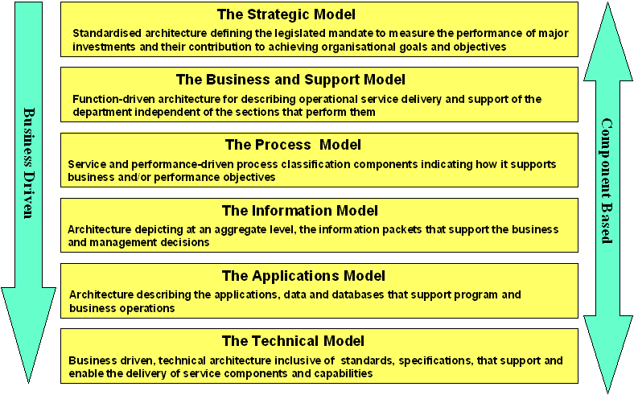
- The Proposed Information Architecture

The Conceptual Enterprise Architecture includes:-

The Strategic model comprises:
- The legislated mandate – acts
- The strategic directives – vision, mission, goals and objectives ( strategic outcomes as per strategic plan)
- Policies, standards and norms
- Performance expectations/indicators - Financial and Non-financial (MIS)
Standardised strategic framework to measure the performance of major investments and their contribution to organisational success

The Business and Support model comprises:
- Business definition
- The organisational structure
- The lines of business(Core Functions) value chain and supply chain
- The planning/delegating/monitoring and control processes
- Task management and routing
- Provinces, regions, local – customers and partners
Function-driven framework for describing business operations of the department independent of the sections/units/agencies that perform them

The Process model comprises:
- The processes for services to be delivered
- The e-gov process requirements
- The mechanism, vehicles and service support processes
- The rules and regulations to ensure the integrity
- The specific processes and controls
Service areas, service types
Business units and Service Categories
Business driven functional framework that classifies processes with respect to how they support business and/or performance objectives

The Information model comprises:
- The information categories
- The high level information flow
- The individual information packets/sub-categories as part of the categories
- The information packet elements/content/data structures
- Enterprise Content Management
- Customer Relationship Management
Model describing, at an aggregate level, the information that support the business and management decisions

The Applications model comprises:
- The web site requirements
- The different applications
- The individual data models
- The database schemas
- The ownerships
Model describing the applications and related data and databases that support business operations

The Technical model comprises:
- The system software needed
- Licensed software
- The technical standards, rules and regulations
- The hardware platform definitions
- The network requirements
- Configuration Management
- Organisational/ technology Relationship
Component-driven, technical framework inclusive of the standards, specifications, and technologies that support and enable the delivery of service components and capabilities

Internal Situation – Common Requirement

Business Strategic Requirements
Business Strategic Requirements (BSR) is derived from the DPW Business Strategy and Value Chain. Five BSDs have been identified, which are the requirements to:
- Grow the business of DPW.
- A client centric approach to efficient service and product delivery.
- Have advanced insight to client requirements and problems.
- Harvest all appropriate client touch points.
- Measure service and product delivery against service levels and requirements.

Business Information Requirements

DPW Business Strategy – Information Requirements
Based on the vision of the DPW Business Strategy, there is a requirement for information on:
- The products and services that DPW provide, support and integrate.
- The current clients of DPW.
- Potential new clients for DPW.

Based on the mission of the DPW Business Strategy, there is a requirement for information on:
- The different stakeholders of DPW.
- Appropriate business practice to be followed by DPW.
- Corporate governance that is in place in DPW.
- BEE levels and targets of DPW.

Based on the values of the DPW Business Strategy, there is a requirement for information on:
- Performance levels of DPW Competency Centres, against service level agreements.
- The opinion that DPW clients have of DPW.
- Problems experienced by clients of DPW with the products and services rendered by DPW.
- The different touch points that DPW have with specific clients.
- Detail of contracts between DPW and clients.
- Processes required too satisfy client requirements.
- Industry forecasts and scenarios.
- Internal and external problems that are experienced by stakeholders, partners and employees in satisfying the information requirements of client projects.
- Trust levels of clients, stakeholders, suppliers, partners and employees in DPW.

DPW Business Architecture – Information Requirements

S no | Organisational units | Information Requirement
1 | District organisations
- Uniform access or Portal to departmental information (Managed Repository).
- The Managed Repository that will be provided by Information Management and should be constituted by a Content Management System and a Data Warehouse.
- There is a specific requirement for consolidated information on projects and forecasts of the different clients and on large project.
- Currently this requirement is satisfied with a complicated interlinked spreadsheet, which is updated regularly.
- It is very painful to obtain information either structured and unstructured by nature of the business units and there is a risk that the quality and repeatability of the reporting may suffer in the long run.

2 | Business Units/Competency centres
2.1 | GITO | - There is a requirement for a repository to store the legislation, policies, processes & procedures of the Way of Work (WOW) putting executing information in context of DPW. (Unstructured documents)  - There is a requirement for uniform reporting on performance data that is gathered from the different islands of information on client’s projects, from a multitude of different sources. (Structured data)  - DPW Data Repository Requirement from Infrastructure Support Services. This Online Repository functionality will have a superior backend installed which will then provide far better service in terms of:  - Accessibility  - Search  - Security  - Information Management  - All business service Technical Standards, processes, procedures related to Infrastructure Services should be contained in a repository, as well covering:  - Process  - Procedure  - Work instruction  - Technical diagrams  - Service Level Agreements  - Contract Agreements  - A project must be launched called the WOW (Way of Working) project together with Enterprise Architecture Framework. By doing this it also ensures that standards meet with critical objectives to create a central Information Repository.
2.1.1 | Networks
2.1.2 | Support Services
2.1.3 | Information Services
2.2 | Business Services
2.2.1 | Project Management
2.2.2 | Building
2.2.3 | Maintenance
2.2.4 | GIS
2.2.5 | Real Estate
2.3 | SCM
2.4 | Professional Services
2.5 | Strategic Solutions
3 | Support Services
3.1 | Commercial services
3.1.1 | Project Office | - The PO have determined their requirement for a Project Management Toolset, and will use Microsoft Project.  - The Toolset will be implemented for all projects, once mature it will be extended and will be bundled to be marketed with project management product offering.  - The Toolset will be used to register projects, store project related documentation, track progress (use of financial and human resources) and report on the status of the projects. (Structured data and unstructured documents)  - The PO Toolset will have to integrate with Information Management reporting and it has, as such been communicated.
3.1.2 | SDI | - SDI focusing on the Service Delivery Improvement potential within the department who must also be responsible for the content of DPW business processes via a Online functionality, which will host all business processes of Dpw on a SQL Server (with identified workflow).  - SDI will be responsible for the maintenance of the process content of DPW.  - There is a specific requirement for version control, change control on DPW processes for the use of a future modeling tool.
3.1.3 | Internal Audit
3.1.4 | Legal Services
3.1.5 | Risk Management
3.2 | Financial Services
3.2.1 | Travel
3.2.2 | Strategic finance
3.2.3
3.2.4 | Payroll finance
3.2.5 | Facilities management
3.3 | Human Resources | - The supporting infrastructure for information management should not be neglected.  - The project should ensure that the shortest possible path to access info on the intranet be followed. (General rule of a maximum of three clicks)  - What is the spin-off of each technology grouping to the enterprise, the benefits must be clear and everything should start with sound business requirements.
3.3.1 | HR Admin
3.3.2 | Employee relations and reward training
3.3.3 | Training, development & recruitment
3.4 | Marketing & Communication | - Marketing must do a detail requirements analysis for the Information / Knowledge requirements of the different disticts regarding marketing. (Trade Marketing Plan, etc.)  - The high level requirement is for access to consolidated reporting on structured information and the ability to search unstructured information.  - It should be considered to look at the information requirements and sources of.  - Nu-Gen is a new EDMS product, which should be investigated.
3.4.1 | Corporate marketing
3.4.2 | Corporate social
3.4.3 | Internal communication
3.4.4 | External communication

Table 3 Specific Information Requirements

Section 4 - Impact Analysis

Impact Analysis
The impact on the current situation of IM in DPW, and IM external to DPW will be evaluated in terms of the factors that may / will influence the adoption and use of IM in DPW. The impact analysis is important to determine what the change management should take place to ensure the implementation and use of IM in DPW. The factors that will be used in the impact analysis are depicted in Figure 8.

- The Social Impact of IM adoption and use
It is necessary to understand the impact that the implementation of the IM strategy will have within the organisation. Below are listed some of the impact indicators:

Impact on Individuals
- Loss of perceived Power
- Empowerment for decision making

Impact on Innovation
- Organisational learning
- Internal communication

Impact on Task
- Stress because of the unknown

Impact on Organisation
- Politics
- Learning

Impact on Environment
- Competition from Outside ICT Suppliers
- Industry innovation

Impact on Group
- Change
- User/ownership changes of systems

Recommended Information Categories
As part of the structuring of information it will be necessary to define specific unifying groups or categories to store information so that it becomes easily accessible. The following are a set of suggested categories for consideration.

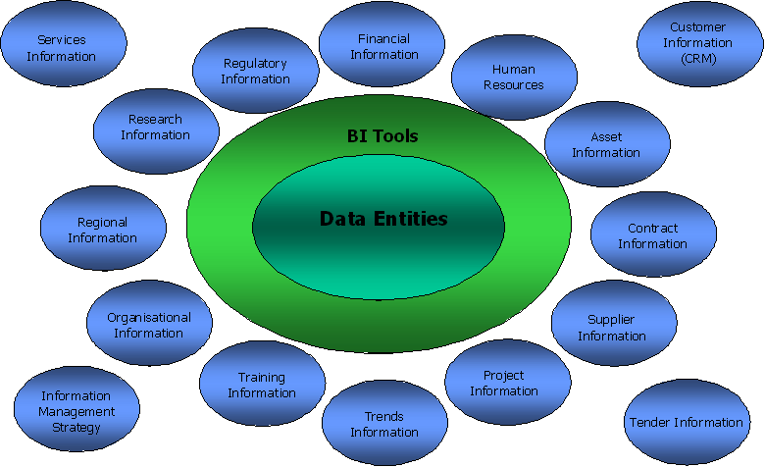
- Information Categories

Sixteen information categories has been identified that should be available to the clients, suppliers, partners and employees of Public Works (Figure 10). The information can be unstructured data, which would reside in a document management system or structured data, which would reside in a data warehouse.

Communities of Practice and Vertical Units
Communities of Practice (COP) is all about business units that share information, insight, experience and tools about a business area of common interest (the region and the client segment e.g., building, maintenance etc.) The vertical units are the business units and service units that enable the regional organisations to deliver value to the clients. The different regional organisations can therefore be regarded as communities of practice that share knowledge, learn together, and create common practices.

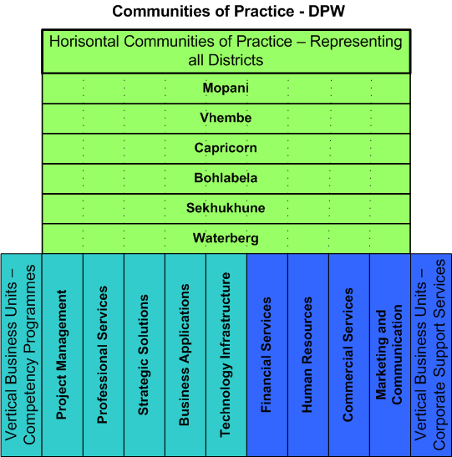
- Communities of Practise

Information Management Scenario
The information in the different categories is mostly available in the current business units, although it is fragmented and in several separate manual files or databases with little or no integration between the different sources. There are also multiple different access mechanisms to the current different business applications (Figure 12) because there are no single sign on.

Access method is the term given to the set of rules by which networks arbitrate the use of a common medium. It is the way the LAN keeps different streams of data from crashing into each other as they share the network.
Networks need access methods for the same reason streets need traffic lights - to keep people from hitting each other. Think of the access method as traffic law. The network cable is the street. Traffic law (or the access method) regulates the use of the street (or cable), determining who can drive (or send data) where and at what time. On a network, if two or more people try to send data at exactly the same time, their signals will interfere with each other, ruining the data being transmitted. The access method prevents this.
The access method works at the data-link layer (layer 2) because it is concerned with the use of the medium that connects users. The access method doesn't care what is being sent over the network, just like the traffic law doesn't stipulate what you can carry. It just says you have to drive on the right side of the road and obey the traffic lights and signs.
Three traditional access methods are used today, although others exist and may become increasingly important. They are Ethernet, Token Ring, and ARCnet. Actually, these technologies encompass wider-ranging standards than their access methods. They also define other features of network transmission, such as the electrical characteristics of signals, and the size of data packets sent. Nevertheless, these standards are best known by the access methods they employ.
ETHERNET
Ethernet is the most common network access method. It was developed by Xerox in the mid-1970s. It describes data transmission at 10Mbits/sec, 100Mbits/sec, 1Gbits/sec, and other throughput rates using the CSMA/CD protocol. Ethernet gained its popularity in engineering, scientific, and university environments. The shipments of Ethernet interface adapters grew substantially faster than those of Token Ring through the 1990s. ARCnet unit shipments have declined, and little new development of ARCnet-based solutions should be expected. Flurries of interest in FDDI and ATM for high speed backbones occurred in the late 1990s, but the multiple flavors of Ethernet dominate the great majority of LAN environments at the turn of the millennium.
The Ethernet access method is Carrier Sense Multiple Access/Collision Detection (CSMA/CD). This is a broadcast access method, which means every computer "hears" every transmission, but not every computer "listens" to every transmission.
Here's how CSMA/CD works. When a computer wants to send a message it does, as long as the cable isn't in use by another transmitting node. (This is the carrier sense part.) The signal it sends moves up and down the cable in every direction, passing every computer on the network segment. (This is multiple access.) Every computer can hear the message, but unless the message is addressed to it, the computer ignores it. Only the computer to which the message is addressed receives the message. The message is recognized because it contains the address of the destination computer.
A "collision" occurs if two computers send at the same time (because there is a narrow window of time in which the second computer may have begun transmitting but the "busy signal" has not yet reached the first computer, which blithely begins to transmit). A collision doesn't make any noise, but the signals become garbled and the messages can't be understood. In fact, nodes that detect a collision automatically transmit a special "jam" signal, which unambiguously destroys the colliding transmissions. When this happens, each of the colliding computers "backs off" or waits for a random amount of time, then tries to retransmit. This wait/retransmission sequence can repeat until both messages are transmitted successfully. The whole process takes a small fraction of a second.
Ethernet's detractors characterize it as an inefficient access method because frames are prone to collisions. But while collisions occur, they don't consume very much throughput capacity in most cases. Since the whole process of transmitting, colliding, and retransmitting takes place so quickly, the delay a collision causes is normally minuscule. Of course, as the traffic on a network approaches the total throughput capacity, the number of collisions will mount and the network will slow considerably. This happens with some large-scale imaging or engineering applications, or network segments with too many nodes. As long as an Ethernet network has a low traffic load, traditionally the most common environment, delay caused by collisions is seldom noticeable. In a switched environment, especially on Ethernet backbones, most links will have only two nodes, and the incidence of collisions on these segments will be minuscule.

TOKEN RING
When Token Ring was introduced in 1984, it was not the first token-passing, ring network, but because it was endorsed by IBM, it has had a tremendous impact on the network industry. Token Ring became part of IBM's connectivity solution for all its computers-personal, midrange, and mainframe. IBM's specifications match those of the IEEE 802.5 standard.
Token Ring unit shipments are still increasing in 1995, though this growth is unlikely to continue for long. IBM has had a stranglehold on the Token Ring market, though it no longer supplies the 90 percent share of Token Ring network interface cards that characterized this market in the 1980s.
The original Token Ring system transmitted data at 4Mbits/sec; the newer specification calls for 16Mbit/sec transmission. In Token Ring, the computers are arranged in a logical ring, but all data passing between work stations is routed through a hub. A multi-station access unit (MSAU or MAU) acts as the hub, and each work station is connected to it. Token Ring uses a token-passing access method to prevent data collisions-a token being a series of data bits created by one of the computers. The token moves around the ring, giving successive computers the right to transmit. When a computer receives the token, it may transmit a message of any length as long as the time to send does not exceed the token-holding timer (this combination of token and data is called a frame). As this message (frame) moves around the network, each computer regenerates the signal. Only the receiving computer copies the message into its memory, then marks the message as received. The sending computer removes the message from the token and recirculates it.
Token Ring's advantages include reliability and ease of maintenance. It uses a star-wired ring topology in which all computers are directly wired to a MAU. The MAU allows malfunctioning computers to be disconnected from the network. This overcomes one disadvantage of token-passing, which is that one malfunctioning computer can bring down the network, since all computers are actively passing signals around the ring.

ARCNET
ARCnet was developed by Datapoint in the early 1970s. It was especially popular in very small networks, since it was inexpensive and easy to maintain. ARCnet uses a token-passing access method that works on a star-bus topology. Data is transmitted at 2.5Mbits/sec. The network cable is laid out as a series of stars. Each computer is attached to a hub at the center of a star, and the hubs are connected in a bus or line. ARCnetPlus was designed as a backbone technology and can transmit data at 20Mbits/sec.
When a computer wants to send data on an ARCnet network, it must have the token. The token moves around the network in a given pattern, which in ARCnet's case is a logical ring. All computers on the network are numbered with an address from 0 to 255. (The maximum number of computers on each ARCnet segment is thus 256.) The token moves from computer to computer in numerical order, even if adjacent numbers are at physically opposite ends of the network. When the token reaches the highest number on the network it moves to the lowest, thus creating a logical ring.
Once a computer has the token, it can send one 512-byte packet. A packet is composed of the destination address, its own address, up to 508 bytes of data, and other information. The packet moves from node to node in sequential order until it reaches the destination node. At the destination, the data is removed and the token released to the next node.
The advantage of token passing is predictability. Because the token moves through the network in a determined path, it is possible to calculate the best and worst cases for data transmission. This makes network performance predictable. It also means introduction of new network nodes will have a predictable effect. This differs from Ethernet, where the addition of new nodes may or may not seriously affect performance. However, claims for a "predictable" network can be misleading-for example, lost tokens will affect worst-case delivery times.
A disadvantage of the token-passing access method is the fact that each node acts as a repeater, accepting and regenerating the token as it passes around the network in a specific pattern. If there is a malfunctioning node, the token may be destroyed or simply lost, bringing down the whole network. The token must then be regenerated.
Most organisations are very must still in the arena of multiple sign on and individual application authorisation.

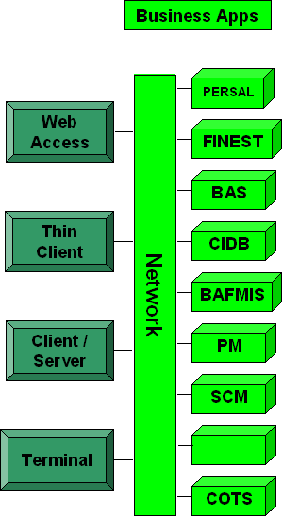
- Current access with required repository

Ideally a single integrated repository or multiple centrally controlled repositories should be made available for seamless and uniform access to all structured and unstructured data (Figure 16).
The future calls for data warehousing (which is a copy of structured and unstructured transaction data specifically structured in a predefined format for query and analysis) to bring about real-time data integration, low computer overhead, high volume data capture and dissemination of information.
The form of the stored data has nothing to do with whether something is a data warehouse or not. A data warehouse can be normalised or denormalised. It can be a relational database, multidimensional database, flat file, hierarchical database, object database, etc. Data warehouse data often gets changed. And data warehouses often focus on a specific activity or entity.
Data warehousing is therefore not necessarily only for the needs of "decision makers" or used only in the process of decision making. Data warehousing is primarily to serve the organisation in terms of uniform standardised information so that everybody uses the exact same information and therefore gets to the same answer every time.
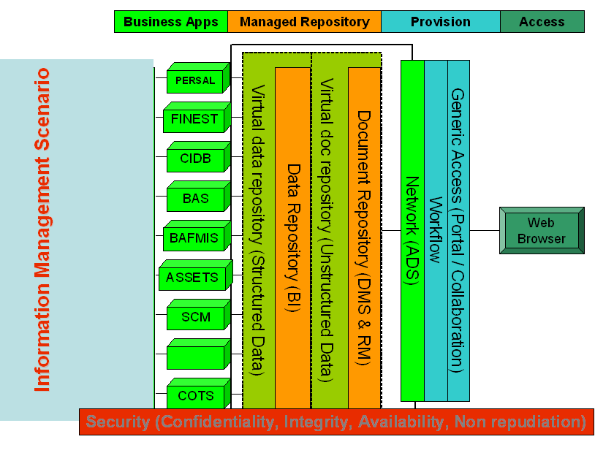
- Proposed Information Management Scenario

Information Management Concept
The focus of the information delivery concept is to provide seamless and uniform access to information for the client, supplier, partner and employee. The districts are regarded as the production units of the enterprise, which has the closest link to the services delivered to the client, supplier and partner, and makes use of employees to deliver value. The different business units and service units provide support to the districts to deliver value. Different data repositories will exist at each of the districts and at the different business and service units at head office. The information in these repositories will be made available through a managed repository, proper provisioning mechanisms and uniform access.

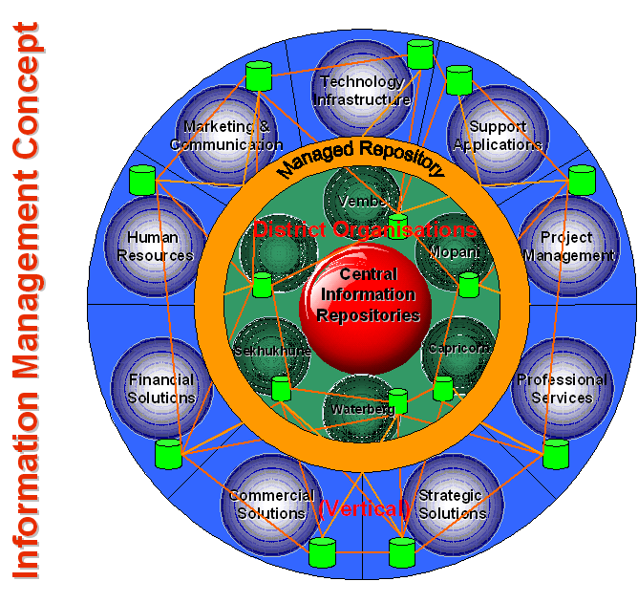

- Information Management Concept

Section 5 – Legislation Related to Information Management
The provision of IM services in Government is mandated by a couple of SA Acts that have a direct bearing on Information Management, and more specifically on Records management as part of Information Management.

The Promotion of Access to Information Act (PAIA) Act, 2 of 2000.

Introduction
The Sate President promulgated the Promotion of Access to Information Act, 2 of 2000 on 9 March 2001. The act has its origin from section 32 of the RSA Constitution stating that everyone has the right of access to any information held by private and public bodies that is required for the exercise or protection of any rights.

The PAIA Regulations must also be taken into account when using the Act.

The purpose of the act is to give effect to the constitutional obligations of the State of promoting a human rights culture and social justice and the right of access to information held by the state, private persons and public bodies. PAIA aims to foster a culture of transparency and accountability and to promote the “Batho Pele” principle by facilitating public access to records and to create mechanisms and procedures to ensure that access to records is swift, inexpensive, and effortless.

Based on the right to access, records can be requested by individuals or by a third party requesting information on behalf of an individual (e.g. a guardian). Records can be requested from public or private bodies. All government Departments (on National, Provincial or Local level) are classified as public bodies.

Only records can be requested via PAIA, and not, for instance, verbal information. A record is defined as any record regardless of the form or medium, regardless of who created the record, or when it was created, or for what purpose, if it is in the possession or under the control of the Department, it must be supplied.

The right of access to records is, however, subject to justifiable limitations, including, but not limited to, limitations aimed at the reasonable protection of privacy, commercial confidentiality and efficient and good governance. The Act, for instance, does not apply to a record of the Cabinet and its committees.

The criteria according to which access to records may not be granted, are specifically listed. No other reasons (for instance not even the security classification of a document) may be used to deny access to a record if that record is not specifically protected by the criteria in the Act.

Non-compliance with the Act is an offence and can lead to fines or a jail sentence.

Implications for Departments
When striving to comply with PAIA, there are certain activities that are prescribed by the Act and thus mandatory, and other activities that are not prescribed, but which will enhance PAIA compliance and the Department’s ability to manage PAIA administration.

Activities required by the Act
- According to Section 4 of Regulation 187, 15 February 2002 a Departmental manual should already have been complied and made available. This manual, which must be updated regularly, must be in at least three official languages.
- In addition to making the manual available to the public, copies must also be delivered to prescribed places of legal deposit and certain other institutions, e.g. the SA Human Rights Commission (SAHRC).
- The Director-General, who is the ex officio Information officer, should designate deputy Information Officers to ensure that PAIA requests will be optimally addressed. Delegations must be provided in writing.
- If the Minister of the DoSD, who is the ex officio relevant authority, will not be able to handle PAIA appeals in person (e.g. due to time constraints), he should designate a relevant authority (in writing) to act on his behalf
- Provision of annual feedback to the SA Human Rights Commission (SAHRC) and the annual submitting of prescribed detail to the Minister of Justice.

Activities that will enhance PAIA administration
- The Department should have operational processes and procedures in place for dealing with requests. This can include:
- Providing a single point of access for all incoming PAIA requests.
- Procedures for granting or refusing access to records.
- Procedures for remedies and appeals.
- Management of PAIA documentation.
- Procedures for handling finances linked to requests.
- Establishing a record keeping system to ensure control and availability of PAIA management information.
- Ensure availability of the PAIA manual on the Departmental website.
- Ensure adequate resources for PAIA to be implemented effectively.
- Determine roles and responsibilities of PAIA officials, e.g.
- Who will be responsible to compile the annual report for the SAHRC.
- Who will have to answer ad hoc queries on PAIA statistics.
- What will be the roles of Registry Services; Reception; Switchboard; etc.
- Identify and prepare physical locations.
- Record inspection room for requesters.
- Administration workspace for PAIA officials
- PAIA file storage space.
- Consider PAIA training and awareness of:
- Deputy Information Officers.
- Legal officers.
- Relevant departmental personnel, e.g. switchboard, reception, CRM, security.
- Ensure PAIA awareness of all personnel.
- Budget for and procure:
- Equipment (if applicable): video recorders, TV’s, audio equipment, stationary, photocopying machines and other reproduction facilities.
- Translation of PAIA manual in other two languages.
- Promote the importance of a document management project to implement sound record keeping within the department according to all applicable acts. Compliance with PAIA will be difficult if requested documents cannot be found.

South African Archives Act (Act no 43 of 1996),

Background
Governmental bodies should recognise their responsibility to the public for accountable and transparent governance as described in sections 141 ad 195(1)(f) of the Constitution of the RSA, 1996. One of the ways to ensure accountability and transparency, is by implementing and maintaining sound records management practices. Records management refers to the process of ensuring the proper creation, maintenance, use and disposal of records to achieve efficient, transparent and accountable governance. Public records are defined as those records created or received in the course of official business by governmental bodies and which are kept as evidence of a governmental body's functions, activities and transactions.
Some stipulations of the Act include:
- Subject to certain provisions stipulated in the Act, the National Archivist shall be charged with the proper management and care of public records (in paper, electronic, or any other format) in the custody of governmental bodies.
- The National Archivist is responsible for:
- ensuring that no public record under the control of a governmental body shall be transferred to an archives repository, destroyed, erased or otherwise disposed of without the written authorisation of the National Archivist.
- determining records classification systems to be applied by governmental bodies;
- determining the conditions subject to which records may be microfilmed or electronically reproduced; and
- determining the conditions subject to which electronic records systems should be managed;
- inspecting public records, with consent of the head of the Department, where deemed necessary;
- issuing of directives and instructions, which shall not be inconsistent with the regulations provided by the Minister, as to the management and care of public records in the custody of governmental bodies.
- The head of a governmental body shall, subject to any law governing the employment of personnel of the governmental body concerned and such requirements as may be prescribed, designate an official of the body to be the records manager of the body. This records manager shall be responsible to see to it that the governmental body complies with the requirements of this Act.
- Not complying with this Act is an offence. For instance: Any person who:
- wilfully damages any public or non-public record in the control of a governmental body; or
- otherwise than in accordance with this Act or any other law, removes, destroys or erases such record, shall be guilty of an offence and liable on conviction to a fine or imprisonment for a period not exceeding two years or both such fine and imprisonment.

Implications for Departments
- The Head of a governmental body is ultimately responsible for the records management practices of his/her Department. He/she should:
- designate a staff member, known as the Records Manager, at a senior management level to whom he/she can delegate the responsibility to ensure that sound records management practices are implemented and maintained in the Department;
- for specified reasons, notify the National Archivist in writing of his/her intention to introduce electronic correspondence systems and other electronic records systems.
- ensure that the Department has sufficient staff, equipped with the necessary skills to enable them to carry out their records management functions.
- All personnel should be trained to the fact that sound records management is the collective responsibility of all Departmental employees and that they have an obligation to apply Records management principles, policies and procedures consistently to all records.
- The Department should have:
- a Records management policy and procedures.
- a file plan, approved by the National Archives. This is a “pre-determined logical and systematic structure into which records are arranged and intellectually stored according to subject groups and subjects to facilitate efficient retrieval and disposal of records. The file plan is used for both current paper-based and current electronic correspondence systems. It usually contains the reference number, title, description and disposal authority of files/folders held in an office”.
- a filing system, which. This is a plan by which documentation is arranged and stored to facilitate efficient retrieval and disposal. The filing system is used for both current paper-based and current electronic correspondence systems.
- schedules of other records.
- record control mechanisms, e.g. a register of all files opened, a register of disposal authorities and a destruction register.
- a systematic record disposal programme, which includes activities such as applying to the National Archives for disposal authorities and determining retention periods.
- A Department must give specific consideration to the management of electronic records, as this differs substantially from the management of paper based records. The Head of the Department should ensure that records management policies and procedures also refers to the electronic records management situation where applicable. One specific area that should notr be omitted is the management of e-mail. E-mail messages received in the course of official business are records and should be managed according to the basic principles that apply to records.

Electronic Communications and Transactions (ECT) Act (Act 25 of 2002)

Introduction
Within the context of the information economy, the primary purpose of the Act is to “enable and facilitate electronic communications and transactions in the public interest… .”

The following objectives pertain specifically to IM:
- promote universal access to electronic transactions;
- remove and prevent barriers to electronic communications and transactions;
- develop electronic transaction services which are responsive to the needs of users, with special attention to the needs of particular communities/areas and the disabled;
- promote legal certainty and confidence in respect of electronic communications and
- promote e-government services and electronic and communications and transactions with public and private bodies, institutions and citizens; and
- development of a safe, secure and effective environment for Government, the consumer and business and to conduct and use electronic transactions.
- The term “data” or “data messages” in this Act means “electronic representations of information in any form”.

Implications for departments
Some is issues covered by the Act that directly or indirectly impacts on IM, includes the following:
- The national e-strategy and e-government services are regulated by this Act. (“E-government services” means any public service provided by electronic means by any public body in the Republic). Examples of how this can impact on Departments from an IM perspective are:
- One of the matters to be addressed by the e-strategy is the implementation of programs to provide Internet connectivity to disadvantaged communities to bring e-government to their doorstep.
- The acceptance of electronic filing and retention of documents, which previously mostly had to be done in paper format. A public body may specify the manner and format in which such electronic information/documents must be filed, created, retained or issued and the type of electronic signature which is required by it.
- The acceptance of electronic issuing of documents, such as permits, licenses, or approvals.
- Acceptance of making or receiving payment in electronic form or by electronic means.
- The legal status of electronic information subject to certain conditions has been recognised. This includes recognition:
- that information is not without legal force and effect merely because it is wholly or partly in electronic form;
- that an agreement may also be formed using electronic agents. (An “electronic agent” means a computer program or an electronic or other automated means used independently to initiate an action or respond to data messages or performances in whole or in part, in an automated transaction);
- that both advanced electronic signatures and electronic signatures may be used;
- that information created in electronic format can be presented or retained in its original form.
- that data messages are admissible in any legal proceedings and that such information must be given due evidential weight.
- Consumers are protected during e-transactions in the following ways:
- E-suppliers must provide a specified range of information to its customers and potential customers including its full name, physical address, telephone number, legal status, description of the goods or services, price and manner of payment. A consumer must be afforded the opportunity to correct any mistakes, or withdraw from a transaction, before actually placing any order.
- Provision is also made for a “cooling off” period. A consumer will be entitled to cancel a transaction for the supply of goods or services within seven days of the receipt of the goods or the conclusion of the agreement without reason and without incurring any penalty. This does not apply to, amongst others, financial services, auctions, goods intended for everyday consumption and sale of newspapers, magazines or books.
- Any person who sends unsolicited commercial communications to customers, must provide the consumer with certain identifying information.
- Protection of personal information that has been obtained through electronic transactions, as well as personal privacy, is addressed. An example of the specifications is: “ The data controller may not use the personal information for any other purpose than the disclosed purpose without the express written permission of the data subject, unless he or she is permitted or required to do so by law”.

“Unfortunately, a person, who collects personal information by electronic means, may voluntarily subscribe to certain principles intended to protect a person’s privacy, but is not required to do so. This part of the Act has been criticised as insufficient in terms of international norms.”

- Protection of Critical Databases
Certain collections of information, regarded as of importance to South Africa’s national security or economic or social well-being of its citizens, may be declared as a critical database by the Minister, who may prescribe certain minimum standards and general management specifications, including access to and control of these databases.
- In terms of managing cyber crime, the following is examples of what has been provided for:
- The appointment of cyber inspectors who may for instance “in the performance of his or her functions, at any reasonable time, without prior notice and on the authority of a warrant issued in terms of section 83( l), enter any premises or access an information system that has a bearing on an investigation and-
  - search those premises or that information system;
  - search any person on those premises if there are reasonable grounds for believing that the person has personal possession of an article, document or record that has a bearing on the investigation;
  - take extracts from, or make copies of any book, document or record that is on or in the premises or in the information system and that has a bearing on the investigation; etc
- the specification that any person who intentionally, and without authority to do so, interferes with data in a way which causes such data to be modified, destroyed or otherwise rendered ineffective, is guilty of an offence.

Public Service Regulations 2001 (Government Notice No. R. 1 of 5 January 2001 as amended by
Government Notice No. R. 441 of 25 May 2001 with effect from 1 May 2001
Government Notice No. R. 753 of 7 June 2002 with effect from 7 June 2002
Government Notice No. R. 838 of 14 June 2002 with effect from 17 June 2002
Government Notice No. R. 840 of 21 June 2002 with effect from 21 June 2002
Government Notice No. R. 1346 of 1 November 2002 with effect from 1 January 2003
Government Notice No. R. 1225 of 29 August 2003 with effect from 29 August 2003
Government Notice No. R. 785 of 28 June 2004 with effect from 1 July 2004)

Specifications
As stipulated in Chapter 1, Part III E: Information Planning and Reporting of the Regulations:
- “a head of department shall establish-
- an information plan for the department that supports-
  - the planning process and objectives contemplated in regulation III B; and
  - compliance with Part I of Chapter 5;
- an information infrastructure plan that supports the information plan; and
- an operational plan that enables the implementation of the information infrastructure plan and information management”.

[Regulation E as substituted by Government Notice R.1346 of 1 November 2002 with effect from 1 January 2003]”

Section 6 – Information Management Roadmap

Technology Roadmap
Different technologies will have to be employed to realise the Information Management Concept. These technologies would be, including the different elements required for each technology:

- Enterprise Content Management System
  - Client and Project Documentation
  - ECM Portal
  - Content
  - Workflow
  - Object store
  - Meta store
  - Archive
  - Security

- Meta Directory
  - Join
  - Synchronise
  - Broker

- Enterprise Portal
  - Content aggregation
  - Application integration
  - Personalisation
  - Collaboration
  - Security service

- Infrastructure
  - Network (WAN & LAN)
  - Active Directory
  - Desktops/Laptops
  - Operating systems
  - COTS

- Data Warehouse
  - Client
  - Collection
  - Cleansing
  - Manager
  - BI (EIS & DSS)
  - Operational store
  - Meta store
  - Staging area
  - Marts / Cubes
  - Security

- Groupware
  - Intranet
  - Messaging
  - Scheduling
  - Workflow

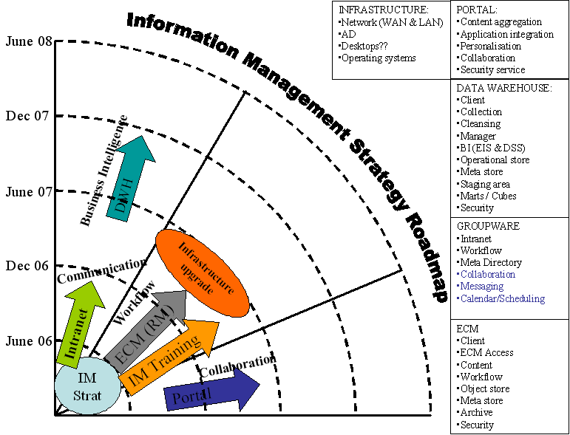
- Information Management Roadmap

Why a Roadmap is Needed for Technology Adoption
We do not know to what extent meaning of this strategy might be captured in a "Semantic Repository."¹ We have not experienced anything that informs about what semantic technology might become within the department. But relevant issues in linguistics, social theory and the nature of science are not well known in components of computer science. Most of computer science today is still shaped by engineering theory and scientific reductionism.

A roadmap is therefore needed. One is provided here by a group of enterprise architects and not mathematicians. This roadmap is proposed to ensure that the recommendations of this report gets attention in the future. It is a small part of a larger plan to eventually establish knowledge science within the department.

We propose a broad program to establish the information intellectual and technology foundation as part of the implementation of the science of knowledge management systems the next phase of information management, and to integrate and deliver to information science based on the proper use of what is called "machine-encoded ontology” (An ontology is a specification of a conceptualization) We refer to these as ontological models or models of ontology. (That is, ontology is a description (like a formal specification of a program) of the concepts and relationships of information management that can exist for an unit or a programme within the department.)

Phase 1
- Technology integration

Phase 2
- Advanced knowledge management certification
- Ontology development

Our proposed roadmap therefore addresses these parts one at a time.
The first part depends on having completed a principled selection of advanced knowledge management systems, semantic extraction data persistence systems. In each case, an in-depth description of each technology component is needed.
Beyond the first deployment of information management, the concept of a knowledge sharing foundation is proposed and should be readied as a "red hat" type business model.

Overview of the Development of a Roadmap
A human-centric information management capability is defined and existing software identified as part of the final recommendation. A distributed information environment is proposed that will enable the real-time representation and sharing of information and human knowledge about situations and solutions within the department. This “global” information framework will be used as a human controllable interface over complex ontology information and knowledge management.

Example: Aircraft landing at a specific airport will express behavioral patterns. An airport ontology and aircraft-landing ontology is used to provide an interpretation of the behavioral patterns expressed in each landing. Over time, the observed behavioral patterns lead to early diagnosis of risks. A human looks at the patterns and makes judgments based on personally held tacit knowledge. New concepts about the patterns are encoded as meta data. The patterns themselves are encoded as new behavioral ontology reflecting the history of observations about aircraft landing at a specific airport.

Inputs come from any reporting software system or manual action. An example is a request from a client department and targeted operations or administrative rulings within the department. Inputs can be developed from any event or reporting mechanism, whether manual written reports or computer generated reports that involve the development or modification of the technology ontology including information structures.
Outputs include a computable and visualable historical record about situations reported through the information structures. The record is expressed as part of the information ontology, and human visualization of this record of information that is provided.

Visualization of graphical information structure requires human perception to evoke an experience of knowledge about a specific operational situation or an event within the operational space. Graph labels suggest meaning in much the same way as sentences suggest meaning when humans compose sentences as part of a conversation.

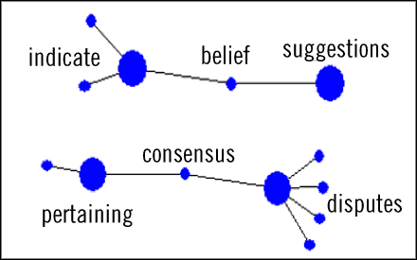
- Visualization of Concept Indicators in a Collection of Fables

Language dependence is not fully achieved, for reasons that have to do with differences between natural languages. Each natural language has language-dependent characteristics. In principle, technology establishes a foundation for using ontological models having correspondences to sets of concept representations.

Ontological models are envisioned as being a type of "interlingua" - not of words composed in grammar, but as systems of information management that are interpreted by humans in. natural language settings.

Ontological models provide meta data that indicate where possible misunderstanding might occur, ontological information models provide a complex formalism to help in the translation and transcription of meaning within the information and knowledge management ambit while the information structure defines the sets of concepts. So that logical models can be developed about the more complex subjects of information, such as the intentions of a determined enemy to bring elements of bioterrorism into the community.

Our proposed recommendation and suggested deployment takes this ontology of technologies and integrates them in a roadmap. We also add a data mining process where fast search transforms have a formulation as well as operational realisation of these transforms as precise data retrieval methods.

The following are the long-term design objectives for the department:
- Improve the quality of analysis and utility of complex information intelligence;
- Provide specific and tailored intelligence to enhance the ability to visualize the operational spaces, and ensure total operational awareness;
- Improve the throughput and speed of delivery of required services;
- Reduce or eliminate unnecessary redundancy and duplication of information in the organisational units of the department;
- Strengthen information and production management and ensure policies, procedures, concept development, training and technical-human engineering;
- Establish and integrate standards (based on mandated community standards/architectures) for commonality, interoperability and modernisation in coordination with appropriate community development elements and activities;
- Explore and examine advanced technology and concepts for future integration;

- Terms, definitions, acronyms and abbreviations
  - Acronyms & abbreviations
BAR | Business Application Requirements
BCR | Business Change Requirements
BI | Business Intelligence
BIR | Business Information Requirements
BSD | Business Strategic Drivers
CIO | Chief Information Officer
CRM | Customer Relationship Management
CRV | Common Requirements Vision
EA | Enterprise Architecture
EIA | Enterprise Information Architecture
EPMO | Enterprise Programme Management Office
ERP | Enterprise Resource Planning
ITR | Information Technology Requirement
KM | Knowledge Management
MIS | Management Information Systems
DPW | Department of Public Works
- Discussing the Approach to formulate the Information Management Strategy

  - Introduction
A pragmatic approach was taken to formulate the Information Management (IM) Strategy for Public Works (DPW), to ensure that all the factors that can and will influence IM in DPW are identified and analysed. This was done to increase the possibility of the successful adoption and use of IM in DPW.

The high level approach to formulate the IM Strategy is presented in (Figure 20), which provides the outline of the strategy and identifies the interaction with thought leaders in DPW to attain consensus on the project approach. The IM Strategy for DPW will be formulated in five-phased approach with sixth phase as the implementation of IM in DPW.

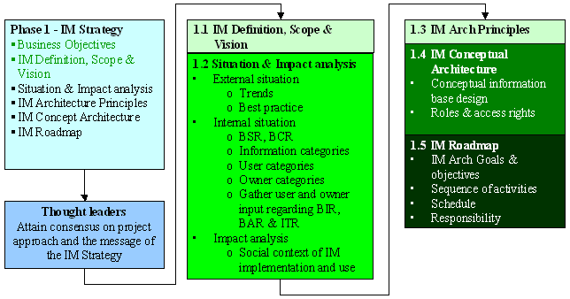
- Information Management Strategy Approach

Stage 1 – Information Management Definition, Scope and Vision
In order to address the question of IM in DPW, it would be appropriate to discuss the various terms and definitions in the realm of Knowledge Management (KM). These terms and definitions will be used as the foundation for the scope of the strategy and further discussion. The scope of the IM Strategy will be formulated, taking the terms and definitions into account, together with theory of KM.

The Vision for IM in DPW will be formulated as the desired end-state that should be reached when all the requirements for IM in DPW are satisfied. The vision will be the foundation for the architecture principles that will be formulated.

“A vision is a realistic, credible, attractive future for your organisation. A brief statement of where and what the organisation would like to achieve and be and how it intends to get there.”

Stage 2 – Situation and Impact analysis
The current situation of IM in DPW will be determined. Factors internal to DPW, that has or could impact the adoption and use of IM in DPW, will be identified. The requirements for IM in DPW and existing information, processes and technology in DPW will be analysed as part of the internal factors.

The different artefacts of the contextual layer of the DPW Enterprise Architecture (EA) Framework (Figure 16) will be used to define the context of IM internal to DPW. This layer of the framework consist of two major parts:
- Strategies and Trends
- Common Requirements Vision (CRV)

Industry trends and best practice regarding IM will be analysed to determine the current situation of IM, external to DPW. Best practice will be applied where applicable to assist in the adoption and use of IM in DPW. Trends will assist in determining possible approaches to IM adoption and use in DPW.

The different stakeholders in DPW in terms of IM will be identified to start with the analysis of IM internal to DPW, in order to identify all relevant information, processes and technology that contribute or that could contribute to IM in DPW.

Further, the situation of IM internal to DPW will be determined by analysing the Business Strategy of DPW, to determine the business strategic and business change requirements. This must be done to ensure a business drive for IM, instead of a technology push.

The Common Requirements Vision (CRV) will be determined, as part of the internal situation of IM in DPW, by considering the results of the Internal DPW EA project in conjunction with the Information Strategy. The requirements of these projects must be examined and confirmed during workshops and interviews with the different stakeholders in DPW.

The CRV will be determined by combining the following:
- Business Strategic Requirements
- Business Change Requirements
- Business Organisational Requirements
- Business Information Requirements
- Business Application Requirements
- Requirement for Technology Infrastructure
- Business and IT Organisation Requirements
- IT Governance

The impact of the current situation of IM in DPW, and IM external to DPW have been evaluated in terms of the factors that may or will influence the adoption and use of IM in DPW. Therefore the indicators in the impact analysis is important to determine what change management should take place to ensure successful adoption and use of IM in DPW.

- DPW EA Conceptual Framework – Context Only
For the details of the Impact Analysis see (Figure 12).
The factors that will be used in the impact analysis to evaluate the current situation are:

Stage 3 – Information Management Architecture Principles
With reference to the DPW EA Framework, the architecture principles for IM will form the first part of the conceptual layer of the framework (Figure 21).

IM Architecture Principles are statements of basic beliefs about the long term use IM, that are selectively adapted from internationally accepted best practice to provide a holistic, cohesive direction and governance by which to establish, manage and sustain IM in DPW. Guidelines that will be used in the formulation of the IM Architecture Principles are:
- its not a principle if it does not cost.
- it constrain freedom.
- represent the outcome of a tough choice (should be able to argue the converse).
- it takes courage.
- test with retrospect

- DPW EA Framework – Conceptual Architecture Principles

Principles should pass the ACID test, meaning that principles should be:
Articulate - well crafted
Consequential - actionable
Informative - better than opposite
Defensible - good reason

Stage 4 – Information Management Conceptual Architecture
The IM Conceptual Architecture will define the realisation of IM that will justify future investment in people, processes and technology. It is essential that the IM Conceptual Architecture fully reflect the Business Drivers and BIRs for IM, the Vision and the application of the IM Architecture Principles. The resulting conceptual architecture will become the “Definitive Investment Framework” for IM in DPW.

The IM Conceptual Architecture will define the basic components that are required to constitute IM in DPW. The concepts will be expressed in terms of the Conceptual Architecture Models in the DPW EA Framework (Figure 19).

- DPW EA Framework – Conceptual Architecture Models
The dependencies and relationships between the models of this layer of the EA Framework will be provided, as essential parts for the adoption and use of IM in DPW. The models that will be addressed are:
- Business Models
- Value Network
- Conceptual Information Architecture
- Conceptual Application Portfolio
- Conceptual Technology Models
- Conceptual Organisation Models
- Governance

Stage 5 – Information Management Roadmap Considering the EA
At this point the contextual and conceptual layers of the EA Framework will be addressed for IM in DPW. The logical and physical layers of the EA Framework will not be addressed as part of the IM Strategy. However, goals and objectives will be formulated for future action to be taken to address the logical and physical layer of the IM Architecture of DPW.

Goals and Objectives for the realisation of the IM Conceptual Architecture will assist in managing the problem, of the adoption and use of IM in DPW. Expressing a number of goals, each goal with a number of objectives, and each objective with multiple tasks. The required finance and time for each task will be identified.

Goals express the desired final outcome; it is the ends towards which activities are aimed. Goals define what, not how. Goals must be within control, result orientated and meaningful. Goals are realised by a hierarchy of Objectives, which must be SMART:
Specific
Measurable (outcome)
Achievable
Reward / pay-off
Timing
The goal structure will contribute to the Roadmap for the realisation of the IM Conceptual Architecture. Four actions contribute to constitute the Roadmap:
- Specific actions to be taken in the immediate short-term.
- Clear time frame for completion
- Identify the outcome of each action
- Assign responsibility for the execution of specific parts of the roadmap

Specific actions, the time frame and desired outcome are specified as part of the IM Goals and Objectives. Responsibility will be assigned for the different tasks and the priorities and sequence of the tasks will be determined. This will enable the team to determine the cash flow requirements, which would be needed for the approval of funds.

The Roadmap will have to be approved at the Exco to authorise further action and to assign resources to the plan. At this point the formulation of the IM Strategy would be completed.

- DPW Current Architecture

DPW Current Business Architecture

DPW Proposed Current Value Chain

- DPW Value Chain

Strategic Planning Process
The Strategic Planning Process is the process that depicts the flow of the strategic planning activities. Its output governs the solution delivery part of the value chain.

Executive Management
- Internal Information Requirements
  - The previous Strategic Plan.
  - Departmental Financial Performance.
  - Performance per service.

- External Information Requirements
  - Legislation
  - Social Demands
  - Political
  - Technology
  - Economical
  - Client Requirements?
  - Best Practices
  - Market Industry Information
  - Supplier Requirements

- Information Output (Strategic Guidelines)
  - Financial Indicators
  - Budgets and Expenditure
  - Service Indicators
  - Strategic Plans
  - Operational Requirements
  - Norms, Standard and Policy Requirements

Senior Management
- Information Requirements
  - Strategic Guidelines
  - Service Detail
  - Service Rules and Regulations

- External Requirements
  - Political
  - Technology
  - Economical
  - Financial Guidance
  - Social
  - Client Requirements?
  - Best Practices
  - Market Information
  - Supplier Requirements

- Information Output
  - Programme Strategy
  - Strategic Objectives
  - Budget Needed
  - Services Delivered
  - New Requirements

Notification/Identification
This really is the first process in the value chain as part of the actual solution delivery. This process highlights the steps to identify service requirements. Sources are the request or notification of a social need, news paper articles, personal engagement through client facing employees.

Engagement
- Information Requirements
  - New request Info from existing or new client.
  - Modification of Services Delivered.
  - Services Information – to compile recommendation.
  - Notification of Service Requirement.

- Information Output
  - Updated Client Information or New Client Information.
  - Service delivery Proposition.
  - Terminated Services.
  - Services Delivered.
  - Registered Request.

Project Qualification
Engagement
- Information Requirements
  - Pro-active information (Predictions).
  - Budget/Expenditure.
  - Re-active information (Notifications Received).
  - Client Information.
  - Current Services Rendered.
  - Decision Criteria.
  - Severity of Current Request/problem.

- Information Output
  - Request analysis.
  - Implementation plan.
  - Expense Forecast.
  - Technology requirements (Business plan).
  - Qualified decision (Yes/No).
  - Risks.
  - Resource requirements.
  - Up front costs.
  - Imbursement Cash flow.
  - Go/No go decision Motivation

Response
- Information Requirements
  - Qualified request detail.
  - Board resolution.

- Information Output
  - Completed recommendation.
  - Service specifications.
  - Legal evaluation.
  - Approval documents.
  - Cover letter.

Implementation
- Information Requirements
  - Qualified request detail.
  - Client Detail.
  - Board resolution.

- Information Output
  - Completed recommendation.
  - Service specifications.
  - Periodic Monitoring and Evaluation Report.
  - Change Approval documents.
  - Cover letter.

Service Management
- Information Requirements
  - Qualified request detail.
  - Responsibility Matrix.

- Information Output
  - Recommendation on Changes.
  - New Service specifications.
  - Legal implications.
  - Approval documents.
  - Cover letter.

Termination
- Information Requirements
  - Qualified request detail.
  - Board resolution.

- Information Output
  - Completed Recommendation.
  - Further Client Requirements.
  - Legal evaluation.
  - Approval documents.
  - Cover letter.

DPW Flat View of the Current Organisational Structure

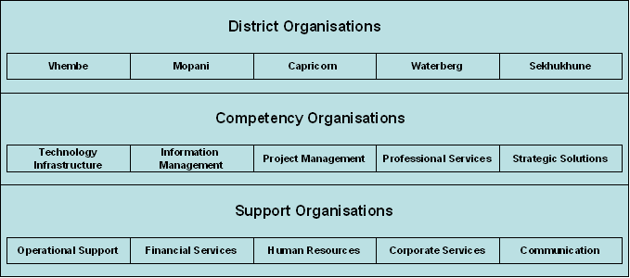
- Public Works Organisational Units

The breakdown of the different competency centres and corporate services are as follow:

Competency centres
- Technology infrastructure
  - Networks
  - Support Services (PC & Servers)
- Information Management
  - ECM
- Professional services
  - CAD
- Project Management
- Strategic solutions
  - GIS

Support Services
- Corporate Services
  - Business Standards Management (BSM)
  - Internal audit
  - Legal
  - Facilities management
- Financial
  - Corporate financial services
  - Payroll
  - Payroll finance
  - Risk management
- Human Resources
  - HR Admin
  - Employee relations and reward training
  - Training, development & recruitment
  - Transformation
  - Wellness Programme
- Marketing and Communication
  - Corporate marketing
  - Corporate social
  - Internal communication
  - External communication
  - Group marketing

Summary of the current information architecture
From the information architecture that was provided, it can be concluded that the following information will be supplied to and requested from the IM Applications.
- External requirements
- Previous engagement information
- Discontinued opportunity information
- Submitted responses
- Signed contacts

The breakdown of the information is as follows:

- External requirements
  - Supplier requirements
  - Political
  - Technology
  - Economical
  - Social
  - Competition Information
  - Client Requirements
  - Internal and External Best Practice
  - Market / Industry Information

- Previous Engagement Information
  - People
  - Response
  - Best practice

- Discontinued opportunity information

- Submitted Response
  - Authorised response
  - Approval documents
  - Responsibility notes
  - Response and cover letter
  - Resource requirements

- Signed Contract
  - Contract number
  - Contract date
  - Parties involved
  - Contract end date
  - Legal entities
  - Description of service to be delivered
  - Description of product to be delivered

Current Application Portfolio

The following is a classified grouping of applications currently used within the department.

S No. | Application Classification | Product | Components | Organisational unit
1. | Customer Management System |  | - Contract register  - Forecasting  - Account Details  - Contracts  - Opportunities Management
1. | Customer Management System | MS Project | Managing Projects
1. | Customer Management System | BAFMIS
1. | Customer Management System | CAD | Building Planning
2. | Financial Applications |  | - Financial  - Logistics
2. | Financial Applications | BAS | - Project Costing  - Accounting  - Assets
2. | Financial Applications | Microsoft Excel | General Accounting
3. | Human Resource Applications
3. | Human Resource Applications | PERSAL | - Payroll  - HR Management
4. | Web based applications | INTRANET
4. | Web based applications | INTERNET
5. | Document management
6 | Commercial Off the Shelf | MS Office 2000 / XP | - Word  - Excel  - Access  - Power Point  - Outlook
6.1 | COTS | MS Project | - Projects
 |  | MS VISIO | - Graphics
7. | Network Support Applications | Anti Virus
7. | Network Support Applications | SMS

Table 4 Current Applications

- Evaluation of the Information Management Practices in the Department of Public Works

Evaluation of the Information Management Practices in the Department of Public Works with the Information Management Best Practices Opportunity Model
The appropriate selection is indicated by (X)
- Understand the importance of improving Information Management Practices.
1

2

3

4 X

c5

Fully Understand

Partially Understand

Do not understand

- Involve Management and Staff to Create Ownership in Information Management.
1

2

3

4

5 X

Always Involve

Sometimes Involve

Never Involve

- Develop plan for achieving information management best practices.
1

2

3

4

5 X

Have Developed
In Process

Have not developed

- Create and Maintain a Set of “Blueprints” to Build an Integrated Information Environment.
1

2

3

4

5 X

Exists and are maintained

In Process

Does not exist

- Link Mission with Information Initiatives and Measure Performance of Improved processes.
1

2

3

4

5 X

Are Linked and Measured

In Process

Not Linked or Measured

- Improve Processes in the Context of the Information Architecture.
1

2

3

4

5 X

Have Improved

In Process

Have not Improved

- Allocate Appropriate Effort and Resources to Reflect the Useful Life of Each Information Investment.
1

2

3

4 X

5

Have Allocated

In Process

Have not Allocated

- Link the Planning, Budgeting and Evaluating Processes to the Information Architecture.
1

2

3

4

5 X

Are Linked

In Process

Not Linked

- Maintain Information Data as a result of Daily Work.
1
2
3 X
4
5
Always Maintained
Sometimes Maintained
Not Maintained

- Upgrade Skills and Knowledge of Managers and Staff on Information Management through adequate training.
1
2
3
4
5 X
Regularly Upgraded
In Process
Not Planned

The score for DPW = 46

Opportunity Comparison Table
46
92%46
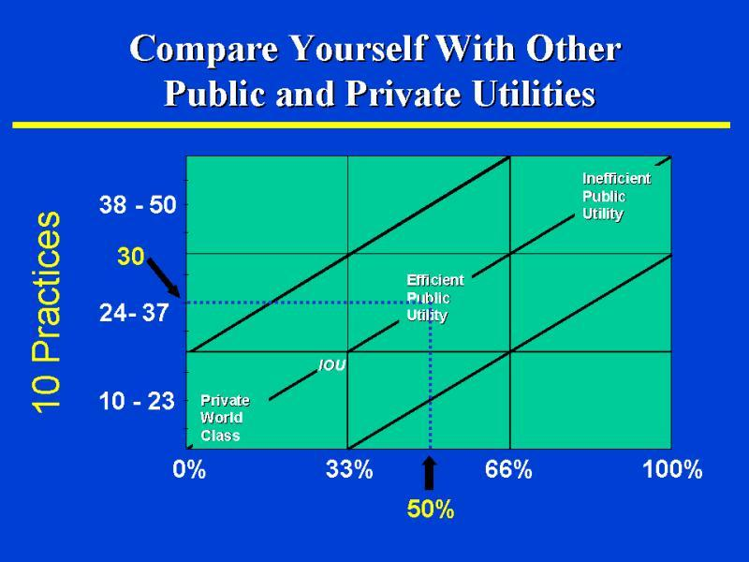
- High Level IDEF0 Processes

  - State Land Management

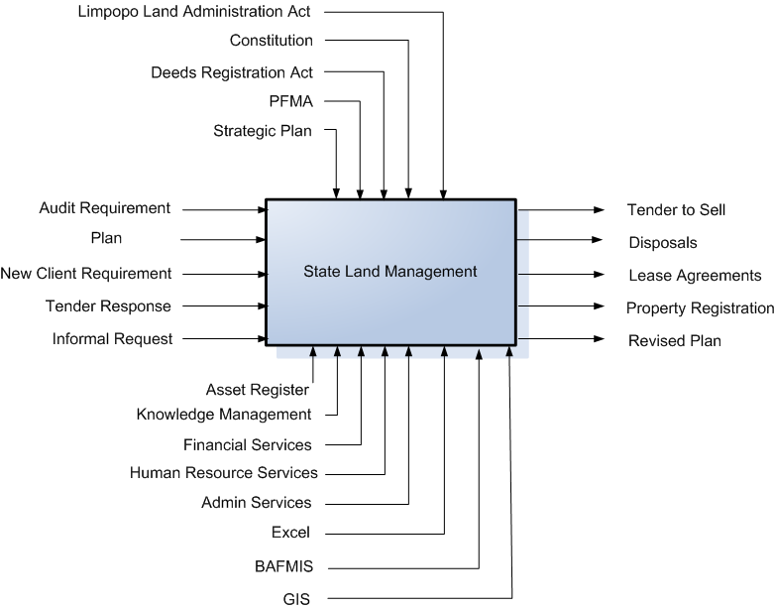
- State Land Management

It must be understood that any one process deals with people in terms of responsibility and information, the information required for the execution of a process could be classified as:
- Governance or Legislated information
- Input Information
- Support Information
- Output Information as well as the processing information.

For that reason the high level processed will indicate these four types of information requirements.

From this high level process flow the lower level processes and information requirements for the business unit of State Land Management. Similar processes must be developed for each business unit to complete the information analysis phase for the formulation of the information management strategy.

The processes must be classified into service delivery processes, district service support processes, head office service support processes and other administrative processes.

  - Professional Services – Electrical and Mechanical

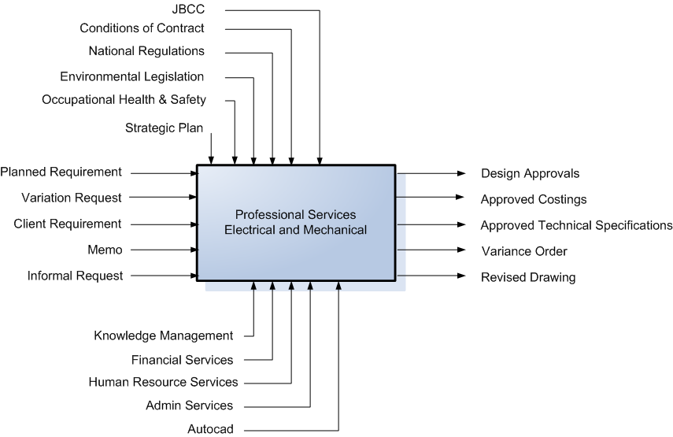

- Professional Services – Electrical and Mechanical

  - Property and Facilities Management

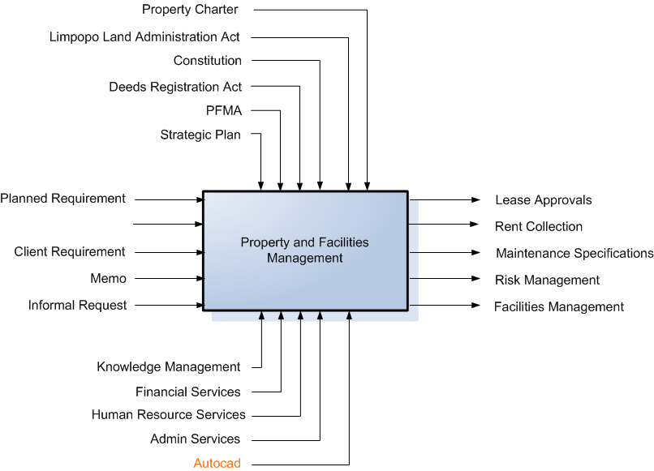

- Property and Facilities Management

  - Building Maintenance

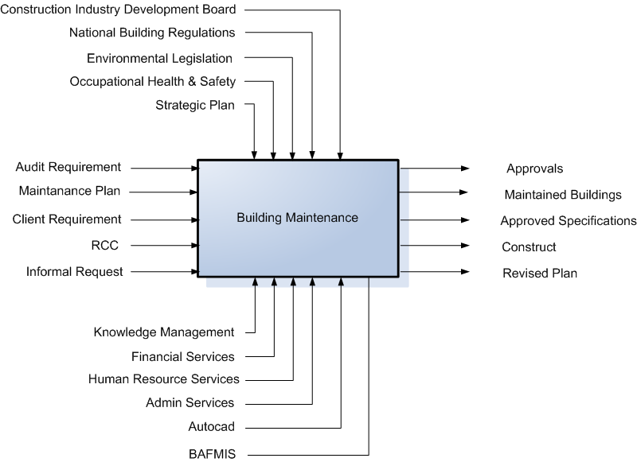

- Building Maintenance

  - Project Management

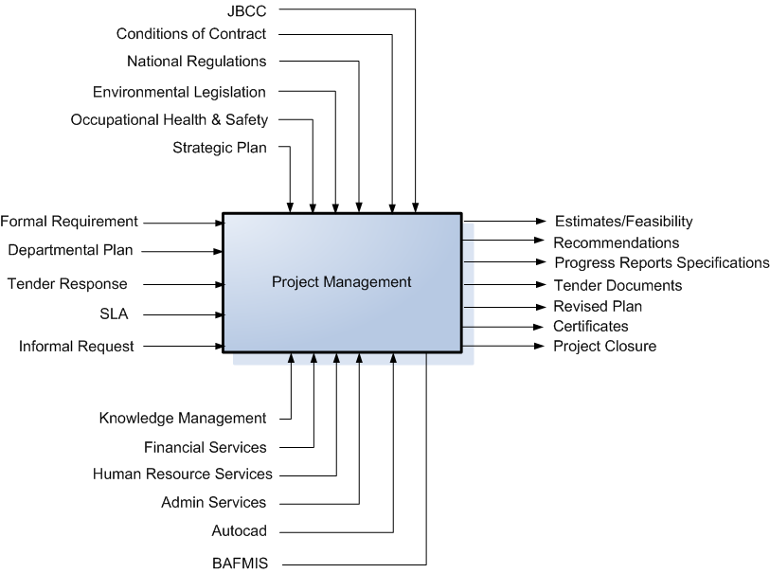

- Project Management
  - EPWP

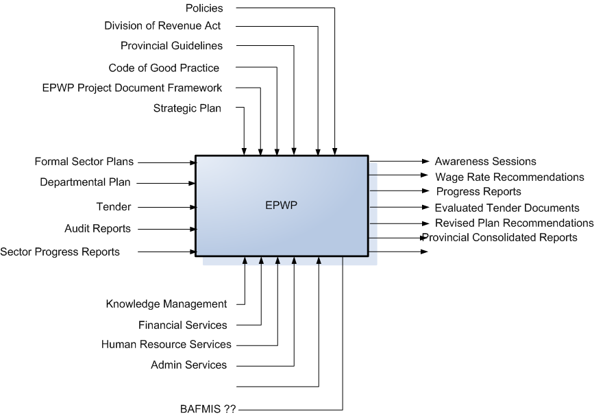

- EPWP

  - Skills Development and Performance Management

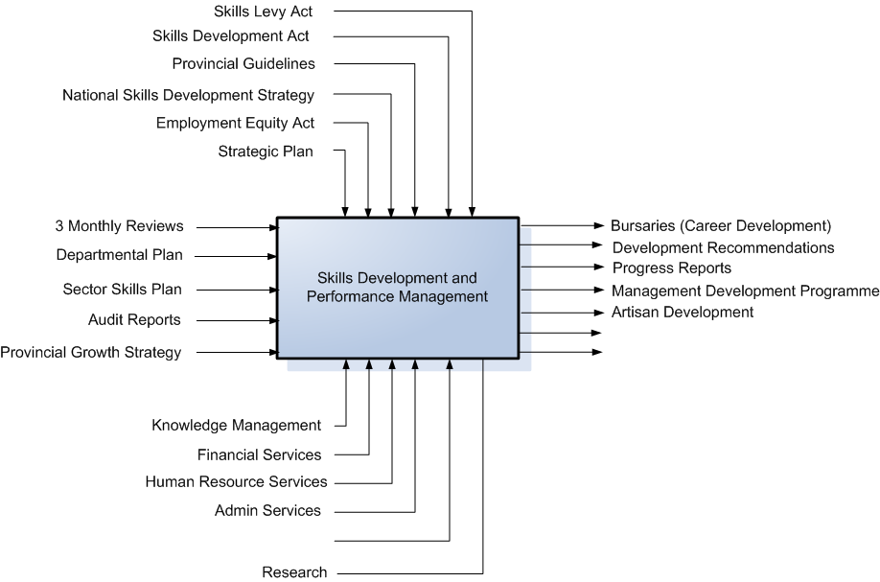

- Skills Development and Performance Management

  - Risk Management

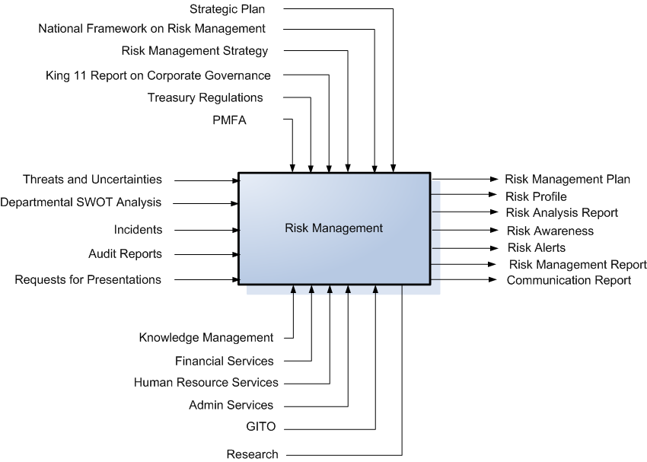

- Risk Management

  - Service Delivery Improvement

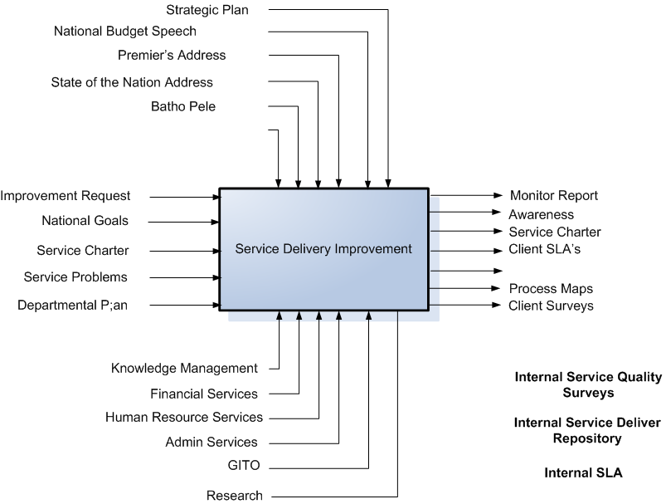

- Service Delivery Improvement

  - Building Maintenance (Districts)

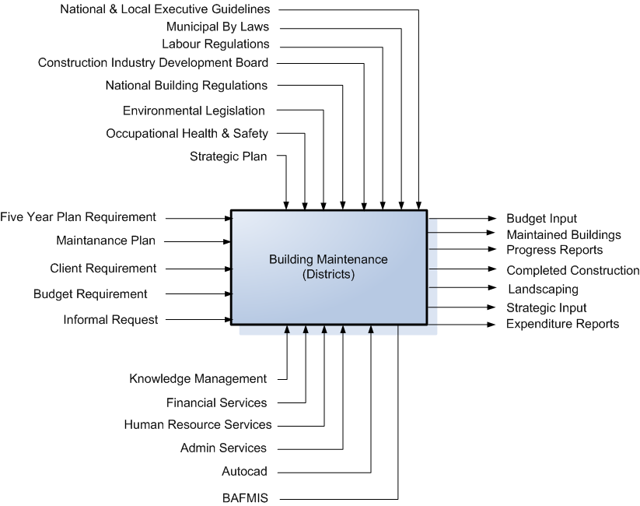

- Building Maintenance (Districts)

  - Strategic Planning

- Strategic Planning

  - Financial Management

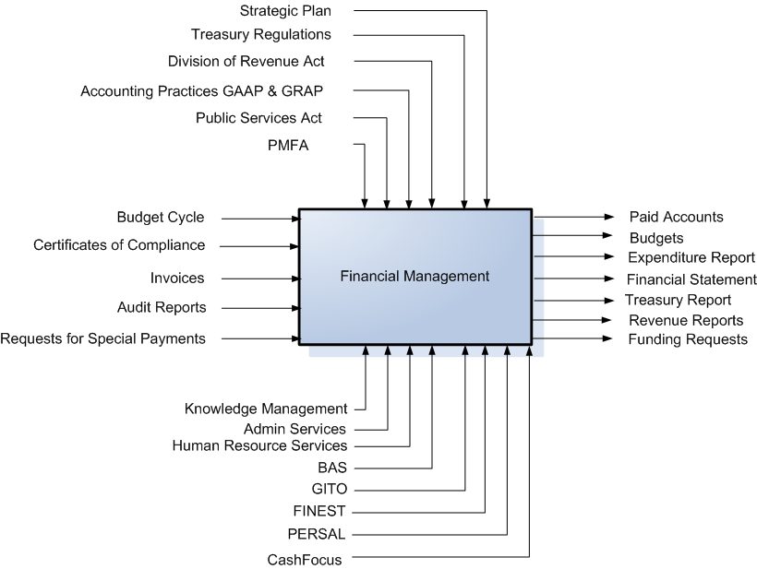

- Financial Management

  - Real Estate (GM)

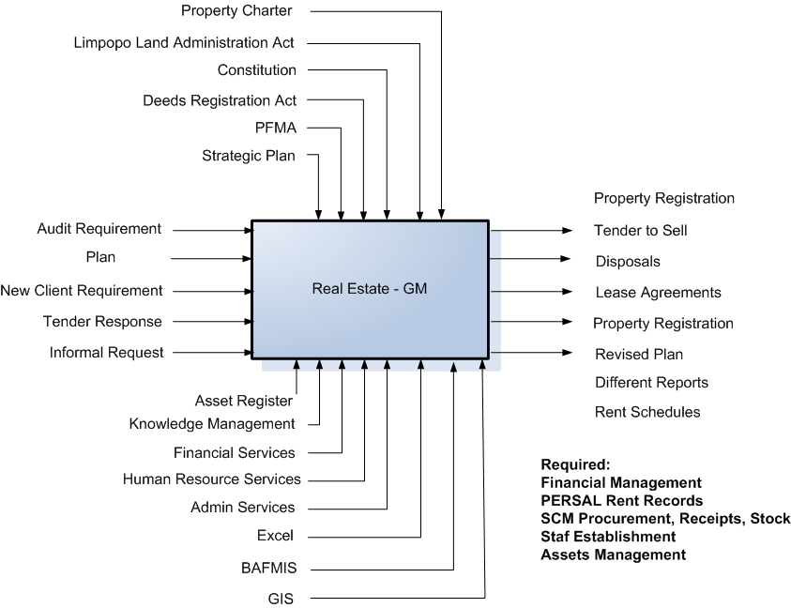

- Real Estate (GM)

  - Maintenance (Buildings)

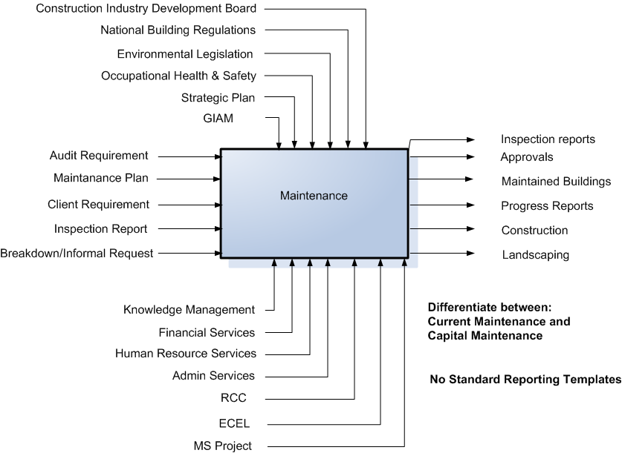

- Maintenance (Buildings)

  - Human Resources

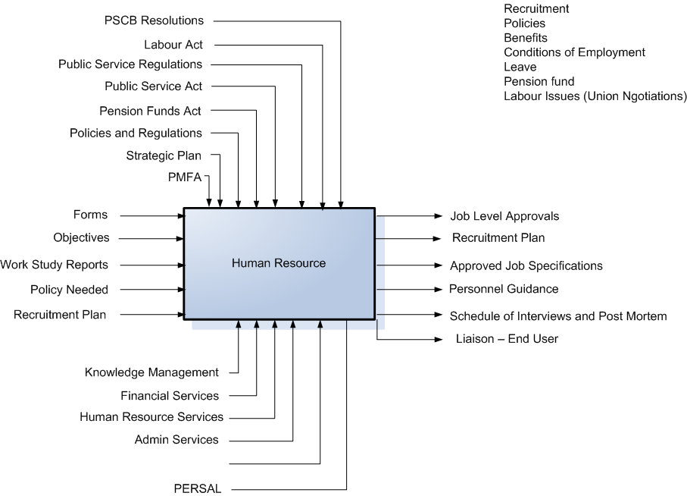

- Human Resources

  - Wellness Programme

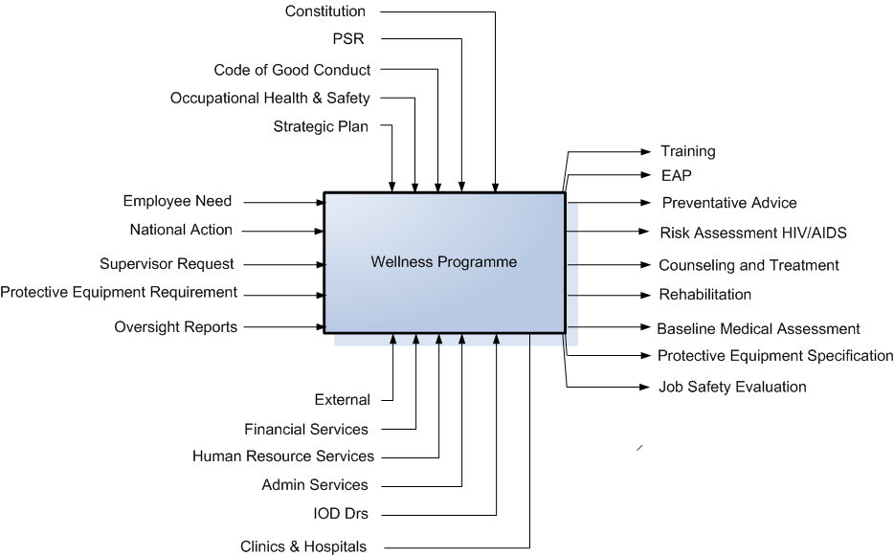

- Wellness Programme

  - Corporate Services (GM)

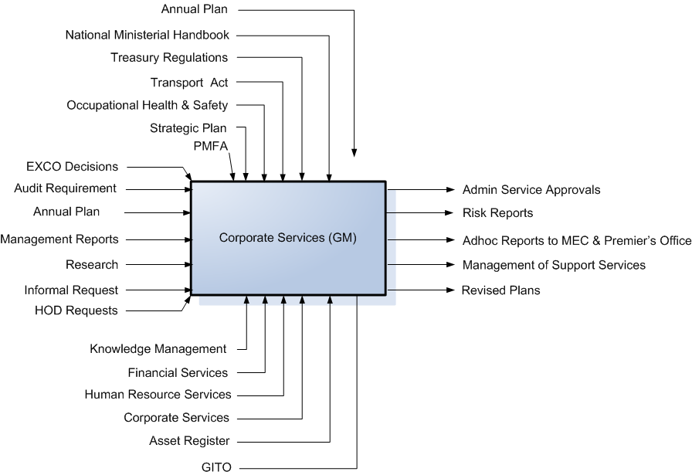

- Corporate Services (GM)

  - Transport

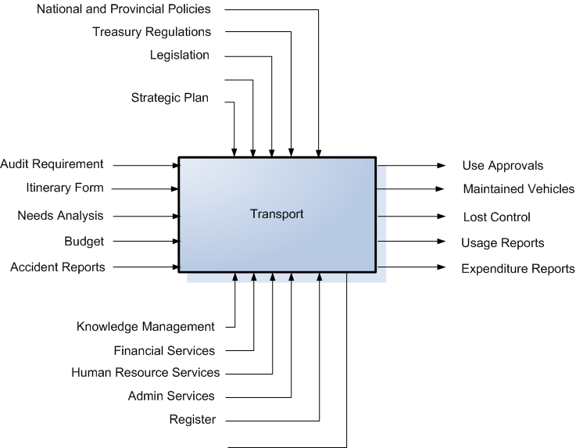

- Transport

  - Office Services

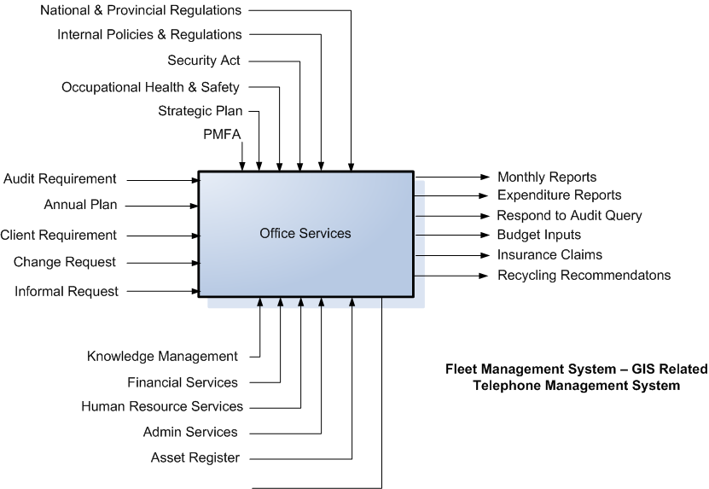

- Office Services
  - Shared Services

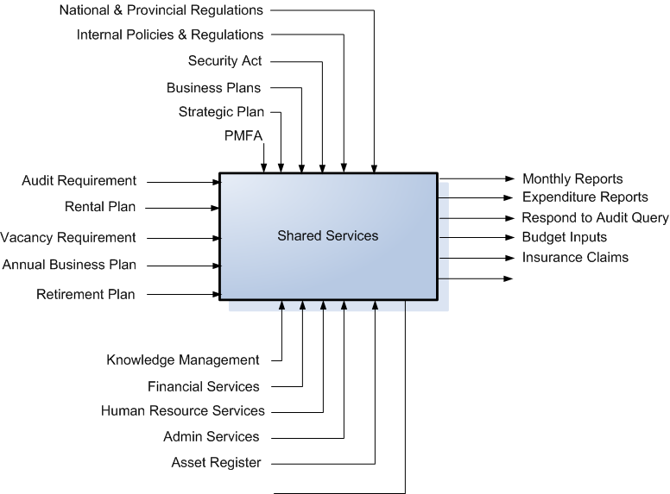

- Shared Services

  - Real Estate (Districts)

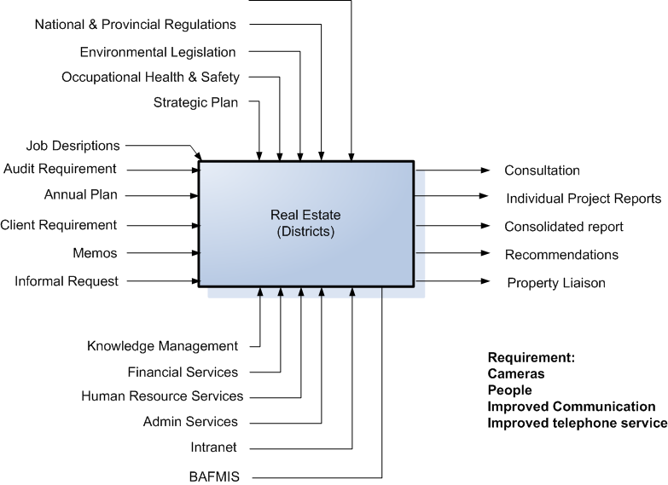

- Real Estate (Districts)
  - Supply Chain Management

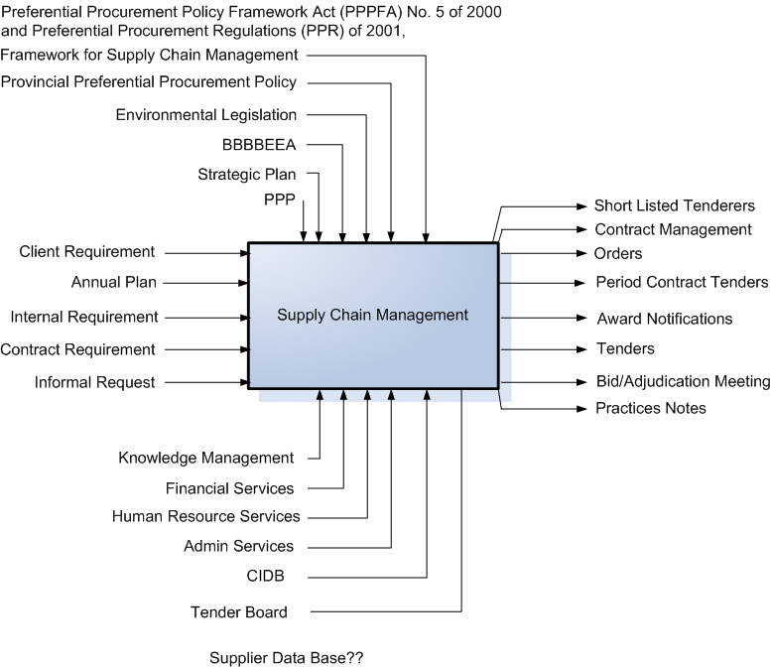

- Supply Chain Management

  - CFO

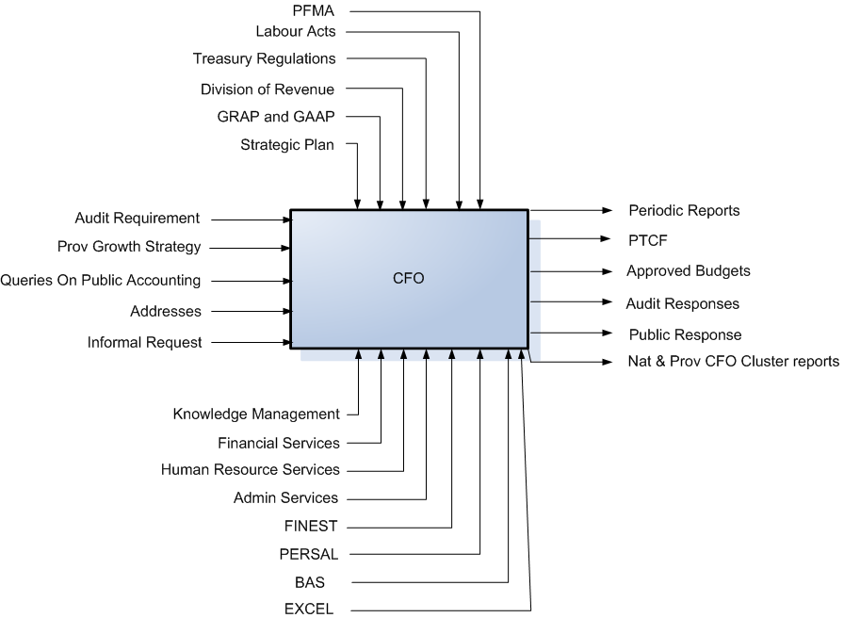

- CFO
  - Professional and Project Management (GM)

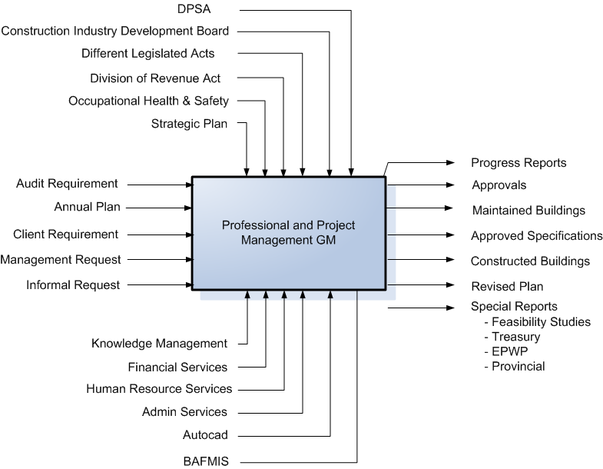

- Professional and Project Management (GM)

  - COO

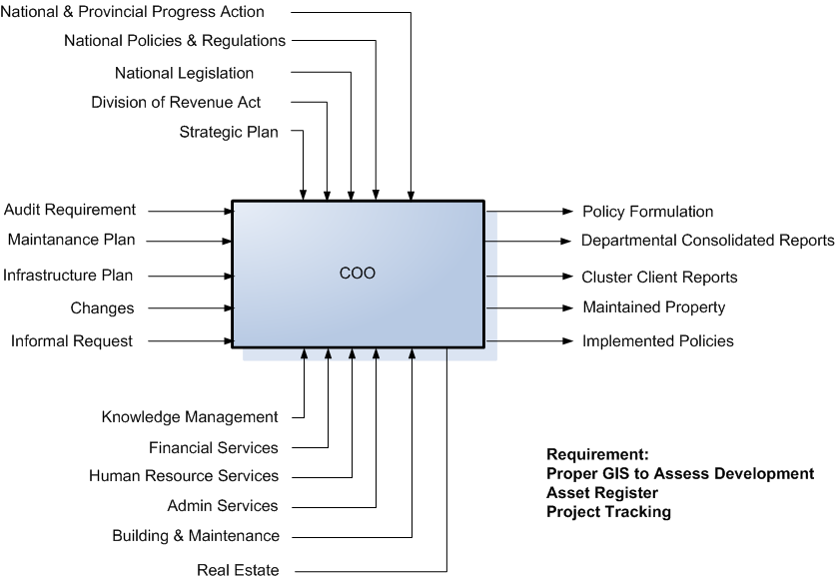

- COO

  - Infrastructure Support (Finance)

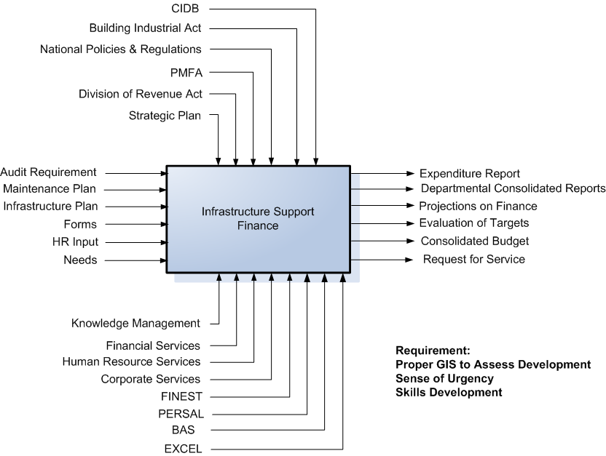

- Infrastructure Support (Finance)

  - Infrastructure Support (Other)

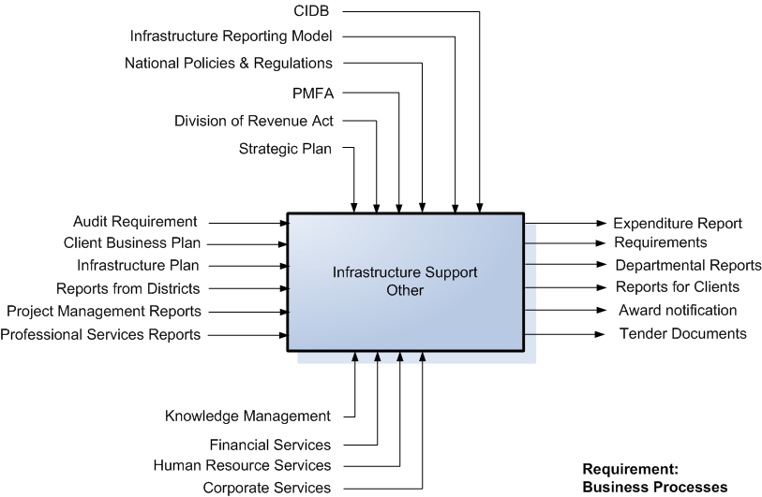

- Infrastructure Support (Other)

- Proposed Organisational Structure for Information Management Function

IM structure in the Department
The Information Management and Records Management function has very good leadership and consists of a knowledgeable and motivated IRM team. However, a IRM culture as part of a departmental general management function has to be developed.

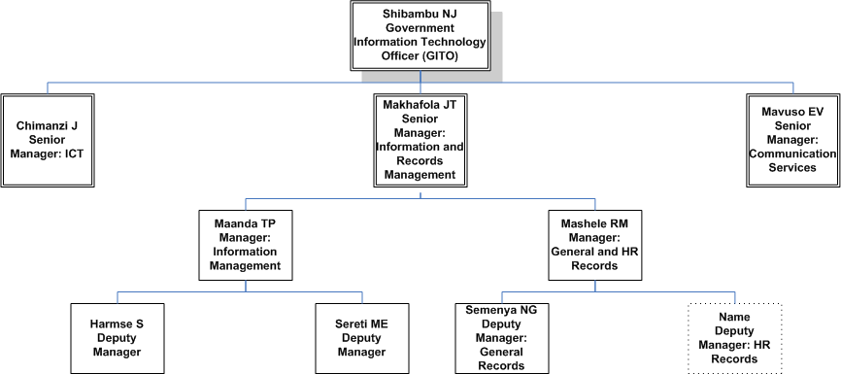

- Current Organisation Structure for IM function

If a wider range of IRM services is to be deployed, such as updating information at regular intervals and making it available to stakeholders based on security clearance and a need to know basis through the use of warehousing and business intelligence tools additional IRM skills may be needed at head office and the districts. The possibility of deploying IRM specialists to serve line functions should be taken into account.

On district level it has been indicated that very little formal IRM skills are currently available.
The current structure of the IRM Programme may also have to be reviewed in terms of personnel and functions when a wider range of IRM services are being put on offer. This, like the enhancement of IRM services, will have an impact on the IRM budget.

To be able to meet with the demand of a changed information management environment due to the implementation of the newly formulated strategy the organisational structure of the current function will have to be adopted.

The following structure represent a possible new information management structure for the department.

- Proposed Organisation Structure for IM function

The roles for a possible new structure:

- Senior Manager Information and Records Management:
- Is the Department’s Senior Information Management professional.
- Is responsible for the leadership and management of a range of IM services to staff of the department.
- Ensures availability of information technology systems and operations, including IM contingency planning, to support the Department’s Information management and business operations.
- Ensures that appropriate procedures are in place for information authorisation of national security systems.
- Implement a departmental wide Information Architecture.
- Ensures the existence of a classification system for organisational records.
- Ensures the existence of a file plan
- Ensure the development of records schedules
- Provide overall records management guidance

- Information Development:
  - Information Analyst:
- Web site creation and maintenance.
- Installation, maintenance, and troubleshooting for computer system and networks.
- Information maintenance/data entry.
- Development of information sources and acquiring information.
- Creating and maintaining relational databases.

  - Information Designer:
- Design and develop effective online and print documents.
- Assist in analyzing and interpreting project needs; create, structure, design and publish documents, determining scope and content; gather and verify source data; use and develop appropriate structures for web publishing, user manuals, instructional brochures and other vehicles; maintain communication and coordinate with team members throughout project on information requirements.
- Assist in producing documents for a variety of media.
- Proofread and edit materials, applying commonly recognised editing and publishing standards to discrete elements of a document as well as assessing organisation, cohesion and effectiveness of documents; shape content to ensure consistency of publications within the department.

  - Information Advisor (Strategy Officer?):
- Assist in the development and coordination of Information and Communication Technology policy and strategy at all levels throughout the department.
- Key responsibilities include institutional liaison, consultancy and review associated relationships with every aspect of information management service provisioning and strategy.
- Provide advisory services on information and related strategies.

- Technical Information and Data Quality:
  - Technical Information Officers:
- A detailed knowledge of information systems, their threats, vulnerabilities and associated risks.
- Provide technical guidance on capturing, storing and disclosing of information
- Assist with the improvement of the technical management of information
- Provide the rules and regulations regarding the disposal of information
- Define the quality criteria for information

  - Performance Evaluation:
- Define activities and processes that would contribute to the efficiency and effectiveness of information
- Define the performance criteria to measure the quality of information
- Define automated processes that would that would capture assessment criteria
- Define overall technical performance criteria for information flows

- Enterprise Content Management:
  - Records Management:
- Responsible for arranging, describing, preserving and providing access to Public Works records.
- Manages archives and records center.
- Regularly deals with confidential information; communication content frequently pertains to public information, managerial and administrative actions; information managed requires the application of appropriate judgment, discretion and adherence to professional code of ethics.
- Designs information delivery systems.

  - Content Managers:
- Provide content management support.
- Ensure the quality and integrity of the content of documents
- Ensure the submission/delivery of documents
- Ensure that information contained within each document is accurate, peer reviewed and regularly updated

  - Governance:
- Ensure interoperability and interchange ability of data/information through defining the required standards
- Define controls for the business intelligence environment
- Ensure the effective maintenance and implementation of the information architecture
- Ensure the development of an information asset discipline
- Ensure the development and effective management of a metadata directory.

- Summary of the Completed Questionnaires

- Amendment History

Revision | Date | Change request no | Paragraphs changed
1.A | 2006/04/22 | N.A. | New document
- Annexures

Annexure Number | Document Name | Document File Name

- Distribution List

Name | Revision | Copy Number
- Public Works Approval Page
<name>  Executive Manager |  | Date and time
<name>  Divisional Manager |  | Date and time

- Client Approval Page
<Add or delete signature list as required, Name, title, date and time of signature.>

<name>  Executive Manager |  | Date and time
<name>  Divisional Manager |  | Date and time

