Project Charter & Plan

Department of Public Works – Information Management Strategy

Document No: | SQSD-00093
Revision: | 01
Author: | Jeannette Kirk
Effective Date: | 2006-01-25
Electronic File: | input.doc

© 2001 SITA. All rights reserved.
No part of this document may be reproduced or transmitted in any form or by any means
without the express written permission of SITA.

Document enquiries can be directed to:
Professional Services
SITA (Pty) Ltd. P.O Box 26100, MONUMENT PARK, 0105, SOUTH AFRICA

Attention: Jeannette Kirk - Jeannette.Kirk@sita.co.za
Telephone: 015 291 8001/ 083 376 6825

Approval
The signatories hereof, being duly authorised thereto, by their signatures hereto authorise the execution of the work detailed herein, or confirm their acceptance of the contents hereof and authorise the implementation/adoption thereof, as the case may be, for and on behalf of the parties represented by them.

Project Manager: Jeannette Kirk |  | Date
Tshidi Makhafula |  | Date

Foreword
1. This document forms part of project-related documents, in terms of forming part of the project life cycle. The document is intended to outline the project charter and plan for the Department of Public Works – Information Management Strategy
This document is applicable to the Department of Public Works (for action and information).

Contents
1. Project Background 5
1.1 Business problem/opportunity 5
1.2 Summary project recommendation 5
1.3 Applicable/reference documents Error! Bookmark not defined.
1.4 Standards/procedures Error! Bookmark not defined.
2. Project Scope and Objectives 5
2.1 Business objectives 5
2.2 Deliverables 6
2.3 Project dependencies and receivables 7
2.4 Constraints and assumptions 7
2.5 Preliminary project context Error! Bookmark not defined.
2.6 Stakeholders list 8
2.7 Controls strategy 8
2.8 Initial cost benefit analysis 9
2.9 Exclusions 9
3. Measurement and acceptance criteria 9
4. Penalties Error! Bookmark not defined.
5. Project Structure 9
5.1 Project steering committee 9
5.2 Steering committee responsibilities 10
5.3 Project management team 10
5.4 Project management team responsibilities 10
5.5 Interviews and work sessions 11
5.6 Communication model 11
6. Delivery Strategy 12
6.1 Recommended delivery option 12
6.2 Proposed technology infrastructure Error! Bookmark not defined.
6.3 Impact and risk assessment 13
7. Current Environment 14
7.1 Enterprise description 14
7.2 Current system profile 14
7.3 Current technology environment 14
7.4 IT policies 15
8. Project Plan 15
8.1 First phase plan Error! Bookmark not defined.
8.1.1 Work breakdown structure Error! Bookmark not defined.
8.1.2 Time and expenses budget 16
8.1.3 Identification of key deliverables/milestones 16
8.1.4 Provisions (schedule and effort) for quality control Error! Bookmark not defined.
8.1.5 Tools and techniques (specific to) Error! Bookmark not defined.
8.1.6 Risk control and monitoring actions Error! Bookmark not defined.
Annex A : Abbreviations & Definitions 17
A.1 Abbreviations 17
A.2 Definitions Error! Bookmark not defined.
Annex B : Project template version control 18
B.1 Document identification 18
B.2 Revision 18
B.3 Approval 18

Figures

Tables
Table 1 : Project dependencies Error! Bookmark not defined.
Table 2 : Risk analysis 13

Project Background

Business problem/opportunity

General Background:

- The department of Public Works supports a medium-sized network of servers, routers, switches and workstations. They have embarked on an enterprise-wide and holistic approach to align their information systems and technology with the Business Strategy, to make sure that Information Management (IM) supports their decision-making process.

Summary project recommendation

The primary aim of this project is to ensure that the Information Management and technology plans of the Department are aligned with the business and therefore it requires that the vision, mission, strategy and activities of the Department are thoroughly analysed to ensure this alignment.

Project Scope and Objectives

Business objectives

Objectives

- This project will introduce DPW to an Integrated Approach and Architectural Framework.
- The primary aim of this project is to ensure that the Information Management and technology plans of the Department are aligned with the business and therefore it requires that the vision, mission, strategy and activities of the Department are thoroughly analysed to ensure this alignment.
- The main focus will be on information systems and related ICT Technologies in support of the business. These will be identified by means of an information needs analysis, defined in terms of data and functions involved, prioritised by means of strategic importance and the existing information systems and technology support.
- The translation and implementation of the MSP

Goals

The main goals of the project are:
- For all stakeholders to agree and fully understand requirements and expectations
- To document an architectural blueprint, describing the current and desired environments
- To document a workable Roadmap from the current to desired environment.
- To pave the way for the implementation of the infrastructure, including policies and procedures, as agreed upon in the design and architecture phase.
- To obtain agreement by all stakeholders on the Statement of Work
Scope

The scope of this IM Strategy will focus on the information needs and systems of the DPW. The analysis will focus on the following logical business areas:
- The office of the acting Head of Department
- The core functions of the Department – Bridges, Building and Construction and Property and Auxiliary services
- Corporate Services with its related functions
- Finance with its related functions
- Human Resources Management, with its related functions
- Information Technology

The following documents will be studied in the development of the IM Strategy:
- All relevant Acts (e.g. Access to information Act and Archive Act)
- National e-Government Strategy
- Provincial e-Government Strategy
- Provincial Growth and Development Strategy
- Departmental Master Systems Plan

Deliverables

- Project Charter, outlining the scope of work
- “As is Report for the current
- Gap Analysis report
- Information Plan and Information Management Strategy
  - All the lower levels defined and specified

Object | Definition
Strategic Model | Standardised architecture defining the legislated mandate to measure the performance of major investments and their contribution to achieving organisational goals and objectives
Business Model | Function-driven framework for describing business operations of the Department independent of the units that perform them
Process Model | Business and performance-driven functional framework that classifies service components with respect to how they support business and/or performance objectives
Information Model | Model describing, at an aggregate level, the information that support the business and management decisions
Application Model | Model describing the data and databases that support program and business operations
Technology Model | Component-driven, technical framework inclusive of the standards, specifications, and technologies that support and enable the delivery of service components and capabilities

- High Level Implementation Plan

Dates provided all milestones

Project dependencies and receivables

Dependencies:

- Computer literacy of users
- The availability of staff members who can assist the team to achieve its goals.
- It is of an essential importance that all staff members be committed to the cause of this project. Any delays in this regard will have a negative effect on the reaching of project deadlines and deliverables.
- The necessary knowledge with regards to conducting of current business processes and knowledge about the requirements is of utmost importance.

Receivables:

- The Department of Public Works will receive all the deliverables as per schedule and cost.

Planned further Project/s

The success of this project will lead to the implementation of the high level plan and roadmap

Constraints and assumptions

- Availability of funds.
- It is assumed that all the afore-mentioned Project Dependencies will be taken care of to such an extent that it does not develop into constraints to the project.
- Regulations and legislation that affects the communications processes, that can differ for geographically dispersed regional offices.
- The availability of key stakeholders and knowledgeable staff within department

Assumptions:

The following assumptions guide the delivery of this IM Strategy.

The Department of Public Works:

- Has a formally approved strategic plan that clearly articulates Vision, Mission, Services, Goals, Objectives and Strategies.

- Is not currently involved in a major re-engineering process that can affect the IMS project.

- Have identified all key processes and allocated it to a process owner.

- Requires alignment of Information Management, Systems and Technology (IMST) to the Business Needs and Direction of the organisation as a key requirement to ensure effective and efficient services delivery.

- Supports and sponsors the IMS project as a formal project and will contribute to ensure the quality participation of all.

- Is available as per agreed schedule. Rescheduling shall be allowed as far as possible. Where the unavailability begins to affect the progress of the project it shall be taken up with the project management team and could result in slippage.

- Will direct the Project Team as to which area need to be assessed.

The RGBS/SITA Project Team will:

- Have access to all recently completed, current and/or proposed/planned future project documentation and proposals.

- Deliver according to the project plan, except if otherwise agreed to and/or authorised due to mutual consent by both parties;

- Have access to all facilities required to complete the project.

- Indicate any opportunities and optimisation requirements identified per phase of the project to the Public Works Department.

- Report on progress as per agreed schedule.

Stakeholders list

- Executive Sponsor: Ms. J. Shibambu Department of Public Works
- Head of Department : Ms. J.T. Makhafola Department of Public Works
- Project Steering Committee
- Project Management Team
- Relevant Provincial Representatives

Controls strategy

This project charter and plan is a working document and shall form the main control mechanism for the project and shall be updated as the project progresses.

The progress of the project shall be monitored by a steering committee. Security policies and procedures normally applicable to the DPW and SITA shall apply. A formal change management procedure shall be applied to all project changes.

2.6.1. Project Meetings

The steering committee will meet once a month to ensure proper management and direction of the project. The steering committee will be chaired by the Executive Sponsor/ General Manager or delegate thereof from the Department of Public Works. Bi-weekly project management meetings will take place, during which the activities of the project will be discussed. The meeting will be chaired by Department of Public Works IT manager and attended by all project managers.
The meeting will be formally minuted and copies of the minutes will be distributed to all the members of the Project Steering Committee.

Other meetings may be arranged with the other relevant bodies as part of the governance processes that will be defined during this project.

Project Reporting

The SITA Project Leader will compile a weekly project progress report, which will reflect the status of the project for the relevant reporting period. The weekly reports will be submitted via the relevant channels to the relevant Business Units and SITA and Real Global Business Solutions management. The report will adhere to the SITA project progress reporting standard.

Initial benefit analysis (value)

The benefits of an Information Management strategy are numerous. They include, but are not limited to,
- cost reductions over a period of time in terms of eliminating paper documents through information architecture,
- Transfer of information and knowledge in a uniform manner that can be controlled.
- Retention of knowledge within the business
- Forecast of how information is benefiting the department as a whole and how it can enhance activities and service delivery in the future

Exclusions

- This project is limited to the Department of Public Works only
- It may extend to the districts as per instruction of the steering committee.

Measurement and acceptance criteria

This will form part of a Quality Assurance format. As the project progresses, milestones and issues regarding milestones will be addressed and quality assured, according to the stated deliverables. Only milestones stated as deliverables will be quality assured. The quality assurance will adhere to the original, accepted project proposal.
Quality Assurance will, in general, be addressed through:
- Depth of Research
- Understanding of the Business of the Department of Public Works
- Implementable recommendations, in terms of meeting expectations in a realistic and implementable fashion.
- Delivery of milestones according to the project plan.

Project Structure

Project steering committee

Name | Company | Roles
Ms. J. Shibambu | DPW | General Manager: GITO (Coordinator)
Mr R. Malele | DPW | General Manager: Policy & HRM
Ms. J.T. Makhafola | DPW | Senior Manager: Information and Records Management
Mr J. Chimanzi | DPW | Senior Manager: Information Technology
Mr T. Phiri | DPW | Senior Manager: Strategy

Steering committee responsibilities

The Steering Committee’s responsibilities are as follows:
- Initiate the start of the project
- Decide on actions to be taken with regards to present and/or anticipated violations of the “limits of the project,” including:
  - Authorising project scope
  - Authorising project costs
- Manage risks and their containment measures
- Make strategic decisions
- Accept and approve deliverables

Project management team

Name | Company | Designation
Thomson Kubeka | RGBS | Project Leader
Jeannette Kirk | SITA | Project Manager
Ms.J.T.Makhafola | DPW | Senior Manager: Information and Records Management (Coordinator)
Mr J. Chimanzi | DPW | Senior Manager: Information Technology
Mr T.P. Maanda | DPW | Manager: Information Management
Mr R. Mashele | DPW | Manager: Records Management
Ms. S. Harmse | DPW | Deputy Manager: Information Management
Ms. M. Seriti | DPW | Deputy Manager: Information Management
Ms. G. Semenya | DPW | Deputy Manager: Records Management
Mr J Schutte | RGBS | Lead Architect

Project management team responsibilities

- Project Sponsor

- The Sponsor will be a senior executive who is responsible for delivering the benefits of the project to the enterprise (preferably GITO).
- He/she must have the capability and authority sufficient to resolve issues of the project and he/she will be the ultimate project escalation point.
- Personal involvement is to be maintained on a planned basis.

- Project Manager

- Formal and informal liaison with all affected users within the Department
- Providing access to the ICT environment together with responsible personnel
- Making project-related business decisions on issues
- Performing any other responsibilities agreed to during the formal definition of the project
- Obtain/provide relevant project approvals

- Project Team members

- Conduct a due diligence exercise at the Department of Public Works
- Submit assessment reports
- Prepare Scope of Work Document
- Conduct a customer review
- Conduct Follow-up workshops
- Complete Policy Documentation

Interviews and work sessions

  - Interviews will be held with key resources from the Department of Public Works on a weekly basis, throughout the project.
  - Work sessions will be conducted on a weekly basis, to clarify any requirements and resolve issues that may arise during the project life cycle.

Communication model

The prime form of communication and control is by means of formal committees and meeting structures.

There will be various models of communication, based on project needs. For the most part, communication channels will be as per Model 1: Reporting Purposes. RGBS is the prime sub-contractor and will report directly to SITA. SITA will, in turn, report to DPW.

Reporting Purposes

Department of Public Works
SITA
RGBS
SITA
Intern

For Operational Purposes:

SITA
RGBS
Department of Public Works
SITA
Intern
DPW Stakeholders

Delivery Strategy

Recommended delivery option

The Integrated Approach

The approach of BETA / RGBS Consulting to any project of this nature is driven purely from a business perspective. This implies that no technology is implemented unless it can truly add value to the business. The following figure depicts the BETA / RGBS Integrated Approach model that contains the primary internal elements of a business as well as the manner in which they interrelate with one another.

Impact and risk assessment

Table 1 : Risk analysis
No | Risk description | Risk containment measure
1 | Unavailability of stakeholders for workshops and interviews | Sufficient scheduling of workshops and interviews for stakeholders and signed commitment.
2 | Decisions/approval Time | Lapse time for approval needs to be a commitment
3 | Ranking of attendees too low | Attendees need to be senior people with decision-making and approval power.

Current Environment

Enterprise description

The Department of Public Works has a mandate to fulfil the objectives listed below.

- Management of government properties
- Offering a building construction management, project management, contract management and building maintenance service to other provincial government departments.
- Contribute towards poverty alleviation, promotion of job creation and skills development in the Province through EPWP

Current system profile
Briefly describe the current system profile at a macro-level, i.e. which processes/functions are automated/manual and what are the problems encountered.

Current technology environment
Diagrammatically describe the current technology architecture.

IT policies
The policies that will be looked at in the development of the IM Strategy are listed below. These policies will be used as drivers for the development of the strategy and its application.

- Information Security Policies
- National e-Government Strategy
- Provincial e-Government Strategy
- Provincial Growth and Development Strategy

Project Plan
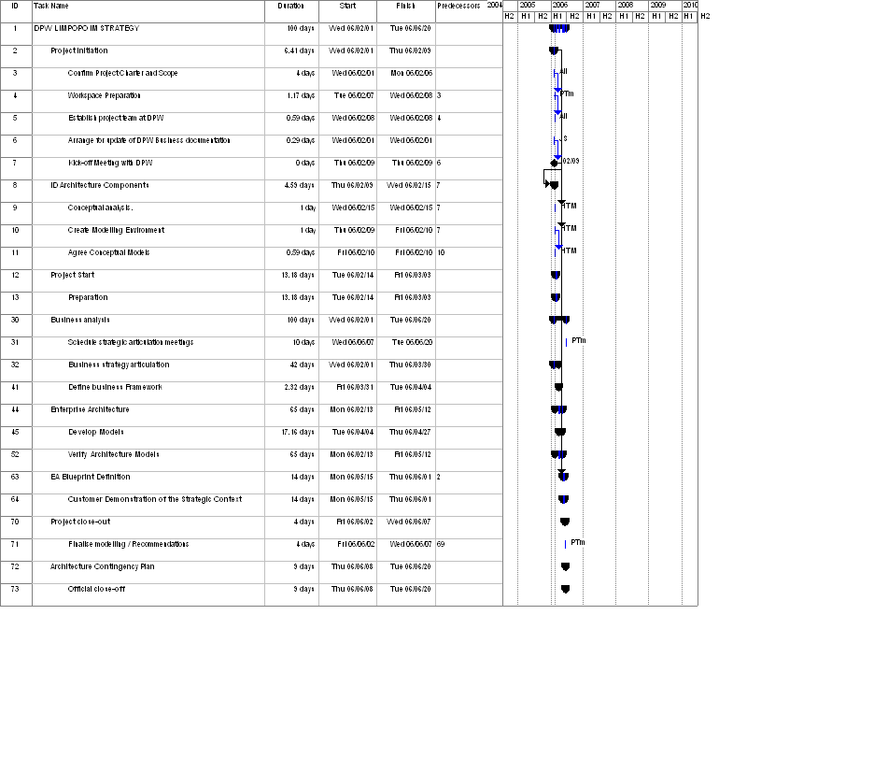

Time and expenses budget

Subsistence and Travel

Subsistence and travelling undertaken by SITA and from local (Polokwane) offices will not be charged. Expenses to and from regional offices of the department will, however, be billed and based on the following rates and actual information:

- Daily allowance at R196.00 per day (modified from time to time)
- Travelling compensation at the current tariff of R1.76 p/km (modified from time to time)
- Accommodation as per the applicable tariff of hotels of not more than a 3-star rating
- Parking, tollgates etc. will be recovered at the actual expenses.

Identification of key deliverables/milestones

Phase | Milestones | Time
Project Charter and Plan | Project Initiation, ID Architecture, Project Start | 2 weeks
“As-is” Report | Business Analysis | 4 weeks
Gap Analysis Report | Strategy articulation | 4 weeks
Information Plan | Enterprise Architecture | 2 weeks
Information Management Strategy | EA Blueprint for IMS | 6 weeks
High Level Implementation Plan | Demonstration of the Strategic Context | 2 weeks

- Abbreviations & Definitions

  - Abbreviations
SITA State Information Technology Agency
DPW Department of Public Works, Limpopo
SE Service Element
RGBS Real Global Business Solutions

- Project template version control

  - Document identification

Document title
Document No: SQSD0200

  - Revision
Revision | Date | Change Request | Change Comment
1.0 | 2002/12/05 | New Template

  - Approval
I, the undersigned, certifies that the above document conforms to SITA quality directives and authorises promulgation hereof for action to applicable department(s)/division(s).

SITA Manager: |  | Date
Project Manager and Author: Jeannette Kirk |  | Date

