

DEPARTMENT OF PUBLIC WORKS

Information Management Strategy
Executive Summary



Document no | : | IM002
Revision | : | 1.0 Final
Author | : | Jan Schutte
Effective date | : | 2006-08-02
Electronic file | : | input.doc
Classification | : | RESTRICTED
Identification Code | : | IMS
© 2006 Public Works. All rights reserved.
The document configuration centre shall hold all change requests and approval documentation. No part of this document may be reproduced or transmitted in any form by any means without the express written permission of Public Works. This electronic version of the document is the only Official/approved version of this document for distribution. Any printed copy of this document is for information purposes only and regarded as obsolete for any other date than the printed date, unless specifically agreed with Client where printed controlled documentation is required for distribution.

Executive Summary Information Management Strategy

Contents

Executive Summary Information Management Strategy 2
Section 1 – Information Management Introduction 4
1. Strategy Requirements 4
2. Background – Internal Enterprise Architecture 4
3. Information in context 4
4. Considerations of the project 5
5. Information Management Strategy in context of Enterprise Architecture 7
6. Business Objects 7
Section 2 – Information Management Scope and Vision 8
7. Components of Information Management. 8
7.1 Data Management 8
7.2 . Information Management 8
7.3. Knowledge Management 8
7.4. Content Management. 9
7.5. Document Management or Electronic Document Management 9
7.9. Messaging 9
7.10. Internet (WEB) 9
7.11. Directory Services 9
7.12. Knowledge Management as a Discipline 10
8. Vision for Information Management in DPW 10
8.1. Information Management Best Practice 11
BUSINESS PRACTICE vs. BEST PRACTICE 11
WHY DO WE NEED BEST PRACTICES FOR INFORMATION MANAGEMENT? 11
8.2. Information Ecology 11
8.3. Information Management Principles 12
Principle 1: Minimize the data collection burden. Who collects data. Data should be shared across the enterprise. 12
Implications: 12
Principle 2: Secure information against unauthorized access 12
Implications: 12
Principle 3: Provide access to information 12
Principle 4: Provide adaptive information delivery mechanisms 12
Principle 5: Information is user-centric and owner-driven 12
Principle 6: Information architecture is based on open standards 13
9. Internal Situation – Current Architecture 14
9.1. Current Business Architecture 14
9.2. Current Information Architecture. 14
9.3. Current Application Portfolio 15
9.4. Applications Architecture Concepts 15
10. Conceptual Architectures 16
The Business and Support model comprises: 16
Service areas, service types 16
The Information model comprises: 16
The Applications model comprises: 16
10.1. Business Strategic Requirements 16
10.2. DPW Business Strategy – Information Requirements 16
11. Recommended Information Categories 17
12. Information Management Concept 18
Section 5 – Legislation Related to Information Management 19
The Promotion of Access to Information Act (PAIA) Act, 2 of 2000. 19
Implications for Departments 19
Implications for Departments 19
Implications for departments 19
Section 6 – Information Management Roadmap 20
13. Roadmap 20
13.1. Strategic Planning Process 21
Executive Management 21
Senior Management 21
13.2. Project Qualification 22
13.3 Implementation 22
13.4. Service Management 22
14. Proposed Organisational Structure for Information Management Function 22
14.1. Proposed Organisation Structure for IM function 22

Section 1 – Information Management Introduction

- Strategy Requirements
- The strategy must enable the Department to manage their information from creation, storage and retrieval through maintenance and dissemination.
- The strategy must adhere to Access to Information Act and Archive Act.
- The strategy must define the users of the information both internal and external.
- Sources of the information must be identified both internal and external.
- The strategy must include information security.
The Information Management Programme of the Department of Public Works has embarked on a drive to establish an effective Information Management (IM) Service in the Department.
In order to plan for the provisioning of the envisaged IM services, an IM strategy is needed.

Background – Internal Enterprise Architecture
In June 2006 the Internal Enterprise Architecture (EA) was delivered for Public Works as part of the completed Information Management Strategy containing specific recommendations on information management.

The Internal Information Enterprise Architecture as part of the Information Management Strategy was initiated in order to:
- Resolve dilemmas regarding internal information systems and implementation choices, to best support strategic business objectives.

The primary thrust of this part of the information management project was to establish Business Information Requirements (BIRs) through discussions with business managers, and to utilise these BIRs to develop a a holistic list of future projects as well as a Project Roadmap setting out proposed internal information systems initiatives on the immediate future.

Currently the successful implementation of an organisational wide strategy is hampered by:
- a multiplicity of independent information gathering inhibit a single view of the client’s projects, and therefore effective client relationship management.
- there appears to be a lack of a clearly defined and communicated Information Architecture Principles, thus inhibiting the effective implementation of Information Management within the department.

Information in context
Information must be dealt with in its context when considering defining an Information Management Strategy. The Information Domain comprises Tacit Information and Explicit Information. Moving into the Tacit area requires a Knowledge Management strategy. This document focuses on the Explicit information. Further more the explicit area can be classified into static i.e. books etc that does not change regularly or the Non-static information which is the core of the business information that changes daily.
The technologies and applications used to manage Static information differs from the technologies and applications used to manage Non-static information. The information strategy recommendations are based on an analysis of the MSP, business strategy, the business execution model, business information requirements identified in the course of the interviews undertaken and through business process evaluation, and the existing organisational infrastructure.

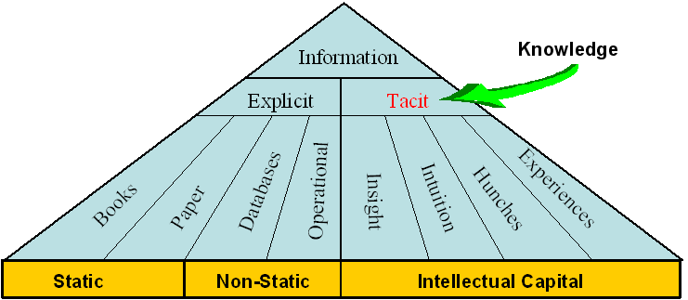

Figure 1 The Information Domain

Considerations of the project
The report recommends the adoption of a number of initiatives. The recommendations were based on an analysis of the MSP, business strategy, the business execution model, business information requirements identified in the course of the interviews undertaken and through business process evaluation, and the existing infrastructure.

The recommendations are summarised in the form of a Schedule of Future Projects (Figure 2), comprising some fourteen projects within the red lines. Apart from that there are also some additional projects identified as part of the eventual roll out of the information strategy. The recommendation regarding Knowledge Management is of special interest to the deployment of the IM Strategy and the subsequent growth of the strategy.

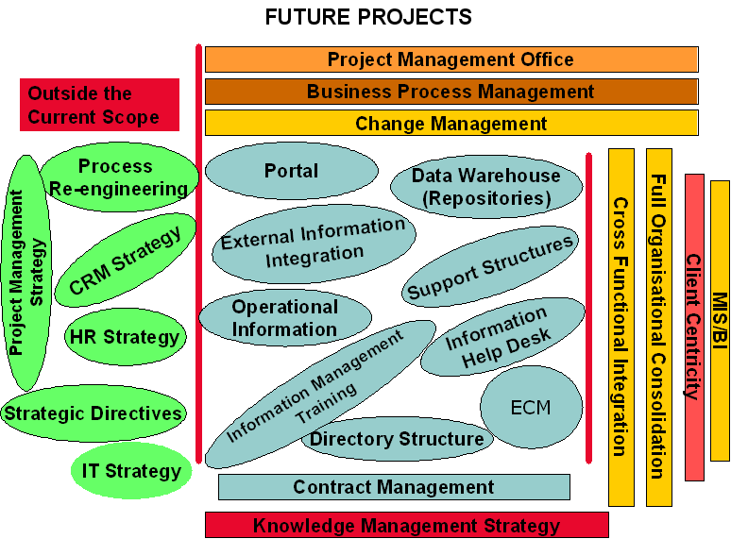

Figure 2 Public Works’ Proposed Future Projects

The green coloured ovals identify projects that will have to be considered in some future scenario.

The blue coloured ovals are an indication of the projects that will have to be initiated in the near future as part of the implementation of this strategy. The projects are:
- Develop a organisational access portal as part of the future rollout of knowledge management
- Launch a project to start with the investigation and deployment of a data warehouse for the department
- Launch one or more projects to negotiate the provisioning of information for the department to enable and facilitate access to information from the transversal applications.
- Define operational information repositories
- Define the operational information structures for the management of information repositories
- Establish information management helpdesk to be able to provide assistance with the provisioning of information
- Define and develop the directory structures to accommodate the data definition and ownership responsibilities as well as the meta data directory
- Define the requirements for a fully fledged enterprise content management system that will incorporate the necessary functionality to allow the establishment of an intranet, extranet and the publishing to the internet.
- Establish a central asset register application and
- a contract management application
- Initiate a project to formulate the next phase of the enhancement of the information management strategy to develop a knowledge management strategy
- Establish a central project office for the department
- As part of SDI establish a business process management functionality
- The important aspect of the implementation of the strategy is to ensure that a comprehensive change management programme is launched

The critical part of the implementation of the strategy would be to ensure that it addresses the cross functional flow and dissemination of information.
The implementation must ensure that information is not duplicated and that it represents an organisational perspective.
What ever the focus all information must enable greater efficiency and improved client focus

Information Management Strategy in context of Enterprise Architecture
A Client Relationship Management Strategy and the Knowledge Management Strategy were identified as two future initiatives that must be addressed. The Information Management (IM) Strategy was formulated as the first structured effort to the second phase which will address KM in DPW.
The formulation of the Information Management Strategy and subsequent Information Technology Plan is aimed at helping to implement a Information Management culture within DPW as a whole, including the relevant processes and recommend technology as the first building block of Knowledge Management.

Business Objects
The primary objective of the Information Management Strategy is to improve the quality and effectiveness of decision-making within Public Works through making appropriate information accessible to those that need it, when and where they need it.

Appropriate information means information that is accurate, complete, consistent, and up-to-date, all within the context of business requirements.

Information resources could include: client intelligence, market intelligence, competitor intelligence, vendor & product information, proposal information, boilerplate and marketing collateral, project files, human resource information, operational and other business information, financial information, legal documentation, policies, procedures – and others.

The deployment of an information management strategy will:

- Ensure information quality, security, and integrity.
- Increase business effectiveness through improved information.

Section 2 – Information Management Scope and Vision

Components of Information Management
The difference between data, information and knowledge and the management there-of will briefly be discussed.

Subsequently document, record and content and the management of these will be discussed in context of the strategy as the possible forms of data, information and knowledge. The contextual section will be concluded with a description of the enablers of infrastructure for data, information and knowledge management.

7.1 Data Management

Data Management therefore refers to the several levels of managing data.
The management of all data within the different applications in an organisation. Data Management needs to maintain a data dictionary for the organisation. Data dictionaries do not contain any actual data from the database, only “bookkeeping” information for managing it. Without a data dictionary, however, a database management system cannot access data from the database.

. Information Management
Data placed in context through different permutations– Information is the understanding of the relationships between the components of different data elements, or selected components of data and other classes of information.
It was also stated by Macpherson (1999) that IM ensures the availability of information to customers, suppliers, and partners, and enables organisations to expose and leverage information products to their advantage.

Information Management deals with the extractions of data into predefined relationships and formats useable for decision making purposes.

Knowledge Management

Beyond relationships there is pattern, which is more than simply a relationship of relations. Patterns encompass both consistency and completeness of relations, and create its own context to some extent. When a pattern exists between data and information, the pattern can potentially present Knowledge. It only becomes Knowledge once the patterns can be realised and its implications are fully understood. Knowledge can evolve over time and is seldom of a static nature, and normally contains a high level of reliability and predictability. Knowledge tends to create its own context. Knowledge talks to trends and norms etc.

Knowledge is information that has been organised and analysed to make it understandable and applicable to problem solving or decision-making. (Turban, 1992).

Content Management.
Enterprise Content Management is the technology used to manage content.
Loss of business due to inability to provide accurate and timeous project information;
Embarrassment to the Organisation and loss of client confidence because of incorrect information;
Develop of standard codifying methods for information at source levels
Ability to centrally “publish” corporate information into hierarchically categorised databases.
Easier methods for system administration, support and development to rapidly deploy and maintain information management architectures.
- The ability to protect sensitive information per groups of users or individually.

7.5. Document Management or Electronic Document Management
It is an essential part any ECM creating collaboration and information sharing through electronic document management. Groupware services encompassing all the afore mention concepts range from unstructured electronic mail to rigorously structured workflow systems. Email exchange of drawings, models and project information (asynchronous)
Product data management, product information management, collaborative product commerce (generally asynchronous)

7.9. Messaging
The Enterprise Architecture as a information architecture will be made available on the intranet. This will ease and facilitate information searching.
The same security access rules need to be applied to the extranet as part of controlling access to sensitive information.

7.10. Internet (WEB)

An intranet is a private (corporate) network that uses Internet software, standards and protocols to provide shared corporate information and supports collaboration in an organisation. It consists of a limited number of interconnected (internal) networks and web servers, protected from outside access.

An intranet’s power lies in the combination of Internet functionality with the speed and security of an internal corporate LAN. An Intranet differs from the Internet in that it provides connectivity only between specific sites, creating a pre-determined infrastructure for business users, customers, or other designated participants.
The Enterprise Architecture as a information architecture will be made available on the intranet. This will ease and facilitate information searching.

7.11. Directory Services
Information Management in DPW must be seen in the context of the future objective to realise Knowledge Management as a discipline to promote “an integrated approach to identifying, managing and sharing all of an enterprise's information assets. The “expertise and experience resident in individual workers” will not be addressed as part of Information Management. No differentiation will be made between structured and unstructured data. Content and document management is regarded to contribute to Information Management and Groupware is regarded as “the collective term for software that provides the infrastructure” to enable Information Management.

7.12. Knowledge Management as a Discipline
When compiling an Information Management strategy it is essential to understand knowledge management as a discipline, KM initiatives are a combination of continuous processes and unrelenting focus brought about by combining information patterns. All organisations possess some level of KM within their existing information management structure. We reference knowledge management as the next phase for information management.
Level 1 – Information Retrieval: This level of KM focuses on making existing explicit knowledge readily available for reuse. The primary objective of an information retrieval project is ensuring easy access to relevant information. This level has a strong tendency to Information Management.

Level 1 – Information retrieval, (explicit knowledge) will be addressed in this strategy. This will be done to leverage existing infrastructure and information sources, and to enhance information sharing in DPW.

8. Considerations for Information Management in DPW
Some Information Management trends in the information industry (external to DPW) were identified and the implications of these trends on Information Management in DPW were identified.
Content: IBM, Oracle, Microsoft attempt to reposition their databases into comprehensive information management systems through 2005/06, with the ability to address structured (data), semi-structured (XML, catalogue SKUs), and unstructured (everything else) information.
Implications: Information Management in DPW must address structured, semi-structured and unstructured information, accompanied by the appropriate technology and tools.
Content: The convergence of structured and unstructured information management systems will continue through 2004/05, with additional overlaps among document-authoring tools, application interfaces, documents, forms, and relational database technologies. Through 2007, driven by increasing content usability/reuse, rights management, and life-cycle/records management issues, organisations will increasingly seek and deploy content management technologies addressing various unstructured content types (e.g., images, documents, reports, rich media, e-mail, product data).
Implications: The overlaps among document-authoring tools, application interfaces, document management, forms and relational database technologies must be understood in DPW. The drive for content reuse, rights management and records management must be well defined within DPW (before any decision is made on a content management application.????)

8.1. Information Management Best Practice

BUSINESS PRACTICE vs. BEST PRACTICE

Work practices (maintenance, operations, etc)
Information Management

WHY DO WE NEED BEST PRACTICES FOR INFORMATION MANAGEMENT?

Because our “Information Enabled” partners, suppliers and competitors have it”

8.2. Information Ecology
The Enterprise Information Architecture (EIA) exists within an information ecosystem that presents layers of context for the different information engineering activities (see Figure 4)

The information ecology represents the integration of key strategic planning artifacts from the enterprise business architecture and is the purview of senior executive management.
Information management represents the set of artifacts that govern the collection, storage, dissemination, and delivery of corporate information, and is the purview of the enterprise information architect. Establish the relevance of information and data within the context of business strategies, goals, and objectives.
Classify business information to ensure information sharing between employees, trading partners, and regulatory bodies.
Ensure alignment of information products to the enterprise bottom line (value proposition).
Formalise the roles, organisation structure, and procedures for managing information content and delivery.
Establish information security access, privacy, confidentiality, quality, integrity, authenticity, and archival cycles.
Support risk management and business resumption planning activities.
Ensure data access and sharing supports physical value chain and information value network.
Ensure data compliance within audit and legal requirements.

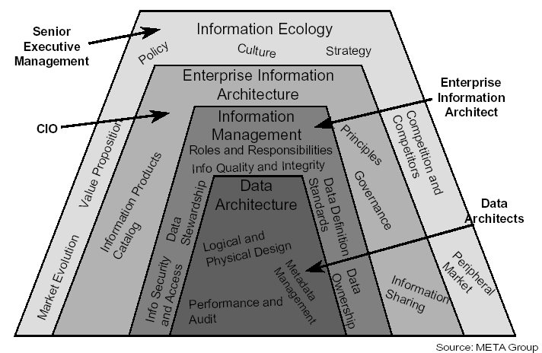
Figure 3 Information Ecology

8.3. Information Management Principles

Principle 1: Minimize the data collection burden. Who collects data. Data should be shared across the enterprise.

Implications:
Each data element should have a trustee accountable for data quality.

Principle 2: Secure information against unauthorized access
Information security must be ensured and increased, commensurate with increased access to information.

Implications:

Principle 3: Provide access to information
Employees should have access to information efficiently, effectively, and economically. DPW should encourage a diversity of public and private access methods for information, including multiple access points, the separation of transactional from analytical data, and data warehousing architecture.
Accessibility involves the ease with which users obtain information.

Principle 4: Provide adaptive information delivery mechanisms
A standards based network.
Support for heterogeneous data (from multiple systems).

Principle 5: Information is user-centric and owner-driven
To be successful, information must meet users' requirements and enable effective decision-making. Users will require access to information in an easy-to-use manner with the ability to retrieve information from many sources.

Principle 6: Information architecture is based on open standards
Resources, information, and software applications can be shared.
Information management involves ensuring the integrity, timeliness, protection, and sharing of information.
Stewardship rather than ownership encourages information use without sacrificing security.

Identified stewards are responsible for specific information categories.
Establish a process to share information enterprise wide, and must address:
Consistent data definitions.
Standard data interchange formats.
A management approach commensurate with the value of the information.
The establishment of an information locator capability as part of a meta data repository.
Information stewards responsible for the definition, integrity, and timeliness of the information within their domain.
Operational issues related to the physical implementation of a shared information environment.
Partnership with information stewards and information technologists is critical.

Principle 8: Enterprise wide access to information is the rule rather than the exception
Timeliness is also an important information quality indicator.

The business necessity of sharing information must be established.
Technology must be deployed to distribute and allow access to information.
Secure information must not be accidentally released.

The attainment of successful work group collaboration using networked computers requires knowledge of the Human/Computer Interaction issues.
Principle 10: DPW will have an information technology infrastructure that seamlessly links offices, programs, facilities, and field locations together
A seamless information technology infrastructure facilitates sharing of information and other resources across the enterprise.

The information technology infrastructure includes some common databases and applications with commonly available access mechanisms.
Information technology infrastructure planning and implementation requires wide and active participation from various organizational elements. The information technology infrastructure is based upon interoperability and standards, supporting the sharing of resources.
Shared resources include data, information, applications, infrastructure, and computing, enabling users to leverage the work of others.

9. Internal Situation – Current Architecture
The full detail of the current architecture is described in Appendix C. A summary of each of the parts of the current architecture will now be provided, to be used as the basis from where to move forward with Information Management in Public Works and to identify possible shortcomings and requirements from the current architecture.

Current Business Architecture
The straight line core processes for the proposed value chain for the Department of Public Works:



Figure 4 DPW Value Chain

Currently there are operational support provided by shared services and infrastructure support in terms of the flow and provisioning of operational information. What is the impact on information management strategy of these.

9.2. Current Information Architecture.
From the analysis of the current information scenario, it can be concluded that the following information will be supplied or, and required in terms of Information Management. External requirements
Previous engagement/operational information
Discontinued opportunity information
Tender information
Current operational information

The breakdown of the information is as follows:

External requirements
Supplier/contractor/Information
Technology
Competition Information not sure on this
Client Requirements
Market / Industry Information
Previous engagement/operational information
People
Discontinued opportunity information
Client
Relevant Approval documents
Responsibility Information
Resource requirements
Asset Requirements
Tender information
Detail Specification Requirement
Resource requirements
Tenderer information
Current operational information
Land Estate Management
Property and Facilities Management
Project Management

9.3. Current Application Portfolio

The Applications Architecture does not design systems or collect detailed requirements. The Applications Architecture addresses capabilities of existing, planned, and future applications to form a complete picture of the vehicles needed for delivering data resources and accomplishing business activities. In defining the applications in a shared data environment, it is beneficial to plan for managing data (Information Architecture) separately from the applications (Applications Architecture) that actually process the data. Data Repositories enable multiple applications to use the same data without duplicative maintenance. List of Applications

Customer Management System: Are there any CRM in DPW. Financial applications linked to project management are fragmented and lack integrated functionality. Integrated financial applications will be a source of structured data for Information Management.
Not correct Predominantly structured data will be obtained from the human resource application for Information Management.
Unstructured data is provided by the web based applications.
Document management: Different manual approaches to document management are used in DPW with the primary control as the registry service. The implementation of an ECM system to formally manage records and documents. Network support applications: Multiple network support applications( which ones) are used to maintain required level of availability of the enterprise network.
Licensed Computer System Software: Consisting of all operating and data base management software.

9.4. Applications Architecture Concepts

The Applications Architecture defines a set of applications that can support the shared data environment and provide the automated capabilities to store, share, and use data needed to conduct the Department's business efficiently. The Applications Architecture does not design systems or collect detailed requirements. The Applications Architecture addresses capabilities of existing, planned, and future applications to form a complete picture of the vehicles needed for delivering data resources and accomplishing information supported business activities. In defining the applications in a shared data environment, it is beneficial to plan for managing data as part of the Information Architecture separately from the Applications Architecture that actually process the data. Data Repositories enable multiple applications to use the same data without duplicative maintenance. The Applications Architecture defines a set of applications that will support the shared data environment and provide the automated capabilities to store, share, and use data needed to conduct the Department's business efficiently. The Applications Architecture does not design systems or collect detailed requirements. The Applications Architecture addresses capabilities of existing, planned, and future applications to form a complete picture of the vehicles needed for delivering data resources and accomplishing business activities.

10. Conceptual Architectures

To be able to deduct information management requirements one needs to understand the enterprise architecture of the organisation. The Proposed Information Architecture

The Business and Support model comprises:
Business definition
Task management and routing
The e-government process requirements
The mechanism, vehicles and service support processes

Service areas, service types
Business units and Service Categories

The Information model comprises:
The information categories
The high level information flow
The individual information packets/sub-categories as part of the categories
The information packet elements/content/data structures
Enterprise Content Management
Customer Relationship Management
Model describing, at an aggregate level, the information that support the business and management decisions

The Applications model comprises:
The individual data models
Model describing the applications and related data and databases that support business operations

The system software needed
The network requirements
Configuration Management
Organisational/ technology Relationship

10.1. Business Strategic Requirements
Business Strategic Requirements (BSR) is derived from the DPW Business Strategy and Value Chain. Grow the business of DPW.
Measure service and product delivery against service levels and requirements.

10.2. DPW Business Strategy – Information Requirements
Based on the vision of the DPW Business Strategy, there is a requirement for information on:
The products and services that DPW provide, support and integrate.
The current clients of DPW.
Potential new clients for DPW.

Based on the mission of the DPW Business Strategy, there is a requirement for information on:
Appropriate business practice to be followed by DPW.
Information requirements of both internal and external clients.

Based on the values of the DPW Business Strategy, there is a requirement for information on:
Performance levels of DPW Competency Centres, against service level agreements.
The opinion that DPW clients have of DPW.
Problems experienced by clients of DPW with the products and services rendered by DPW.

11. Recommended Information Categories

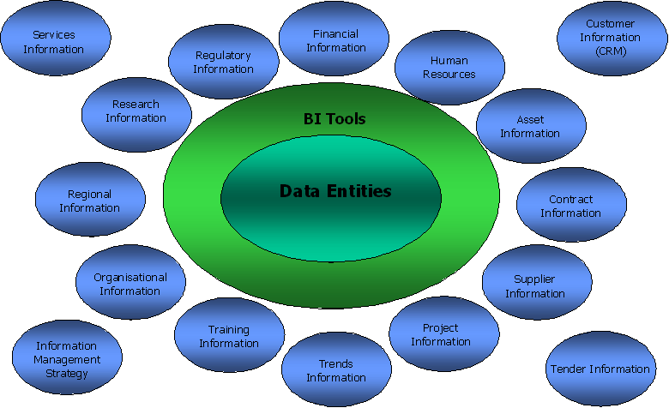
Figure 5 Information Categories

The information can be unstructured data, which would reside in a document management system or structured data, which would reside in a data warehouse. These are only a proposed set of categories and needs to be refined by the organisation as they implement information management.

12. Information Management Concept
The focus of the information delivery concept is to provide seamless and uniform access to information for the client, supplier, partner and employee. Information Management Concept

Section 5 – Legislation Related to Information Management
The provision of IM services in Government is mandated by a couple of SA Acts that have a direct bearing on Information Management, and more specifically on Records management as part of Information Management.

The Promotion of Access to Information Act (PAIA) Act, 2 of 2000.
Only records can be requested via PAIA, and not, for instance, verbal information.

Implications for Departments
The Director-General, who is the ex officio Information officer, should designate deputy Information Officers to ensure that PAIA requests will be optimally addressed. Management of PAIA documentation.
Establishing a record keeping system to ensure control and availability of PAIA management information.
Deputy Information Officers.

Implications for Departments
a Records management policy and procedures.
a filing system, which. schedules of other records.
The Head of the Department should ensure that records management policies and procedures also refers to the electronic records management situation where applicable. promote universal access to electronic transactions;
The term “data” or “data messages” in this Act means “electronic representations of information in any form”.

Implications for departments
The legal status of electronic information subject to certain conditions has been recognised. search those premises or that information system;

Section 6 – Information Management Roadmap

13. Roadmap
Different technologies will have to be employed to realise the Information Management Concept. These technologies would be, including the different elements required for each technology: Technology does not lead to information management.

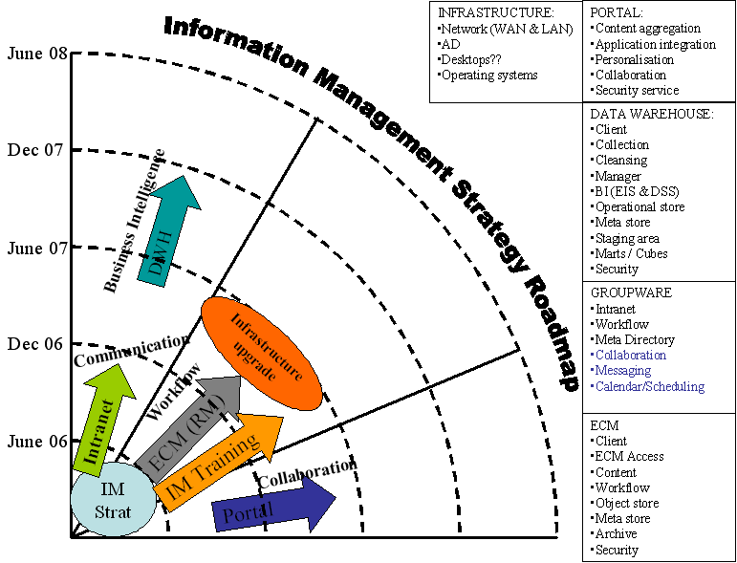
Figure 6 Information Management Roadmap

Advanced knowledge management certification
The first part depends on having completed a principled selection of advanced knowledge management systems, semantic extraction data persistence systems. A human-centric information management capability is defined and existing software identified as part of the final recommendation. A distributed information environment is proposed that will enable the real-time representation and sharing of information and human knowledge about situations and solutions within the department. This “global” information framework will be used as a human controllable interface over complex ontology information and knowledge management.

The record is expressed as part of the information ontology, and human visualisation of this record of information that is provided.

Ontological models provide meta data that indicate where possible misunderstanding might occur, ontological information models provide a complex formalism to help in the translation and transcription of meaning within the information and knowledge management ambit while the information structure defines the sets of concepts. Improve the quality of analysis and utility of complex information intelligence;
Strengthen information and production management and ensure policies, procedures, concept development, training and technical-human engineering;

13.1. Strategic Planning Process

Executive Management
Internal Information Requirements
Performance per service.

External Information Requirements
Technology
Client Requirements?
Market Industry Information
Supplier Requirements

Information Output (Strategic Guidelines)
Service Indicators
Strategic Plans
Operational Requirements

Senior Management
Information Requirements
Service Detail
Service Rules and Regulations

External Requirements
Technology
Client Requirements?
Market Information
Supplier Requirements

Information Output
Programme Strategy
Strategic Objectives
Budget Needed
Services Delivered
This process highlights the steps to identify service requirements. Information Requirements
Modification of Services Delivered.
Services Information – to compile recommendation.
Notification of Service Requirement.

Information Output
Updated Client Information or New Client Information.
Service delivery Proposition.
Terminated Services.
Services Delivered.

13.2. Project Qualification
Information Requirements
Pro-active information (Predictions).
Re-active information (Notifications Received).
Client Information.
Current Services Rendered.
Information Output
Implementation plan.
Technology requirements (Business plan).
Resource requirements.
Information Requirements
Information Output
Service specifications.
Approval documents.

Implementation
Information Requirements
Client Detail.
Information Output
Service specifications.
Change Approval documents
.

Service Management
Information Requirements
Information Output
New Service specifications.
Approval documents.
Information Requirements
Information Output
Further Client Requirements.
Approval documents.

Proposed Organisational Structure for Information Management Function
The Information Management and Records Management function has very good leadership and consists of a knowledgeable and motivated IRM team. Current Organisation Structure for IM function

The following structure represent a possible new information management structure for the department.

Proposed Organisation Structure for IM function

Senior Manager Information and Records Management:
Is the Department’s Senior Information Management professional.
Ensures availability of information technology systems and operations, including IM contingency planning, to support the Department’s Information management and business operations.
Ensures that appropriate procedures are in place for information authorisation of national security systems.
Implement a departmental wide Information Architecture.
Ensures the existence of a classification system for organisational records.
Ensure the development of records schedules
Provide overall records management guidance

Information Development:
Information Analyst: I would remove those with ????? and combine the rest with information advisor post.
Installation, maintenance, and troubleshooting for computer system and networks.???????
Information maintenance/data entry.
Development of information sources and acquiring information.
Information Designer:
Information Advisor (Strategy Officer?):
Assist in the development and coordination of Information and Communication Technology policy and strategy at all levels throughout the department.
Key responsibilities include institutional liaison, consultancy and review associated relationships with every aspect of information management service provisioning and strategy.
Provide advisory services on information and related strategies.

Technical Information and Data Quality:
Technical Information Officers:
A detailed knowledge of information systems, their threats, vulnerabilities and associated risks.????????
Provide technical guidance on capturing, storing and disclosing of information
Assist with the improvement of the technical management of information
Provide the rules and regulations regarding the disposal of information
Define the quality criteria for information
??document scanning

Define activities and processes that would contribute to the efficiency and effectiveness of information
Define the performance criteria to measure the quality of information
Define overall technical performance criteria for information flows
Meta data, data dictionary etc Ensure the effective maintenance and implementation of the information architecture
Ensure the development of an information asset discipline
Enterprise Content Management:
Records Management: Personnel and General Records
Manages archives and records center.
Regularly deals with confidential information; communication content frequently pertains to public information, managerial and administrative actions; information managed requires the application of appropriate judgment, discretion and adherence to professional code of ethics.
Designs information delivery systems. Define controls for the business intelligence environment

Provide content management support.
Ensure the submission/delivery of documents
Ensure that information contained within each document is accurate, peer reviewed and regularly updated
Ensure interoperability and interchangeability of data/information through defining the required standards

Evaluation of the Information Management Practices in the Department of Public Works

Evaluation of the Information Management Practices in the Department of Public Works with the Information Management Best Practices Opportunity Model

The appropriate selection is indicated by (X)
- Understand the importance of improving Information Management Practices.
1

2

3

4 X

c5

Fully Understand

Partially Understand

Do not Understand

- Involve Management and Staff to Create Ownership in Information Management.
1

2

3

4

5 X

Always Involve

Sometimes Involve

Never Involve

- Develop plan for achieving information management best practices.
1

2

3

4

5 X

Have Developed
In Process

Have not Developed

- Create and Maintain a Set of “Blueprints” to Build an Integrated Information Environment.
1

2

3

4

5 X

Exists and are Maintained

In Process

Does not Exist

- Link Mission with Information Initiatives and Measure Performance of Improved processes.
1

2

3

4

5 X

Are Linked and Measured

In Process

Not Linked or Measured

- Improve Processes in the Context of the Information Architecture.
1

2

3

4

5 X

Have Improved

In Process

Have not Improved

- Allocate Appropriate Effort and Resources to Reflect the Useful Life of Each Information Investment.
1

2

3

4 X

5

Have Allocated

In Process

Have not Allocated

- Link the Planning, Budgeting and Evaluating Processes to the Information Architecture.
1

2

3

4

5 X

Are Linked

In Process

Not Linked

- Maintain Information Data as a result of Daily Work.
1
2
3 X
4
5
Always Maintained
Sometimes Maintained
Not Maintained

- Upgrade Skills and Knowledge of Managers and Staff on Information Management through adequate training.
1
2
3
4
5 X
Regularly Upgraded
In Process
Not Planned

The score for DPW = 46

Opportunity Comparison Table
46
92%46
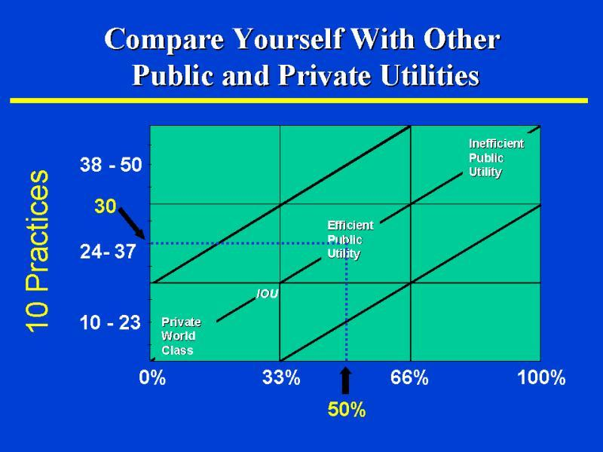

Conclusion
There is a lot of hard work ahead to really getting information management deployed within DPW.

