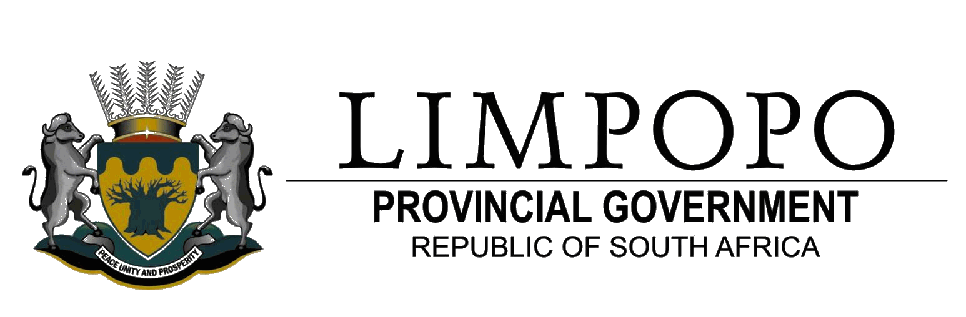
DEPARTMENT OF PUBLIC WORKS

LEARNING NETWORK SESSION 2, 2008/09
REPORT

ABBRIVIATIONS

SDIP: Service Delivery Improvement Plan

IDIP: Infrastructure Delivery Improvement Programme

IPMP: Infrastructure Programme Management Plan

IAR: Immovable Asset Register

C-AMP: Custodian Asset Management Plan

U-AMP: User Asset Management Plan

OTP: Office of the Premier

LDPW: Limpopo Department of Public Works

PALAMA: Public Administration Leadership and Management Academy

REPORT ON LEARNING NETWORK SESSION 2; 2008/09

- INTRODUCTION
Learning Network is a session whereby LDPW and its stakeholders share information on service delivery improvement initiatives. The first session was held on the 16 May 2008 for quarter one as indicated on our APP. The second session was held on the 26 September 2008.

Participants were as follows:
Departmental: learning network forum members.
Provincial Stakeholders: OTP, Department of Agriculture, LG&H.
External Stakeholders: Paul Botha from National Treasury.
PALAMA (SAMDI) was represented by Dr. S. Mohlokoane and Mr. K. Perumel.
Univen: was represented by Mr MM Nekhavhambe.

- DEVELOPMENT
2.1 Ms R. Zwane from SDI Unit was the Programme Director. She opened, welcomed all present and introduced our guests.

2.2 MP Manamela was task to give the summation of the previous event and report back on Departmental Customer Survey and the Provincial Customer Survey conducted by Unilim.

In his presentation he indicated why there is a need for network sessions in the department. He maintained that the interaction with stakeholders will improve CRM and the improvement of service delivery in the department. Furthermore information will be disseminated to all internal and external customers.

His presentation on the Provincial Customers Survey Report ; he indicated that OTP requested that all departments, and municipalities should study the report and come up with improvement plans on areas where they scored lower on ratings by Limpopo Citizenry.

He introduced the delegates especially districts managers on how to interpret the data tables in the report. Districts made a concern that it is difficult to attribute a particular problem to LDPW due to items under review not directly linked to LDPW Programmes. Since the scope of the survey was very wide; OTP through IGR should facilitate district meetings between all Districts Departments and Municipalities where the document can be interrogated holistically as one District.

Albeit the above statement LDPW Districts were requested to compile improvement plans on areas where departmental programmes are directly or indirectly link to the items under review.

His presentation on Departmental Customer Satisfaction Survey Report; he mentioned that the scope of the survey was limited to Real Estate (Government Flats) and Maintenance. The report shows that Capricorn District score the highest overall satisfaction level of 64% and the lowest score 40% from Waterberg District. The difference of 24% between the highest and lowest overall rating is an indication that service are not offered equitably and impartially to all beneficiaries across the province. The problem might as well be attributed to the district management style. Districts should strive towards obtaining an overall rating of 80% -100%.

Recommended improvement initiatives were identified as implementation of the following value adding strategies:
- Installing effective and reliable IAR as indicated in GIAMA.
- Compilation of C-AMP
- As the custodian department, coordinate compilation of U-AMPs.
- Allocate some maintenance projects to EPWP, and NYS
programmes.
- Restructuring of Real Estate, Maintenance and PMS.
- Retraining of personnel on BPCMEP and Customer Care.
The recommendations should be brought to the attention of the HOD.
These strategies should be the main focus area in 2009/10 APP, and should be incorporated in 2009/10 – 2011/12 SDIP.

2.3 PALAMA (SAMDI) Presentation
Dr S. Mohlokoane introduced the delegates to their new name and the role PALAMA can play in improving Public Sector service delivery. PALAMA’s mandate is to form strategic partner with Institutions for Higher Learning and Individual Consultants/ Training Service Providers in capacitating the Public Servants with accredited portable skills and qualifications. He clearly spelt out how PALAMA is more effective than SAMDI. He as well indicated how PALAMA is penetrating the African training market sector. PALAMA is going global as their dream. One point to note is that if any department is entering into agreement with PALAMA the procurement rule of three quotations does not apply. So it is very easy to procure PALAMA services as government department. PALAMA has structured programmes ranging from short courses to MDP. AMDP, EMDP.

2.4. National Treasury Presentation
- Mr P. Botha gave the progress made with regard to implementation of
IDIP in Limpopo Province. There is significant improvement with
regard to Programme and Project Planning by the client departments
namely: DoE and DoH&SD. Challenges are experienced in the
implementing department LDPW with regard to Project Delivery.
These shortcomings led to client departments appointing Implementing
Agents and own Professional Teams to address infrastructure delivery
backlog. His presentation indicated the snap shot at infrastructure
delivery. The following were indentified:
- LDPW is still addressing infrastructure delivery backlog dating back
from 2003 to 2007.
- Customer’s loyalty is waning.
- Due to the problems client departments give LDPW few projects on
IPMP.

The following initiatives were recommended:
- Introduction of PMU model
- Restructuring of PMS
- Consultation with key customers ( DoE, DoH&SD ) at all levels.
- Fast tracking delivery to win back customer’s loyalty.

- Vote of Thanks
Ms M. Molema thanked the guest for their inputs in making LDPW a better organization in future. She extended her thanks to all presenters, the delegates and event organizers.

- Closing
The programme director declared the session closed at 13h15 with tantalizing motivational statement from S.R. Covey :2004 ; The 7-habits of highly effective people.

