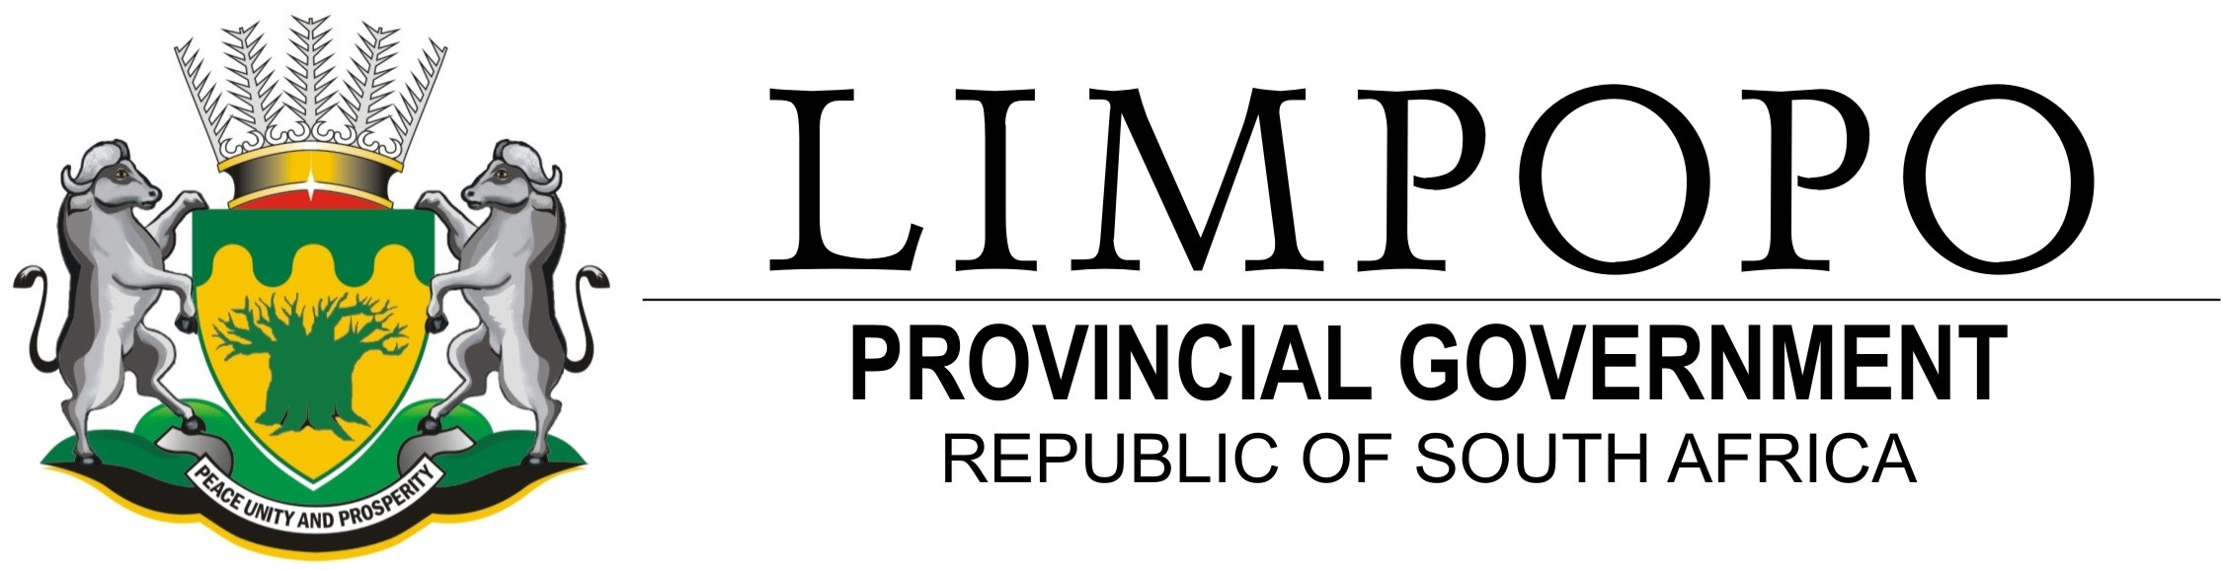
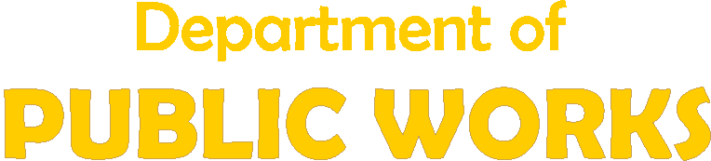

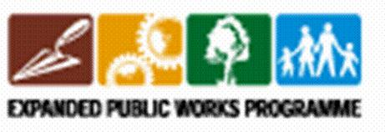

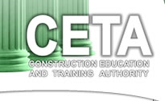
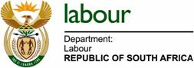

National Youth Service Building Maintenance Programme

VOLUNTEER FOR THE NATIONAL YOUTH SERVICE PROGRAMME

The Limpopo Department of Public Works, Limpopo Youth Commission, Department of Labour, CETA (Construction, Education and Training Authority) and Municipalities have collaborated in implementing NYSP. 500 opportunities for young people have been identified in bricklaying, carpentry, painting, welding, electrical, plumbing and landscaping for a period of 12 months, through the LDPW Building Maintenance Programme.

Interested youth who qualify must meet the following minimum criteria:
- Out-of-school youth between 17 and 35 years of age
- Unemployed and unskilled youth
- Rural youth, young women and youth with disabilities.
- Youth in conflict with the law
- Youth accessing social grant (those that are medically fit to work)
- Students from Higher education and further education and training colleges
- Resident in Limpopo Province
- Be willing to enter into or sign a twelve months service contract

Volunteers will be taken for training (technical and life skills) and placed at various projects in their respective local municipalities.

Applications are obtainable at the following offices:
- Public Works District offices.
- All district and local municipalities.
- Community Development Worker’s offices.
- Limpopo Youth Commission

The applications indicating, reference no. LDPW-EP 08/09/01 should be deposited in tender boxes in the following offices:
- All Department of Public works district offices.
- All district and local municipalities
- The Department of Public Works tender/ bid box situated in corner River and Blaauwberg Street.

  - The closing date for submission of application forms is on or before the 26th of November 2008 at 11H00.
  - The completed prescribed application forms should be addressed to the HOD, Department of Public Works P/bag x 9490, and Polokwane 0700.

For any other information, please contact the following:

Person Name | Department | Contact details

All youth who have already expressed interest to participate in the National Youth Service with the Youth Commission, should please apply for this specific service project.
For more information on NYS, visit www.uyf.org.za (Umsobomvu Youth Fund).

