
FETAKGOMO MUNICIPALITY

Waste Management Business Plan
Tirisano Community Waste Collection Services

June 2008

Table of Contents
Abbreviations &acronyms ii
1. Introduction 2
2. Background 2
3. Current Situation 2
4. Objectives of the Project 2
5. Legislative Mandate 2
6. Proposed programme 2
7. Training 2
8. Services to be provided 2
9. Recycling 2
10. Operational and Personal Protective Equipment 2
11. Target Beneficiaries 2
12. Conditions of Employment and Remuneration 2
13. Implementation plan for EPWP 2
13.1 Work organization 2
13.2 Recruitment 2
13.3 Exit Opportunities/Placement 2
13.4 Project Steering Committee (PSC) 2
13.5 Roles and responsibilities 2
14. Sustainability of the Programme 2
15. Monitoring & Evaluation 2
16. Project Budget and Cashflow 2
17. Activity Schedule 2

List of Tables
Table 1: Level of Education in Fetakgomo 2
Table 2: Estimated Waste Quantities for the Pilot Zones 2
Table 3: Accredited DOL Courses 2
Table 4: Estimated Recycled Waste in Pilot Zones 2
Table 5: Recommended Task Rates and Productivity 2
Table 6: Stakeholder Roles and Responsibilities 2
Table 7: Framework for Monitoring and Evaluation 2
Table 8: Budget and Budget Projection 2
Table 9: 2008/09 Cashflow Projection 2
Table 10: 2008/09 Budget Aanalysis 2
Table 11: Stakeholder Contribution Analysis 2

List of Figures
Figure 1: Delimitation of the wards in the Fetakgomo municipal area 2
Figure 2: Average Annual Individual Income for Fetakgomo municipal area 2
Figure 3: Activity Schedule (Part 1 of 3) 2
Figure 4: Activity Schedule (Part 2 of 3) 2
Figure 5: Activity Schedule (Part 3 of 3) 2

Abbreviations &acronyms
BeB | Buyisa-e-Bag
CBO | Community Based Organisation
DEAT | Department of Environmental Affairs and Tourism
DLGH | Department of Local Government and Housing
DoA | Department of Agriculture
DOL | Department of Labour
DPLG | Department of Provincial and Local Government
DWAF | Department of Water Affairs and Forestry
EPWP | Expanded Public Works Programme
GSDM | Greater Sekhukhune District Municipality
IDT | Independent Development Trust
LDPW | Limpopo Department of Public Works
LEDET | Limpopo Economic Development, Environment and Tourism
LI | Labour Intensive
LIBSA | Limpopo Business Support Agency
NDPW | National Department of Public Works
NQF | National Qualifications Framework
PSC | Project Steering Committee
SALGA | South African Local Government Association
SoE | State Owned Enterprises

Introduction
The Fetakgomo Local Municipality is one of the Local Councils in the Sekhukhune District Municipality in Limpopo. The Municipality is totally rural in nature with a population of approximately 105,196 people that reside in 87 settlements of which the majority are small, i.e. less than 1000 people/inhabitants. The municipal area covers 1123.18km², which represents 8.4% of the District's total land area. There is widespread poverty in Fetakgomo yet ironically the area is endowed with mineral deposits such as platinum, chromium and diamond. The fertile soils along the rivers of Lepelle and Lepellane present enormous agricultural potential. The majestic mountains in the area present potential for tourism development.
The municipality is divided into 13 wards. The recently (2006) revised location and delimitation of wards are indicated in the Figure below:
Figure 1: Delimitation of the wards in the Fetakgomo municipal area
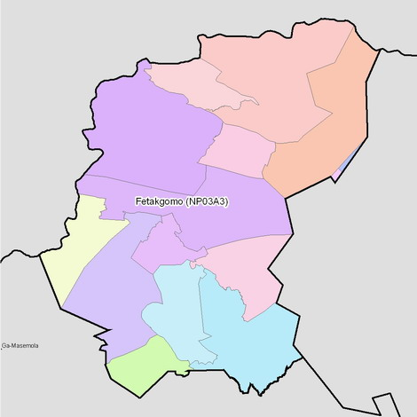
11
9
1
3
4
2
6
5
7
8
10
12
13
8
The Municipality has three nodal points, namely Apel, Atok and Mphanama.

The Municipal area currently has no Waste Management System. The Municipality therefore intends to formulate and implement an innovative Waste Management System that will include a Community Based Food-for-Waste aspect for the Waste collection component of the system.

Background
The Proposed Waste Management system to be adopted by the Municipality basically involves members of the community collecting waste which they exchange for food parcels. This waste management concept that is referred to as “Garbage that is not Garbage” was originated in Curitiba, Brazil. Curitiba is the Capital City of the Brazilian state of Paraná. The City has a population of approximately 1.8 million and is also the largest economy in Southern Brazil. Curitiba is the 7th largest City in Brazil. The programme was initiated and piloted in Curitiba in 1989 and 1991 respectively.

After a visit by a delegation from KwaZulu Natal Provincial Department of Transport to Curitiba in September 2006, the concept was adapted to the South African concept by the Expanded Public Works Programme (EPWP) in KwaZulu Natal. The Piloting of the project in the Hibiscus Coast Municipality was officially launched in Port Shepstone in April 2007 under the banner of the “Siyazenzela” Project. Beneficiaries work a maximum of two days per week and in return they receive food parcels and vegetables every two weeks.

The concept has several advantages which include the following:
- Compensating Communities with food assures Food Security and protection of the vulnerable. Money can easily be misused and abused.
- It ensures reduced alcohol and substance abuse.
- Ensures a reasonable period of employment.
- Beneficiaries have free time to pursue other economic activities.

The disadvantages of the concept include the following:
- Logistics of handling of food may be a challenge in rural remote areas.
- In agricultural rich areas the model may not succeed.
- The adopted payment methods limit workers’ choices in using their income. People still need money for other responsibilities such as school fees.

Current Situation
The Municipality currently has no formalised Waste Collection services. It also does not have any suitable equipment nor does it have suitable staff for the operation of the Waste Management Services.

There are, however, eight waste recycling clubs who have a total membership of 100. Four of the clubs have been allocated land for recycling. The Municipality has also initiated a Youth Programme called the Itireleng Environmental Club that endeavours to address environmental issues. The recycling clubs are involved in the re-use of plastic, boxes and glass. They also manufacture shoe polish from melted plastic bags. A state company called “Buyisa-e-bag” has plans to establish a buy-a-bag centre for recycling purposes.

Because of poor solid waste practices there are risks of disease, flooding due to drain blockages, pollution of surface and sub-surface water sources and general pollution of the area. This also discourages local economic development.

On the other hand; the Municipality is reeling from problems of poverty and unemployment. According to the IDP Review (2007/08) of the municipality unemployment in 2001 was 73% having increased from 68.28% in 1996. The 2001 Census results indicate that the average annual individual income of the population in the Fetakgomo area is very low.

The Figure below clearly shows the extent of poverty in the Fetakgomo area in terms of the overall annual individual income profiles. An estimated 73.4% of the population do not have any income, while only 0.41% of the population has an average income of more than
R12,801 per year.

Figure 2: Average Annual Individual Income for Fetakgomo municipal area
Data Source: Statistics South Africa, 2001

The literacy level of the population in the Municipality is relatively very low. Over 50% of the population have primary or no education at all. Only 2% have Tertiary Education qualifications. The education profile of the area is summarised in the Table below:

Table 1: Level of Education in Fetakgomo
Level of Education | No. of People | % Total
No schooling | 21,606 | 24%
Primary | 32,709 | 36%
Secondary | 18,288 | 20%
Matric/Grade 12 | 4,604 | 5%
Tertiary | 2,141 | 2%
Higher degree | 401 | 0%
Unspecified | 10,071 | 11%
Total | 89,820 | 100%
Source: Fetakgomo IDP

Objectives of the Project
The main objectives of the proposed project are:
- To employ local people in the collection; sorting and recycling of waste in order to clean up the living environment and enhance the livelihood of the community
- To create the mostly needed jobs in the area thereby contributing towards the alleviation of poverty in the Municipality. The Project will be implemented in line with the EPWP principles.

The current socio-economic situation of Fetakgomo is conducive for the implementation of the project and provides a typical case for the justification of the EPWP. The area has high unemployment, a large pool of people with no or just primary school education and a backlog of basic services. The Municipality, therefore, intends to ensure that the Project is in compliance with the requirements of EPWP and deliberately intends that all waste collections be undertaken labour intensively thereby maximising creation of jobs.

At the end of the project the Municipality will have established a self-regulating community based waste collection service that assists in improving the local environment and that is able to create jobs for the unemployed.

Legislative Mandate
The Municipality is obliged by law to provide the following services related to Solid Waste Management:

- Cleansing
- Control of public nuisances
- Refuse removal, refuse dumps and solid waste disposal

Several pieces of Legislation mandate the Municipality to provide these services and in particular the following explicitly spell out this mandate:

- The Constitution (In particular Sections 156 and 229)
  - Schedules 4 Part B and 5 Part B
- Municipal Finance Management Act
- Municipal Structures Act
- Municipal Systems Act

Other relevant regulatory Acts and Regulations in the provision of Solid Waste Management services include:

- National Environmental Management Act
- Environmental Management Inspectorate Regulations

As a Public Body the Municipality is also required to implement EPWP as part of its regular programmes. The EPWP is a culmination of several initiatives and is now Government Policy legally supported by the following Acts and Regulations:

- Division of Revenue Act of 2004
- Skills Development Act of 2004
- Provincial Infrastructure Grant Regulations
- Municipal Infrastructure Grant Regulations
- Code of Good Practice for employment and conditions of work for Special Public Works Programmes (Basic Conditions of Employment Act 1997).

Proposed programme
Fetakgomo Municipality has resolved to brand the Waste Collection programme Tirisano. The programme will be funded by National Department of Public Works. The Municipality intends to pilot the project in three villages namely Apel, Mashung-a-Nkoana and Mashung-a-Nchabeleng for one Financial Year before full scale implementation.

During the pilot phase 2,750 households will be serviced; that is Apel has 791, Mashung-a- Nchabeleng has 1,200 and Mashung-a-Nkoana has 759 households. The Municipality estimates that the three areas generate over 9 tonnes a day. The average occupancy in the Municipal area is 5.28 persons per household (see Table below).

Table 2: Estimated Waste Quantities for the Pilot Zones
Locality | Waste Generation  Rate in kg/cap.day | Population | Households | Occupancy  per household | Waste in ton/wk | Total Waste in ton/year | Mean Waste Per household kg/wk
Apel | 0.2 | 4,176 | 791 | 5.28 | 5.85 | 304.88 | 7.39
Mashung-a-Nkoana | 0.8 | 4,008 | 759 | 5.28 | 22.44 | 1,170.20 | 29.57
Mashung-a-Nchabeleng | 0.8 | 6,336 | 1,200 | 5.28 | 35.48 | 1,850.11 | 29.57
Totals |  | 14,520 | 2,750 | 5.28 | 63.77 | 3,325.19 | 23.19
The shopping mall is estimated to generate approximately 208 tonnes of waste per year.

The less affluent residents of Apel generate less waste than those with higher incomes in Mashung-a-Nkoana and Mashung-a-Nchabeleng.

In the Pilot phase the following activities are envisaged:

- Formal appointment of all the 100 active recycling clubs’ members
- Select three individuals (from the 100) to be team leaders
- Training of the members in life skills; waste collection and health and safety
- Supervisory training for team leaders
- Improve Recycling Businesses and Marketing
  - Training by LIBSA
- Prepare the project document or service level agreement for NDPW and the Municipality
- Prepare Contracts and work specification for the beneficiaries
- Implementation of the Pilot Phase of the Programme.

Compensation for the services shall be in the form of food parcels based on a minimum of twelve days of work a month. It is not recommended to link compensation to the weight or volume of waste collected as this will disadvantage those workers working in zones that do not generate a lot of waste. Also handling of excess food parcels may prove to be a challenge. However, beneficiaries shall be expected to collect the stipulated minimum weight per week.

Training
The Beneficiaries shall receive training accredited by the Department of Labour or non-accredited training approved by NDPW. The Technical Training shall cover the following broad aspects:

- Recycling and composting
- The main hazards for solid waste workers including:
  - Cuts and wounds from sharp objects;
  - Contamination from hazardous waste such as hospital waste, chemicals; etc.
  - Waste or handling dead animals;
  - Air pollution: respiration problems from the fumes that are generated by waste as well as dust created by sweeping;
  - Other diseases transmitted through solid waste and through direct contact with exposed skin;
  - Muscle and back strains due to wrong posture or having to lift heavy waste;
  - Road accidents.
- Mitigation of hazards including
  - Ensuring use of protective gear such as dust muffs, gloves, boots, dust masks, goggles (PPE);
  - Ensure availability of first-aid kit within reasonable reach of the work site;
  - Use reliable equipment and maintain it in good condition;
  - No alcoholic drinks or drugs during work;
  - Workers should undergo medical check-ups regularly (at least once annually);
  - No eating or drinking while working;
  - Workers to wash hands and face before leaving the place of work or before eating.

The courses that will be covered have been identified in the DOL catalogue as indicated in the Table below:

Table 3: Accredited DOL Courses
Course Id | Description | Course Duration (days)
555 | Occupational Health, Safety & Environment | 1
602 | Handle & Dispose of Waste | 1
603 | Handle & Store Cleaning Equipment & Materials | 1
742 | First Aid Level I | 2
172 | Principles Of Supervision* | 5
*For Group Leaders and Drivers

NDPW is in the process of developing Waste Management Training courses which shall be used should DOL be unable to support the programme.

Services to be provided
The beneficiaries shall operate in pairs to provide the required services twice a week on Mondays and Fridays. The primary collection truck which shall provide services on these days too shall transfer the waste to designated transfer points. This will ensure that no waste is stored in residential areas. The routine services shall include:

- Door to door household refuse collection
- Litter Picking
- Street Cleaning
- On designated days they shall deliver waste to designated points for collection and disposal

Additional services to be provided periodically shall include:

- Drain Clearing
- Disinfecting and Reporting hazardous wastes
- Collection of garden wastes
- Compost Production

Waste will be transferred by pickup truck on all working days to the designated transfer stations.

Recycling
The Recycling is to be undertaken by Recycling Clubs which are already established. In the Apel, Mashung-a-Nkoana and Mashung-a-Nchabeleng there are four recycling clubs which recycle waste as given in the Table below.
Table 4: Estimated Recycled Waste in Pilot Zones
Recycling Club | Recyclables being |  |  |  |  | Totals
Recycling Club | Cans | Glass Bottles | Plastic Bottles | Corrugated  Cardboard Boxes | Plastic Bags | Totals
Recycling Club | in tonnes per Year
Nchabeleng | 54 | 60 | 36 | - | - | 150
Nkoana | 12 | 48 | 6 | - | - | 66
Apel | 24 | 36 | 6 | 96 | 24 | 186
Maisela | 36 | 24 | 6 | - | - | 66
Totals | 126 | 168 | 54 | 96 | 24 | 468

The Recycling Clubs will be assisted to a level where they become commercially viable. Limpopo Business Support Agency (LIBSA) shall be engaged so that they help in capacitating the Clubs with Marketing, Finance and Administration skills. The range of materials recycled shall be broadened to include but not limited to:

- Waste paper, like newspapers, magazines, cardboard, books, letters and the like;
- Base metals, for example scrap metal, beverage (aluminium) cans, iron, copper, etc.;
- Precious and semi precious metals;
- Textile cut-offs that can be used for the production of door mats, cushions, mattresses, children’s wear, homemade caps and duster coats, stuffing for dolls and so on;
- Plastic, such as broken buckets, containers, etc., that can be re-melted and made into new products;
- Wood to make pallets;
- Used oil;
- Glass Cullet for use in fibre glass insulation;

Operational and Personal Protective Equipment
The waste collection and recycling exposes workers to dirt and hazardous materials that may increase health risks. The workers should at all times be sufficiently protected using appropriate protective tools, equipment and clothing. The following tools and Personal Protective Equipment are proposed for each worker:
- A Boiler suit
- Safety shoes
- UPVC Gloves
- Dust Masks
- Transparent goggles
- Long-handled outdoor broom
- Hand brushes for sweeping rubbish onto dustpans and bins
- Shovel/rake
- Drain clearing poker
- Plastic bins/sacks for waste
- A Push Cart/wheelbarrow

The Municipality will also procure Capital Equipment and Construct a Waste Transfer Station necessary for the implementation of the programme. The required equipment will include:

- Light Collection Vehicle
- Rear-end Loader
- 6 m3 Bulk (Skip) Bins (compatible for use with Rear-end Loader)

Target Beneficiaries
At the pilot phase the Recycling Clubs’ Members shall be targeted to provide the services. However, as a guide the following shall be targeted at full implementation:

- Households headed by single mothers and widows,
- Households headed by orphans,
- Households headed by the terminally ill alternatively households with terminally ill members,
- Poor households,
- Household headed by the aged alternatively households with aged members, and
- Youth.

Conditions of Employment and Remuneration
The workers engaged in the programme shall be protected by law as stipulated in the Code of Good Practice for Special Public Works Programs. In particular the following shall apply:

- They shall be employed for a continuous period of twelve months renewable up to a maximum period of 24 months.
- Beneficiaries shall work for a maximum of three days a week this should depend on the availability of waste in the area.
- The minimum waste collected and exchanged shall be 620 kg per week per worker before sorting and removal of recyclables. (Each worker will be assigned 86 households in Apel and those working in Mashung-a-Nkoana and Mashung-a-Nchabeleng shall be assigned 22 households each). This shall be subject to workers not walking excessive distances this shall be in conformity with the guideline in the Table below
- On a bi-weekly basis they shall receive food parcels. The maximum value of the food parcels and voucher shall be 12 (being the number of days worked) multiplied by p (where p is the daily wage applicable to SPWPs currently R60 per day, and 12 is the maximum number of days worked). The daily wage rate will be revised from time to time.
- The food parcels shall be so designed to meet basic Nutritional requirements and the contents shall be agreed with the beneficiaries. Relevant Sector Departments shall assist in this regard.
- Beneficiaries shall receive accredited or suitable non-accredited training.
- Daily Task Rates and Performance will be guided by the Table below:

Table 5: Recommended Task Rates and Productivity
Area | Task Rate | Activities/Comment
Parks, termini, malls | 7,500 to 10,000 m²/worker-day  Alternatively 170 litres compacted litter per day | Litter collection and transportation to bulk container within the facility
Paved streets in City Centre | 1.0 to 1.5 km/worker-day  Alternatively 170 litres compacted litter per day | Litter collection and transportation to bulk container or Transfer Station. Total walking distance not to exceed 2.0km
Paved and unpaved streets in low density areas | 1.5 to 2.0 km/worker-day Alternatively 85 litres compacted litter per day | Litter collection and transportation to bulk container or Transfer Station. Total walking distance not to exceed 2.0km
Paved and unpaved streets in high density areas | 1.0 to 1.5 km/worker-day Alternatively 170 litres compacted litter per day | Litter collection and transportation to bulk container or Transfer Station. Total walking distance not to exceed 2.0km
Drain Clearing– Loose soil | 3.0 m³/worker-day | Drain Clearing and spreading at a maximum of 4 metre throwing distance
Drain Clearing– Firm Soil | 2.0 m³/worker-day | Drain Clearing and spreading at a maximum of 4 metre throwing distance
Drain Clearing and loading wheelbarrow – Loose soil | 2.5 - 3.0 m³/worker-day | Drain Clearing and loading
Drain Clearing and loading wheelbarrow – Firm Soil | 1.5 – 2.0 m³/worker-day | Drain Clearing and loading
Hauling and unloading of earth from drains | 6.0 m³/worker-day | Using Wheelbarrow for a distance not exceeding 150 metres

Implementation plan for EPWP

Work organization
The initial project will be implemented in three phases. The first phase shall involve formal training of beneficiaries, pilot implementation and develop a waste rates Billing system over one Financial Year. After the pilot phase, from the experience gained and lessons learnt the Municipality will revise the Business Plan incrementally expand the Waste Collection coverage in the second phase. In this phase the Municipality shall also pilot the billing system. The final phase shall involve progressive increase in coverage of the waste collection service and Billing system with progressive reduction of support from Sector Departments as necessary.

Recruitment
The Municipality will have to establish a Solid Waste Management Division which shall be responsible for Waste Management. At the Pilot Phase and in the first few years it is recommended that a smaller staff compliment be recruited and housed in the Corporate Services Department’s Community Services Section to run the programme and a Department be established when the waste service is extensive. At the pilot stage subject to the following shall be recruited:

1 No. Driver (Rear-end Loader)
1 No. Driver (Primary Collection)
3 No. Waste Collectors (To assist Drivers and collect waste from Institutions)

The following staff are required from the onset subject to budgetary constraints:
1 No. Waste Manager (NQF Level 5)
1 No. Environmental Health Inspector (NQF Level 4)

Before their appointment their duties will be assigned to available suitable members of staff.

After the pilot phase there will be need to engage more beneficiaries in line with the criteria set above. Identification of beneficiaries shall be transparent and shall be carried out publicly in the presence of all Stakeholders.

Exit Opportunities/Placement
In accordance with EPWP regulations all beneficiaries will be employed for a maximum of 24 months. During this period a skills audit of the area shall be undertaken. Suitable scarce skills shall be identified and with the input of all stakeholders the beneficiaries shall be trained as necessary so that they can acquire skills which can enhance their livelihoods after exiting the programme. After exiting the Programme the beneficiaries shall, as Clubs, Community Groups or private companies, be eligible to bid to provision of waste collection services to the Municipality which shall be procured through normal Supply Chain Management procedures by the Municipality. The Municipality shall make the necessary budgetary provisions for the full implementation and expansion of the services in subsequent Financial Years. Recycling clubs shall continue to be supported until they are commercially viable.

Project Steering Committee (PSC)
A project steering committee comprised of various role players of the municipality and stakeholders will be established for the duration of the project to coordinate and monitor the progress of the project and serve as a link to the community at large. It shall consist of relevant National and Provincial Departments, SoEs including LIBSA, CBOs, Councillors, local leadership and the Private Sector. Their roles and responsibilities are outlined herein below.

More specifically the PSC will be responsible for:

- Supervision of WSP
- Awareness Creation
- Facilitate Community Participation
- Enforcement of regulations
- Monitoring Project activities

The PSC will have a Leaner Technical Sub-Committee that is responsible for Project Coordination, Monitoring and Evaluation during and after the Pilot phase.

Roles and responsibilities
The following roles and responsibilities of the various stakeholders are envisaged.

Table 6: Stakeholder Roles and Responsibilities
Stakeholders | Roles and Responsibilities
National Department of Provincial and Local Government/ Department of Local Government and Housing | - Oversight of Municipality
National Department of Environmental and Tourism/ LEDET | - Development of Environmental regulations  - Enforcement of regulations  - Issuing licences (Operators, Landfills etc)  - Community Awareness Programme  - Give technical support to the program.
National and Limpopo Departments of Public Works | - Oversee overall project implementation through the EPWP unit  - Participate in the engagement of training service providers  - Assist in Identifying exit opportunities and strategies  - Assist in the formulation business plans  - Assist in the realigning project to EPWP principles  - Assist in the selection of learners  - Assist in coordination of workers training  - Assist in monitoring of the project
Department of Water Affairs and Forestry | - Protection of Water Resources
Department of Labour | - Facilitate Training of Workers  - Enforce Labour, Occupational Health and Safety Regulations  - Set Fair Wages and Compensation  - Enforce Workers' Compensation
Department of Health and Social Development | - Management of Health Waste  - Health care for Waste Workers
Department of Agriculture | - Support Municipality in Programme implementation  - Collect and Collate Reports for submission to LDPW  - Assist in design of Food Parcels
Municipality | - Contracting Workers/Beneficiaries  - Supervision of Beneficiaries  - Programme Monitoring  - Enforcement of regulations  - Rates collection  - Payment of Workers/Beneficiaries  - Provision of Secondary transport  - Landfill Management  - Managing special waste  - Protection of Water Bodies  - Serve as a secretariat to the PSC
IDT | - Act on behalf of NDPW  - Social facilitation
LIBSA | - Business Training of Recycling Cub  - Technical Training Support to Recycling Clubs  - Assist in Marketing of Products
Waste service Provider:  CBOs/Beneficiaries | - Provide waste collection services  - Primary transport  - Cleaning of roads  - Cleaning of drains  - Waste recycling
Community at Large | - Payment of services  - Transfer waste to designated places of collection  - Cleaning of side walks  - Minimising waste produced  - Separating recyclables
NGOs/CBOs | - Community Facilitation  - Awareness creation  - Community Training
Industry and Mining | - Management and safe disposal of Hazardous Waste  - Social Responsibility Programmes  - Assist in Training

Sustainability of the Programme
The Municipality shall during the Pilot Phase of the programme provide the collection service for free at the same time with the help of DEAT shall conduct an intensive awareness campaign and consultation with the community and other stakeholders. At full implementation, rates shall be charged for the service in line with relevant Guidelines. DEAT have previously estimated that the cost of collection is R8/month/household and this will have to be reviewed after consultation.

Monitoring & Evaluation
The overall responsibility for implementation and monitoring of the project rests with the Fetakgomo Municipality in line with their mandates discussed above. In addition the project activities will be coordinated and closely monitored by the PSC. The PSC shall sit Monthly in the Pilot Phase of the programme. The leaner Technical Sub Committee shall be established after the Pilot phase that will sit Monthly whilst the PSC shall then meet quarterly. The project will have three Pilot sites which shall be overseen by a Group Leader who will be responsible for the quantification of waste collected and recording for remuneration. The Drivers shall also keep records of waste collected for validation purposes. Reports from Group Leaders and Drivers shall be collected and collated by the Waste Manager for consolidation into the Monthly Report for submission to the PSC.

LEDET shall assist in organising an annual “Cleanest Village Competition” that will result in identifying the best performing Waste Collection group and issuance of awards.

The Table below provides a Framework for Monitoring and Evaluation:

Table 7: Framework for Monitoring and Evaluation
Performance  measures | What is measured? | How is it  measured? | Where is it  measured? | How often is  it measured? | By whom is it  measured? | Basis for  Management Action?
Cleanliness  of service  areas | Existence of litter;  Existence of illegal waste piles;  Waste in drains;  Improperly placed waste bins;  Regularity and frequency of collection service;  Cleanliness around public dumping areas;  Weekly washing of communal containers;  Completeness of collection service  – number of collection points un-serviced;  False loading with water,  stone, etc. to increase payments | Zone inspection reports;  Customer  complaints register | Service  zones | Daily | Health Inspector;  Collection Leaders | Yes
Safe disposal  of collected  wastes | Waste quantity delivered at official site;  Illegal dumping | Service Zone inspections;  Records at Landfills;  Complaints by witnesses of illegal dumping | Landfills; Designated Transfer Stations | Daily | Health Inspector;  Collection Leaders | Yes
Customer  satisfaction | Perception about cleanliness of zone;  Willingness to pay;  Willingness to comply with collection requirements | Surveys of customer satisfaction;  Surveys of willingness to pay | Service  zones | Bi-annually | Health Inspector;  Interns;  Students;  Volunteers | Yes
Customer  dissatisfaction | Complaints about improperly placed waste bins, damage of skip bins, uncollected wastes, rude behaviour by collectors, poor appearance of collection vehicle and collection crew. | Zone inspection reports; Records of complaints;  Records of follow-up of complaints;  Records on attainment of service frequency targets | Service  zones | Weekly | Waste Manager;  Health Inspector | Yes
Worker productivity | Number of workers in service;  Waste quantity collected per worker each shift;  Waste Quantity delivered to Landfill per trip;  Absenteeism | Zone inspection reports;  Records at Landfill;  Vehicle log books;  Worker Time Sheets | Service zones;  Disposal sites | Weekly | Health Inspector;  Collection Leaders;  Landfill Superintendents | No
Vehicle  productivity | Waste quantity delivered per vehicle each trip;  Vehicle downtime | Records at Landfill;  Vehicle log books;  Zone inspection reports;  Load inspections at landfill | Service zones;  Disposal sites | Weekly | Health Inspector;  Landfill Superintendents | No
Recycling achievements | Types of secondary materials recycled; Quantity of secondary materials recycled | Zone inspection reports; Records from sales of recyclables | Service zones  Records from Collection Leaders | Weekly | Health Inspector;  Recycling Clubs | No
Environmental controls | Exhaust emission control of vehicles; Sump tank control of leakage from wastes in vehicles;  Control of litter from vehicles;  Cleanliness of vehicles | Vehicle Service Records;  Zone inspection reports; Complaints about vehicle emissions and litter spills from vehicles | Service zones;  Records from Collection Leaders | Weekly | Health Inspector;  Drivers | Yes
Occupational health and safety controls | Use of gloves;  Use of respiratory masks;  Use of Protective Clothing;  Tools on vehicle to load loose waste;  Annual medical checks;  Provision of Health service;  Control over size and weight of lifted loads; Operational status of vehicle lights (night lights, brake lights, and reversing lights);  Number of accidents;  Adequate accident liability coverage (insurance) | Zone inspection reports; Survey of workers; Medical records; Accident records; Insurance policies | Service zones;  Records from Collection Leaders | Weekly | Health Inspector;  Collection Leaders | Yes
Fair labour practices | Compensation paid - minimum or above;  Payment for overtime for emergency work;  Adequacy of work breaks;  Compassionate Leave;  Proper hiring and justifiable termination procedures | Zone inspection reports | Service zones;  Records from Collection Leaders | Bi-Weekly | Health Inspector;  Collection Leaders | Yes
Hazardous waste segregation | Refusal to collect hazardous waste;  Provision of special collection for household hazardous waste | Zone inspection reports; Inspection of loads at disposal sites | Service zones;  Landfill Sites;  Records from Collection Leaders | Monthly | Health Inspector;  Landfill Superintendents | Yes
Fuel consumption | Fuel records showing consumption – per kilometre and per tonne;  Maintenance records;  Route rationalization | Vehicle log books;  Workshop vehicle records;  Zone inspection reports;  Route plans | Service zones;  Records from Collection Leaders | Monthly | Health Inspector;  Drivers | No
Reliability | Downtime of vehicles;  Number of accidents;  Worker strikes;  Absenteeism, illness and accidents of workers | Vehicle log books; Workshop's vehicle records;  Medical records | Service zones;  Records from Collection Leaders | Monthly | Health Inspector;  Drivers | Yes
Communication | Notification of service problems;  Continuous radio accessibility;  Use of designated routes so that vehicles can be easily located | Correspondence files; Zone inspection reports; Radio/Mobile Phone functioning between all vehicles and central offices;  Adherence to route plans | Communication from Collection Leaders and Workers Representatives | Monthly | Health Inspector;  Drivers | No
Finance | Regular payment of fair Compensation and benefits to workers | Financial records; Reports of Auditors | Payment Records | Annually | CFO  Waste Manager  Health Inspector | Yes
Adapted from World Bank’s Guidance Pack: Private sector participation in Municipal Solid Waste Management

Project Budget and Cashflow
Fetakgomo Municipality has Budgeted R200,000 for the programme this year and is committed to source some more funding to meet its commitments for the programme. NDPW has pledged to provide the bulk of the resources whilst other stakeholders will assist financially and in kind. NDPW support will decrease to 60% in 2009/10 and 30% in 2010/11 Financial years after suitable reviews of the sustainability of the programme. For Budgetary purposes we have assumed that the service will expand by 50% in the second year in the third year it will be covering twice the initial number of households.

The project Budget, Cashflow Projection, Budget and Stakeholder Contribution Analyses are presented in the Tables below:

Table 8: Budget and Budget Projection
Item | Description | Resp. | Unit | Quantity | Rate | Amount | Projected Amount at 2008/09 Rates
 |  |  |  | 2008/09 | R | 2008/09 | 2009/10 | 2010/11
1.0 | Capital Budget
1.1 | Primary Collection Truck | FLM | No. | 1 | R 500,000 |  | R 500,000
1.2 | Secondary Collection Rear-end Loader |  | No. | 1 | R 800,000 |  | R 800,000
1.3 | Skip Bins | BeB/FLM | No. | 3 | R 25,000 | R 75,000 | R 75,000 | R 75,000
1.4 | Fence Transfer Station Site | FLM | No. | 1 | R 100,000 | R 100,000
1.5 | Construct Transfer Stations |  | No. | 1 | R 1,400,000 |  | R 1,400,000
1.6 | Push Carts |  | No. | 100 | R 1,500 |  | R 150,000
 | Sub Total Capital Budget |  |  |  |  | R 175,000 | R 2,925,000 | R 75,000
2.0 | PPE and Tools
2.1 | A Boiler suit | FLM | No. | 100 | R 225 | R 22,500 | R 33,750 | R 45,000
2.2 | Safety shoes | FLM | No. | 100 | R 200 | R 20,000 | R 30,000 | R 40,000
2.3 | UPVC Gloves |  | No. | 400 | R 85 |  | R 51,000 | R 68,000
2.4 | Dust Masks | FLM | No. | 1200 | R 13 | R 15,600 | R 23,400 | R 31,200
2.5 | Transparent goggles | FLM | No. | 100 | R 100 | R 10,000 | R 15,000 | R 20,000
2.6 | Long-handled outdoor brooms | FLM | No. | 400 | R 90 | R 36,000 | R 54,000 | R 72,000
2.7 | Hand brushes for sweeping rubbish onto dustpans | FLM | No. | 300 | R 20 | R 6,000 | R 9,000 | R 12,000
2.8 | Shovel/rake | NDPW | No. | 200 | R 315 | R 63,000 | R 94,500 | R 126,000
2.9 | Consumables (Plastic Bags, soap etc.) | FLM | Sum |  |  | R 9,000 | R 13,500 | R 18,000
 | Sub Total PPE and Tools |  |  |  |  | R 182,100 | R 324,150 | R 432,200
3.0 | Consultancies
3.1 | Architect |  | Sum |  |  |  | 150,000.00
3.2 | Quantity Surveyor |  | Sum |  |  |  | 112,500.00
3.3 | Civil Engineer |  | Sum |  |  |  | 90,000.00
3.4 | BS Engineer |  | Sum |  |  |  | 75,000.00
3.5 | Disbursements |  | Sum |  |  |  | 30,000.00
 | Sub Total Consultancies |  |  |  |  |  | R 457,500
4.0 | Municipal Staff Costs
4.1 | Senior Waste Manager |  | Month | 12 | R 40,000 |  | R 480,000 | R 480,000
4.2 | Waste Manager |  | Month | 12 | R 30,000 |  | R 360,000 | R 360,000
4.3 | Senior Environmental Health Inspector |  | Month | 12 | R 25,000 |  | R 300,000 | R 300,000
4.4 | Environmental Health Inspector (1) |  | Month | 12 | R 20,000 |  | R 240,000 | R 240,000
4.5 | Environmental Health Inspector (2) |  | Month | 12 | R 20,000 |  | R 240,000 | R 240,000
4.6 | Rear End Loader Driver |  | Month | 12 | R 2,500 |  | R 30,000 | R 30,000
4.7 | Driver (1) |  | Month | 12 | R 2,000 |  | R 24,000 | R 24,000
4.8 | Driver (2) |  | Month | 12 | R 2,000 |  | R 24,000 | R 24,000
4.9 | Waste Collectors |  | worker-Month | 36 | R 1,500 |  | R 108,000 | R 162,000
 | Sub Total Municipal Staff Costs |  |  |  |  |  | R 1,806,000 | R 1,860,000
5.0 | Beneficiaries Compensation
5.1 | Collection Leaders' (3 No.) Food Parcels | NDPW | worker-Month | 36 | R 1,350 | R 48,600 | R 97,200 | R 194,400
5.2 | Workers (97) Food Parcels | NDPW | worker-Month | 1164 | R 720 | R 838,080 | R 1,676,160 | R 3,352,320
 | Sub Total Beneficiaries Compensation |  |  |  |  | R 886,680 | R 1,773,360 | R 3,546,720
 | Operational Costs
6.0 | Primary Collection Truck | FLM | km/yr | 5200 | R 10 | R 52,000 | R 78,000 | R 104,000
6.7 | Secondary Collection Rear-end Loader Hire charges | NDPW | km/yr | 10400 | R 25 | R 260,000 | R 260,000 | R 260,000
6.8 | Skip Bins |  | % | 10% |  | R 7,500 | R 15,000 | R 22,500
6.9 | Transfer Stations |  | % | 1% |  | R 1,000 | R 15,000 | R 15,000
6.10 | Push Carts |  | km/yr | 15600 | R 2 |  | R 46,800 | R 62,400
6.11 | Community Awareness (DEAT) (Provisional) | DEAT | Sum |  | R 100,000 | R 100,000 | R 100,000 | R 100,000
6.12 | LIBSA Business Training | LIBSA | Sum |  | R 150,000 | R 150,000 | R 150,000 | R 150,000
6.13 | Training (DOL/NDPW) | DOL/ NDPW | Sum |  |  | R 73,680 | R 73,680 | R 73,680
6.14 | Training Logistics, Travel and Subsistence | NDPW | Sum |  |  | R 25,000 | R 25,000 | R 25,000
 | Sub Total Operational Costs |  |  |  |  | R 669,180 | R 763,480 | R 812,580
 | Sub Totals |  |  |  |  | R 1,912,960 | R 8,049,490 | R 6,726,500
7.0 | Contingencies |  |  | 5% |  | R 95,648 | R 402,475 | R 336,325
 | Grand Totals |  |  |  |  | R 2,008,608 | R 8,451,965 | R 7,062,825

Table 9: 2008/09 Cashflow Projection
Item | Description | Resp. | Cashflow 2008/09
 |  |  | Quarter 1 | Quarter 2 | Quarter 3 | Quarter 4
1.0 | Capital Budget
1.1 | Primary Collection Truck | FLM
1.2 | Secondary Collection Rear-end Loader
1.3 | Skip Bins | BeB/FLM | R 75,000
1.4 | Fence Transfer Station Site | FLM | R 100,000
1.5 | Construct Transfer Stations
1.6 | Push Carts
 | Sub Total Capital Budget |  | R 175,000
2.0 | PPE and Tools
2.1 | A Boiler suit | FLM | R 22,500
2.2 | Safety shoes | FLM | R 20,000
2.3 | UPVC Gloves
2.4 | Dust Masks | FLM | R 3,900 | R 3,900 | R 3,900 | R 3,900
2.5 | Transparent goggles | FLM | R 10,000
2.6 | Long-handled outdoor brooms | FLM | R 9,000 | R 9,000 | R 9,000 | R 9,000
2.7 | Hand brushes for sweeping rubbish onto dustpans | FLM | R 2,000 | R 2,000 | R 2,000
2.8 | Shovel/rake | NDPW | R 31,500 |  | R 31,500
2.9 | Consumables (Plastic Bags, soap etc.) | FLM | R 2,250 | R 2,250 | R 2,250 | R 2,250
 | Sub Total PPE and Tools |  | R 101,150 | R 17,150 | R 48,650 | R 15,150
3.0 | Consultancies
3.1 | Architect
3.2 | Quantity Surveyor
3.3 | Civil Engineer
3.4 | BS Engineer
3.5 | Disbursements
 | Sub Total Consultancies
4.0 | Municipal Staff Costs
4.1 | Senior Waste Manager
4.2 | Waste Manager
4.3 | Senior Environmental Health Inspector
4.4 | Environmental Health Inspector (1)
4.5 | Environmental Health Inspector (2)
4.6 | Rear End Loader Driver
4.7 | Driver (1)
4.8 | Driver (2)
4.9 | Waste Collectors
 | Sub Total Municipal Staff Costs
5.0 | Beneficiaries Compensation
5.1 | Collection Leaders' (3 No.) Food Parcels | NDPW | R 12,150 | R 12,150 | R 12,150 | R 12,150
5.2 | Workers (97) Food Parcels | NDPW | R 209,520 | R 209,520 | R 209,520 | R 209,520
 | Sub Total Beneficiaries Compensation |  | R 221,670 | R 221,670 | R 221,670 | R 221,670
 | Operational Costs
6.0 | Primary Collection Truck | FLM | R 13,000 | R 13,000 | R 13,000 | R 13,000
6.7 | Secondary Collection Rear-end Loader Hire charges | NDPW | R 65,000 | R 65,000 | R 65,000 | R 65,000
6.8 | Skip Bins |  | R 1,875 | R 1,875 | R 1,875 | R 1,875
6.9 | Transfer Stations |  |  |  | R 1,000
6.10 | Push Carts
6.11 | Community Awareness (DEAT) (Provisional) | DEAT | R 25,000 | R 25,000 | R 25,000 | R 25,000
6.12 | LIBSA Business Training | LIBSA |  | R 50,000 | R 50,000 | R 50,000
6.13 | Training (DOL/NDPW) | DOL/ NDPW | R 73,680
6.14 | Training Logistics, Travel and Subsistence | NDPW | R 25,000
 | Sub Total Operational Costs |  | R 203,555 | R 154,875 | R 155,875 | R 154,875
 | Sub Totals |  | R 701,375 | R 393,695 | R 426,195 | R 391,695
7.0 | Contingencies |  | R 35,069 | R 19,685 | R 21,310 | R 19,585
 | Grand Totals |  | R 736,444 | R 413,380 | R 447,505 | R 411,280

Table 10: 2008/09 Budget Analysis
Description | Amount | %ge
Capital Budget | 175,000 | 9%
PPE and Tools | 182,100 | 9%
Consultancies | - | 0%
Municipal Staff Costs | - | 0%
Beneficiaries Wages | 886,680 | 44%
Operational Costs | 669,180 | 33%
Sub Totals | 1,912,960 | 95%
Contingencies | 95,648 | 5%
Grand Totals | 2,008,608 | 100%

Table 11: Stakeholder Contribution Analysis for 2008/09
Stakeholder | Budget | %
Fetakgomo Local Municipality | 271,100 | 13%
LIBSA* | 150,000 | 7%
LEDET/DEAT | 100,000 | 5%
NDPW | 1,413,828 | 70%
DoL/NDPW | 73,680 | 4%
Total | 2,008,608 | 100%
* To be confirmed.

Activity Schedule
The following Gantt Chart outline the Schedule of Activities to be carried out in the first three years of the programme.

Figure 3: Activity Schedule (Part 1 of 3)
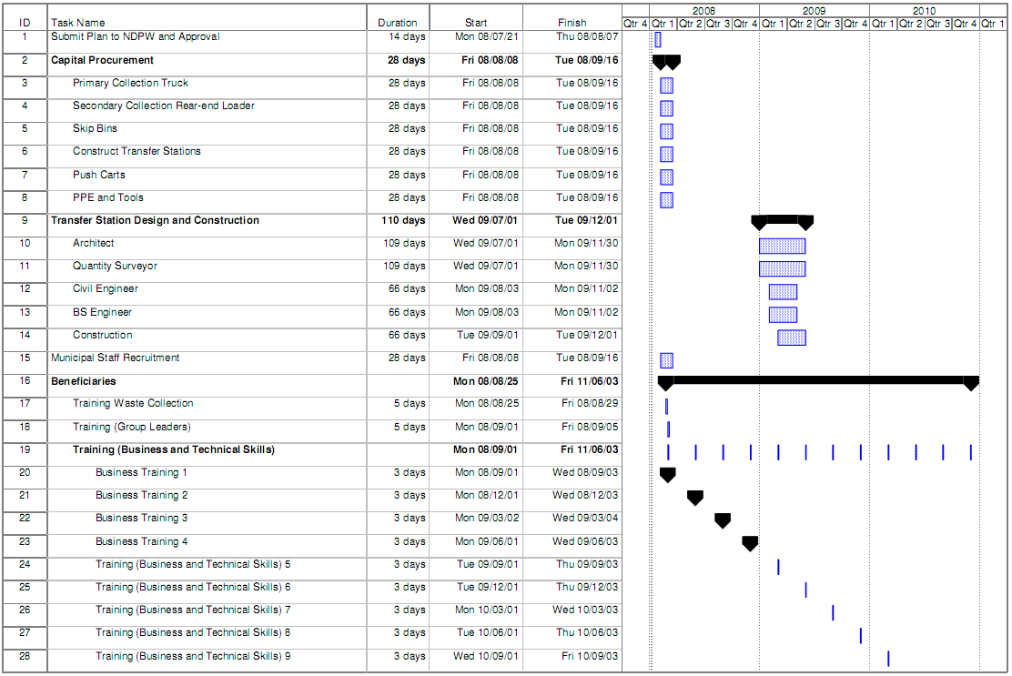

Figure 4: Activity Schedule (Part 2 of 3)
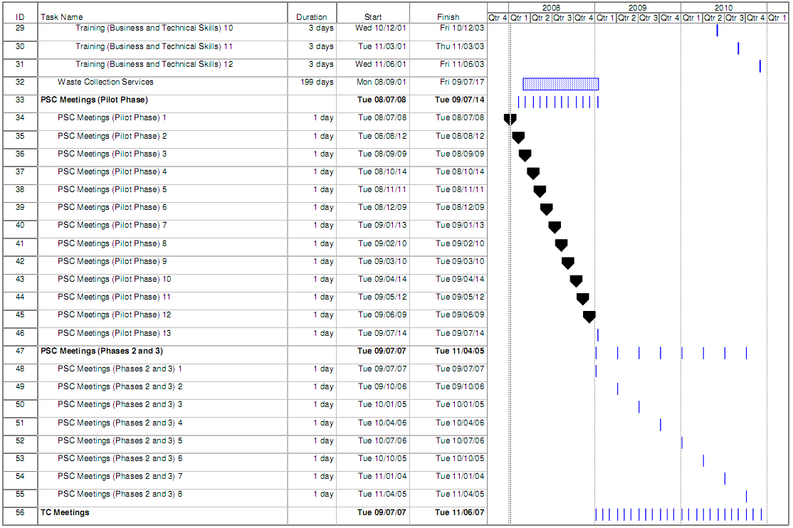

Figure 5: Activity Schedule (Part 3 of 3)
